Digital Biosignal Processing

MATLAB Laboratory 8

The power spectral density (PSD) characterizes the frequency content of a random signal. For random signals, the PSD needs to be estimated from the available samples. In this exercise, you will work with an experimental spike train of a motor neuron (see Figure). This is a series of delta functions with an average inter-spike interval (*T*) and This signal can be modeled as one realization of a random process. The scope is to estimate the PSD of this random process.

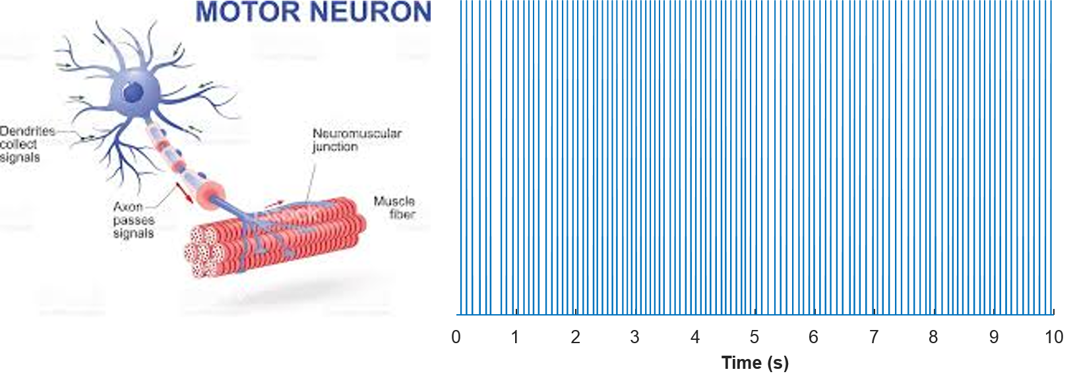

For the estimate, we will use the periodogram, defined as:

$${\hat{Φ}}_{xx}\left(e^{jω}\right)=\frac{1}{2L+1}{\left|X_{L}\left(e^{jω}\right)\right|}^{2}$$

Where $X_{L}\left(e^{jω}\right)= \sum_{n=-L}^{L}{x[n]e^{-jωn}}$ will be computed with the DFT (over a fixed number of frequency values).

You are provided with one signal as in the Figure, stored in 'spike_neural.mat'. You are also provided with some Matlab instructions below. By dividing the recording in windows, you will estimate the bias and variance of the periodogram.

**In your report, please provide the following:**

* Plot of the mean periodogram for rectangular window sizes of 0.2 s, 0.5 s, and 2 s. (Note: plot the mean periodogram for the frequency range of -50Hz ≤ freq. ≤ 50 Hz). [30%]
* Quantify and report (in a table) the bias of the estimate for the rectangular window sizes of 0.2 s, 0.5 s, and 2 s. (*hint:* compute the PSD area around the peak for the frequency range: -5Hz ≤ freq. ≤ 5 Hz and normalize this area by the peak value). Comment on the bias of the estimate depending on window size. [20%]
* Plot the variance of estimation of the periodogram as a function of the window size, for rectangular, Hanning, and Hamming windows. Comment on the effect of window size and type on the variance. [50%]

*PLEASE NOTICE: The report is limited to one A4 page, including all graphs and comments.*

% Eighth tutorial.

close all; clear all; clc

load('spike_neural.mat') % Load the neural_sig signal

L = length(neural_sig); % Duration of the signal in samples

fs = 10240; % Sample frequency in Hz

WinSize = [0.2:0.1:2]; % Window size in seconds

WinSize = round(WinSize.*fs); % Window size in samples

f_ax = (-pi:2*pi/fs:pi-2*pi/fs)./(2*pi).*fs; % Frequency axis in Hz

variance_periodogram_estimate = [];

for uu = 1 : length(WinSize)

% Estimate of the periodogram

window = rectwin(WinSize(uu))';

for n = 1:35 %For each window length, estimate the periodogram for the first 35 signal segments

wind_signal=neural_sig((n-1)*WinSize(uu)+(1:WinSize(uu))).*window;

Segm_spect{uu}(n,:) = fftshift(abs(fft(wind_signal,fs)).^2)./WinSize(uu);

end

%Variance of the periodogram estimate for each window size

variance_periodogram_estimate = [variance_periodogram_estimate var(Segm_spect{uu})'];

end

**[Here please complete with instructions for plotting the mean periodogram for rectangular window sizes of 0.2 s, 0.5 s, and 2 s]**

**[Here please complete with instructions for computing the bias for rectangular window sizes of 0.2 s, 0.5 s, and 2 s]**

**[Here please complete with instructions for plotting variance of estimation of the periodogram as a function of the window size, for rectangular, Hanning, and Hamming windows]**

%Variance of estimation of periodogram as a function of window size for rectangular window

figure; boxplot(**Please fill**)

xlabel(**Please fill**)

ylabel(**Please fill**)

title(**Please fill**)

%hanning window

**Please fill**

%hamming window

**Please fill**