Digital Biosignal Processing

MATLAB Laboratory 9

The power spectral density (PSD) characterizes the frequency content of a random signal. For random signals, the PSD needs to be estimated from the available samples. In this exercise, you will work with an experimental spike train of a motor neuron (Figure). This is a series of delta functions with an average inter-spike interval (*T*) and a random variability of discharge around the *T*. This signal can be modeled as one realization of a random process. The scope is to estimate the PSD of this random process.

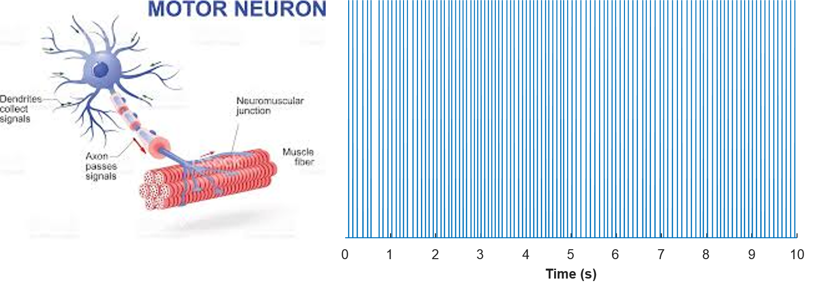

In this week’s lab, Welch’s method will be used for estimating the power spectral density. You are provided with one signal as in the Figure, stored in 'spike_neural.mat'. By dividing the recording in windows, you will estimate the bias and variance of the periodogram. You are provided with some Matlab instructions below and an empty MATLAB function “*welch_periodogram*” where you will be estimating the power spectral density using Welch’s method for varying window sizes (100ms to 1s (in steps of 100ms)), window overlaps (0%, and 50%), and window types (rectangular and hanning). *(Hint: For completing “welch_periodogram” function please use the code provided in Lab 8 as reference.)*

**In your report, please provide the following:**

* Estimate the power spectral density using the Welch’s method for different window sizes, overlaps and window types. For each estimation, provide plots of the bias of the estimate (*hint:* compute the power within the frequency range: -5Hz ≤ freq. ≤ 5 Hz and normalize it by the peak power within the same range) and median variability of the estimate of the periodogram.

Comment on the differences observed in the plots for different settings. [80%]

* Comment on the expected (i.e. theoretical) effects on the bias and the variability of the periodogram when changing
  + (i) the window sizes
  + (ii) overlaps
  + (iii) window types

Do your expectations match your observations in this exercise? [20%]

*PLEASE NOTICE: The report is limited to one A4 page, including all graphs and comments.*

% Ninth tutorial.

close all; clear all; clc

load('spike_neural.mat') % Load the neural_sig signal

fs = 10240; % Sample frequency in Hz

WinSize = [0.1:0.1:1]; % Window size in seconds

WinSize = round(WinSize.*fs); % Window size in samples

OverlapValues = [0 0.50];

Bias_Estimate_Rectangular = zeros(numel(WinSize),numel(OverlapValues));

Bias_Estimate_Hanning = zeros(numel(WinSize),numel(OverlapValues));

Var_Estimate_Rectangular = zeros(numel(WinSize),numel(OverlapValues));

Var_Estimate_Hanning = zeros(numel(WinSize),numel(OverlapValues));

for uu = 1 : length(WinSize)

overlap_count=1;

for Overlap=OverlapValues % size of overlap in percents of window size

%Rectangular window type

[periodogram,var_estimate,bias] = welch_periodogram(neural_sig, WinSize(uu), Overlap, 'rect', fs );

Bias_Estimate_Rectangular(uu,overlap_count) = bias;

Var_Estimate_Rectangular(uu,overlap_count) = median(var_estimate);

%Hanning window type

[periodogram,var_estimate,bias] = welch_periodogram(neural_sig, WinSize(uu), Overlap, 'hann', fs );

Bias_Estimate_Hanning(uu,overlap_count) = bias;

Var_Estimate_Hanning(uu,overlap_count) = median(var_estimate);

overlap_count = overlap_count + 1;

end

end

%Plots for the bias of the estimate for different window types and overlaps over different window sizes

figure; hold on;

plot([PLEASE COMPLETE])

xlabel([PLEASE COMPLETE])

ylabel([PLEASE COMPLETE])

legend([PLEASE COMPLETE])

% Plots for the variability of the estimate for different window types and overlaps over different window sizes

figure; hold on;

plot([PLEASE COMPLETE])

xlabel([PLEASE COMPLETE])

ylabel([PLEASE COMPLETE])

legend([PLEASE COMPLETE])

function [periodogram,var_estimate,bias] = welch_periodogram(Data, WindowSize, Overlap, WindowType, fs )

% Estimate of the periodogram

L = length(Data); % Duration of the signal in samples

f_ax = (-pi:2*pi/fs:pi-2*pi/fs)./(2*pi).*fs; % Frequency axis in Hz

if strcmp(WindowType,'rect')

window = [PLEASE COMPLETE];

elseif strcmp(WindowType,'hann')

window = [PLEASE COMPLETE];

end

n=1;

while max(round((n-1)*WindowSize*(1-Overlap))+(1:WindowSize))<=L

wind_signal=[PLEASE COMPLETE];

Segm_spect(n,:) = [PLEASE COMPLETE];

n=n+1;

end

periodogram = [PLEASE COMPLETE];

var_estimate = [PLEASE COMPLETE];

bias = [PLEASE COMPLETE];

figure; plot(f_ax,periodogram);

end