Digital Biosignal Processing

MATLAB Laboratory 1

Two EMG signals have been recorded from the biceps brachii muscle of a healthy subject during a voluntary contraction. The two EMG bipolar systems have been spaced by 24 mm and mounted between the innervation zone and the distal tendon. A segment of these signals is saved in the matlab data file Signals_EMG.mat. The sampling frequency during the experimental recording was 2048 Hz. The aim of this exercise if to estimate with high accuracy the conduction velocity of the active muscle fibres by processing the two recorded signals. A scheme of the experiment is reported below.

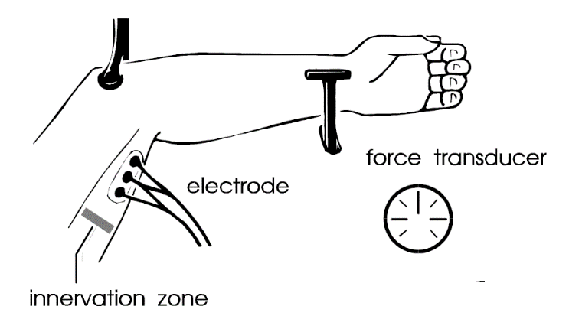

Study the short Matlab script provided and understand the meaning of the parameters. Use the Matlab script to estimate conduction velocity from the signals provided. Change the parameters of the script to obtain estimates with different step sizes, downsampling factors, and number of steps. The script provides plot of the signals before and after time shift.

**In your report, please provide the following:**

* For the optimal alignment case, plot the two signals in time domain and report the set of parameters (step size, number of steps, downsampling factor) used for this plot in a table. Report the optimal delay and estimated conduction velocity. [30%]
* Plot the estimation error (variable MSE_vect in the Matlab function) as a function of the delay, for downsampling factors M=1,2,4,8 (please include all graphs for the different M in the same plot with different colors). For each M, report the optimal delay, estimated conduction velocity, and optimal MSE in a table. Comment on the estimates in the different cases of downsampling factors. [70%]

*PLEASE NOTICE: The report is limited to 1 A4 page, including all graphs and comments.*

close all

clear all

fclose('all')

load('Signals_EMG.mat'); % Loading the recorded EMGs (two channels)

n_step = 100; % Number of steps in the loop for optimal alignment

stepSize = 0.2; % Size of the step of non-integer delay applied to one of the signals for alignment

ied=24; % Interelectrode distance of the recordings in mm

Fs = 2048; % Recording sampling frequency

Ts = 1/Fs; % Sampling interval

% Downsampling by an integer

M = 1; % Downsampling factor

channel1 = channel1(1:M:end); % Downsampling first channel

channel2 = channel2(1:M:end); % Downsampling second channel

Fs=Fs/M;

Ts=Ts*M;

% End downsampling

timeAxis=[1:length(channel1)].*Ts.*1000; % Definition of time axis in ms

freqAxis=fftshift([-0.5:1/(length(channel1)):0.5-1/(length(channel1))]); % Definition of discrete frequency axis

figure(1);plot(timeAxis,channel1,'k');hold on; plot(timeAxis,channel2-1000,'k'); % Plot of the two recordings after down-sampling

xlabel('Time (ms)')

ylabel('Signals (AU)')

channel1_ft = fft(channel1); % Fourier transform of the first channel

figure(2)

for uu = 1 : n_step

channel1_dt = (channel1_ft).*exp(-i*2*pi*stepSize*uu*freqAxis); % complex exponential multiplication (delay in frequency domain)

channel1_dt = real(ifft((channel1_dt))); % inverse transform to go back to the time domain

plot(timeAxis,channel1_dt,'r'); % Plot of the time-shifted signal

hold on

plot(timeAxis,channel2,'k');

uu

MSE_vect(uu)= sum((channel1_dt - channel2).^ 2)./sum(channel2.^ 2).*100; % normalized mean square error between aligned signals

delay(uu) = stepSize*uu; % Imposed delay in samples

end;

xlabel('Time (ms)')

ylabel('Signal amplitude (AU)')

% Identification of the optimal delay (minimum mean sqaure error)

[MSEopt, optDelay] = min(MSE_vect);

% Plot of optimal alignment

**[Here please complete with plot instructions of the two signals with optimal alignment. This means that channel1 has to be plotted after shift by the optimal delay.]**

% Delay and conduction velocity estimate

fprintf('The optimal delay is %2.2f ms \n',delay(optDelay)*Ts*1000);

fprintf('The estimated conduction velocity is %2.2f m/s \n',ied/(delay(optDelay)*Ts*1000));

fprintf('Optimal MSE between signals: %2.2f %%\n',MSEopt);