Digital Biosignal Processing

MATLAB Laboratory 4

Electrocardiography (ECG or EKG) is a technique used to record the electrical activity of the heart using electrodes placed on a patient's body. The electrodes detect electrical potentials on the skin surface, arising from the heart muscle depolarization, which occurs at each heartbeat. ECG recordings are inevitably contaminated by noise, mainly due to electrical activity of other muscles (see Figure). An ECG signal with high signal-to-noise ratio can be used effectively for screening and diagnosis of heart conditions. One method for increasing the signal-to-noise ratio of ECG recordings is to filter them with a moving average filter. For the analysis of this filter, the z-transform is particularly useful.

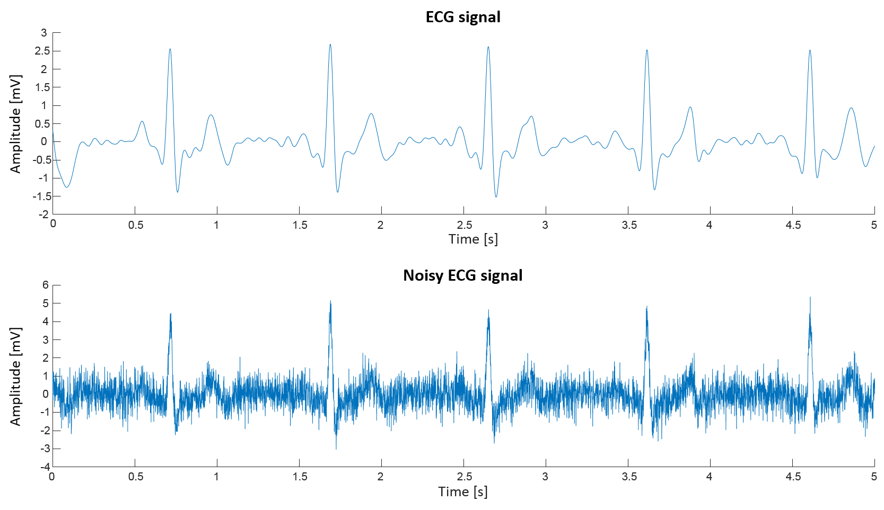

The objective of this exercise is to represent discrete-time signals and systems in the *z*-plane, and to understand the properties of LTI systems through the analysis of the frequency response of the moving average filter.

You have been provided with an ECG signal recording stored in “ECG.mat”. Study the Matlab script provided below. Create a moving average filter to reduce the noise from the ECG signal. Derive analytically the z-transform of the filter, which is the system function *H*(z). Vary the filter length and observe the effect on the ECG signal.

**In your report, please provide the following:**

* Determine the poles and zeroes for *H(z)* with lengths of 2, 10, and 50, and plot them in the *z*-plane [30%].
* Plot the input and output signals for *H(z)* with lengths of 2, 10, and 50, and their DFTs [70%].

*PLEASE NOTICE: The report is limited to one A4 page, including all graphs and comments.*

% Fourth Tutorial.

clear all; close all; clc;

load('ECG.mat') % Load the signal

ECG=ECG-mean(ECG); % Remove mean

fs = 1000; % Sample frequency in Hz

t_ax = (0:length(ECG)-1)/fs; % Time axis of the signal

% Plot the signal

figure(1), plot(t_ax, ECG );

title('ECG signal');

xlabel('Time (s)'),ylabel('Amplitude (AU)');

xlim([0 5]);

ECG_duration=size(ECG,2); % Duration of the ECG signal in samples

f_ax=[-pi+pi/ECG_duration:2*pi/ECG_duration:pi-pi/ECG_duration]; % Frequency axis for DFT

F_ECG = fftshift(fft(ECG)); % Calculate DFT

% Plot the DFT of the signal

figure(2), plot(f_ax,abs(F_ECG));

title('DFT of the input ECG signal');

xlabel('Frequency (rad)')

ylabel('Magnitude (AU)');

% Create moving average filter

MA_coef_num = 50;

MA = **[Here please complete with instructions for generating the Moving Average filter (MA) and use it to filter the ECG signal (ECG_filt).]**

% Plot the filtered ECG signal

figure(3); plot(t_ax, ECG_filt, 'r');

title('Filtered ECG signal with MA filter');

xlabel('Time (s)'),ylabel('Amplitude (AU)');

xlim([0 5]);

F_ECG_filt = fftshift(fft(ECG_filt));% Calculate DFT of the filtered ECG

% Plot the Fourier transform of the filtered signal

figure(4), plot(f_ax,abs(F_ECG_filt));

title('DFT of the filtered ECG signal');

xlabel('Frequency (rad)')

ylabel('Magnitude (AU)');

% Create system function of the z-transform of the MA filter

H = tf(MA,1,1/fs,'variable','z^-1');

% Evaluate the magnitude and the phase of the filter with respect to the normalized frequency

figure(5), freqz(MA,1);

% Go from coefficients to zeroes and poles of the moving average filters

[MA_zeros,MA_poles] = tf2zpk(H.Numerator{1,1},(H.Denominator{1,1}));

% Z-plane of the moving average filter

figure(6), zplane(MA_zeros,MA_poles)

title('Filter coefficients represented in the z-plane')