Digital Biosignal Processing

MATLAB Laboratory 5

The surface myoelectric signal (sEMG) is commonly used for interfacing prosthetic limbs. The information content within the EMG of muscles above the amputation is sufficient to provide users with basic functionalities needed for carrying out simple everyday tasks (see Figure). The most common prosthetic controllers rely on EMG amplitude estimation and hence, the extraction of high quality sEMG envelopes is crucial.

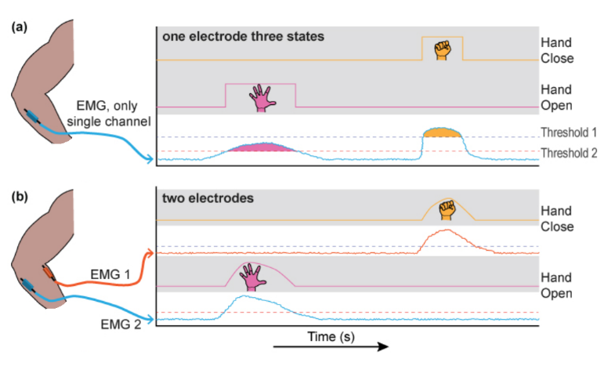

The objective of this exercise is to extract the EMG envelope of an EMG signal recorded from an amputee subject, using a Finite Impulse Response (FIR) filter of your own design.

You have been provided with an EMG signal recording stored as “EMG.mat”. The signal has been recorded from the forearm muscles of a transradial amputee during the use of his prosthesis. The sampling frequency is 1.6 kHz. Study the Matlab script provided below. Design a low-pass FIR filter with cut-off frequency 5Hz using the method of truncation of the impulse response (sinc function). Also, design a moving average filter of variable lengths. Compare the properties of the two filters and evaluate their performance by applying them on the rectified EMG signal to extract the signal envelope.

**In your report, please provide the following:**

* Plots of the Sinc function used for designing the FIR filter and of its DFT [10%]
* Plots of the EMG envelopes obtained by the two filters (FIR designed by truncation with rectangular window and moving average) when using for both filters the lengths of 400 and 1000. Comment qualitatively (and with one sentence) on the effect of filter length on the filtered signals.[30%]
* For FIR filter of 400 points, plot the EMG envelopes obtained when using Hanning (hann) and rectangular window (rectwin). Comment on the qualitative differences between the filtered signals. Do you expect to see these differences and why? [35%]
* Comment on the frequency responses (magnitude and phase) of the digital filters used. (Hint: For magnitude response, think in terms of filter design parameters such as cut-off frequency. During comparison only consider the moving average and sinc fir (rect) cases.) [25%]

*PLEASE NOTICE: The report is limited to one A4 page, including all graphs and comments.*

% Fifth Tutorial

clear all; close all; clc;

load 'emg'; % Load the EMG signal

fs = 1600; % Sampling frequency

L = length(emg); % Duration of the signal in samples

time_ax=[0:1/fs:(L-1)/fs]; % Time axis of the signal in seconds

fc = 5; % Filter cut-off frequency in (Hz)

wc = 2*fc/fs*pi; % Normalized cut-off frequency

% Generate Sinc function with a given sampling rate

t = -floor(L):floor(L); % Form the time axis of the Sinc function (theoretically it can be infinetly long)

sinc_func=(wc/pi)*sinc((2*fc/fs)*t);

figure; plot(t, sinc_func);

title('Sinc function');

xlabel('n');

ylabel('AU');

f_snc=fftshift(fft(sinc_func)); % Find the DFT of the sinc function

f_ax =(-pi+pi/length(sinc_func):2*pi/length(sinc_func):pi-pi/length(sinc_func))./pi; % Frequency axis for the DFT of sinc function

figure; plot(f_ax,abs(f_snc));

title('Magnitude of discrete time Fourier transform of the Sinc');

xlabel('Frequency (rad)')

ylabel('AU');

% Create the FIR filter by truncating the very long sinc function and by using

% one of the following windows: hanning (hann) and rectangular (rectwin);

FIR_duration=1000;

truncation_section=floor(length(sinc_func)/2-FIR_duration/2):floor(length(sinc_func)/2+FIR_duration/2);

fir_filt = sinc_func(truncation_section).*rectwin(length(truncation_section))';

figure;freqz(fir_filt,1,8192);

% Create moving avarege filter with the lenght of MA_coef_num

MA_coef_num=1000;

MA=**[Here please complete with instructions for generating the Moving Average filter (MA)]**

figure;freqz(MA);

% Filter the rectified EMG using FIR filter

env_FIR=**[Here please complete with instructions needed to filter the rectified EMG signal using generated FIR filter]**

% Filter the rectified EMG using moving avarage filter

env_MA = **[Here please complete with instructions needed to filter the rectified EMG signal using generated Moving Average filter]**