Digital Biosignal Processing

MATLAB Laboratory 6

Infinite impulse response (IIR) is a property of many linear time-invariant (LTI) systems, such as most electronic and digital filters. The impulse response of these filters has infinite length, as opposite to the Finite Impulse Response (FIR) systems that were analyzed in Lab 5. The infinite response comes from recurrent terms in the system difference equation (i.e. the output values depend both on the previous output and input values). Therefore, the IIR system function is a rational function with both zeros and poles in the z-plane. Using infinite impulse response, various filters can be implemented very efficiently.

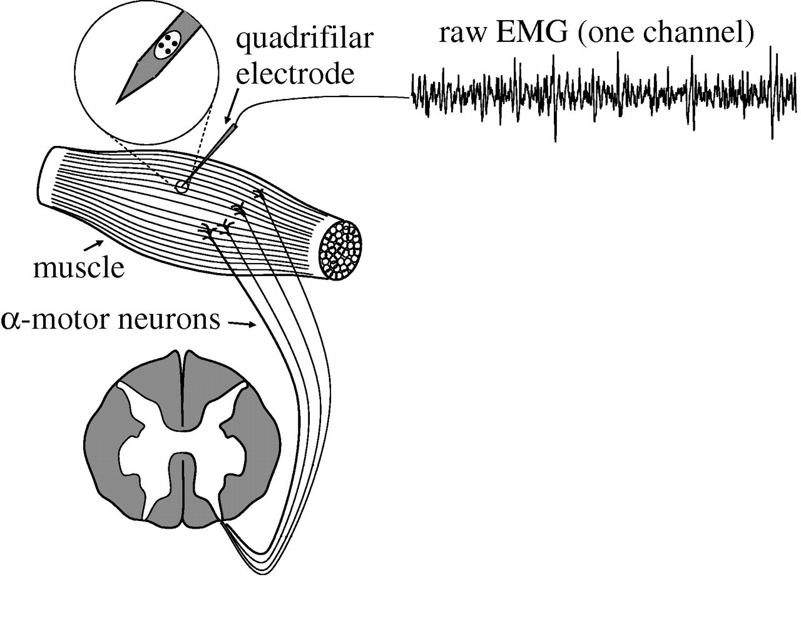Band-stop filter is a frequency selective implementation that eliminates a specified frequency band. If the stop band is very narrow and highly attenuated over a few hertz, then the band-stop filter is more commonly referred to as a *notch filter*. In such implementations of the band stop filter, the frequency response shows a deep notch with high selectivity (a steep-side curve).  
  
The objective of this exercise is to implement in Matlab an IIR band-stop filter and understand its properties through the analysis of its frequency response and system function (z-transform of impulse response). You are provided with an intramuscular EMG (iEMG) signal in the file “EMG.mat”. The signal has been recorded with a needle electrode (see Figure) and is corrupted by power line interference at 60 Hz and multiples of this frequency (120 Hz, 180 Hz). The interference can be seen in the frequency domain by plotting the DFT of the signal.

Study the Matlab script provided below. Using the script, implement notch filters to remove the interference at the frequencies 60, 120, 180 Hz (note that the stop band should be of a few Hz around the frequency to eliminate, to make the filter design feasible). Obtain the z-transform of the filter, which is the system function *H*(z) and identify zeros and poles. Compute the DFT of the filtered signal.

**In your report, please provide the following:**

* Plot the magnitude of the EMG signal DFT. Identify and indicate the interference peaks on the plot. [35%]
* In the z-plane, plot the poles and zeros of the three filters. Comment on their locations. [35%]
* Using a cascade of the three filters, remove the 60Hz noise and its harmonics from the iEMG signal. Plot the magnitude of the DFT of the signal filtered at each filter output. [30%]

*PLEASE NOTICE: The report is limited to one A4 page, including all graphs and comments.*

% Sixth tutorial.

close all; clear all; clc

load('EMG.mat'); % Load the EMG signal

L = length(EMG); % Duration of the signal in samples

Fs = 2500; % Sample frequency in Hz

t_ax = (0:L-1)/Fs; % Time axis of the signal in seconds

figure(1), plot(t_ax,EMG)

title('Intramuscular EMG signal')

xlabel('Time [s]')

ylabel('AU')

F_EMG = fftshift(fft(EMG)); % Find the DFT of the EMG

f_ax = (-L/2:L/2-1)*Fs/L;

figure(2), plot(f_ax,abs(F_EMG));

xlabel('Frequency (Hz)')

title('Spectrum of the signal before the filtering')

% Create band-stop filters to remove 60 Hz and harmonics

N = 3; % Filter order

band1 = [58 62];

[B1,A1] = butter(N,band1/(Fs/2),'stop'); % Generate filter coefficients

band2 = **[Here please complete with instructions for generating the second band-stop filter]**

band3 = **[Here please complete with instructions for generating the third band-stop filter]**

% Analyze the properties of the filter

H1 = tf(B1,A1,1/Fs,'variable','z^-1'); % Create transfer function object

[z,p,k] = tf2zp(B1,A1); % Calculate zeros and poles

figure(3), freqz(B1,A1);

title('Analysis in frequency domain of the filter that remove 60Hz-band frequency ')

figure(4), zplane(B1,A1);

title('z-plane to represent zeros and poles of the filter that remove 60Hz-band frequency ')

H2 = **[Here please complete with instructions for generating the transfer function and analysing the properties of the second band-stop filter]**

H3 = **[Here please complete with instructions for generating the transfer function and analysing the properties of the third band-stop filter]**

% Filter the signal

figure(9), hold on, plot(t_ax,EMG,'b'); %original signal

EMG_f = filter(B1,A1,EMG);

figure(9), hold on, plot(t_ax,EMG_f,'r');

EMG_f2 = **[Here please complete with instructions in order to apply and plot the effects in time domain of the second band-stop filter]**

EMG_f3 = **[Here please complete with instructions in order to apply and plot the effects in time domain of the third band-stop filter]**

% DFT of the filtered signal

F_EMG_f = fftshift(fft(EMG_f));

F_EMG_f2 = **[Here please complete with instructions in order to obtain DFT of the second band-stop filter]**

F_EMG_f3 = **[Here please complete with instructions in order to obtain DFT of the third band-stop filter]**