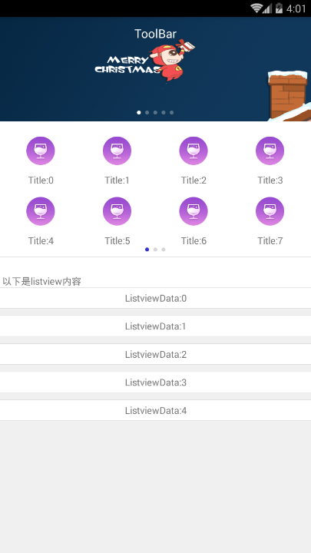

LinearLayout

ViewPager

ViewPager

Header

Listview