**Metrics**

## 一、基础知识

**1 Metrics是一个给JAVA服务的各项指标提供度量工具的包**，在JAVA代码中嵌入Metrics代码，可以方便的对业务代码的各个指标进行监控，同时，Metrics能够很好的跟Ganlia、Graphite结合，方便的提供图形化接口。基本使用方式直接将core包（目前稳定版本3.0.1）导入pom文件即可，配置如下：

**Metrics Registries类似一个metrics容器，维护一个Map，可以是一个服务一个实例。**

**支持五种metric类型：Gauges、Counters、Meters、Histograms和Timers。**

**可以将metrics值通过JMX、Console，CSV文件和SLF4J loggers发布出来**

**2 maven依赖**

<dependency>

<groupId>com.codahale.metrics</groupId>

<artifactId>metrics-core</artifactId>

<version>3.0.1</version>

</dependency>

## 二、五种Metrics

**1.Gauges**

Gauges是一个最简单的计量，一般用来统计瞬时状态的数据信息，比如系统中处于pending状态的job。测试代码

package com.netease.test.metrics;

import com.codahale.metrics.ConsoleReporter;

import com.codahale.metrics.Gauge;

import com.codahale.metrics.JmxReporter;

import com.codahale.metrics.MetricRegistry;

import java.util.Queue;

import java.util.concurrent.LinkedBlockingDeque;

import java.util.concurrent.TimeUnit;

public class TestGauges {

/**

* 实例化一个registry，最核心的一个模块，相当于一个应用程序的metrics系统的容器，维护一个Map

*/

private static final MetricRegistry metrics = new MetricRegistry();

private static Queue<String> queue = new LinkedBlockingDeque<String>();

/**

* 在控制台上打印输出

*/

private static ConsoleReporter reporter = ConsoleReporter.forRegistry(metrics).build();

public static void main(String[] args) throws InterruptedException {

reporter.start(3, TimeUnit.SECONDS);

//实例化一个Gauge

Gauge<Integer> gauge = new Gauge<Integer>() {

@Override

public Integer getValue() {

return queue.size();

}

};

//注册到容器中

metrics.register(MetricRegistry.name(TestGauges.class, "pending-job", "size"), gauge);

//测试JMX

JmxReporter jmxReporter = JmxReporter.forRegistry(metrics).build();

jmxReporter.start();

//模拟数据

for (int i=0; i<20; i++){

queue.add("a");

Thread.sleep(1000);

}

}

}

/*

console output:

14-2-17 15:29:35 ===============================================================

-- Gauges ----------------------------------------------------------------------

com.netease.test.metrics.TestGauges.pending-job.size

value = 4

14-2-17 15:29:38 ===============================================================

-- Gauges ----------------------------------------------------------------------

com.netease.test.metrics.TestGauges.pending-job.size

value = 6

14-2-17 15:29:41 ===============================================================

-- Gauges ----------------------------------------------------------------------

com.netease.test.metrics.TestGauges.pending-job.size

value = 9

*/

通过以上步骤将会向MetricsRegistry容器中注册一个名字为com.netease.test.metrics .TestGauges.pending-job.size的metrics，实时获取队列长度的指标。另外，Core包种还扩展了几种特定的Gauge：

JMX Gauges—提供给第三方库只通过JMX将指标暴露出来。

Ratio Gauges—简单地通过创建一个gauge计算两个数的比值。

Cached Gauges—对某些计量指标提供缓存

Derivative Gauges—提供Gauge的值是基于其他Gauge值的接口。

**2.Counter**

Counter是Gauge的一个特例，维护一个计数器，可以通过inc()和dec()方法对计数器做修改。使用步骤与Gauge基本类似，在MetricRegistry中提供了静态方法可以直接实例化一个Counter。

package com.netease.test.metrics;

import com.codahale.metrics.ConsoleReporter;

import com.codahale.metrics.Counter;

import com.codahale.metrics.MetricRegistry;

import java.util.LinkedList;

import java.util.Queue;

import java.util.concurrent.TimeUnit;

import static com.codahale.metrics.MetricRegistry.*;

public class TestCounter {

/**

* 实例化一个registry，最核心的一个模块，相当于一个应用程序的metrics系统的容器，维护一个Map

*/

private static final MetricRegistry metrics = new MetricRegistry();

/**

* 在控制台上打印输出

*/

private static ConsoleReporter reporter = ConsoleReporter.forRegistry(metrics).build();

/**

* 实例化一个counter,同样可以通过如下方式进行实例化再注册进去

* pendingJobs = new Counter();

* metrics.register(MetricRegistry.name(TestCounter.class, "pending-jobs"), pendingJobs);

*/

private static Counter pendingJobs = metrics.counter(name(TestCounter.class, "pedding-jobs"));

// private static Counter pendingJobs = metrics.counter(MetricRegistry.name(TestCounter.class, "pedding-jobs"));

private static Queue<String> queue = new LinkedList<String>();

public static void add(String str) {

pendingJobs.inc();

queue.offer(str);

}

public String take() {

pendingJobs.dec();

return queue.poll();

}

public static void main(String[]args) throws InterruptedException {

reporter.start(3, TimeUnit.SECONDS);

while(true){

add("1");

Thread.sleep(1000);

}

}

}

/*

console output：

14-2-17 17:52:34 ===============================================================

-- Counters --------------------------------------------------------------------

com.netease.test.metrics.TestCounter.pedding-jobs

count = 4

14-2-17 17:52:37 ===============================================================

-- Counters --------------------------------------------------------------------

com.netease.test.metrics.TestCounter.pedding-jobs

count = 6

14-2-17 17:52:40 ===============================================================

-- Counters --------------------------------------------------------------------

com.netease.test.metrics.TestCounter.pedding-jobs

count = 9

*/

**3.Meters**

Meters用来度量某个时间段的平均处理次数（request per second），每1、5、15分钟的TPS。比如一个service的请求数，通过metrics.meter()实例化一个Meter之后，然后通过meter.mark()方法就能将本次请求记录下来。统计结果有总的请求数，平均每秒的请求数，以及最近的1、5、15分钟的平均TPS。

package com.netease.test.metrics;

import com.codahale.metrics.ConsoleReporter;

import com.codahale.metrics.Meter;

import com.codahale.metrics.MetricRegistry;

import java.util.concurrent.TimeUnit;

import static com.codahale.metrics.MetricRegistry.*;

public class TestMeters {

/**

* 实例化一个registry，最核心的一个模块，相当于一个应用程序的metrics系统的容器，维护一个Map

*/

private static final MetricRegistry metrics = new MetricRegistry();

/**

* 在控制台上打印输出

*/

private static ConsoleReporter reporter = ConsoleReporter.forRegistry(metrics).build();

/**

* 实例化一个Meter

*/

private static final Meter requests = metrics.meter(name(TestMeters.class, "request"));

public static void handleRequest() {

requests.mark();

}

public static void main(String[] args) throws InterruptedException {

reporter.start(3, TimeUnit.SECONDS);

while(true){

handleRequest();

Thread.sleep(100);

}

}

}

/*

14-2-17 18:43:08 ===============================================================

-- Meters ----------------------------------------------------------------------

com.netease.test.metrics.TestMeters.request

count = 30

mean rate = 9.95 events/second

1-minute rate = 0.00 events/second

5-minute rate = 0.00 events/second

15-minute rate = 0.00 events/second

14-2-17 18:43:11 ===============================================================

-- Meters ----------------------------------------------------------------------

com.netease.test.metrics.TestMeters.request

count = 60

mean rate = 9.99 events/second

1-minute rate = 10.00 events/second

5-minute rate = 10.00 events/second

15-minute rate = 10.00 events/second

14-2-17 18:43:14 ===============================================================

-- Meters ----------------------------------------------------------------------

com.netease.test.metrics.TestMeters.request

count = 90

mean rate = 9.99 events/second

1-minute rate = 10.00 events/second

5-minute rate = 10.00 events/second

15-minute rate = 10.00 events/second

*/

**4. Histograms**

Histograms主要使用来统计数据的分布情况，最大值、最小值、平均值、中位数，百分比（75%、90%、95%、98%、99%和99.9%）。例如，需要统计某个页面的请求响应时间分布情况，可以使用该种类型的Metrics进行统计。具体的样例代码如下：

package com.netease.test.metrics;

import com.codahale.metrics.ConsoleReporter;

import com.codahale.metrics.Histogram;

import com.codahale.metrics.MetricRegistry;

import java.util.Random;

import java.util.concurrent.TimeUnit;

import static com.codahale.metrics.MetricRegistry.name;

public class TestHistograms {

/**

* 实例化一个registry，最核心的一个模块，相当于一个应用程序的metrics系统的容器，维护一个Map

*/

private static final MetricRegistry metrics = new MetricRegistry();

/**

* 在控制台上打印输出

*/

private static ConsoleReporter reporter = ConsoleReporter.forRegistry(metrics).build();

/**

* 实例化一个Histograms

*/

private static final Histogram randomNums = metrics.histogram(name(TestHistograms.class, "random"));

public static void handleRequest(double random) {

randomNums.update((int) (random*100));

}

public static void main(String[] args) throws InterruptedException {

reporter.start(3, TimeUnit.SECONDS);

Random rand = new Random();

while(true){

handleRequest(rand.nextDouble());

Thread.sleep(100);

}

}

}

/*

14-2-17 19:39:11 ===============================================================

-- Histograms ------------------------------------------------------------------

com.netease.test.metrics.TestHistograms.random

count = 30

min = 1

max = 97

mean = 45.93

stddev = 29.12

median = 39.50

75% <= 71.00

95% <= 95.90

98% <= 97.00

99% <= 97.00

99.9% <= 97.00

14-2-17 19:39:14 ===============================================================

-- Histograms ------------------------------------------------------------------

com.netease.test.metrics.TestHistograms.random

count = 60

min = 0

max = 97

mean = 41.17

stddev = 28.60

median = 34.50

75% <= 69.75

95% <= 92.90

98% <= 96.56

99% <= 97.00

99.9% <= 97.00

14-2-17 19:39:17 ===============================================================

-- Histograms ------------------------------------------------------------------

com.netease.test.metrics.TestHistograms.random

count = 90

min = 0

max = 97

mean = 44.67

stddev = 28.47

median = 43.00

75% <= 71.00

95% <= 91.90

98% <= 96.18

99% <= 97.00

99.9% <= 97.00

*/

**5. Timers**

Timers主要是用来统计某一块代码段的执行时间以及其分布情况，具体是基于Histograms和Meters来实现的。样例代码如下：

package com.netease.test.metrics;

import com.codahale.metrics.ConsoleReporter;

import com.codahale.metrics.MetricRegistry;

import com.codahale.metrics.Timer;

import java.util.Random;

import java.util.concurrent.TimeUnit;

import static com.codahale.metrics.MetricRegistry.name;

public class TestTimers {

/**

* 实例化一个registry，最核心的一个模块，相当于一个应用程序的metrics系统的容器，维护一个Map

*/

private static final MetricRegistry metrics = new MetricRegistry();

/**

* 在控制台上打印输出

*/

private static ConsoleReporter reporter = ConsoleReporter.forRegistry(metrics).build();

/**

* 实例化一个Meter

*/

// private static final Timer requests = metrics.timer(name(TestTimers.class, "request"));

private static final Timer requests = metrics.timer(name(TestTimers.class, "request"));

public static void handleRequest(int sleep) {

Timer.Context context = requests.time();

try {

//some operator

Thread.sleep(sleep);

} catch (InterruptedException e) {

e.printStackTrace();

} finally {

context.stop();

}

}

public static void main(String[] args) throws InterruptedException {

reporter.start(3, TimeUnit.SECONDS);

Random random = new Random();

while(true){

handleRequest(random.nextInt(1000));

}

}

}

/*

14-2-18 9:31:54 ================================================================

-- Timers ----------------------------------------------------------------------

com.netease.test.metrics.TestTimers.request

count = 4

mean rate = 1.33 calls/second

1-minute rate = 0.00 calls/second

5-minute rate = 0.00 calls/second

15-minute rate = 0.00 calls/second

min = 483.07 milliseconds

max = 901.92 milliseconds

mean = 612.64 milliseconds

stddev = 196.32 milliseconds

median = 532.79 milliseconds

75% <= 818.31 milliseconds

95% <= 901.92 milliseconds

98% <= 901.92 milliseconds

99% <= 901.92 milliseconds

99.9% <= 901.92 milliseconds

14-2-18 9:31:57 ================================================================

-- Timers ----------------------------------------------------------------------

com.netease.test.metrics.TestTimers.request

count = 8

mean rate = 1.33 calls/second

1-minute rate = 1.40 calls/second

5-minute rate = 1.40 calls/second

15-minute rate = 1.40 calls/second

min = 41.07 milliseconds

max = 968.19 milliseconds

mean = 639.50 milliseconds

stddev = 306.12 milliseconds

median = 692.77 milliseconds

75% <= 885.96 milliseconds

95% <= 968.19 milliseconds

98% <= 968.19 milliseconds

99% <= 968.19 milliseconds

99.9% <= 968.19 milliseconds

14-2-18 9:32:00 ================================================================

-- Timers ----------------------------------------------------------------------

com.netease.test.metrics.TestTimers.request

count = 15

mean rate = 1.67 calls/second

1-minute rate = 1.40 calls/second

5-minute rate = 1.40 calls/second

15-minute rate = 1.40 calls/second

min = 41.07 milliseconds

max = 968.19 milliseconds

mean = 591.35 milliseconds

stddev = 302.96 milliseconds

median = 650.56 milliseconds

75% <= 838.07 milliseconds

95% <= 968.19 milliseconds

98% <= 968.19 milliseconds

99% <= 968.19 milliseconds

99.9% <= 968.19 milliseconds

*/

## 三、Health Checks

**1 Metrics提供了一个独立的模块：H**ealth Checks，用于对Application、其子模块或者关联模块的运行是否正常做检测。该模块是独立metrics-core模块的，使用时则导入metrics-healthchecks包。

<dependency>

<groupId>com.codahale.metrics</groupId>

<artifactId>metrics-healthchecks</artifactId>

<version>3.0.1</version>

</dependency>

使用起来和与上述几种类型的Metrics有点类似，但是需要重新实例化一个Metrics容器HealthCheckRegistry，待检测模块继承抽象类HealthCheck并实现check()方法即可，然后将该模块注册到HealthCheckRegistry中，判断的时候通过isHealthy()接口即可。如下示例代码：

**2 代码**

package com.netease.test.metrics;

import com.codahale.metrics.health.HealthCheck;

import com.codahale.metrics.health.HealthCheckRegistry;

import java.util.Map;

import java.util.Random;

public class DatabaseHealthCheck extends HealthCheck{

private final Database database;

public DatabaseHealthCheck(Database database) {

this.database = database;

}

@Override

protected Result check() throws Exception {

if (database.ping()) {

return Result.healthy();

}

return Result.unhealthy("Can't ping database.");

}

/**

* 模拟Database对象

*/

static class Database {

/**

* 模拟database的ping方法

* @return 随机返回boolean值

*/

public boolean ping() {

Random random = new Random();

return random.nextBoolean();

}

}

public static void main(String[] args) {

// MetricRegistry metrics = new MetricRegistry();

// ConsoleReporter reporter = ConsoleReporter.forRegistry(metrics).build();

HealthCheckRegistry registry = new HealthCheckRegistry();

registry.register("database1", new DatabaseHealthCheck(new Database()));

registry.register("database2", new DatabaseHealthCheck(new Database()));

while (true) {

for (Map.Entry<String, Result> entry : registry.runHealthChecks().entrySet()) {

if (entry.getValue().isHealthy()) {

System.out.println(entry.getKey() + ": OK");

} else {

System.err.println(entry.getKey() + ": FAIL, error message: " + entry.getValue().getMessage());

final Throwable e = entry.getValue().getError();

if (e != null) {

e.printStackTrace();

}

}

}

try {

Thread.sleep(1000);

} catch (InterruptedException e) {

}

}

}

}

/*

console output:

database1: OK

database2: FAIL, error message: Can't ping database.

database1: FAIL, error message: Can't ping database.

database2: OK

database1: OK

database2: FAIL, error message: Can't ping database.

database1: FAIL, error message: Can't ping database.

database2: OK

database1: FAIL, error message: Can't ping database.

database2: FAIL, error message: Can't ping database.

database1: FAIL, error message: Can't ping database.

database2: FAIL, error message: Can't ping database.

database1: OK

database2: OK

database1: OK

database2: FAIL, error message: Can't ping database.

database1: FAIL, error message: Can't ping database.

database2: OK

database1: OK

database2: OK

database1: FAIL, error message: Can't ping database.

database2: OK

database1: OK

database2: OK

database1: OK

database2: OK

database1: OK

database2: FAIL, error message: Can't ping database.

database1: FAIL, error message: Can't ping database.

database2: FAIL, error message: Can't ping database.

*/

**3 其他支持**

metrics提供了对Ehcache、Apache HttpClient、JDBI、Jersey、Jetty、Log4J、Logback、JVM等的集成，可以方便地将Metrics输出到Ganglia、Graphite中，供用户图形化展示。

## 四、度量数据的输出

收集了这么多数据之后，我们需要把数据时实的动态展示或者保存起来。Metric提供了多种的数据报告接口。包括自带的Metrics.NET.FlotVisualization， 以及输出到专业的系统监控Graphite，输出到开源，分布式，时间序列的中InfluxDB，或者输出到ElasticSearch中。配置起来也非常简单。比如如果要直接在http页面上展现，只需要在初始化的时候，设置合适的EndPoint即可:

Metric.Config

.WithHttpEndpoint("http://localhost:1234/metrics/")

.WithAllCounters()

.WithInternalMetrics()

.WithReporting(config => config

.WithConsoleReport(TimeSpan.FromSeconds(30))

然后在浏览器中输入 http://localhost:1234/metrics/，就可以看到各种采集的准实时各种度量信息：

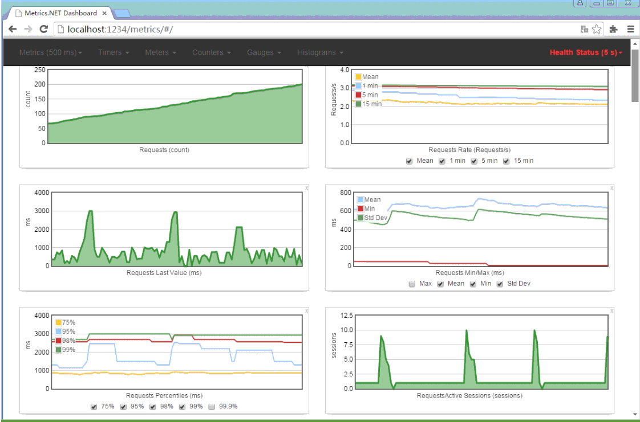

上面自带的性能DashBoard略显简陋。 通常，我们一般会将这些实时采集的数据存储到分布式时序数据库InfluxDB中，然后利用开源的图表控件Grafana来实时展现这些数据，比如，可以制作想下面这样的，动态的性能准实时监控系统：

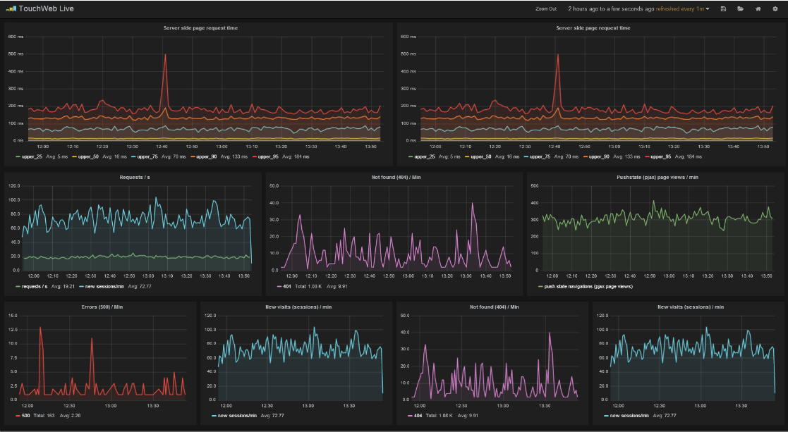

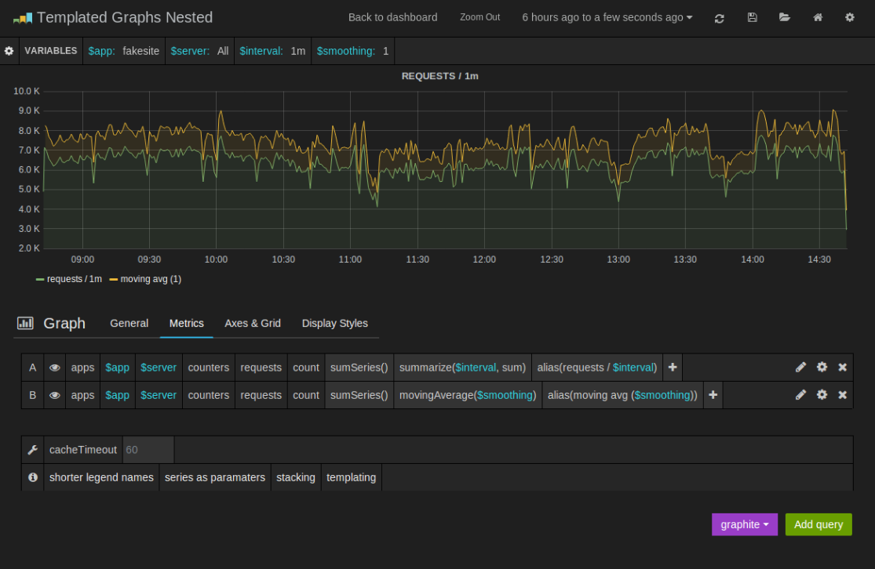

## 五、总结

**使用埋点和各种度量工具来实时监测应用程序的性能，介绍了.NET中Metrics度量工具的使用。与传统的记录日志的方式不同，这种实时或者准实时的对当前系统各种关键指标的采样和监控，对于应用程序的运维，性能优化，提供了一种动态的视角，能帮助我们更好的了解当前应用程序或者服务在线上的各种性能参数和表现状态。Metrics的采样应该尽量减少对原有系统的侵入性，所以一般的最好是将采样的结果存储到消息队列或者内存DB中，然后进行动态展示，另外采样频率也是需要考虑的一个重要因素。因为对于一个较大的系统来说，实时采样产生的数据量会比较大。InfluxDB 似乎只能在非Windows平台使用，所以本文没有完整演示整个Metrics+InfluxDB+Grafana 构建应用程序实时监控系统的搭建。**