**Linux nginx**

**//安装依赖**

yum -y install gcc zlib zlib-devel pcre-devel openssl openssl-devel

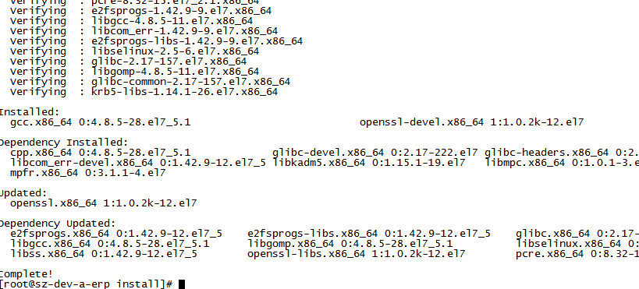

**//下载解压缩**  
wget http://nginx.org/download/nginx-1.8.1.tar.gz  
tar -zxvf nginx-1.8.1.tar.gz -C /home/dev/ops/local

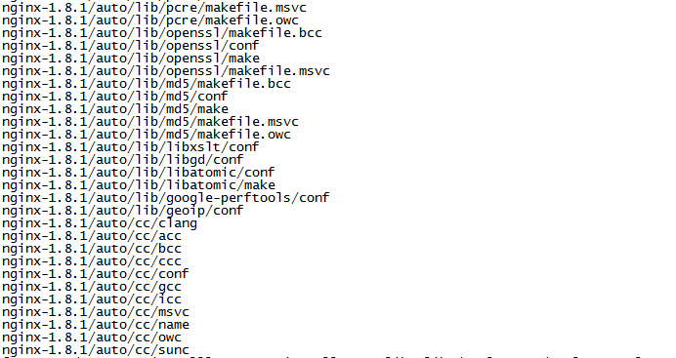

**//安装nginx**

cd /usr/local/nginx

./configure

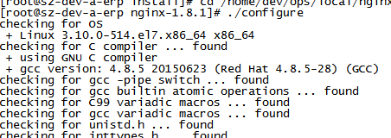

Make

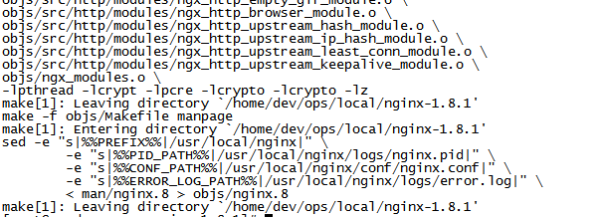

make install

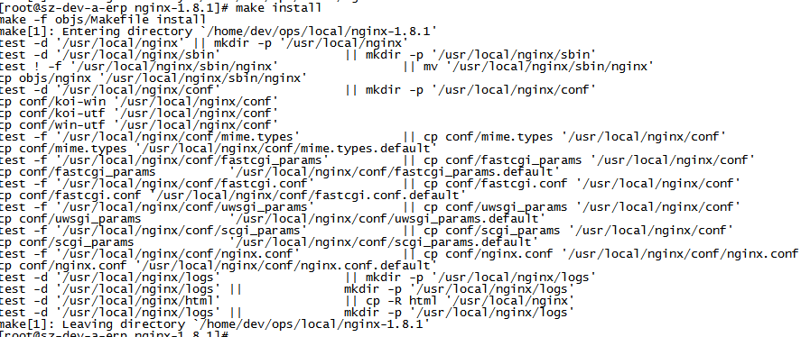

**特别注意：**

**/home/dev/ops/local/nginx-1.8.1是安装文件的路径**

**/usr/sbin/nginx 是命令执行目录，可以执行目录**

**/etc/nginx 才是安装的路径，配置文件**

**/var/log/nginx/aeecss.log nginx访问日志**

**/var/log/nginx/error.log nginx错误日志**

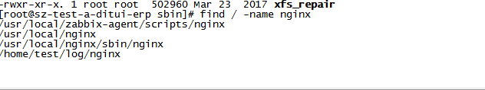

**1、查看nginx安装目录**

# ps -ef | grep nginx

返回结果包含安装目录

root 2662 1 0 07:12 ? 00:00:00 nginx: master process /usr/sbin/nginx

**2、查看nginx.conf配置文件目录**

# nginx -t

返回结果包含配置文件目录

nginx: the configuration file /etc/nginx/nginx.conf syntax is ok

nginx: configuration file /etc/nginx/nginx.conf test is successful

**3、启动nginx服务**

[root@localhost ~]# nginx安装目录 -c nginx.conf配置文件目录

参数 “-c” 指定了配置文件的路径，如果不加 “-c” 参数，Nginx 会默认加载其安装目录的 conf 子目录中的 nginx.conf 文件。

**//测试配置文件**

/usr/sbin/nginx -t

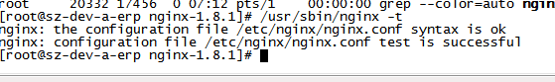

**//启动命令**

/usr/sbin/nginx

**//停止命令**

/usr/sbin/nginx -s stop

**//重启命令**

/usr/sbin/nginx -s reload

**在conf文件夹中新建proxy.conf**

#!nginx (-)

# proxy.conf

proxy_redirect off;

proxy_set_header Host $host;

proxy_set_header X-Real-IP $remote_addr; #获取真实ip

#proxy_set_header X-Forwarded-For $proxy_add_x_forwarded_for; #获取代理者的真实ip

client_max_body_size 10m;

client_body_buffer_size 128k;

proxy_connect_timeout 90;

proxy_read_timeout 90;

proxy_buffer_size 4k;

proxy_buffers 4 32k;

proxy_busy_buffers_size 64k;

proxy_temp_file_write_size 64k;

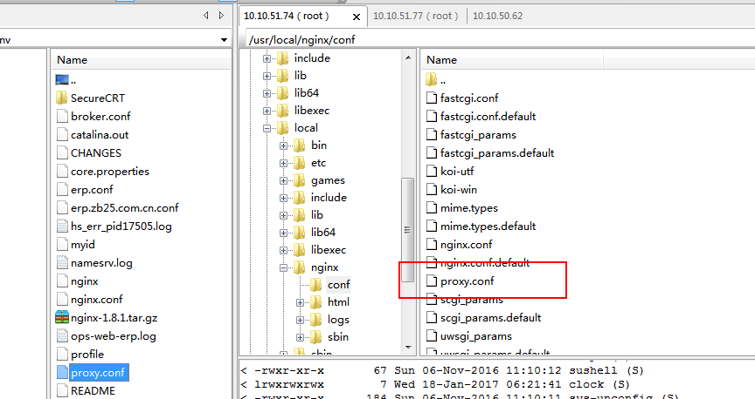

**编辑安装目录下conf文件夹中的nginx.conf，输入如下内容**

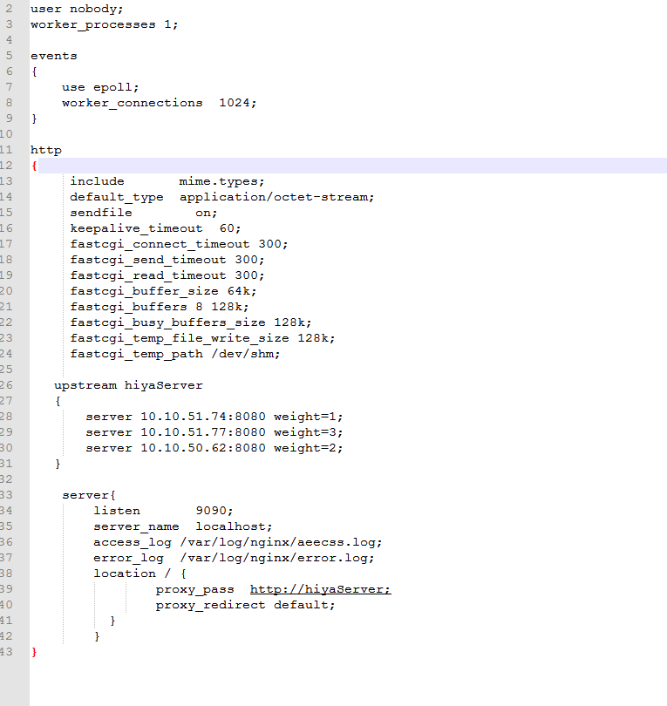

user nobody;

worker_processes 1;

events

{

use epoll;

worker_connections 1024;

}

http

{

include mime.types;

default_type application/octet-stream;

sendfile on;

keepalive_timeout 60;

fastcgi_connect_timeout 300;

fastcgi_send_timeout 300;

fastcgi_read_timeout 300;

fastcgi_buffer_size 64k;

fastcgi_buffers 8 128k;

fastcgi_busy_buffers_size 128k;

fastcgi_temp_file_write_size 128k;

fastcgi_temp_path /dev/shm;

upstream hiyaServer

{

server 10.10.51.74:8080 weight=1;

server 10.10.51.77:8080 weight=3;

server 10.10.50.62:8080 weight=2;

}

server{

listen 9090;

server_name localhost;

access_log /var/log/nginx/aeecss.log;

error_log /var/log/nginx/error.log;

location / {

proxy_pass http://hiyaServer;

proxy_redirect default;

}

}

}

**问题：**

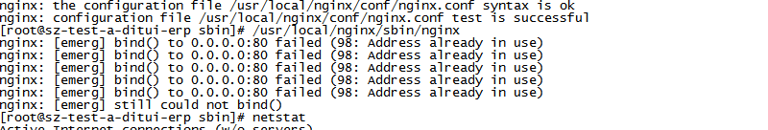

netstat -ntpl

查看80端口，杀死

**[nginx作代理时，查看请求被转发到哪台服务器](https://www.cnblogs.com/notDog/p/5336900.html)**

server {

listen 80;

server_name demo.testcas.com;

#charset koi8-r;

#access_log logs/host.access.log main;

location / {

#root html;

#index index.html index.htm;

**add_header backendIP $upstream_addr;**

proxy_pass http://demo;

}

}

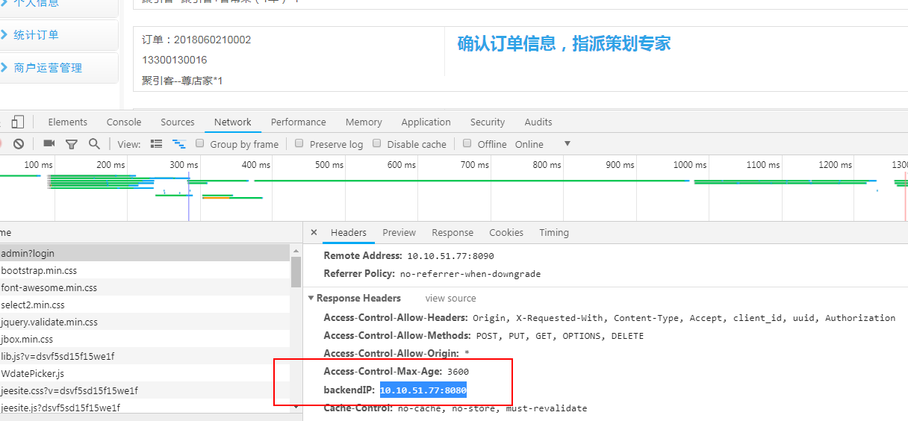

**测试单个机子**

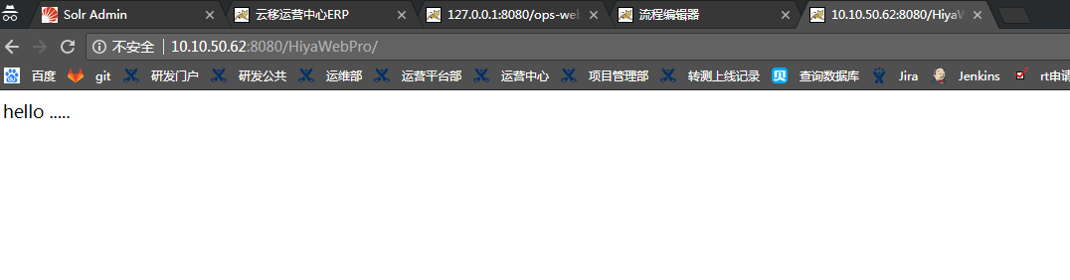

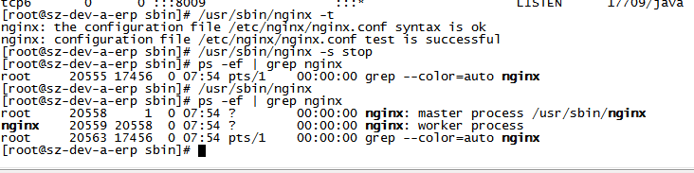

**看端口使用情况**

netstat -ntpl

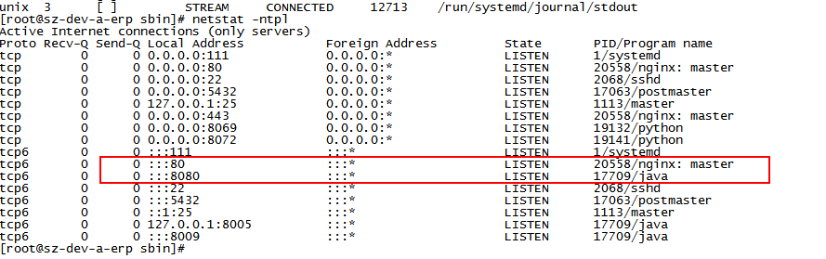

**访问：<http://10.10.51.74:9090/HiyaWebPro/> （nginx地址）**

**会负载均衡到 三台机器上**

