**Linux Solr**

**//下载solr7.1.0与tomcat8，JDK**  
wget [http://archive.apache.org/dist/lucene/solr/7.1.0/solr-7.1.0.zip](http://archive.apache.org/dist/lucene/solr/7.1.0/solr-7.1.0.zip" \t "https://blog.csdn.net/shanshanw/article/details/_blank)

wget [http://mirrors.shuosc.org/apache/tomcat/tomcat-8/v8.5.24/bin/apache-tomcat-8.5.24.tar.gz](http://mirrors.shuosc.org/apache/tomcat/tomcat-8/v8.5.24/bin/apache-tomcat-8.5.24.tar.gz" \t "https://blog.csdn.net/shanshanw/article/details/_blank)

**//解压缩**

unzip -oq solr-7.1.0.zip -d /home/dev/ops/local

### **//将运行solr7所需的文件以及jar复制到tomcat中**

cd /home/dev/ops/local/solr-tomcat-8.0.51/webapps   
创建solr目录：mkdir solr   
切换到该目录：cd solr

.标识拷贝到当前目录

cp -r /home/dev/ops/local/solr-7.1.0/server/solr-webapp/webapp/* .   
cp -r /home/dev/ops/local/solr-7.1.0/server/lib/ext/* WEB-INF/lib/   
cp -r /home/dev/ops/local/solr-7.1.0/server/lib/metrics*.* WEB-INF/lib/   
cp -r /home/dev/ops/local/solr-7.1.0/dist/solr-dataimporthandler-* WEB-INF/lib/

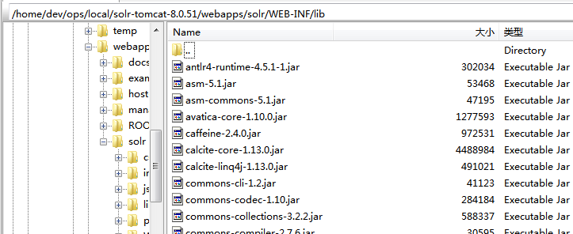

**日志配置：**   
mkdir -p WEB-INF/classes   
cp /home/dev/ops/local/solr-7.1.0/server/resources/log4j.properties WEB-INF/classes/

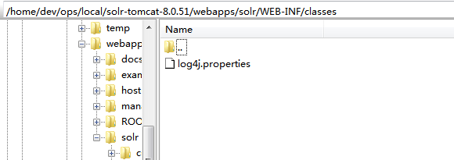

**vim WEB-INF/web.xml，放开env-entry，注释掉security-constraint**

cd /home/dev/ops/local

mkdir solr_home

vim WEB-INF/web.xml

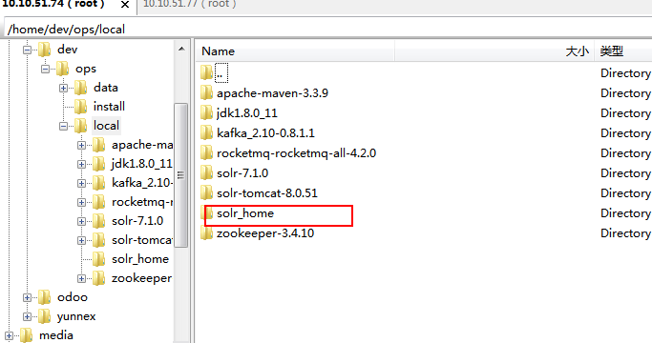

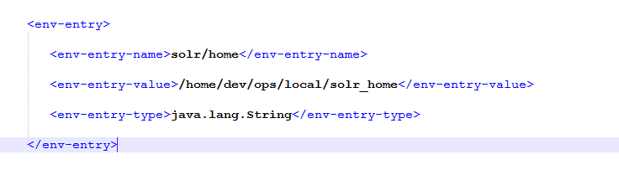

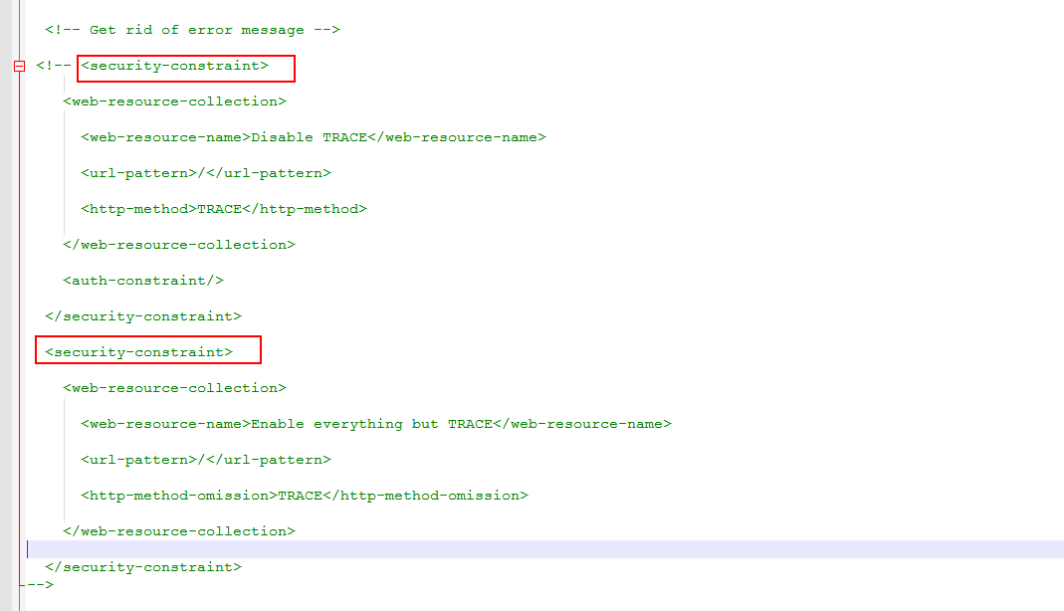

**配置solr运行的配置**

cd /home/dev/ops/local/solr_home   
cp -r /home/dev/ops/local/solr-7.1.0/server/solr/* .   
cp -r /home/dev/ops/local/solr-7.1.0/contrib/ .   
cp -r /home/dev/ops/local/solr-7.1.0/dist/ .

### **配置修改tomcat端口，并启动**

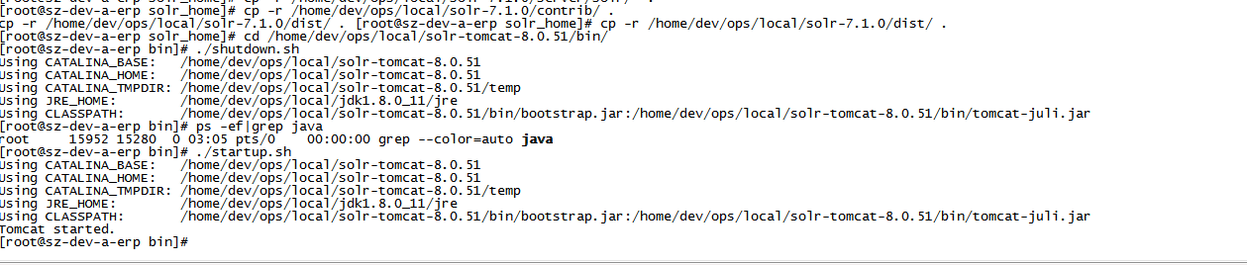

### **[http://10.10.51.74:8080/solr/index.html](http://ip:port/solr/index.html" \t "https://blog.csdn.net/shanshanw/article/details/_blank)**

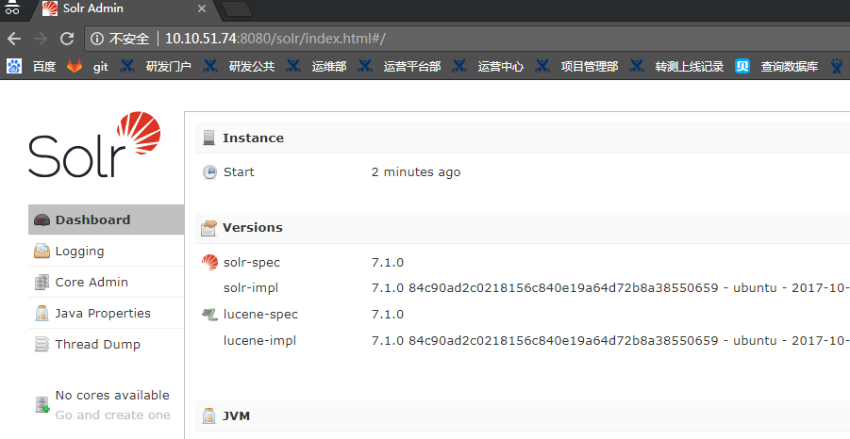

**新建Core:**

**1 界面添加core报错**

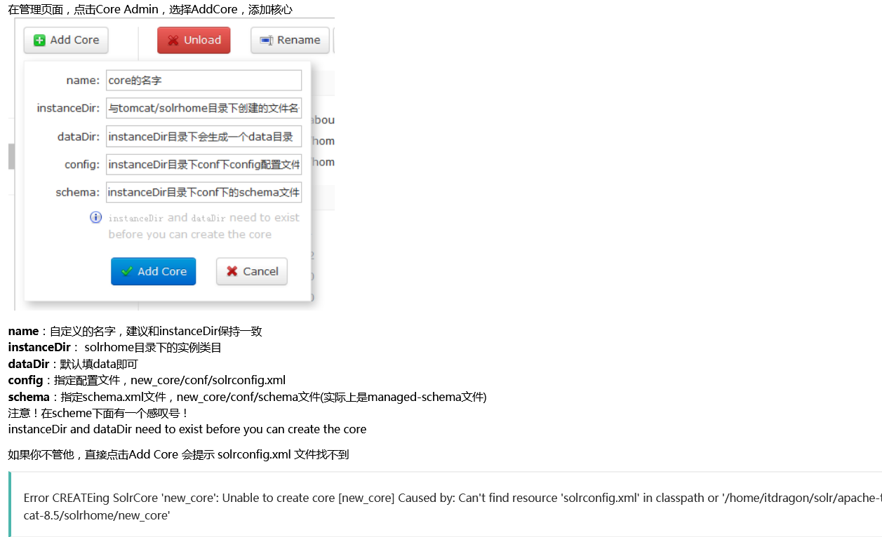

**2 命令创建目录**

cd /home/dev/ops/local/solr_home

mkdir -p hiya_core1/conf/

cd hiya_core1/conf/

cp -r /home/dev/ops/local/solr-7.1.0/server/solr/configsets/_default/conf/* .

**修改jar的相对目录：   
vim solrconfig.xml**



修改后

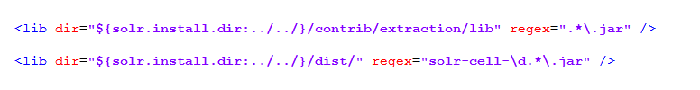

**3 再次添加成功**

四个选项填写：

name: **hiya_core1**

instanceDir:**hiya_core1**

dataDir:**data**

config: **config/solrconfig.xml**

schema: **config/schema.xml**

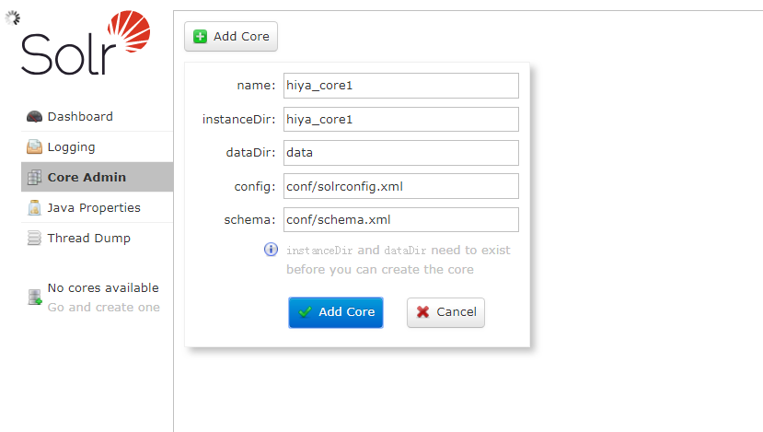

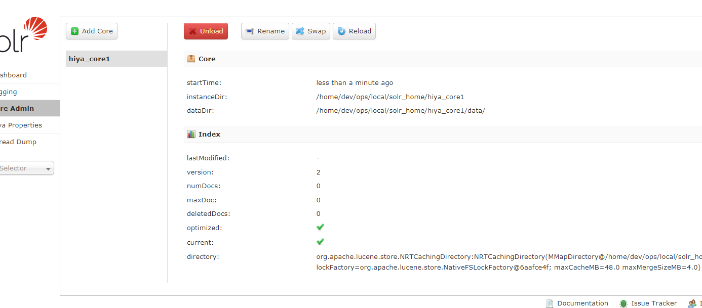

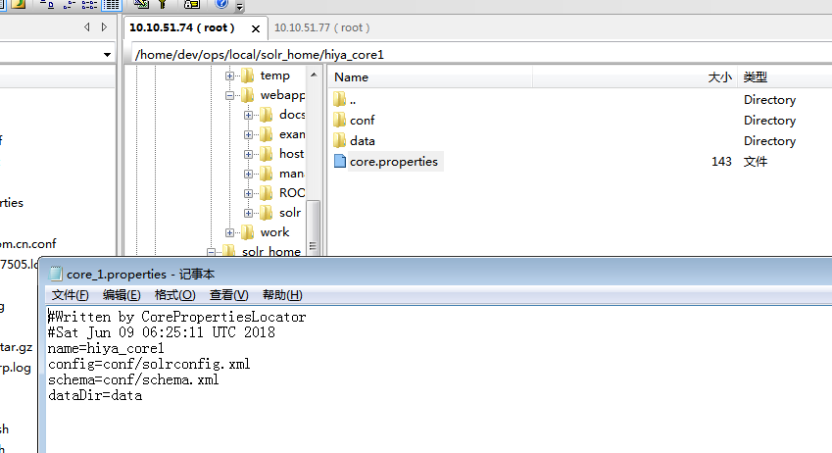

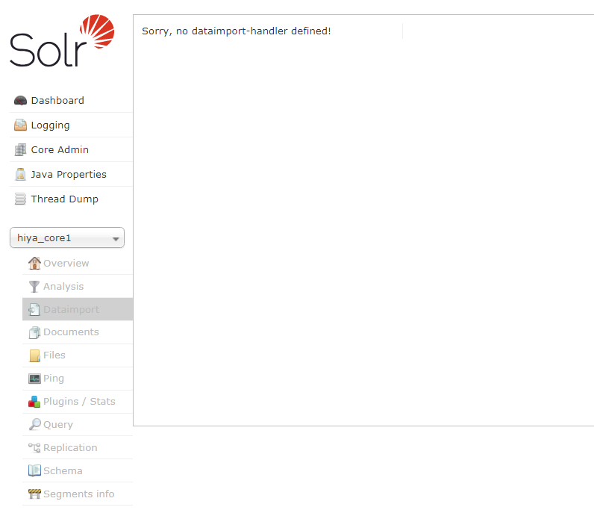

**4 界面创建分词，文档，索引**

<https://blog.csdn.net/jiangjun0130/article/details/50912167>

https://blog.csdn.net/shanshanw/article/details/78805454

