**Linux安装zookeeper**

**一、单机安装**

**1、创建 /usr/local/services/zookeeper 文件夹：**

mkdir -p /usr/local/services/zookeeper

**2、进入到 /usr/local/services/zookeeper 目录中：**

cd /usr/local/services/zookeeper

**3、下载 zookeeper-3.4.9.tar.gz：**

wget https://mirrors.tuna.tsinghua.edu.cn/apache/zookeeper/zookeeper-3.4.9/zookeeper-3.4.9.tar.gz

**4、解压缩 zookeeper-3.4.9.tar.gz：**

tar -zxvf zookeeper-3.4.9.tar.gz

**5、进入到 /usr/local/services/zookeeper/zookeeper-3.4.9/conf 目录中：**

cd zookeeper-3.4.9/conf/

**6、复制 zoo_sample.cfg 文件的并命名为为 zoo.cfg：**

cp zoo_sample.cfg zoo.cfg

**7、用 vim 打开 zoo.cfg 文件并修改其内容为如下：**

# The number of milliseconds of each tick

# zookeeper 定义的基准时间间隔，单位：毫秒

tickTime=2000

# The number of ticks that the initial

# synchronization phase can take

initLimit=10

# The number of ticks that can pass between

# sending a request and getting an acknowledgement

syncLimit=5

# the directory where the snapshot is stored.

# do not use /tmp for storage, /tmp here is just

# example sakes.

# dataDir=/tmp/zookeeper

**# 数据文件夹**

**dataDir=/usr/local/services/zookeeper/zookeeper-3.4.9/data**

**# 日志文件夹**

**dataLogDir=/usr/local/services/zookeeper/zookeeper-3.4.9/logs**

# the port at which the clients will connect

# 客户端访问 zookeeper 的端口号

**clientPort=2181**

# the maximum number of client connections.

# increase this if you need to handle more clients

#maxClientCnxns=60

#

# Be sure to read the maintenance section of the

# administrator guide before turning on autopurge.

#

# http://zookeeper.apache.org/doc/current/zookeeperAdmin.html#sc_maintenance

#

# The number of snapshots to retain in dataDir

#autopurge.snapRetainCount=3

# Purge task interval in hours

# Set to "0" to disable auto purge feature

#autopurge.purgeInterval=1

**8、保存并关闭 zoo.cfg 文件:**

**9、进入到 /usr/local/services/zookeeper/zookeeper-3.4.9/bin 目录中：**

cd ../bin/

**10、用 vim 打开 /etc/ 目录下的配置文件 profile：**

vim /etc/profile

并在其尾部追加如下内容：

# idea - zookeeper-3.4.9 config start - 2016-09-08

export ZOOKEEPER_HOME=/usr/local/services/zookeeper/zookeeper-3.4.9/

export PATH=$ZOOKEEPER_HOME/bin:$PATH

export PATH

# idea - zookeeper-3.4.9 config start - 2016-09-08

**11、使 /etc/ 目录下的 profile 文件即可生效：**

source /etc/profile

**12、启动 zookeeper 服务：**

zkServer.sh start

如打印如下信息则表明启动成功：

ZooKeeper JMX enabled by default

Using config: /usr/local/services/zookeeper/zookeeper-3.4.9/bin/../conf/zoo.cfg

Starting zookeeper ... STARTED

**13、查询 zookeeper 状态**：

zkServer.sh status

**14、关闭 zookeeper 服务**：

zkServer.sh stop

如打印如下信息则表明成功关闭：

ZooKeeper JMX enabled by default

Using config: /usr/local/services/zookeeper/zookeeper-3.4.9/bin/../conf/zoo.cfg

Stopping zookeeper ... STOPPED

**15、重启 zookeeper 服务：**

zkServer.sh restart

如打印如下信息则表明重启成功：

ZooKeeper JMX enabled by default

Using config: /usr/local/services/zookeeper/zookeeper-3.4.9/bin/../conf/zoo.cfg

ZooKeeper JMX enabled by default

Using config: /usr/local/services/zookeeper/zookeeper-3.4.9/bin/../conf/zoo.cfg

Stopping zookeeper ... STOPPED

ZooKeeper JMX enabled by default

Using config: /usr/local/services/zookeeper/zookeeper-3.4.9/bin/../conf/zoo.cfg

Starting zookeeper ... STARTED

1. **集群安装**
2. **安装zookeeper：**   
   从官网上面下载zookeeper安装包(本文使用的版本为zookeeper-3.4.6),放到/usr/local目录下面然后解压 tar -zxvf zookeeper-3.4.10.tar.gz -C /home/dev/ops/local  
   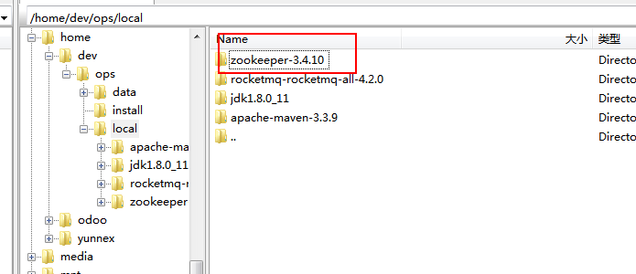

**2. 配置环境变量：编辑/etc/profile文件将zookeeper的环境变量配置进去**

export ZOOKEEPER=/home/dev/ops/local/zookeeper-3.4.10

export PATH=$PATH:$ZOOKEEPER/bin

**3.配置zoo.cfg文件**  
进入zooKeeper的conf目录，将 zoo_sample.cfg复制为zoo.cfg文件，然后编辑zoo.cfg文件  
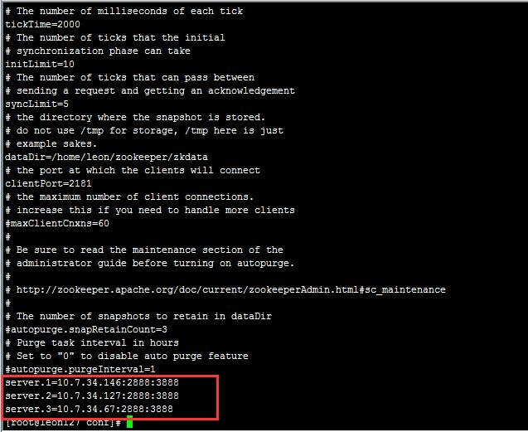

server.A=B：C：D：其中 A 是一个数字，表示这个是第几号服务器；B 是这个服务器的 ip 地址；C 表示的是这个服务器与集群中的 Leader 服务器交换信息的端口；D 表示的是万一集群中的 Leader 服务器挂了，需要一个端口来重新进行选举，选出一个新的 Leader，而这个端口就是用来执行选举时服务器相互通信的端口。如果是伪集群的配置方式，由于 B 都是一样，所以不同的 Zookeeper 实例通信端口号不能一样，所以要给它们分配不同的端口号。

**4.创建myid文件**   
在dataDir目录下创建一个myid文件，然后分别在myid文件中按照zoo.cfg文件的server.A中A的数值，在不同机器上的该文件中填写相应的值。

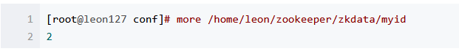

**5.按照上述方法同样在另外2台机器上面配置或者直接将该机器上面的文件拷贝到另外的2台机器上面**

**6.启动各服务器的zooKeeper：**

./zkServer.sh start

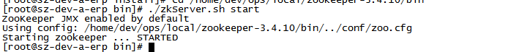

**7. 开发人员可以使用命令“JPS”查看Zookeeper是否成功启动**，以及执行命令“zkServer.sh status”查看Zookeeper集群状态，如下所示：

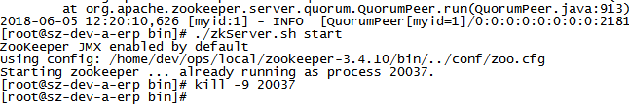

**8.查看log成功运行：**

2016-08-16 17:18:06,678 [myid:2] - INFO [WorkerReceiver[myid=2]:FastLeaderElection@597] - Notification: 1 (message format version), 2 (n.leader), 0x5f (n.zxid), 0x1 (n.round), LOOKING (n.state), 3 (n.sid), 0x2 (n.peerEpoch) LEADING (my state)2016-08-16 17:18:06,710 [myid:2] - INFO [LearnerHandler-/10.7.34.67:40382:LearnerHandler@330] - Follower sid: 3 : info : org.apache.zookeeper.server.quorum.QuorumPeer$QuorumServer@4f68565b2016-08-16 17:18:06,727 [myid:2] - INFO [LearnerHandler-/10.7.34.67:40382:LearnerHandler@385] - Synchronizing with Follower sid: 3 maxCommittedLog=0x5f minCommittedLog=0x1 peerLastZxid=0x02016-08-16 17:18:06,727 [myid:2] - WARN [LearnerHandler-/10.7.34.67:40382:LearnerHandler@446] - Unhandled proposal scenario2016-08-16 17:18:06,727 [myid:2] - INFO [LearnerHandler-/10.7.34.67:40382:LearnerHandler@462] - Sending SNAP2016-08-16 17:18:06,728 [myid:2] - INFO [LearnerHandler-/10.7.34.67:40382:LearnerHandler@486] - Sending snapshot last zxid of peer is 0x0 zxid of leader is 0x300000000sent zxid of db as 0x3000000002016-08-16 17:18:06,750 [myid:2] - INFO [LearnerHandler-/10.7.34.67:40382:LearnerHandler@522] - Received NEWLEADER-ACK message from 32016-08-16 17:47:53,528 [myid:2] - INFO [NIOServerCxn.Factory:0.0.0.0/0.0.0.0:2181:NIOServerCnxnFactory@197] - Accepted socket connection from /127.0.0.1:526962016-08-16 17:47:53,529 [myid:2] - INFO [NIOServerCxn.Factory:0.0.0.0/0.0.0.0:2181:NIOServerCnxn@827] - Processing srvr command from /127.0.0.1:526962016-08-16 17:47:53,536 [myid:2] - INFO [Thread-6:NIOServerCnxn@1007] - Closed socket connection for client /127.0.0.1:52696 (no session established for client)

