**Linux Hive（伪分布式）**

**1 准备阶段**

**（1） hadoop**

版本：Hadoop 2.5.1

教程：https://blog.csdn.net/vpqtxzmzezeqjj9977/article/details/79947540

**（2） mysql**

版本：5.5.60 MySQL Community Server (GPL)

教程：https://blog.csdn.net/vpqtxzmzezeqjj9977/article/details/80330701

**（3） mysql驱动包**

版本：mysql-connector-java-5.1.27.jar

**（4） hive安装包**

官网下载：[apache-hive-2.3.3-bin.tar.gz](http://mirrors.hust.edu.cn/apache/hive/hive-2.3.3/apache-hive-2.3.3-bin.tar.gz)

**http://mirrors.hust.edu.cn/apache/hive/hive-2.3.3/[apache-hive-2.3.3-bin.tar.gz](http://mirrors.hust.edu.cn/apache/hive/hive-2.3.3/apache-hive-2.3.3-bin.tar.gz)**

**https://mirrors.tuna.tsinghua.edu.cn/apache/hive/hive-2.3.3/[apache-hive-2.3.3-bin.tar.gz](https://mirrors.tuna.tsinghua.edu.cn/apache/hive/hive-2.3.3/apache-hive-2.3.3-bin.tar.gz)**

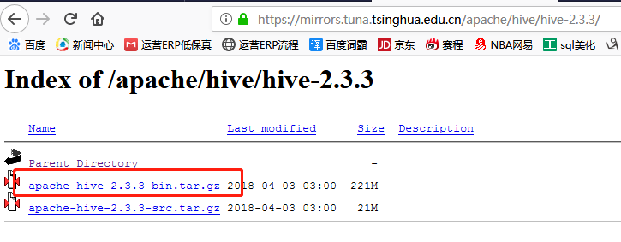

**2 hive安装和部署**

**（1）解压：**

[root@master Desktop]# cd /home/dev/ops/install

[root@master hive13]# tar -zxvf apache-hive-2.3.3-bin.tar.gz -C /home/dev/ops/local

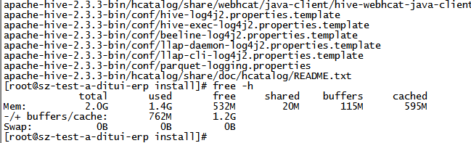

**（2）导入mysql驱动包：进到解压好的目录/apache-hive-0.13.1-bin，查看**

把在桌面的驱动包mysql-connector-java-5.1.27.jar放在/lib文件中

[root@master apache-hive-0.13.1-bin]# cd lib/

[root@master lib]# mv /home/gznc-hadoop/Desktop/mysql-connector-java-5.1.27.jar ./

[root@master lib]# ls

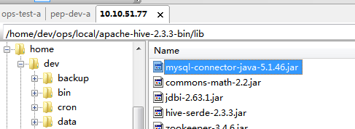

**（3）配置环境变量**

[root@master apache-hive-0.13.1-bin]# vim /etc/profile

export HIVE_HOME=/home/dev/ops/local/apache-hive-2.3.3-bin

export PATH=$PATH:$HIVE_HOME/bin

source /etc/profile

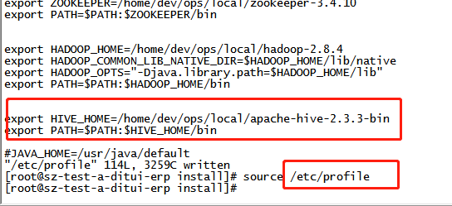

**（4）hive-site.xml配置**

[root@master conf]# vim hive-site.xml

<?xml version="1.0"?>

<?xml-stylesheet type="text/xsl" href="configuration.xsl"?>

<configuration>

<property>

<name>hive.metastore.local</name>

<value>true</value>

</property>

<property>

<name>javax.jdo.option.ConnectionURL</name>

<value>jdbc:mysql://10.10.50.107:3306/erp?characterEncoding=utf-8</value>

</property>

<property>

<name>javax.jdo.option.ConnectionDriverName</name>

<value>com.mysql.jdbc.Driver</value>

</property>

<property>

<name>javax.jdo.option.ConnectionUserName</name>

<value>root</value>

</property>

<property>

<name>javax.jdo.option.ConnectionPassword</name>

<value>yunnex6j7</value>

</property>

</configuration>

**（5）hive-env.sh**

export HADOOP_CLIENT_OPTS=" -Xmx2000m"

export HADOOP_HEAPSIZE=200

HADOOP_HOME=/home/dev/ops/local/hadoop-2.8.4

**3 启动hive**

**（1）启动hadoop：**start-all.sh

**（2）启动mysql：**service mysql start

**（3）初始化hive**   
命令：schematool -initSchema -dbType mysql   
最后显示schemaTool completed，没有报错就成功了。

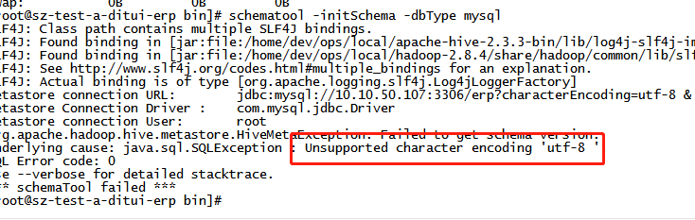

问题显示不支持 utf-8

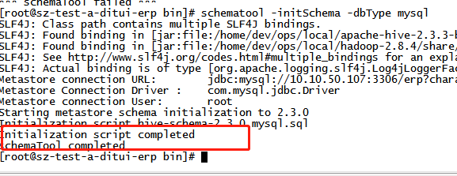

**（4）启动hive**

[root@master Desktop]# hive

18/05/28 20:52:32 WARN conf.HiveConf: DEPRECATED: Configuration property hive.metastore.local no longer has any effect. Make sure to provide a valid value for hive.metastore.uris if you are connecting to a remote metastore.

Logging initialized using configuration in jar:file:/home/gznc-hadoop/hive13/apache-hive-0.13.1-bin/lib/hive-common-0.13.1.jar!/hive-log4j.properties

hive>

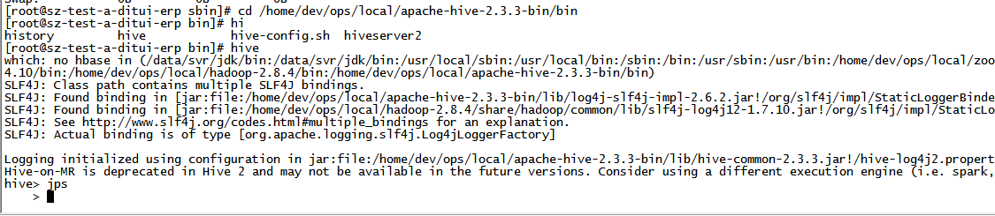

**（5）停止进程**

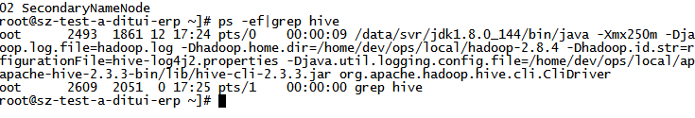

**Kill -9 2493**

**4 hive提供了一个可以交互的shell命令行**

SHOW DATABASES;

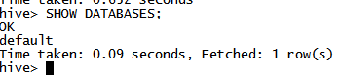

默认数据库 default

CREATE DATABASE hiya_hive;



SHOW DATABASES;

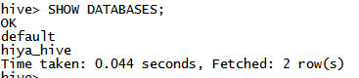

use hiya_hive;



create table hiya_hive_user(id int,name string) ROW FORMAT DELIMITED FIELDS TERMINATED BY '\t';



show tables;

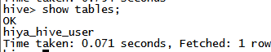

-----------------------慎用-----------------------------

DROP DATABASE hiya_hive;

DELETE FROM hiya_hive_user;

DROP TABLE hiya_hive_user;

UPDATE hiya_hive_user SET 字段名1='a',字段名2='b' WHERE 字段名3='c';

LOAD DATA LOCAL INFILE "D:/mysql.txt" INTO TABLE hiya_hive_user;

-----------------------慎用-----------------------------

INSERT INTO hiya_hive_user VALUES ("1001","Wade");

INSERT INTO hiya_hive_user VALUES ("1002","James");

INSERT INTO hiya_hive_user VALUES ("1003","Tmac");

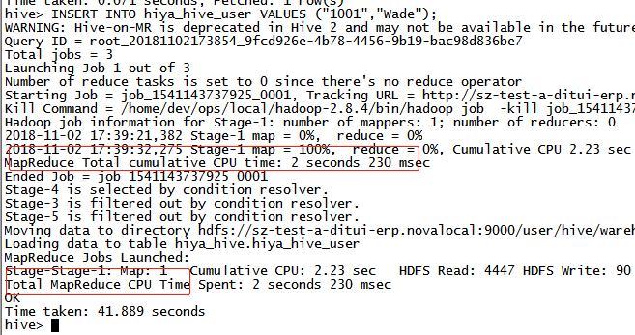

select * from hiya_hive_user;

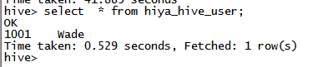

select count(1) from hiya_hive_user;

