CE Characteristic

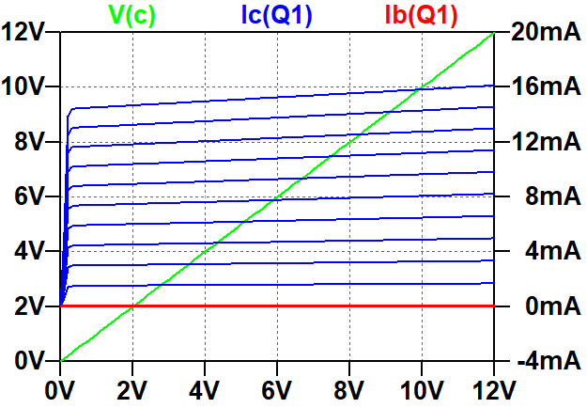

Part 1 Schematic

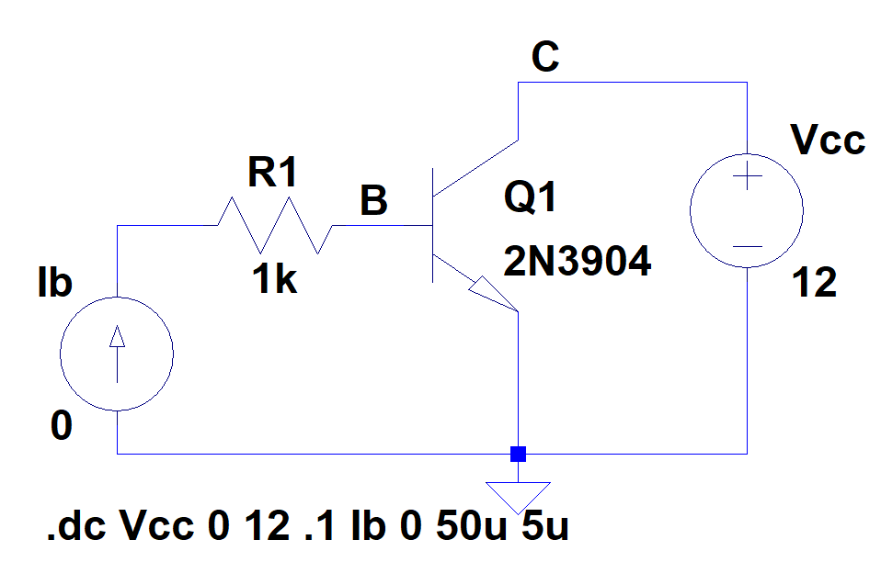

Npn Diode current source .op and schematic

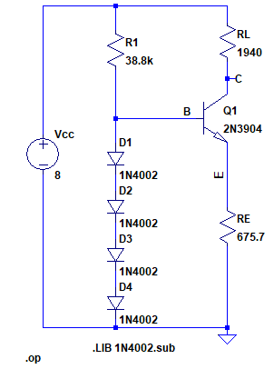

**--- Operating Point ---**

**V(c): 4.78399 voltage**

**V(b): 1.79158 voltage**

**V(e): 1.12377 voltage**

**V(n004): 0.447895 voltage**

**V(n003): 0.89579 voltage**

**V(n002): 1.34368 voltage**

**V(n001): 8 voltage**

**Ic(Q1): 0.00165774 device_current**

**Ib(Q1): 5.38683e-006 device_current**

**Ie(Q1): -0.00166312 device_current**

**I(D1): 0.000154624 device_current**

**I(D2): 0.000154624 device_current**

**I(D3): 0.000154624 device_current**

**I(D4): 0.000154624 device_current**

**I(Re): 0.00166312 device_current**

**I(R1): 0.000160011 device_current**

**I(Rl): 0.00165774 device_current**

**I(Vcc): -0.00181775 device_current**

Npn Diode current source dc sweep

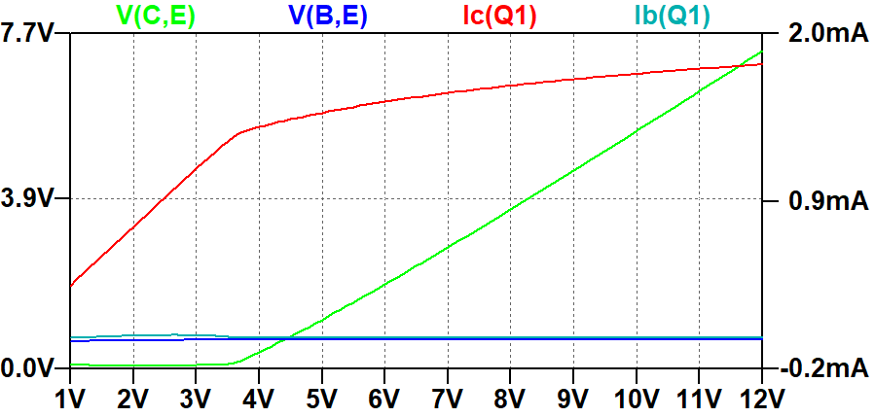

Pnp Diode current source .op and schematic

**--- Operating Point ---**

**V(n001): 6.6587 voltage**

**V(b): 6.21161 voltage**

**V(n002): 7.1058 voltage**

**V(n003): 7.5529 voltage**

**V(n004): 8 voltage**

**V(c): 3.2019 voltage**

**V(e): 6.87935 voltage**

**Ic(Q1): -0.00165046 device_current**

**Ib(Q1): -8.04329e-006 device_current**

**Ie(Q1): 0.00165851 device_current**

**I(D1): 0.00015205 device_current**

**I(D2): 0.00015205 device_current**

**I(D3): 0.00015205 device_current**

**I(D4): 0.00015205 device_current**

**I(Re): -0.00165851 device_current**

**I(R1): -0.000160093 device_current**

**I(Rl): -0.00165046 device_current**

**I(Vcc): -0.00181056 device_current**

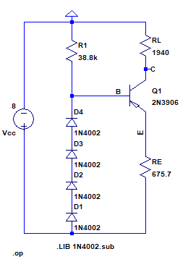

pnp Diode current source dc sweep

