NMOS NAND

|  |  |  |
| --- | --- | --- |
| Vin1 | Vin2 | Vout |
| 0 | 0 | 1 |
| 0 | 1 | 1 |
| 1 | 0 | 1 |
| 1 | 1 | 0 |

00 => 1

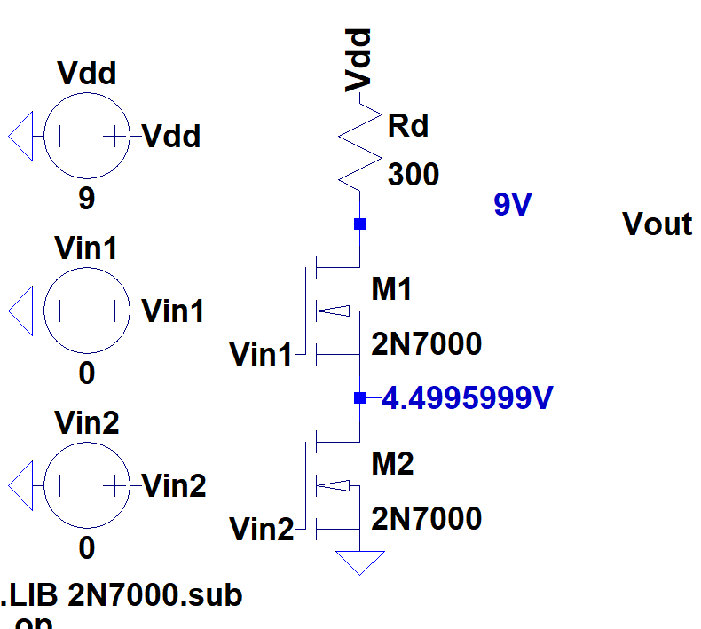

01 => 1

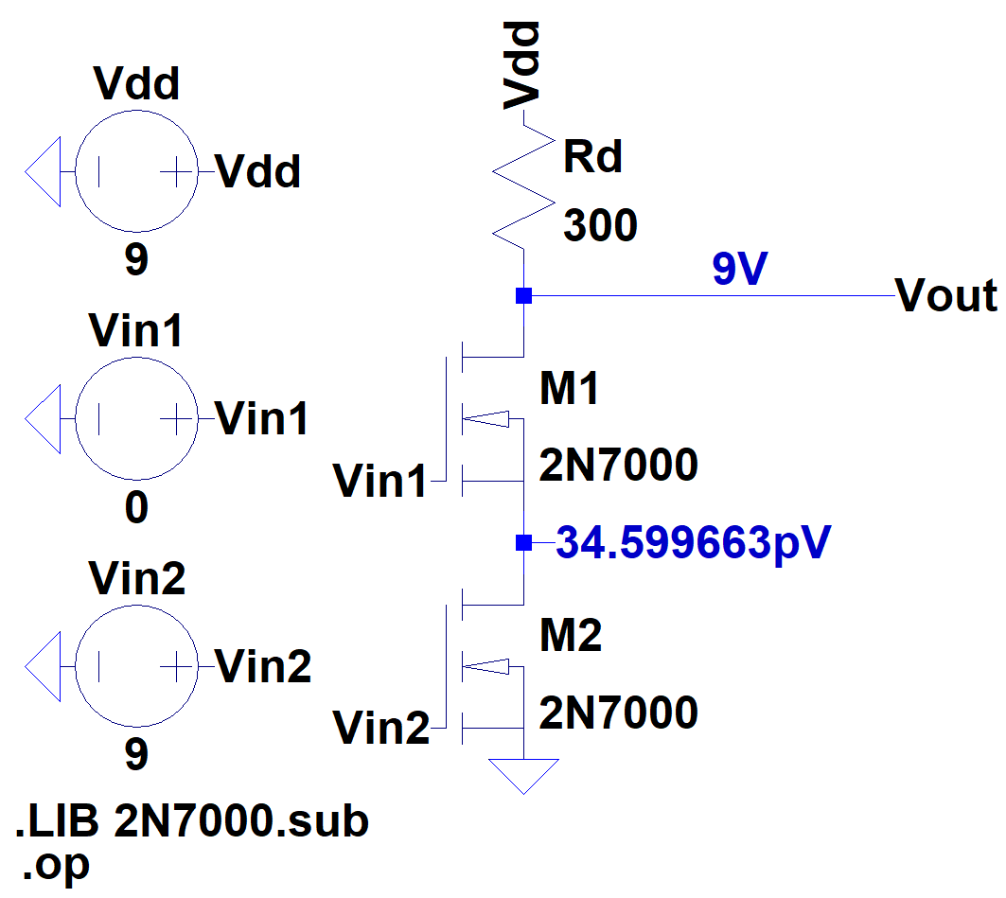

10 => 1

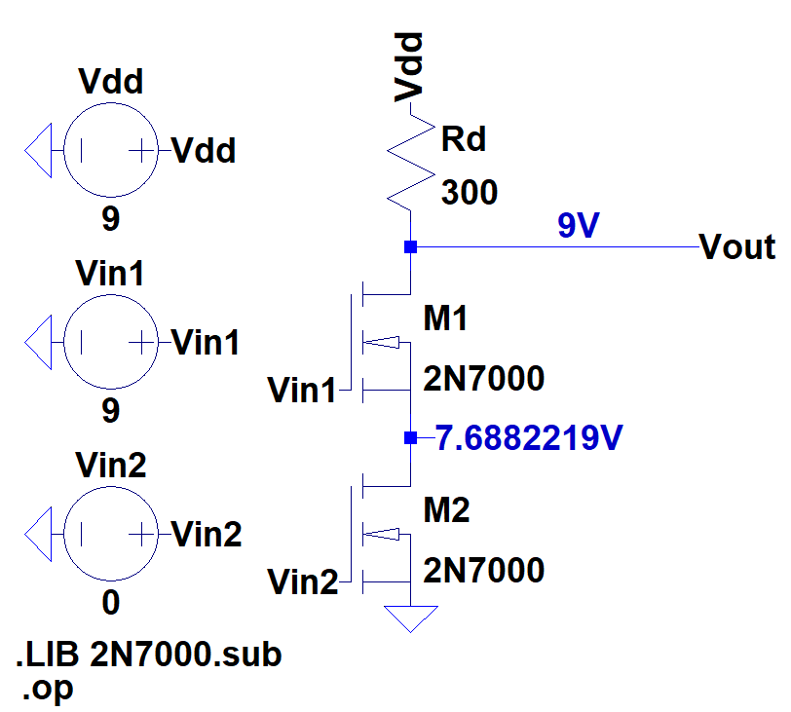

11 => 0

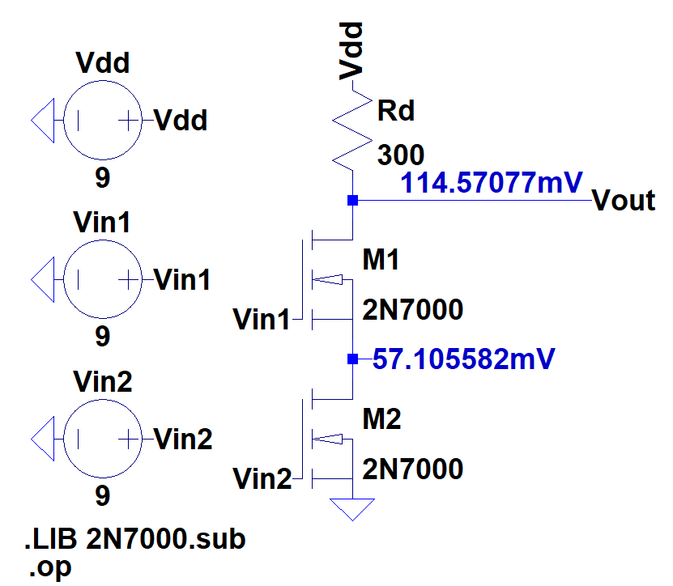

NMOS NOR

|  |  |  |
| --- | --- | --- |
| Vin1 | Vin2 | Vout |
| 0 | 0 | 1 |
| 0 | 1 | 0 |
| 1 | 0 | 0 |
| 1 | 1 | 0 |

00 => 1

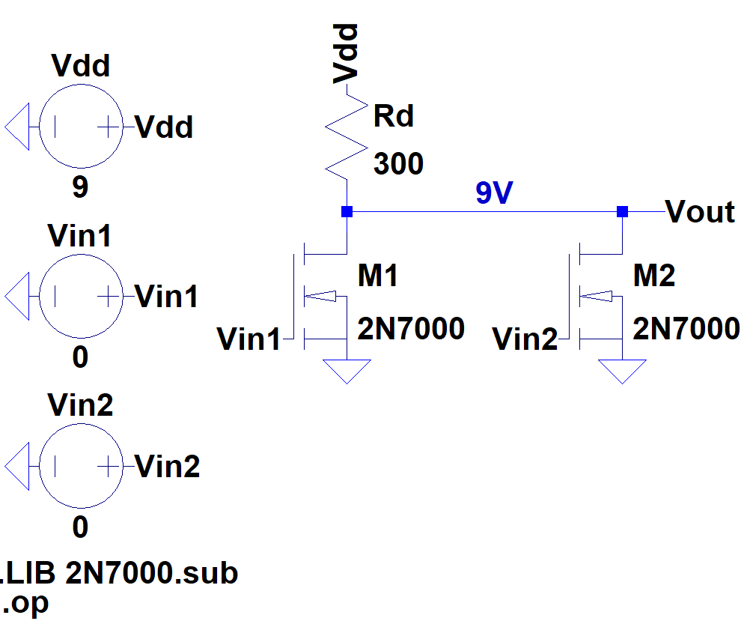

01 => 0

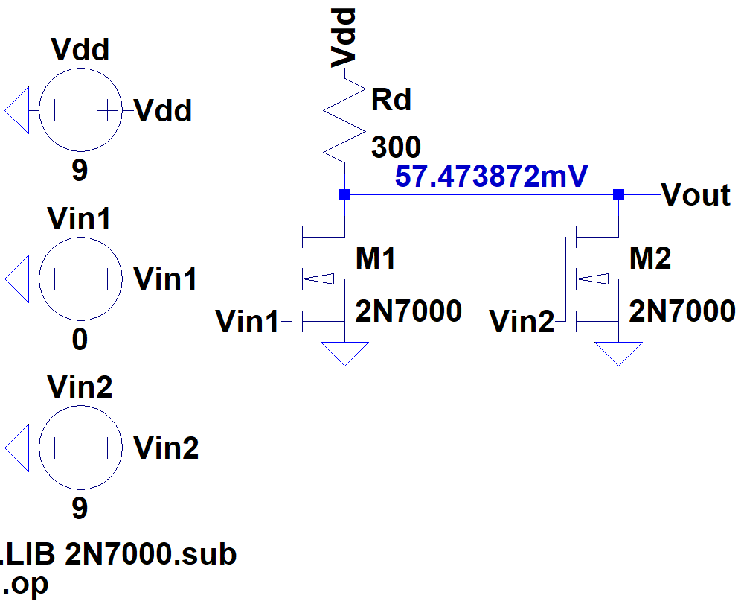

10 => 0

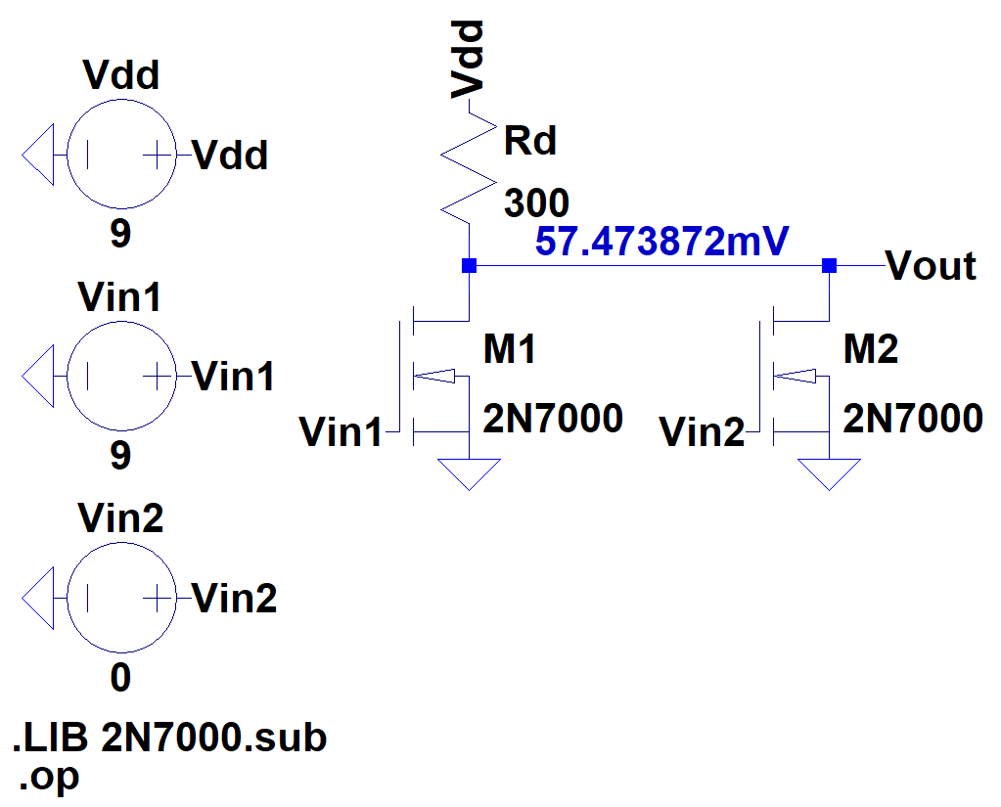

11 => 0

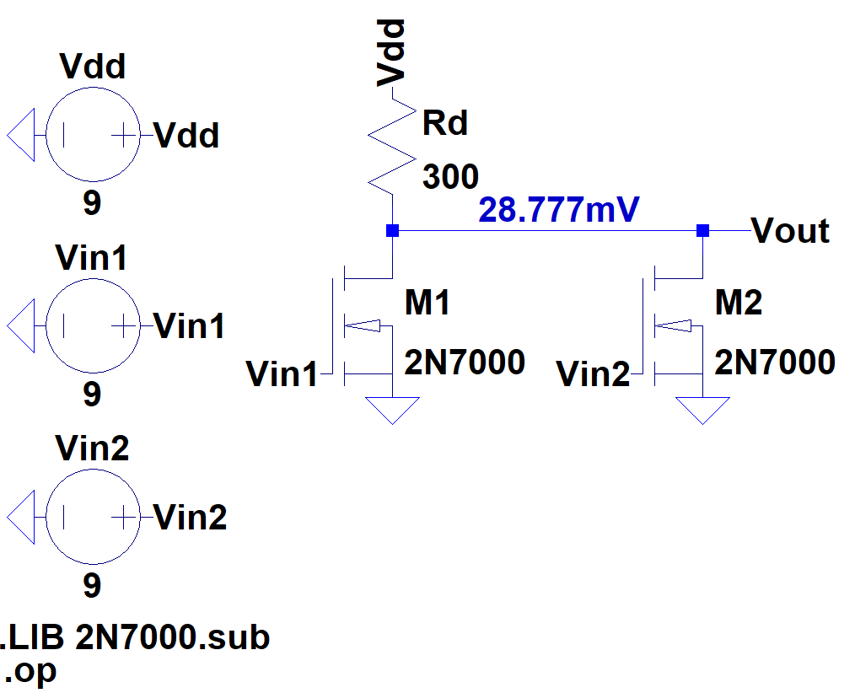

CMOS Inverter Triangle

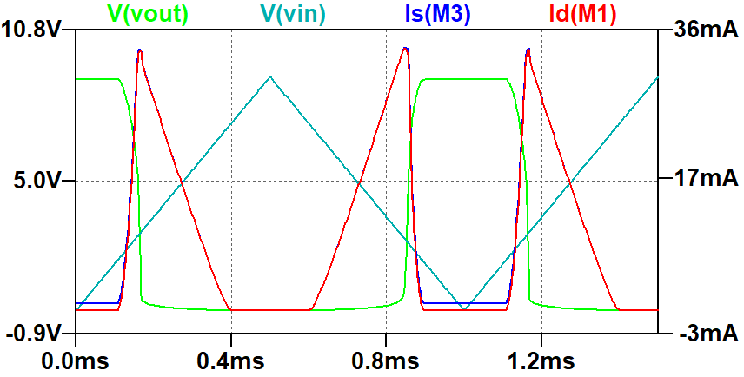

CMOS Inverter Square

