Single Transistor NPN Vin=5V

Output Load Current is $13.3μA$

Output Voltage $133mV$

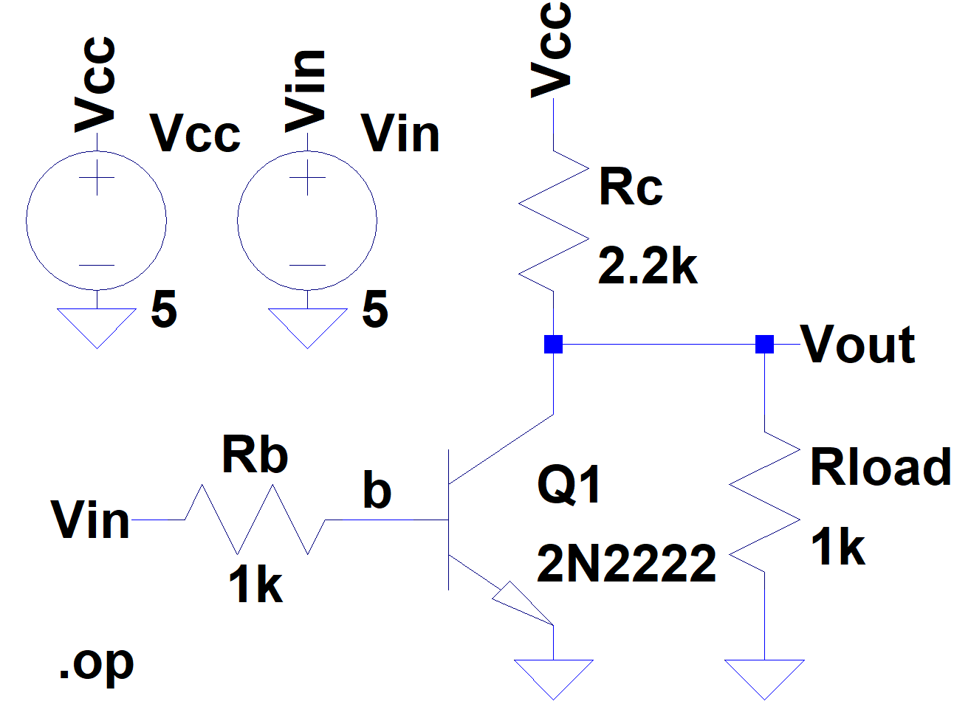

|  |
| --- |
| **--- Operating Point ---**  **V(vout): 0.0133124 voltage**  **V(b): 0.775097 voltage**  **V(vin): 5 voltage**  **V(vcc): 5 voltage**  **Ic(Q1): 0.00225336 device_current**  **Ib(Q1): 0.0042249 device_current**  **Ie(Q1): -0.00647827 device_current**  **I(Rc): 0.00226668 device_current**  **I(Rb): -0.0042249 device_current**  **I(Rload): 1.33124e-005 device_current**  **I(Vcc): -0.00226668 device_current**  **I(Vin): -0.0042249 device_current** |

Single Transistor NPN Vin=0V

Output Load Current is $1.56mA$

Output Voltage $1.56V$

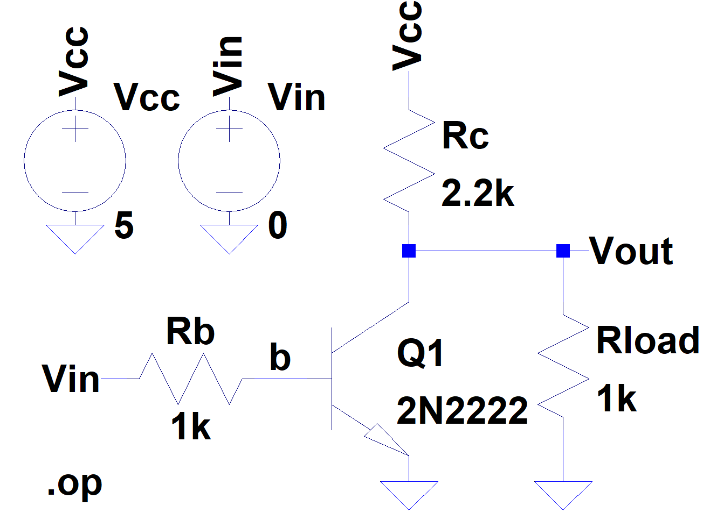

|  |
| --- |
| **--- Operating Point ---**  **V(vout): 1.5625 voltage**  **V(b): 1.56583e-009 voltage**  **V(vin): 0 voltage**  **V(vcc): 5 voltage**  **Ic(Q1): 1.57578e-012 device_current**  **Ib(Q1): -1.56583e-012 device_current**  **Ie(Q1): -1.01563e-014 device_current**  **I(Rc): 0.0015625 device_current**  **I(Rb): 1.56583e-012 device_current**  **I(Rload): 0.0015625 device_current**  **I(Vcc): -0.0015625 device_current**  **I(Vin): 1.56583e-012 device_current** |

Single Transistor NPN DC Sweep

The inverted switches from high to low when Vin is around 0.75V

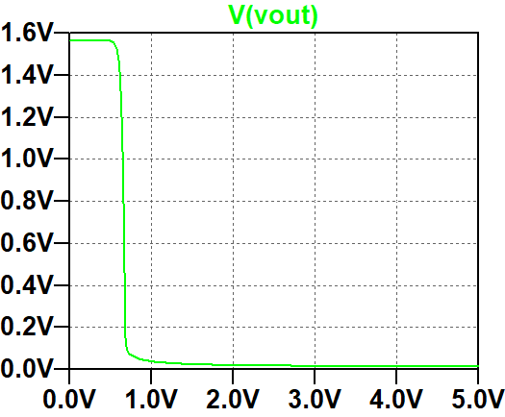

TTL Inverter Vin = 5V Rload = 1k

Output Load Current is $17.8μA$

Output Voltage $17.8mV$

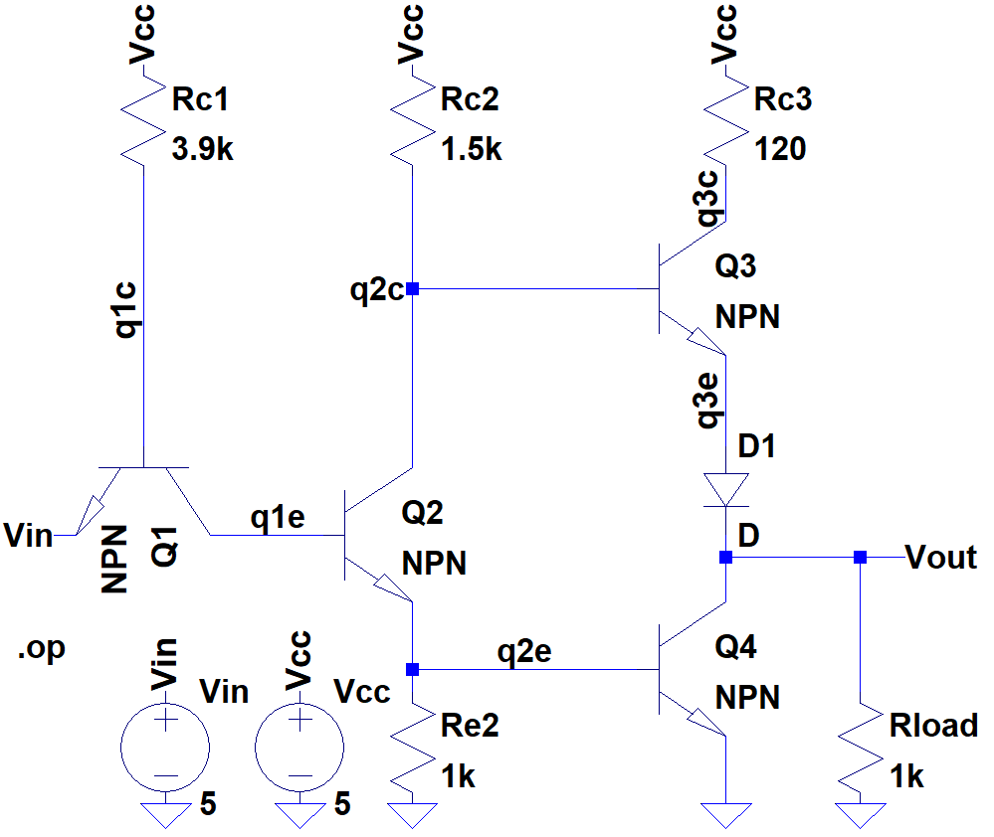

|  |
| --- |
| **--- Operating Point ---**  **V(vcc): 5 voltage**  **V(q1c): 2.40338 voltage**  **V(q2c): 0.859088 voltage**  **V(q3c): 5 voltage**  **V(q2e): 0.822221 voltage**  **V(vout): 0.0178561 voltage**  **V(vin): 5 voltage**  **V(q1e): 1.63967 voltage**  **V(q3e): 0.379045 voltage**  **Ic(Q4): -1.78445e-005 device_current**  **Ib(Q4): 0.00326999 device_current**  **Ie(Q4): -0.00325214 device_current**  **Ic(Q3): 1.14946e-008 device_current**  **Ib(Q3): 1.11243e-010 device_current**  **Ie(Q3): -1.16058e-008 device_current**  **Ic(Q2): 0.00276061 device_current**  **Ib(Q2): 0.0013316 device_current**  **Ie(Q2): -0.00409221 device_current**  **Ic(Q1): -0.0013316 device_current**  **Ib(Q1): 0.000665799 device_current**  **Ie(Q1): 0.000665799 device_current**  **I(D1): 1.16058e-008 device_current**  **I(Rload): 1.78561e-005 device_current**  **I(Re2): 0.000822221 device_current**  **I(Rc3): 1.14946e-008 device_current**  **I(Rc2): 0.00276061 device_current**  **I(Rc1): 0.000665799 device_current**  **I(Vcc): -0.00342642 device_current**  **I(Vin): -0.000665799 device_current** |

TTL Inverter Vin = 0V Rload = 1k

Output Load Current is $3.45mA$

Output Voltage $3.45V$

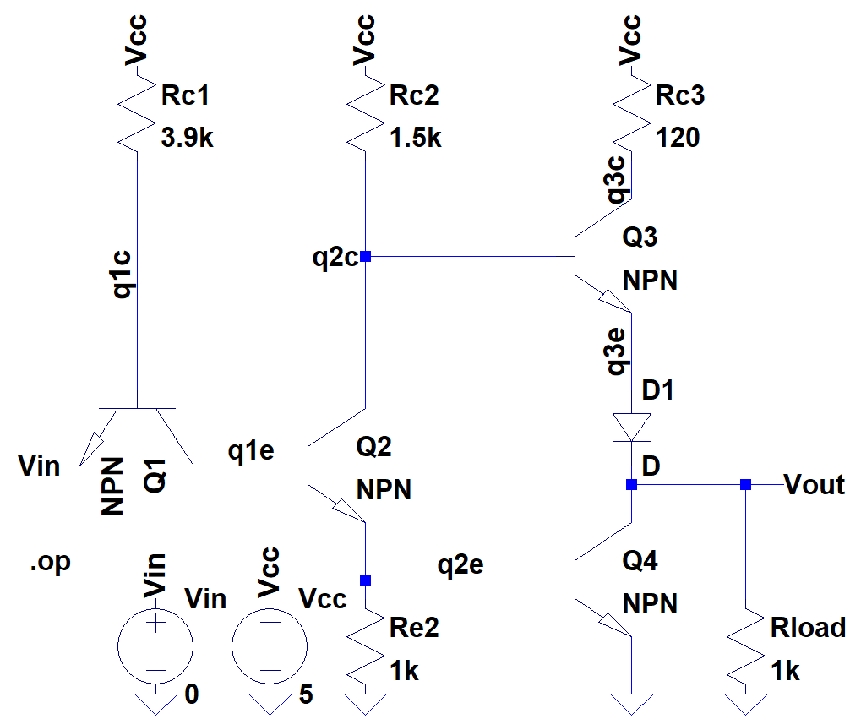

|  |
| --- |
| **--- Operating Point ---**  **V(vcc): 5 voltage**  **V(q1c): 0.793603 voltage**  **V(q2c): 4.94868 voltage**  **V(q3c): 4.58945 voltage**  **V(q2e): 3.47368e-009 voltage**  **V(vout): 3.45545 voltage**  **V(vin): 0 voltage**  **V(q1e): 0.0179282 voltage**  **V(q3e): 4.14264 voltage**  **Ic(Q4): 3.45565e-012 device_current**  **Ib(Q4): -3.45555e-012 device_current**  **Ie(Q4): -1.00003e-016 device_current**  **Ic(Q3): 0.00342123 device_current**  **Ib(Q3): 3.42124e-005 device_current**  **Ie(Q3): -0.00345545 device_current**  **Ic(Q2): 4.93105e-012 device_current**  **Ib(Q2): -4.91292e-012 device_current**  **Ie(Q2): -1.81292e-014 device_current**  **Ic(Q1): 4.91293e-012 device_current**  **Ib(Q1): 0.00107856 device_current**  **Ie(Q1): -0.00107856 device_current**  **I(D1): 0.00345545 device_current**  **I(Rload): 0.00345545 device_current**  **I(Re2): 3.47368e-012 device_current**  **I(Rc3): 0.00342123 device_current**  **I(Rc2): 3.42125e-005 device_current**  **I(Rc1): 0.00107856 device_current**  **I(Vcc): -0.00453401 device_current**  **I(Vin): 0.00107856 device_current** |

TTL Inverter Vin = 0V Rload = 47k

Output Load Current is $78.7μA$

Output Voltage $3.70V$

While the output voltage has only marginally increased, the load current has been divided by the change in resistor.

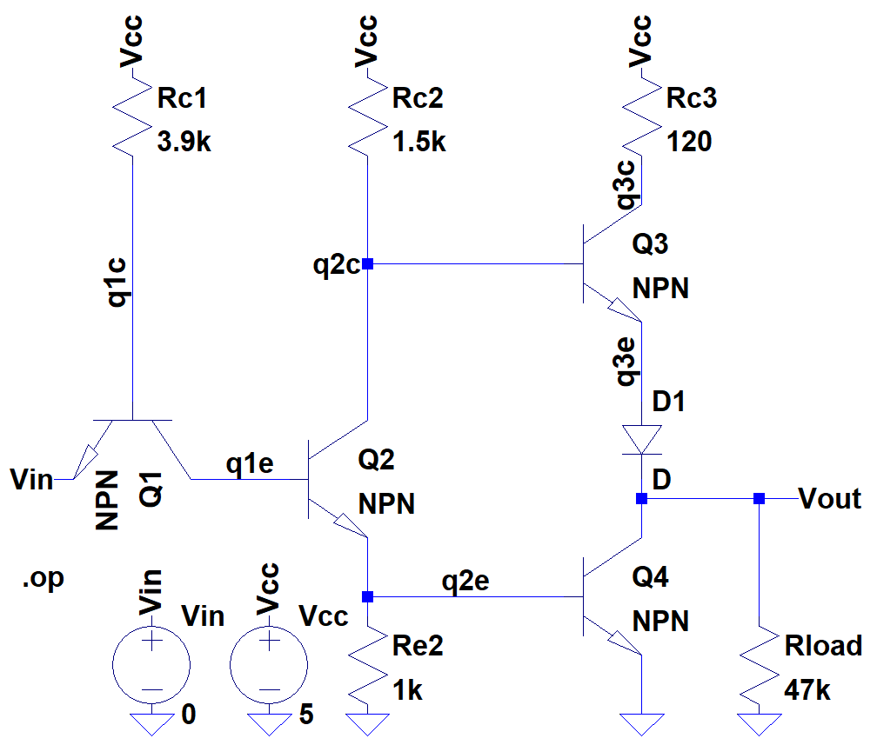

|  |
| --- |
| **--- Operating Point ---**  **V(vcc): 5 voltage**  **V(q1c): 0.793603 voltage**  **V(q2c): 4.99883 voltage**  **V(q3c): 4.99064 voltage**  **V(q2e): 3.71944e-009 voltage**  **V(vout): 3.70121 voltage**  **V(vin): 0 voltage**  **V(q1e): 0.0179282 voltage**  **V(q3e): 4.29059 voltage**  **Ic(Q4): 3.70141e-012 device_current**  **Ib(Q4): -3.70131e-012 device_current**  **Ie(Q4): -1.00004e-016 device_current**  **Ic(Q3): 7.79694e-005 device_current**  **Ib(Q3): 7.79695e-007 device_current**  **Ie(Q3): -7.87491e-005 device_current**  **Ic(Q2): 4.9812e-012 device_current**  **Ib(Q2): -4.96307e-012 device_current**  **Ie(Q2): -1.81292e-014 device_current**  **Ic(Q1): 4.96305e-012 device_current**  **Ib(Q1): 0.00107856 device_current**  **Ie(Q1): -0.00107856 device_current**  **I(D1): 7.87491e-005 device_current**  **I(Rload): 7.87491e-005 device_current**  **I(Re2): 3.71944e-012 device_current**  **I(Rc3): 7.79694e-005 device_current**  **I(Rc2): 7.797e-007 device_current**  **I(Rc1): 0.00107856 device_current**  **I(Vcc): -0.00115731 device_current**  **I(Vin): 0.00107856 device_current** |

Ring Oscillator

Amplitude: 4V

Wavelength: (51ns – 21ns) = 30ns

=> Frequency: 33.33MHz

