I-V Curve

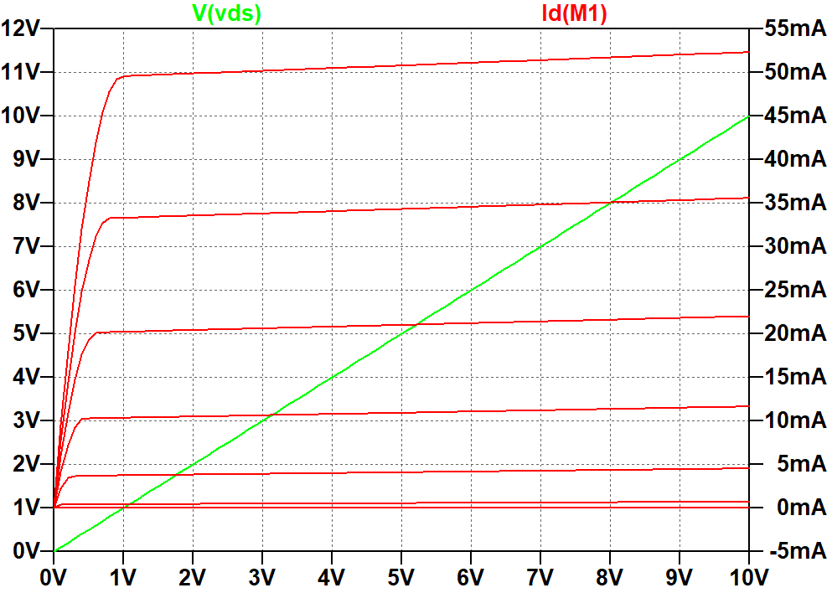

4 Res w/ Design Values

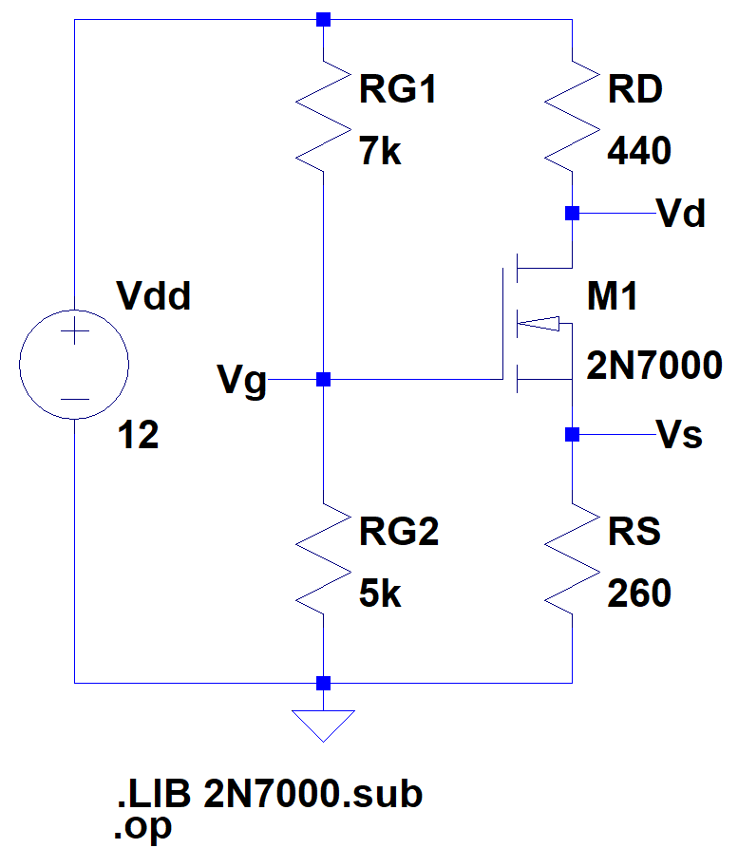

**--- Operating Point ---**

**V(n001): 12 voltage**

**V(vg): 5 voltage**

**V(vd): 7.56688 voltage**

**V(vs): 2.61957 voltage**

**Id(M1): 0.0100753 device_current**

**Ig(M1): 0 device_current**

**Ib(M1): -4.95773e-012 device_current**

**Is(M1): -0.0100753 device_current**

**I(Rs): 0.0100753 device_current**

**I(Rd): 0.0100753 device_current**

**I(Rg2): 0.001 device_current**

**I(Rg1): 0.001 device_current**

**I(Vdd): -0.0110753 device_current**

4Res w/ Standard Values

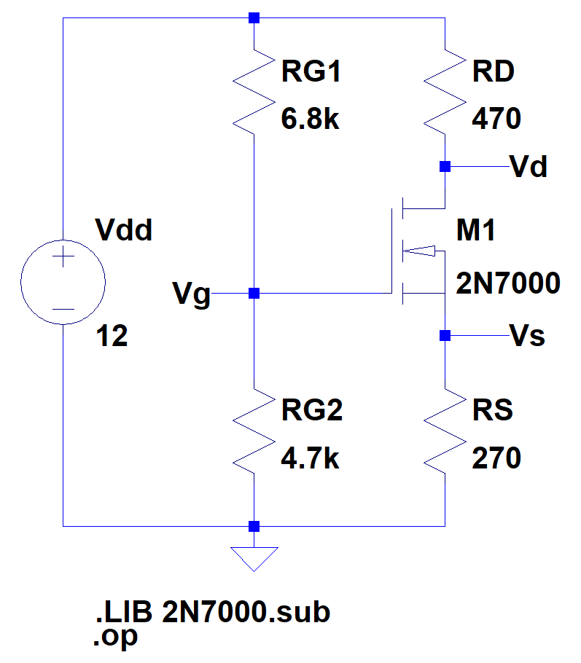

**--- Operating Point ---**

**V(n001): 12 voltage**

**V(vg): 4.90435 voltage**

**V(vd): 7.57709 voltage**

**V(vs): 2.54082 voltage**

**Id(M1): 0.00941045 device_current**

**Ig(M1): 0 device_current**

**Ib(M1): -5.04667e-012 device_current**

**Is(M1): -0.00941045 device_current**

**I(Rs): 0.00941045 device_current**

**I(Rd): 0.00941045 device_current**

**I(Rg2): 0.00104348 device_current**

**I(Rg1): 0.00104348 device_current**

**I(Vdd): -0.0104539 device_current**

DC Sweep Current

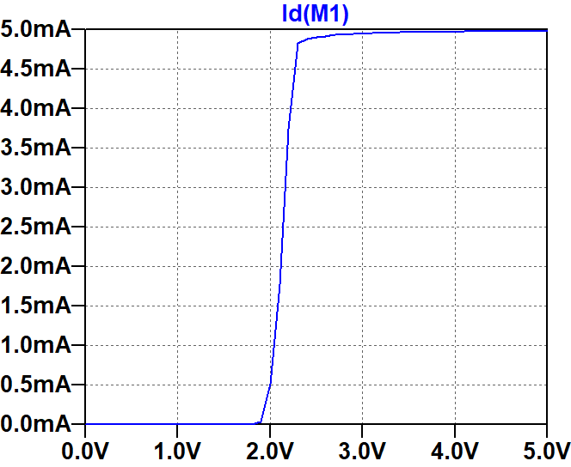

DC Sweep Voltage

