Muyassar Kokhkharova

Total effort: 4 hours

**Use case diagram**

**Activate:** User presses button on SensorTag to turn it on. PC app connects to SensorTag and starts receiving data

**Deactivate:** PC stops receiving data from SensorTag, disconnects from SensorTag and User presses button on SensorTag to turn it off

**Out of Range:** PC app stops receiving data, loses connection and sends help request to Helper

**Fall**: User falls, system recognizes fall and requests help

**False Alarm:** User “falls”, system recognizes fall and receives False Alarm signal

**Modify personal data:** User modifies his personal data and system saves changes

**Modify calibration:** User modifies calibration and system saves changes

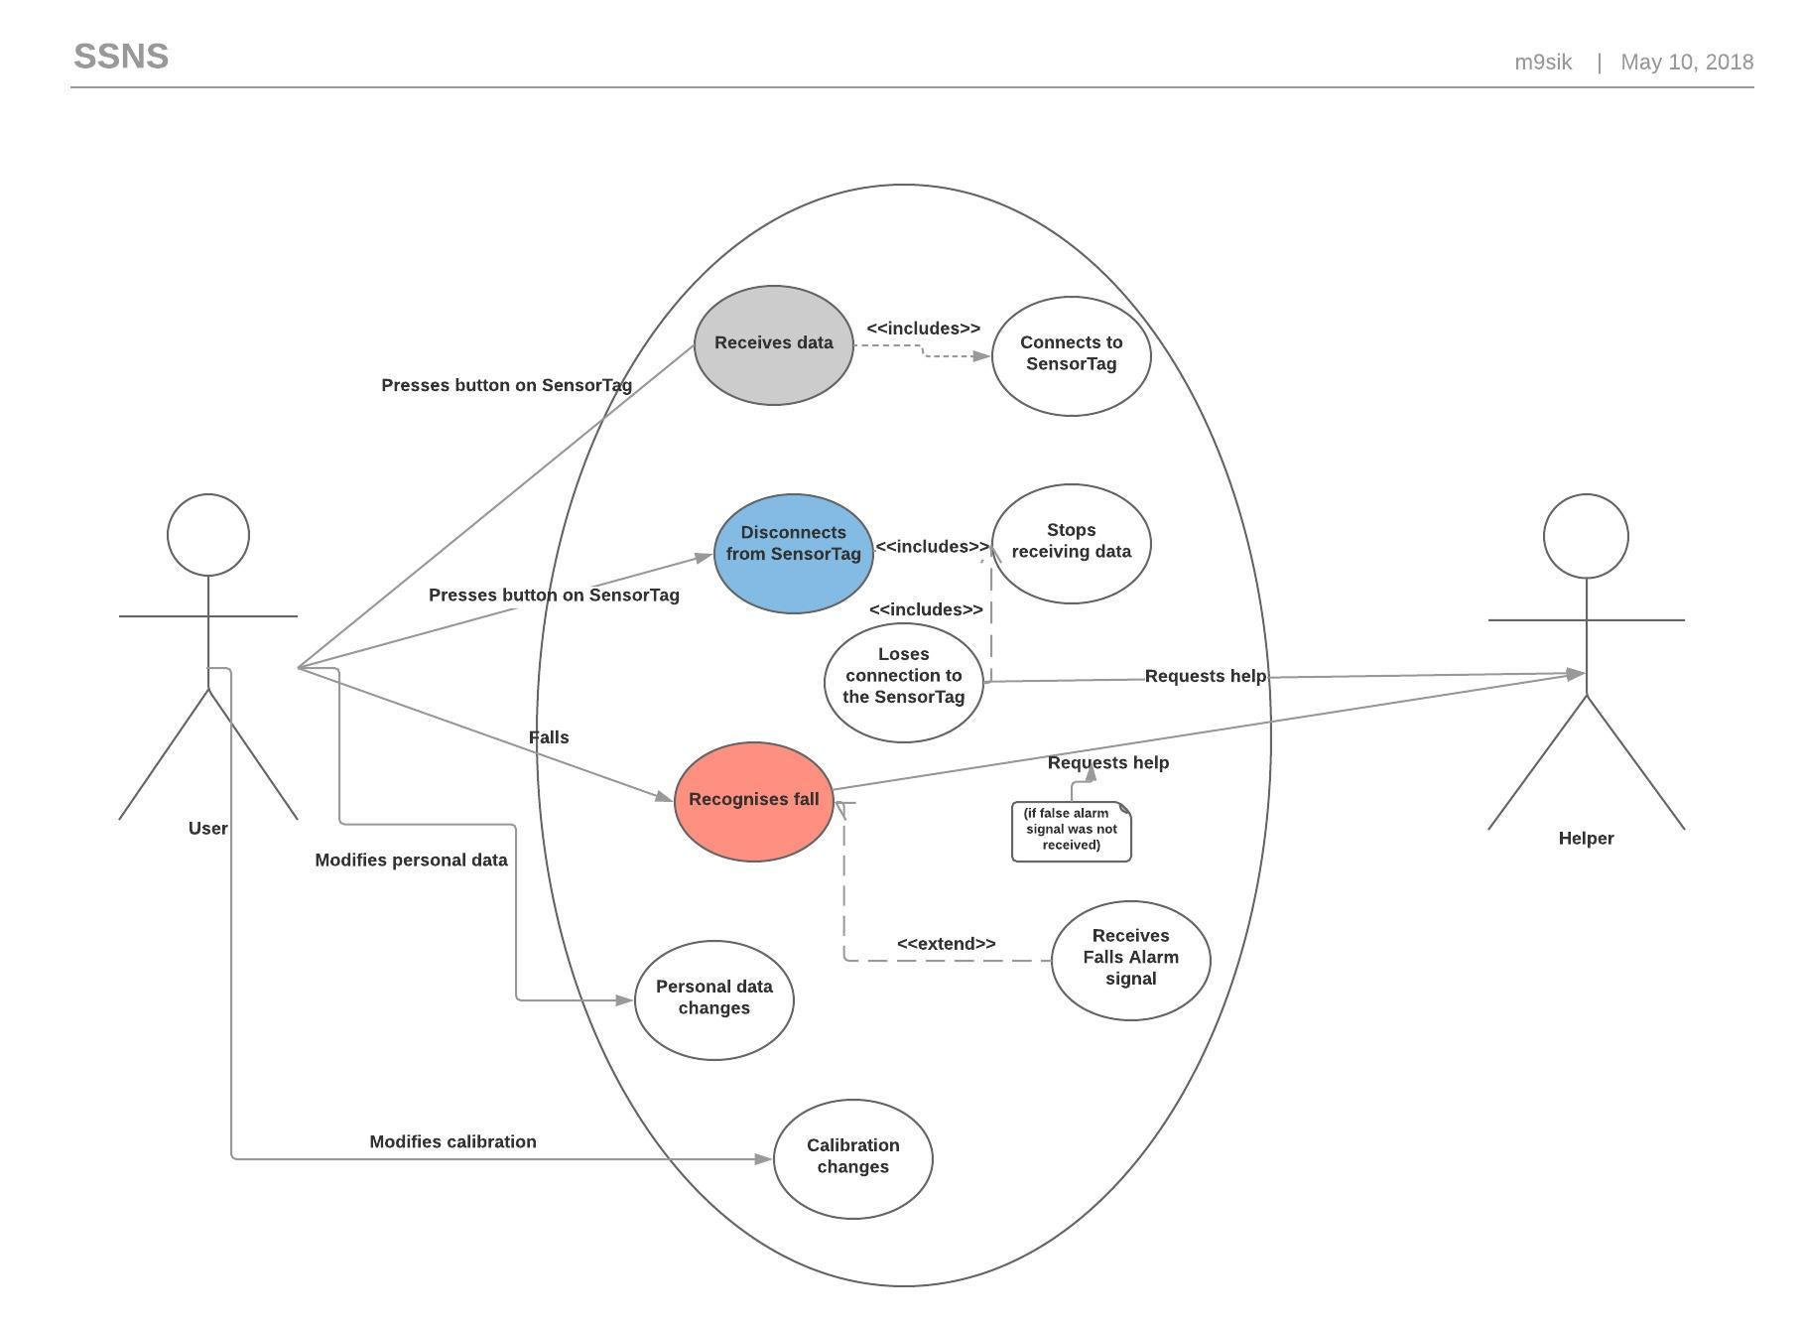

**Sequence diagrams**

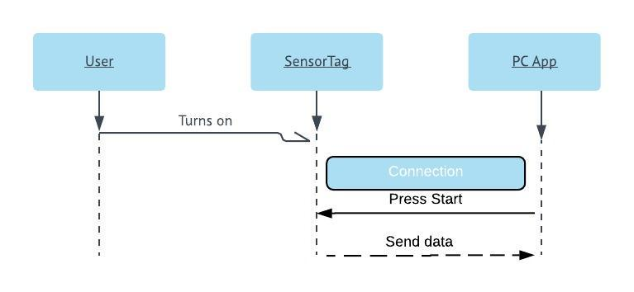Activate:

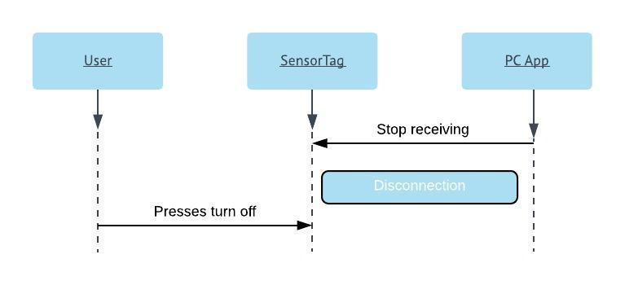Deactivate:

Fall:

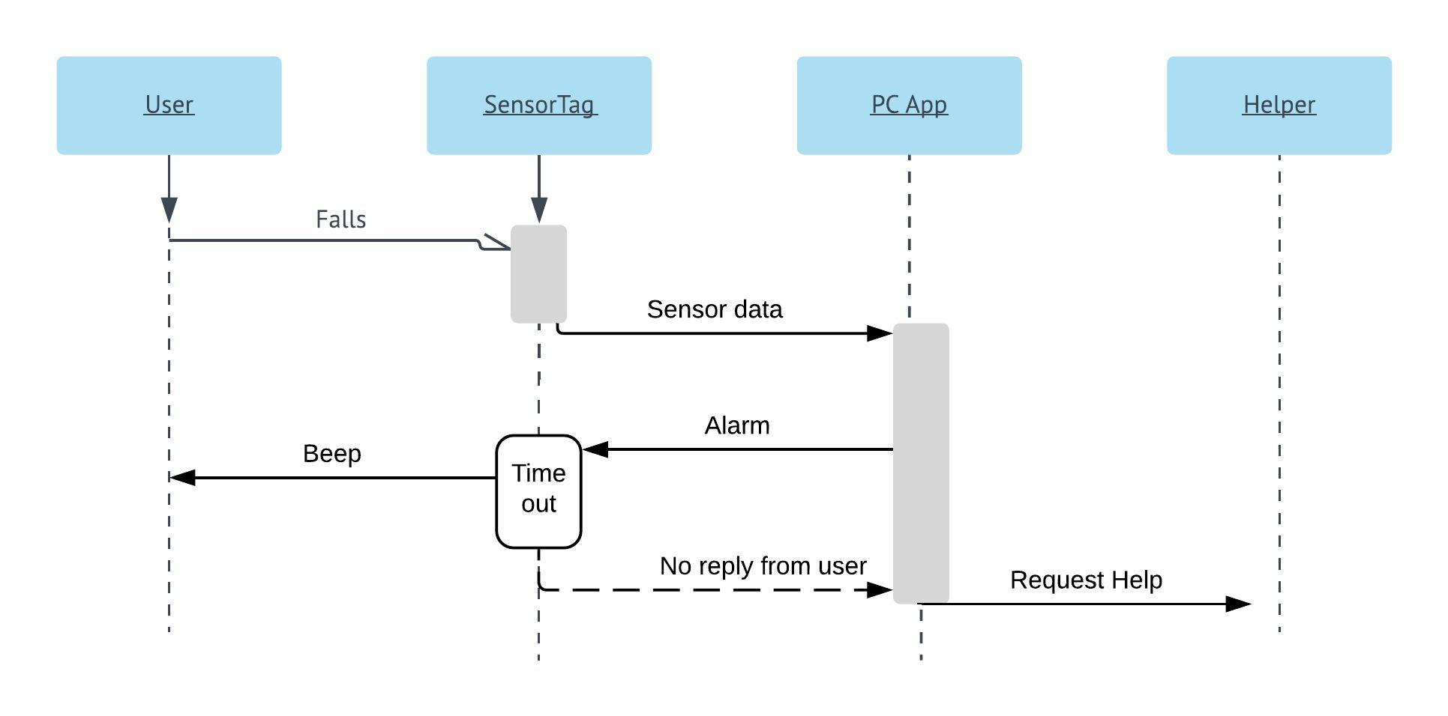

False Alarm:

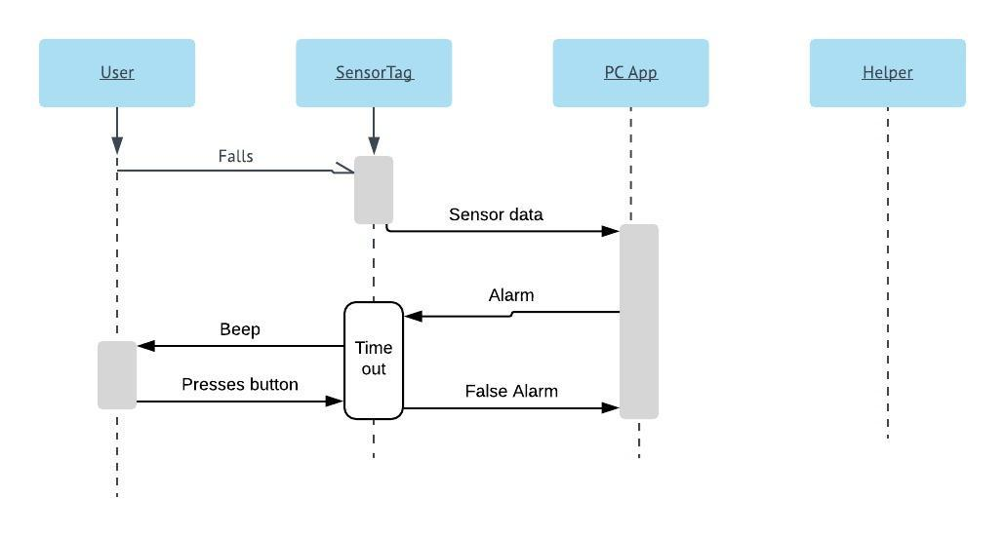

Out of range:

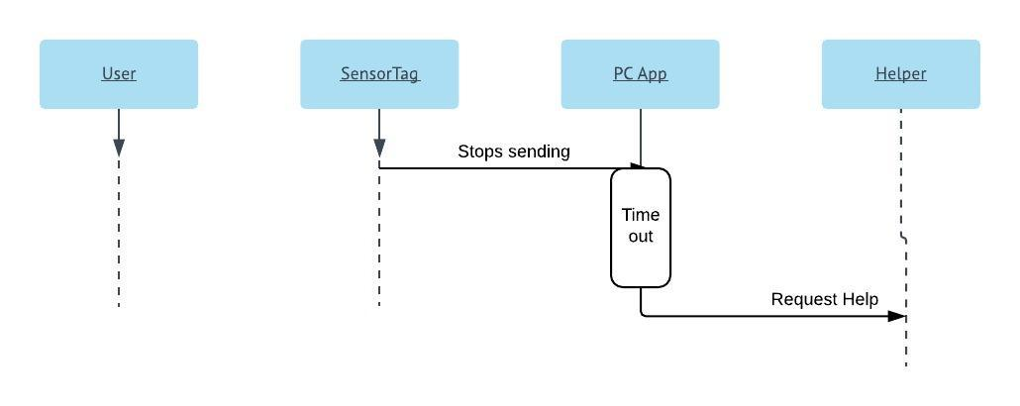

Modify personal data:

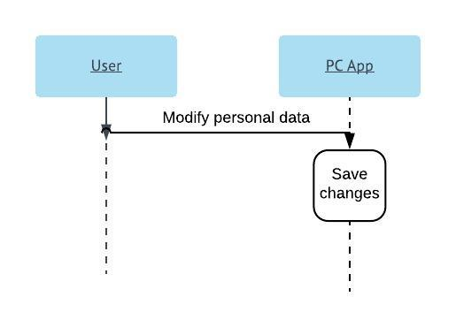

Modify calibration:

