1. 模板

@{

Layout = "~/Views/Shared/_Index.cshtml";

ViewBag.Title = "**综合信息管理系统";

}

访问：http://localhost:4051/Home/Index

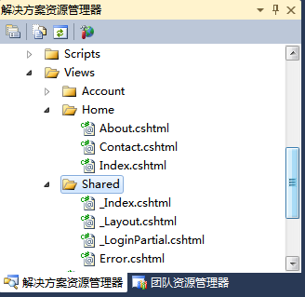

1. 引用css

@Styles.Render("~/Content/Index.css")

1. 渲染

<div id="body">

@RenderSection("featured", required: false)

<section class="content-wrapper main-content clear-fix">

@RenderBody()

</section>

</div>

1. 一个简单的css排版样式：

<!DOCTYPE html>

<html lang="en">

<head>

<meta charset="utf-8" />

<title>@ViewBag.Title</title>

<link href="~/favicon.ico" rel="shortcut icon" type="image/x-icon" />

<meta name="viewport" content="width=device-width" />

@Styles.Render("~/Content/css")

@Styles.Render("~/Content/Index.css")

@Scripts.Render("~/bundles/modernizr")

</head>

<body>

<div class="box top">

<div class="logo">logo</div>

</div>

<div class="box mid">

<div class="login">login</div>

<div class="banner">banner</div>

<div class="telephone">telephone</div>

</div>

<div id="body">

@RenderSection("featured", required: false)

<section class="content-wrapper main-content clear-fix">

@RenderBody()

</section>

</div>

@Scripts.Render("~/bundles/jquery")

@RenderSection("scripts", required: false)

</body>

</html>

样式Index.css：

body

{

margin-top:0px;

padding-top:0px;

}

.box

{

margin: 0 auto;

}

.top

{

width:800px;

height:200px;

position:relative;

background-color:Gray;

}

.logo

{

width:120px;

height:50px;

background-color:yellow;

top:16px;

left:0px;

display:block;

position:absolute;

}

.mid

{

width:800px;

height:200px;

position:relative;

border:1px solid red;

}

.mid .banner

{

width:800px;

height:150px;

top:25px;

position:relative;

background-color:Silver;

}

.mid .login

{

width:100px;

height:20px;

top:5px;

right:5px;

position:absolute;

background-color:Green;

color:White;

}

.wenzi

{

}

.telephone

{

width:150px;

height:25px;

bottom:0px;

left:0px;

position:absolute;

background-color:Orange;

color:White;

}