1. 路由(Route)配置

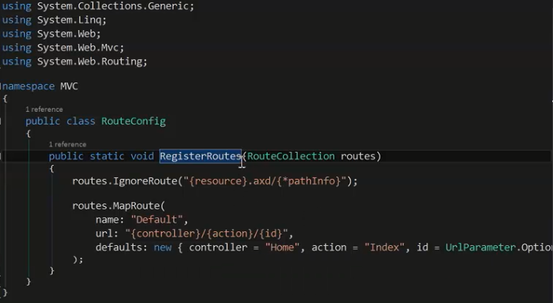

1. Controller

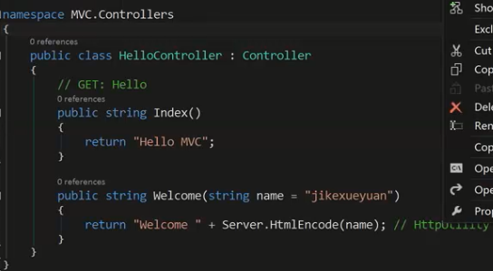

返回值两种，ActionResult和void，String好像不行。

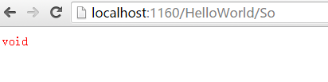

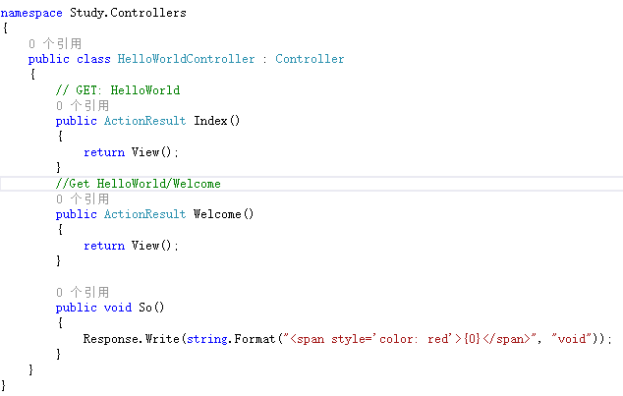

public ActionResult Index()

{

return View(db.Movies.ToList());

}

public ActionResult Details(string id)

{

if (id == null)

{

return new HttpStatusCodeResult(HttpStatusCode.BadRequest);

}

Movie movie = db.Movies.Find(id);

if (movie == null)

{

return HttpNotFound();

}

return View(movie);

}

public ActionResult Create([Bind(Include = "ID,Name,Score")] Movie movie)

{

if (ModelState.IsValid)

{

db.Movies.Add(movie);

db.SaveChanges();

return RedirectToAction("Index");

}

return View(movie);

}

public ActionResult Edit([Bind(Include = "ID,Name,Score")] Movie movie)

{

if (ModelState.IsValid)

{

db.Entry(movie).State = EntityState.Modified;

db.SaveChanges();

return RedirectToAction("Index");

}

return View(movie);

}

public ActionResult DeleteConfirmed(string id)

{

Movie movie = db.Movies.Find(id);

db.Movies.Remove(movie);

db.SaveChanges();

return RedirectToAction("Index");

}

1. View

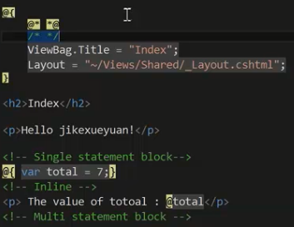

1. ViewBag