**[UML图示与代码对照](http://www.cnblogs.com/iamlilinfeng/archive/2012/08/29/2662740.html)**

**一、类继承**

1 public class Father

2 {

3 }

4 public class Child : Father

5 {

6 }

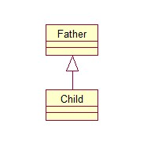

**二、接口继承**

1 public interface IBreath { }

2 public interface IRun { }

3

4 public class Animal : IBreath, IRun

5 { }

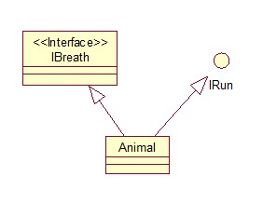

**三、实现**

[复制代码](javascript:void(0);)

1 public interface ISpeak

2 {

3 void Speak();

4 }

5 public class Person : ISpeak

6 {

7 void ISpeak.Speak()

8 {

9 throw new NotImplementedException();

10 }

11 }

[复制代码](javascript:void(0);)

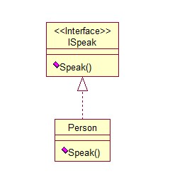

**四、关联**

1 public class Weather { }

2 public class People

3 {

4 private Weather weather;

5 }

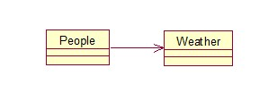

**五、依赖**

1 public class Water { }

2 public class Animal

3 {

4 public Animal(Water water) { }

5 }

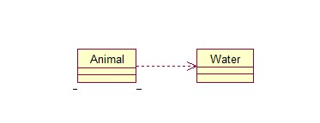

**六、聚合**

1 public class Car { }

2 public class Motorcade

3 {

4 private Car[] carList;

5 }

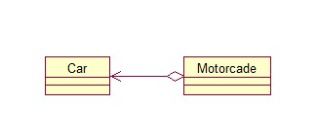

**七、组合**

[复制代码](javascript:void(0);)

1 public class Wheel { }

2 public class Car

3 {

4 private Wheel wheel;

5 public Car()

6 {

7 wheel = new Wheel();

8 }

9 }

[复制代码](javascript:void(0);)

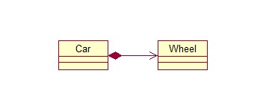

**八、版权**

转载请注明出处：<http://www.cnblogs.com/iamlilinfeng>