例子：
E:\开发\个人\HtmlStudy\HTMLStudy\src\NameSpace
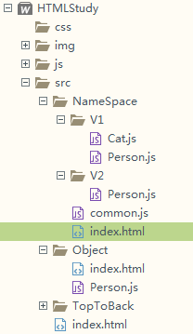
(1)Common.js很关键，它提供了一个命名空间的注册类：
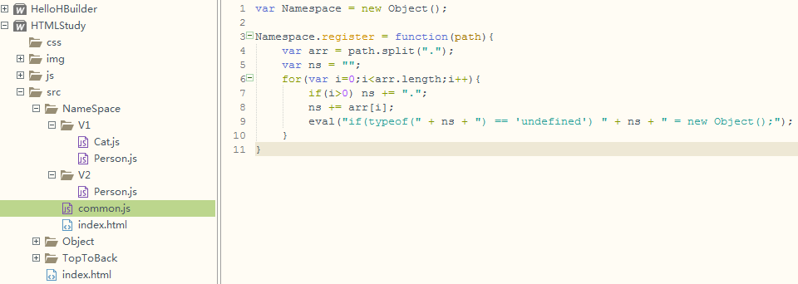
var Namespace = new Object();

Namespace.register = function(path){
var arr = path.split(".");
var ns = "";
for(var i=0;i<arr.length;i++){
if(i>0) ns += ".";
ns += arr[i];
eval("if(typeof(" + ns + ") == 'undefined') " + ns + " = new Object();");
}
}
- index.html:
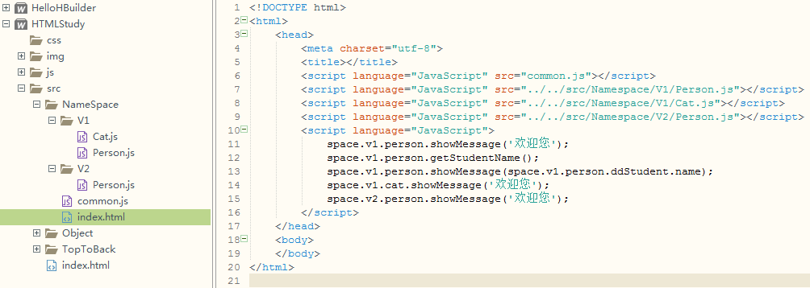
<!DOCTYPE html>
<html>
<head>
<meta charset="utf-8">
<title></title>
<script language="JavaScript" src="common.js"></script>
<script language="JavaScript" src="../../src/Namespace/V1/Person.js"></script>
<script language="JavaScript" src="../../src/Namespace/V1/Cat.js"></script>
<script language="JavaScript" src="../../src/Namespace/V2/Person.js"></script>
<script language="JavaScript">
space.v1.person.showMessage('欢迎您');
space.v1.person.getStudentName();
space.v1.person.showMessage(space.v1.person.ddStudent.name);
space.v1.cat.showMessage('欢迎您');
space.v2.person.showMessage('欢迎您');
</script>
</head>
<body>
</body>
</html>
- 其他js文件的写法：
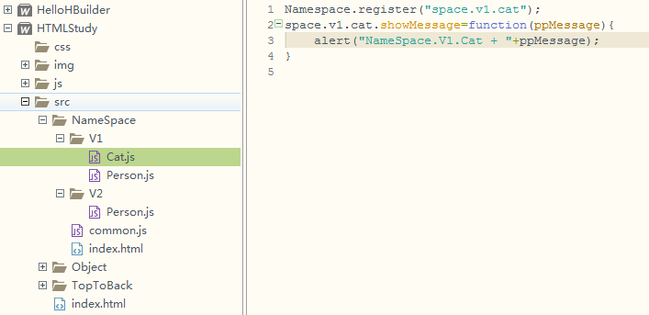
Namespace.register("space.v1.cat");
space.v1.cat.showMessage=function(ppMessage){
alert("NameSpace.V1.Cat + "+ppMessage);
}
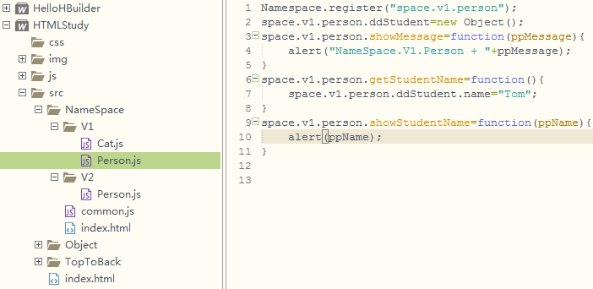
Namespace.register("space.v1.person");
space.v1.person.ddStudent=new Object();
space.v1.person.showMessage=function(ppMessage){
alert("NameSpace.V1.Person + "+ppMessage);
}
space.v1.person.getStudentName=function(){
space.v1.person.ddStudent.name="Tom";
}
space.v1.person.showStudentName=function(ppName){
alert(ppName);
}
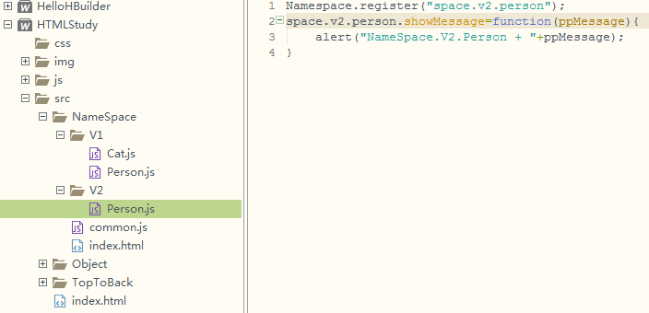
Namespace.register("space.v2.person");
space.v2.person.showMessage=function(ppMessage){
alert("NameSpace.V2.Person + "+ppMessage);
}

