Groovy Script

def listHostNames(servertypename, environment) {

def servers = []

if (environment == "DEV") {

switch (servertypename) {

case "WebServer":

servers = ["au2106sde055.esdevau.wbcdevau.westpac.com.au"]

break

case "MiddlewareServer":

servers = ["au2106sde056.esdevau.wbcdevau.westpac.com.au"]

break

case "ELKServer":

servers = ["au2106sde057.esdevau.wbcdevau.westpac.com.au"]

break

}

}

if (environment == "IAT1") {

switch (servertypename) {

case "WebServer":

servers = ["twa190708164148.estestau.wbctestau.westpac.com.au"]

break

case "MiddlewareServer":

servers = ["twa190708164614.estestau.wbctestau.westpac.com.au"]

break

case "ELKServer":

servers = ["twa190708172453.estestau.wbctestau.westpac.com.au"]

break

}

}

if (environment == "IAT2") {

switch (servertypename) {

case "WebServer":

servers = ["twa190708164511.estestau.wbctestau.westpac.com.au"]

break

case "MiddlewareServer":

servers = ["twa190708172401.estestau.wbctestau.westpac.com.au"]

break

case "ELKServer":

servers = ["twa190708172535.estestau.wbctestau.westpac.com.au"]

break

}

}

if (environment == "IAT3") {

switch (servertypename) {

case "WebServer":

servers = ["twa200925103535.estestau.wbctestau.westpac.com.au"]

break

case "MiddlewareServer":

servers = ["twa200925103556.estestau.wbctestau.westpac.com.au"]

break

case "ELKServer":

servers = ["twa190708172619.estestau.wbctestau.westpac.com.au"]

break

}

}

if (environment == "IAT4") {

switch (servertypename) {

case "WebServer":

servers = ["tww210426111038.estestau.wbctestau.westpac.com.au"]

break

case "MiddlewareServer":

servers = ["twa210426111032.estestau.wbctestau.westpac.com.au"]

break

case "ELKServer":

servers = ["twa210426111043.estestau.wbctestau.westpac.com.au"]

break

}

}

if (environment == "IAT5") {

switch (servertypename) {

case "WebServer":

servers = ["tww220330100723.estestau.wbctestau.westpac.com.au"]

break

case "MiddlewareServer":

servers = ["twa220330100801.estestau.wbctestau.westpac.com.au"]

break

case "ELKServer":

servers = ["twa220330101007.estestau.wbctestau.westpac.com.au"]

break

}

}

if (environment == "SVP") {

switch (servertypename) {

case "WebServer":

servers = ["twa200217133131.estestau.wbctestau.westpac.com.au","twa200217133040.estestau.wbctestau.westpac.com.au"]

break

case "MiddlewareServer":

servers = ["twa200217132829.estestau.wbctestau.westpac.com.au","twa200217132707.estestau.wbctestau.westpac.com.au"]

break

case "ELKServer":

servers = ["twa200217130426.estestau.wbctestau.westpac.com.au","twa200217130336.estestau.wbctestau.westpac.com.au","twa200217130335.estestau.wbctestau.westpac.com.au","twa200217120001.estestau.wbctestau.westpac.com.au","twa200217115825.estestau.wbctestau.westpac.com.au","twa200217115405.estestau.wbctestau.westpac.com.au"]

break

}

}

return servers

}

def hostNames = listHostNames(ServerType, Env_Name)

return hostNames

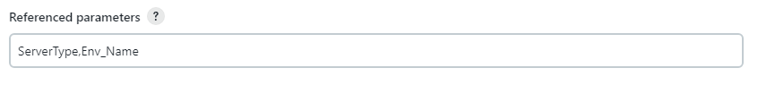

Groovy Script

def listServices(servertypename, environment) {

def services = []

switch (servertypename) {

case "WebServer":

services = ["IIS"]

break

case "MiddlewareServer":

if (environment == "SVP") {

services = ["ActiveMQ", "jbossfdim", "jbossEAP-7"]

} else {

services = ["ActiveMQ", "JBossEAP7"]

}

break

case "ELKServer":

services = ["ELKService"]

break

}

return services

}

def services = listServices(ServerType, Env_Name)

return services

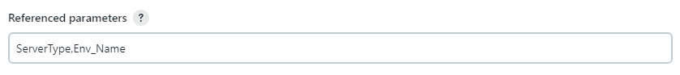

Groovy Script

def listActions(servicename) {

def actions = []

switch (servicename) {

case "IIS":

actions = ["Reset"]

break

case "ActiveMQ":

actions = ["Start", "Stop"]

break

case "JBossEAP7":

actions = ["Start", "Stop"]

break

case "ELKService":

actions = ["Start", "Stop"]

break

}

return actions

}

def actions = listActions(Service_Name)

return actions

