Lab 4 XML Lab: Create an XML document
姓名：乔润喆 学号：247050
实验一 XML Lab: Create an XML document
一、实验目的
In this lab, you will create an XML document representing a simple book catalogue. You will then validate the XML to ensure it's well-formed and finally display the XML data in an HTML page.
二、实验内容
Create the XML Document:
- Create a new XML document named book.xml.
- Each book should have an id attribute.
- Each book should contain child elements: title, author, and price.
Validate the XML:
- Ensure that your XML is well-formed.
- Use online XML validators like XML Validation to check the structure.
Display the XML Data in an HTML Page:
- Fetch the XML data using fetch API in JavaScript.
- Parse the XML string “xmlText” using:
const parser = new DOMParser();
const xmlDoc = parser.parseFromString(xmlText, 'text/xml');
- Display each book's title, author, and price in the HTML page.
- Publish your webpage on GitHub Pages and share the link in your submission.
三、实验结果
核心代码
【调试成功的核心源程序代码】
（1）book.xml —— XML 文档（每个 <book> 都有 id 属性，并包含 title、author、price 子元素）
<?xml version="1.0" encoding="UTF-8"?>
<!-- book.xml : a simple book catalogue -->
<bookCatalogue>
<book id="B001">
<title>Web Development Foundations</title>
<author>Jane Smith</author>
<price>59.99</price>
</book>
<book id="B002">
<title>Learning JavaScript</title>
<author>Michael Brown</author>
<price>45.50</price>
</book>
<book id="B003">
<title>XML and JSON in Practice</title>
<author>Sarah Johnson</author>
<price>72.00</price>
</book>
<book id="B004">
<title>HTML and CSS Design</title>
<author>David Wilson</author>
<price>38.75</price>
</book>
<book id="B005">
<title>Asynchronous JavaScript with Fetch</title>
<author>Emily Chen</author>
<price>64.20</price>
</book>
</bookCatalogue>
（2）xml-lab/index.html —— 使用 fetch API 获取并用 DOMParser 解析 XML 的核心代码
// Step 1: fetch the XML file from the server
fetch("book.xml")
.then(function (response) {
if (!response.ok) {
throw new Error("Fetch error: " + response.status);
}
// read the response as raw text (the XML string "xmlText")
return response.text();
})
.then(function (xmlText) {
// Step 2: parse the XML string into an XML document
const parser = new DOMParser();
const xmlDoc = parser.parseFromString(xmlText, 'text/xml');

// Step 3: check that the XML is well-formed.
// DOMParser puts a <parsererror> element in the document when the XML is broken.
const parseError = xmlDoc.getElementsByTagName("parsererror");
if (parseError.length > 0) {
document.getElementById("message").textContent =
"The XML document is not well-formed.";
return;
}

// Step 4: get all <book> elements
const allBooks = xmlDoc.getElementsByTagName("book");

const outputDiv = document.getElementById("bookList");
outputDiv.innerHTML = "";

// Step 5: loop through each book and show title, author and price
for (let i = 0; i < allBooks.length; i++) {
const oneBook = allBooks[i];

const bookId = oneBook.getAttribute("id");
const bookTitle = oneBook.querySelector("title").textContent;
const bookAuthor = oneBook.querySelector("author").textContent;
const bookPrice = oneBook.querySelector("price").textContent;

const div = document.createElement("div");
div.className = "book-item";
div.innerHTML = `
<h2>${bookTitle}</h2>
ID: ${bookId}<br>
Author: ${bookAuthor}<br>
<span class="price">Price: $${bookPrice}</span>
`;
outputDiv.appendChild(div);
}

document.getElementById("message").textContent =
"The XML document is well-formed. " + allBooks.length + " books found.";
})
.catch(function (error) {
// runs if the file cannot be loaded or parsed
console.error("Fetch error: " + error.message);
document.getElementById("message").textContent =
"Cannot load the XML file. " + error.message;
});
运行效果：
【用截图方式辅助说明程序运行结果】
- book.xml 通过在线 XML 校验器检查，结构良好（well-formed），浏览器控制台无 parsererror。
- 页面加载后提示 “The XML document is well-formed. 5 books found.”，5 本书的 id、title、author、price 全部正确显示。
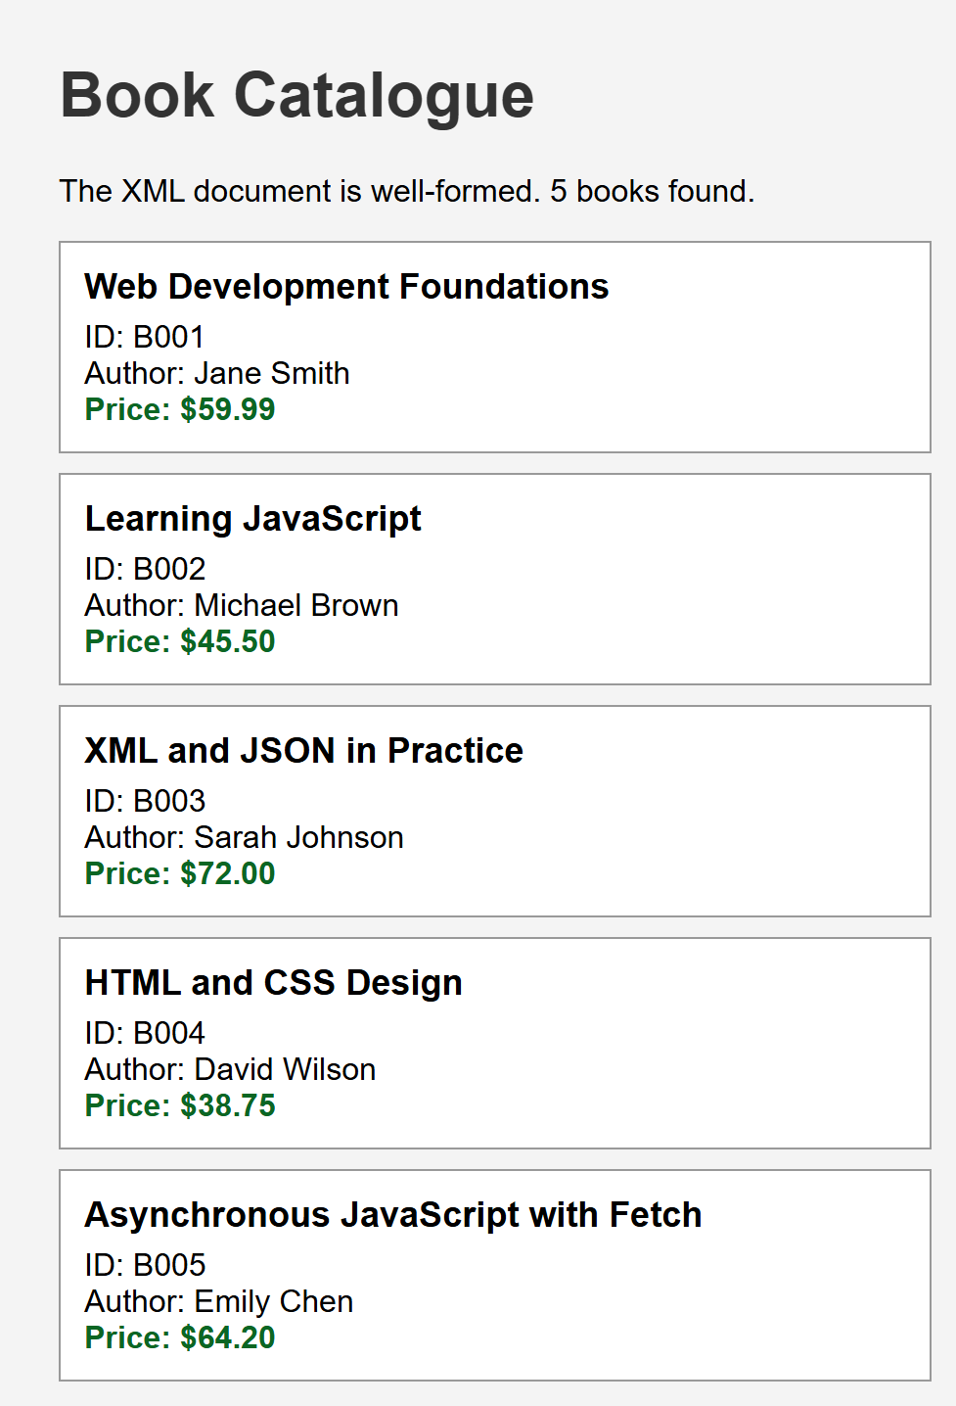
图 1 xml-lab/index.html 运行效果：成功读取并显示 book.xml 中的 5 本书
GitHub Pages 链接：https://<your-username>.github.io/lab4-xml-json/xml-lab/

实验二 JSON Lab: Creating a Simple User Profile
In this lab, you will craft a JSON document representing a set of user profiles. After creating the document, you will validate its structure to ensure its correctness. Finally, you will display the user profile data on an HTML page.
二、实验内容
Create the JSON Document:
- Create a new JSON document named userProfiles.json.
- Each user profile should have the following data: firstName, lastName, email, dateOfBirth, and user preferences (which includes theme, language, notifications).
- Add at least 3 user profiles to the document, each with its unique details and preferences.
Validate the JSON:
- Confirm that your JSON structure is well-formed.
- Use online JSON validators like JSONFORMATTER&VALIDATOR to check the structure. Simply paste your JSON data into the validator and check for any errors.
Extend the JSON:
- Add an address field to the profile section of each user. The address should include street, city, state, and zipCode.
- Add a subscription field to the preferences section indicating whether the user has subscribed to the newsletter (true or false).
Display the User Profiles in an HTML Page:
- Fetch and parse the JSON data employing fetch API in JavaScript.
fetch('xxx.json')
.then(response => {
if (!response.ok)
throw new Error('Fetch error: ' + response.status)
else
return response.json();
})
.then(json => {...}) // things you are going to do with the parsed json
.catch(err => console.error('Fetch error: ' + err.message));
- Exhibit each user's firstName, lastName, email, dateOfBirth, and other attributes on the HTML page.
- Publish your webpage on GitHub Pages and share the link in your submission.
三、实验结果
核心代码
【调试成功的核心源程序代码】
（1）userProfiles.json —— 4 个用户资料，包含 firstName、lastName、email、dateOfBirth、address（street / city / state / zipCode）与 preferences（theme / language / notifications / subscription）
[
{
"firstName": "Alice",
"lastName": "Johnson",
"email": "alice.johnson@example.com",
"dateOfBirth": "1999-04-12",
"address": {
"street": "12 Queen Street",
"city": "Auckland",
"state": "Auckland",
"zipCode": "1010"
},
"preferences": {
"theme": "dark",
"language": "en",
"notifications": true,
"subscription": true
}
},
{
"firstName": "Bob",
"lastName": "Chen",
"email": "bob.chen@example.com",
"dateOfBirth": "2001-09-30",
"address": {
"street": "88 Victoria Road",
"city": "Wellington",
"state": "Wellington",
"zipCode": "6011"
},
"preferences": {
"theme": "light",
"language": "zh",
"notifications": false,
"subscription": false
}
},
{
"firstName": "Carla",
"lastName": "Martinez",
"email": "carla.martinez@example.com",
"dateOfBirth": "1997-01-25",
"address": {
"street": "5 Riccarton Avenue",
"city": "Christchurch",
"state": "Canterbury",
"zipCode": "8041"
},
"preferences": {
"theme": "blue",
"language": "es",
"notifications": true,
"subscription": true
}
},
{
"firstName": "David",
"lastName": "Kim",
"email": "david.kim@example.com",
"dateOfBirth": "2003-07-08",
"address": {
"street": "230 Great South Road",
"city": "Hamilton",
"state": "Waikato",
"zipCode": "3204"
},
"preferences": {
"theme": "dark",
"language": "ko",
"notifications": false,
"subscription": true
}
}
]
（2）json-lab/index.html —— 使用 fetch API 获取并解析 JSON 的核心代码
// fetch and parse the JSON data with the fetch API
fetch('userProfiles.json')
.then(response => {
if (!response.ok)
throw new Error('Fetch error: ' + response.status)
else
return response.json();
})
.then(json => {
// things we are going to do with the parsed json
const outputDiv = document.getElementById("profileList");
outputDiv.innerHTML = "";

json.forEach(function (user) {
const div = document.createElement("div");
div.className = "profile-item";
div.innerHTML = `
<h2>${user.firstName} ${user.lastName}</h2>
<span class="label">Email:</span> ${user.email}<br>
<span class="label">Date of Birth:</span> ${user.dateOfBirth}<br>
<span class="label">Address:</span>
${user.address.street}, ${user.address.city},
${user.address.state} ${user.address.zipCode}<br>
<span class="label">Theme:</span> ${user.preferences.theme}
&nbsp;|&nbsp;
<span class="label">Language:</span> ${user.preferences.language}
&nbsp;|&nbsp;
<span class="label">Notifications:</span> ${user.preferences.notifications}
&nbsp;|&nbsp;
<span class="label">Subscribed:</span> ${user.preferences.subscription}
`;
outputDiv.appendChild(div);
});

document.getElementById("message").textContent =
json.length + " user profiles loaded.";
})
.catch(err => {
console.error('Fetch error: ' + err.message);
document.getElementById("message").textContent =
"Cannot load the JSON file. " + err.message;
});
运行效果：
【用截图方式辅助说明程序运行结果】
- userProfiles.json 通过在线 JSON 校验器检查，JSON 结构良好，无语法错误。
- 页面加载后提示 “4 user profiles loaded.”，4 位用户的姓名、邮箱、出生日期、地址以及 theme、language、notifications、subscription 全部正确显示。
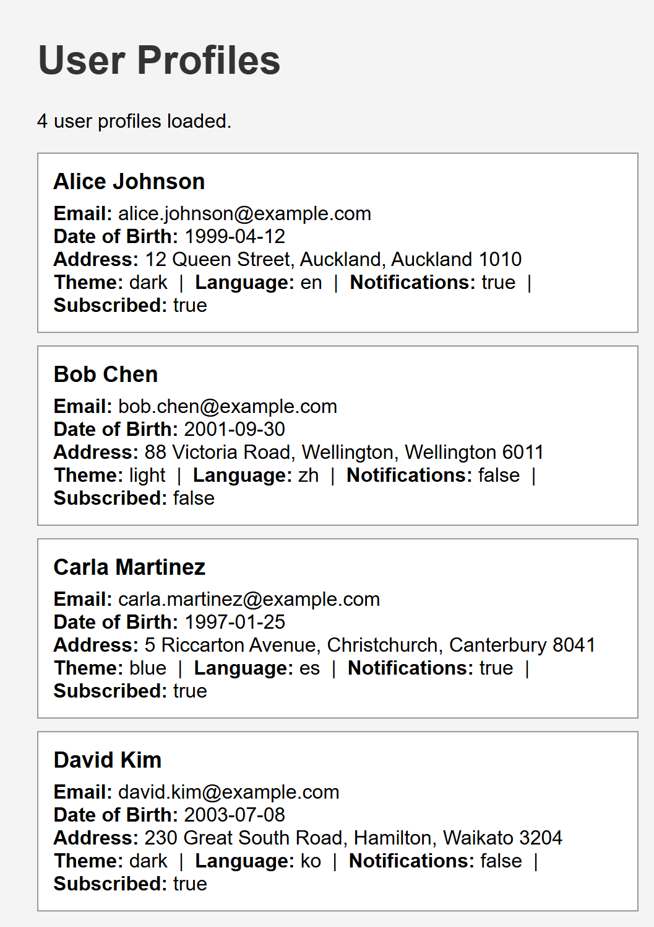
图 2 json-lab/index.html 运行效果：成功读取并显示 userProfiles.json 中的 4 个用户资料
GitHub Pages 链接：https://<your-username>.github.io/lab4-xml-json/json-lab/
备注：上传文件命名要求：Lab4-学号-姓名.doc —— 本文件：Lab4-247050-乔润喆.doc

