 | 1 2 3 4 5 |  | 6
A  B  C  D | LicheeRV Nano 70415 Pin Definition  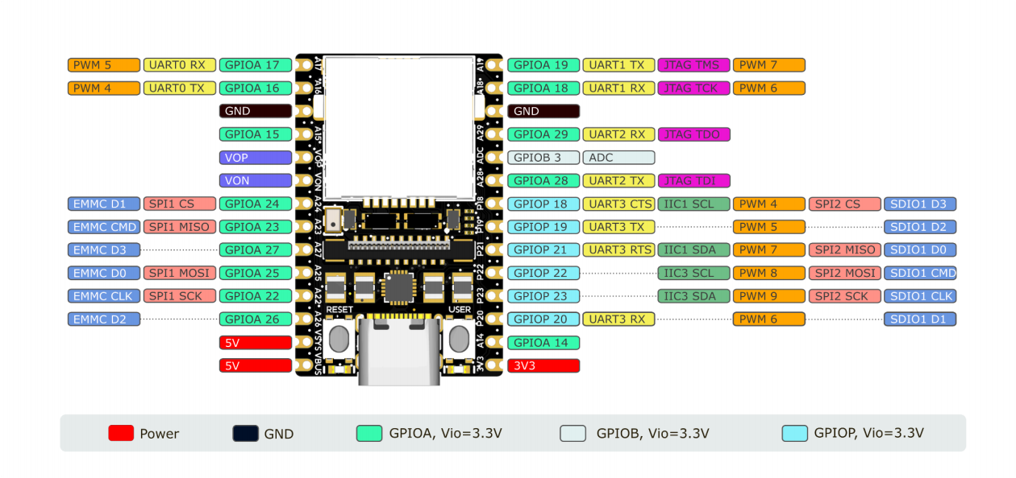 |  |  | A  B  C  D
 |  | 
 |  | Shenzhen Sipeed Techno. Co,Ltd. | Date: 24-2-28
 |  | SCH: LicheeRV Nano 70415 | Rev: 1.3
 |  | Page: Config | Id: 1/ 4
 | 1 2 3 4 5 |  | 6

1 |  | 2 |  | 3 |  |  | 4 |  |  | 5 |  |  |  | 6
A | 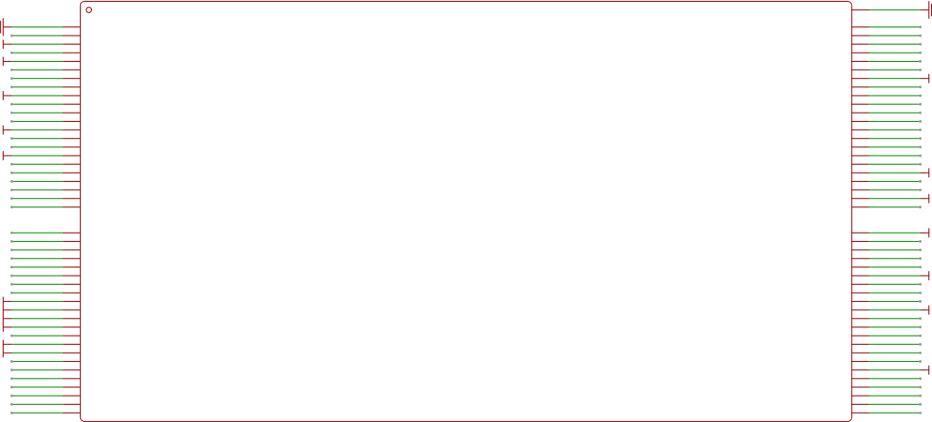  64  53  48  47  83  79  77  74  73  72  71  67  1  2  4  7  11  12  14  16  17  21  22  EMMC_DAT[3]/SPINOR_WP_X/SPINAND_WP/XGPIOA[27]/SPINOR_WP_X VDD33A_ETH_USB  EMMC_CMD/SPINOR_MISO/SPINAND_MISO/XGPIOA[23]/SPINOR_MISO ETH_RXM)/UART3_CTS/CAM_MCLK0/XGPIOB[26]/PWM[14]/CAM_VS0/SPI1_CS_X/IIS2_DI  EMMC_DAT[1]/SPINOR_CS_X/SPINAND_CS/XGPIOA[24]/SPINOR_CS_X ETH_RXP/UART3_TX/CAM_MCLK1/XGPIOB[27]/PWM[15]/CAM_HS0/SPI1_SCK/IIS2_DO  CR_4WTMS/CAM_MCLK0/PWM[7]/XGPIOA[19]/UART1_RTS/AUX0/UART1_TX/VO_D[28]/JTAG_CPU_TMS ETH_TXM/UART3_RTS/IIC1_SDA/XGPIOB[24]/PWM[12]/CAM_MCLK1/SPI1_SDI/IIS2_BCLK  CR_4WTCK/CAM_MCLK1/PWM[6]/XGPIOA[18]/UART1_CTS/AUX1/UART1_RX/VO_D[29]/JTAG_CPU_TCK ETH_TXP/UART3_RX/IIC1_SCL/XGPIOB[25]/PWM[13]/CAM_MCLK0/SPI1_SDO/IIS2_LRCK  CR_4WTDI/UART1_TX/UART2_TX/XGPIOA[28]/WG0_D0/DBG[10]/IIC0_SCL VDDC  CR_4WTDO/UART1_RX/UART2_RX/XGPIOA[29]/WG0_D1/WG1_D0/DBG[11]/IIC0_SDA USB_VBUS_DET/XGPIOB[6]/CAM_MCLK0/CAM_MCLK1  AUX0/XGPIOA[30]/IIS1_MCLK/VO_D[31]/WG1_D1/DBG[12] ADC[1]/XGPIOB[3]/KEY_COL2  VDDQ_DRAM PWM[0]/XGPIOB[0]  VDDQ VDDIO_SD1  VDDQ PWR_SD1_CLK_VO37/SPI2_SCK/IIC3_SDA/PWR_GPIO[23]/CAM_HS0/EPHY_SPD_LED/PWR_SPINOR1_SCK/PWM[9]/SD1_CLK  VDDQ_DRAM PWR_SD1_CMD_VO36/SPI2_SDO/IIC3_SCL/PWR_GPIO[22]/CAM_VS0/EPHY_LNK_LED/PWR_SPINOR1_MOSI/PWM[8]/SD1_CMD  GPIO_ZQ)/PWR_GPIO[24]/PWM[2]/GPIO_ZQ PWR_SD1_D0_VO35/SPI2_SDI/IIC1_SDA/PWR_GPIO[21]/CAM_MCLK1/UART3_RTS/PWR_SPINOR1_MISO/PWM[7]/SD1_D0  VDDIO_RTC PWR_SD1_D1_VO34/IIC1_SDA/UART2_RX/PWR_GPIO[20]/CAM_MCLK1/UART3_RX/PWR_SPINOR1_WP_X/PWM[6]/SD1_D1  VDDC_RTC PWR_SD1_D2_VO33/IIC1_SCL/UART2_TX/PWR_GPIO[19]/CAM_MCLK0/UART3_TX/PWR_SPINOR1_HOLD_X/PWM[5]/SD1_D2  PWR_VBAT_DET(PWRSAR.VIN3) PWR_SD1_D3_VO32/SPI2_CS_X/IIC1_SCL/PWR_GPIO[18]/CAM_MCLK0/UART3_CTS/PWR_SPINOR1_CS_X/PWM[4]/SD1_D3  PWR_RSTN VDDC  PWR_SEQ1/PWR_GPIO[3]/PWR_SEQ1 PWR_GPIO[2](PWRSAR.VIN1)/EPHY_SPD_LED/PWM[10]/PWR_IIC_SDA/IIC2_SDA/CR_2WTCK/PWR_GPIO2  PWR_SEQ2/PWR_GPIO[4]/PWR_SEQ2 PWR_GPIO[1](PWRSAR1.VIN2)/UART2_RX/EPHY_LNK_LED/PWM[9]/PWR_IIC_SCL/IIC2_SCL/CR_SDA0/PWR_GPIO1  PTEST PWR_GPIO[0]/UART2_TX/PWR_UART0_RX/PWM[8]/PWR_GPIO0  PWR_WAKEUP0/PWR_IR0/PWR_UART0_TX/PWR_GPIO[6](PWR_IIC_SDA)/UART1_TX/IIC4_SCL/EPHY_LNK_LED/WG2_D0/PWR_WAKEUP0 XTAL_XOUT  PWR_BUTTON1/PWR_GPIO[8](PWR_IIC_SCL)/UART1_RX/IIC4_SDA/EPHY_SPD_LED/WG2_D1/PWR_BUTTON1 XTAL_XIN  EP  VI0_D[10]/VO_D[3]/XGPIOC[13]/CAM_MCLK0/PWM[15]/CAM_HS0/DBG[13]/MIPI_TXP0 VI0_D[9]/VO_D[4]/XGPIOC[12]/CAM_MCLK1/PWM[14]/CAM_VS0/DBG[12]/PAD_MIPI_TXM0 CR_2WTCK/VI0_D[12]/VO_D[1]/XGPIOC[15]/IIC2_SCL/PWM[11]/SPI0_SDI/DBG[15]/MIPI_TXP1 CR_2WTMS/VI0_D[11]/VO_D[2]/XGPIOC[14]/IIC2_SDA/PWM[10]/SPI0_SDO/DBG[14]/MIPI_TXM1 CR_SCL0/VI0_D[14]/VO_CLK0/XGPIOC[17]/IIC1_SCL/PWM[9]/SPI0_CS_X/SD1_D3/MIPI_TXP2 CR_SDA0/VI0_D[13]/VO_D[0]/XGPIOC[16]/IIC1_SDA/PWM[8]/SPI0_SCK/SD1_D2/MIPI_TXM2 VDD18A_MIPI  VI0_D[8]/VO_D[5]/XGPIOC[11]/CAM_MCLK0/DBG[11]/MIPIRX0P VI0_D[7]/VO_D[6]/XGPIOC[10]/IIC1_SCL/CAM_MCLK1/DBG[10]/MIPIRX0N VI0_D[6]/VO_D[7]/XGPIOC[9]/IIC1_SDA/KEY_ROW2/DBG[9]/MIPIRX1P VI0_D[5]/VO_D[8]/XGPIOC[8]/KEY_ROW3/DBG[8]/MIPIRX1N  VI0_D[4]/VO_D[9]/XGPIOC[7]/VI1_D[18]/IIC4_SDA/DBG[7]/MIPIRX2P VI0_D[3]/VO_D[10]/XGPIOC[6]/VI1_D[17]/IIC4_SCL/DBG[6]/MIPIRX2N CR_2WTCK/VI0_D[2]/VI1_D[16]/XGPIOC[5]/MUX_SPI1_MOSI/MIPIRX3P  CR_2WTMS/VI0_D[1]/VI1_D[15]/XGPIOC[4]/CAM_MCLK0/MUX_SPI1_MISO/MIPIRX3N CR_SDA0/VI0_D[0]/VI1_D[14]/XGPIOC[3]/IIC1_SCL/CAM_MCLK1/KEY_ROW1/MUX_SPI1_CS/MIPIRX4P CR_SCL0/VI0_CLK/VI1_D[13]/XGPIOC[2]/IIC1_SDA/CAM_MCLK0/KEY_ROW0/MUX_SPI1_SCK/MIPIRX4N VDDC  USB_DM  USB_DP  VDD18A_USB_PLL_ETH GPIO_RTX/XGPIOB[23]/PWM[1]/CAM_MCLK0  VSS18A_AUD  AUD_AINL_MIC/XGPIOC[23]/IIS1_BCLK/IIS2_BCLK PAD_AUD_AVREF  AUD_AOUTR/XGPIOC[24]/IIS1_DI/IIS2_DO/IIS1_DO VDD18A_AUD  SDIO0_CLK/IIC1_SDA/SPI0_SCK/XGPIOA[7]/PWM[15]/EPHY_LNK_LED/DBG[0]  SDIO0_CMD/IIC1_SCL/SPI0_SDO/XGPIOA[8]/PWM[14]/EPHY_SPD_LED/DBG[1]  SDIO0_D[0]/CAM_MCLK1/SPI0_SDI/XGPIOA[9]/UART3_TX/PWM[13]/WG0_D0/DBG[2] VDDC  SDIO0_D[1]/IIC1_SDA/AUX0/XGPIOA[10]/UART1_TX/PWM[12]/WG0_D1/DBG[3]  SDIO0_D[2]/IIC1_SCL/AUX1/XGPIOA[11]/UART1_RX/PWM[11]/WG1_D0/DBG[4]  SDIO0_D[3]/CAM_MCLK0/SPI0_CS_X/XGPIOA[12]/UART3_RX/PWM[10]/WG1_D1/DBG[5] VDDIO_SD0_SPI  SDIO0_CD/XGPIOA[13]  SDIO0_PWR_EN/XGPIOA[14]  VDDC  XGPIOA[15]  UART0_TX/CAM_MCLK1/PWM[4]/XGPIOA[16]/UART1_TX/AUX1/DBG[6]/UART0_TX UART0_RX/CAM_MCLK0/PWM[5]/XGPIOA[17]/UART1_RX/AUX0/DBG[7]/UART0_RX EMMC_DAT[2]/SPINOR_HOLD_X/SPINAND_HOLD/XGPIOA[26]/SPINOR_HOLD_X EMMC_CLK/SPINOR_SCK/SPINAND_CLK/XGPIOA[22]/SPINOR_SCK  EMMC_DAT[0]/SPINOR_MOSI/SPINAND_MOSI/XGPIOA[25]/SPINOR_MOSI  ADU_VREF  VDD1V8_SYS  VDD0V9_CPU  VDD3V3_SYS  VDD0V9_CPU  VDD1V35_DRAM  VDD1V35_DRAM  VDD1V35_DRAM  VDD1V35_DRAM  VDD1V8_SYS  VDDC_RTC  GND  VDD1V8_SYS  VDD0V9_CPU  VDD1V8_SYS  VDD3V3_SYS  VDD0V9_CPU  VDD3V3_SYS  VDD0V9_CPU  EPHY_TX_P  EPHY_TX_N  EPHY_RX_P  EPHY_RX_N  USB_DET ADC1 PWR_PWM  SDIO1_CLK  SDIO1_CMD  SDIO1_D0  SDIO1_D1  SDIO1_D2  SDIO1_D3  BL_PWM CAM_IO0 LCD0_RESET XTAL_XOUT  XTAL_XIN  AUD_IN  AUD_OUT  SDIO0_CLK  SDIO0_CMD  SDIO0_D0  SDIO0_D1  SDIO0_D2  SDIO0_D3  GND  GPIOA_14  GPIOA_15  GPIOA_16  GPIOA_17  GPIOA_26  GPIOA_22  GPIOA_25  MIPI_TX0_P  MIPI_TX0_N  MIPI_TX1_P  MIPI_TX1_N  MIPI_TX2_P  MIPI_TX2_N  MIPI_RX0_P  MIPI_RX0_N  MIPI_RX1_P  MIPI_RX1_N  MIPI_RX2_P  MIPI_RX2_N  MIPI_RX3_P  MIPI_RX3_N  MIPI_RX4_P  MIPI_RX4_N  USB_D_N  USB_D_P  CPU_SEL  GPIOA_27  GPIOA_23  GPIOA_24  GPIOA_19  GPIOA_18  GPIOA_28  GPIOA_29 BOOT_KEY  GPIO_ZQ  PWR_DET SYS_RSTN TP0_INT  TP0_RST GND  CAM_SCL  CAM_SDA  23  24  25  26  27  28  29  30  31  32  33  34  35  36  37  38  39  40  41  42  43  44  89  88  GND  49  46  45  20  69  68  60  62  61  66  65  63  86  87  81  80  85  84  82  54  50  51  52  58  59  55  56  57  75  70  78  76  15  18  19  10  13  U1  6  8  9  3  5 |  |  |  |  |  |  |  |  |  |  |  |  |  | A
B |  |  |  |  |  |  |  |  |  |  |  |  |  |  | B
C |  |  |  |  |  |  |  |  |  |  |  |  |  |  | C
C | VDD0V9_CPU VDD1V35_DRAM |  |  |  | C13  VDD3V3_SYS  2.2uF 2.2uF100nF100nF100nF  GND | VDD1V8_SYS VDDC_RTC ADU_VREF |  |  |  |  |  |  |  |  | C
  C9 | C10 | C11 | C12
  GND
  CPU_SEL = 0 : A53 ; CPU_SEL = 1 : C906
  R2 5.1K CPU_SEL R7 NC
  VDD1V8_SYS
C | C5  2.2uF 2.2uF 2.2uF  100nF  o 。  GND |  | C7 C8 2.2uF100nF  GND |  |  | C20  2.2uF100nF 100nF  100nF |  | 厂 厂  C21 l lC23 100nF 100nF  C22  2.2uF |  |  |  |  |  |  | C
  C1 | C2 | C4
  C14 | C17 | C19
 |  |  |  |  |  |  |  |  | VDD1V8_SYS  VDD1V8_SYS |  | USB_DET = 1 : Device ; USB_DET= 0 : Host  R3 5.1K USB_DETR8 NC R4 33K PWR_DETR9 56K |  | GND  GND |  | C
 |  |  |  |  |  | GND GND GND
C | 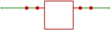  XTAL_XOUT XTAL_XIN  C3 C6  10pFX1 25MHz10pF  R1 1M  3  2  GND  1  4 |  |  |  |  |  |  |  |  |  |  |  |  |  | C
  Shenzhen Sipeed Techno. Co,Ltd. |  | Date: | 24-2-28
  SCH: | LicheeRV Nano 70415 | Rev: | 1.3
  Page: | GC2002-QFN88 | Id: | 2/ 4
D |  |  |  |  |  |  |  |  |  |  |  |  |  |  | D
1 |  | 2 |  | 3 |  |  | 4 |  |  | 5 |  |  |  | 6

1 |  | 2 | 3 |  | 4 | 5 |  | 6
A |   1 VSS  T厂  10  7  19  1  L1 2 2uH  11  VDD3V3_SYS  . R15  C76 C77 C78  o  C30 10uF  10uF 10uF 22uF  150K  14  6  3  L3 n 2.2uH20  33K  GND  VDD1V35_DRAM  ·  R12  4  5  12  13  L2 aaaa 2.2uH  C79 C75  GND  R16  15  17  16  9  22uF 10uF 43K  R13 33K  GND  VDD0V9_CPU  GND  - o o r  l C80 l C72 > R17 __ VSYS :  8  22uF 10uF 33K 2 VSYS  18  21  SW1  FB1  SW2  FB2  GND  GND  R1401· R14140.2K VDD3V3_SYS XC6206P182MR-MS VDD1V8_SYS  PWR PWM  3 VIN VOUT 2  2.2uF l U3  l i l C36 l C42  DNP  GND  U4 TMI7003C VSYS  3CH DCDC + LDO  GND 10uF 10uF  R14 W 56K- - FB3 i |  |  |   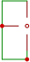  3 2  GND  RN1  RF1  VDD3V3_SYS  4  C48  1 C68 Pi0 · WL_BT_2 C69 C70  4G  100nF  NC  U13  44 BT CTS  43 BT RXD  42 BT TXD  41 BT RTX 40  1  GND  GND  GND  2  3  4  5  6  39  38  37  8  36  9  VDD3V3_SYS  VDD3V3_SYS  GND  10  11  33K WF PWR EN 兰  R53  12  GND  GND  13  33K SDIO1 D2 ×  R47  14  R48  33K SDIO1 D3  _  15  30  33K SDIO1 CMD  R49 R50  _  29  16  _  NC SDIO1 CLK  28  17  R51  33K SDIO1 D0  _  18  27  R52  33K SDIO1 D1  19  26  _  20  25  GND  VDD3V3_SYS  24 HOST_WAKE_WFR54 33K  21  VDD3V3_SYS Fn-Link N240 R54 = 33K  23  22  Pi2 Pi1  UART1_CTS  UART1_RX  UART1_TX  UART1_RTS NC  NC  NC  NC GND GPIOB6 NC GND NC GND  UART0 RX  Wi-Fi & BT  2.4G  GND AIC8800D-44Pin  10uF 10uF  7  UART0 TX PCM_SYNC  PCM_DIN  PCM_CLK  PCM_DOUT HOST_WAKE_WF GPIO_B4 |  |  |  |  |  | A
  VIN1
  VIN2
  VIN3
  GND
  GND
  GND
  GND
  GND
  GND
  GND NC
  SW3
  EN1
  EN2
  EN3 EP
  C46 | C47
  BT_CTS |  | GPIOA_19
  BT_RTX |  | GPIOA__18
  BT_TXD |  | GPIOA__29
  BT_RXD |  | GPIOA__28
  GND
  WL_BT_ANT GND
  NC
  GND
  HOST_WAKE_BT
  BT_WAKE_HOST
  NC
  VBAT
  USB DM
  USB DP WL_PWR
  WL_WAKE_HOST SDIO_DATA_2
  SDIO_DATA_3
  SDIO_DATA_CMD
  SDIO_DATA_CLK
  SDIO_DATA_0
  SDIO_DATA_1
  GND
  NC
  VDDIO
  WL BT 2 4G
  35
  34
  33
  32
  31
B |  |  |  |  |  |  |  |  |  | B
C |  |  |  |  |  |  |  |  |  | C
C |   EP  VSYS  PWM L4 -rrr-10uH  U14 AW9962EDNR  LCD0_BL-  BL  D1  C40  BL  o C35 6 4 。  R11  10K  2.2uF NIC FB 10uF/25V R19 R18  I  CTRL GND 10R 10R  LCD0_BL+  Backlight LED Driver  R = 200mV/20mA/N = 10Ω/N  GND |  |  |  |  |  |  |  |  | C
  Backlight LED (N) | BL (R18)
  1 Series | NC
  2 Series | 10Ω
  4 Series | 3.3Ω
C |  |  |  |   GND  GND  GND  GND  R6410K SYS_RSTN  VDD1V8_SYS  ' C63 l 2 1  100nF · ·iW2 i  PWR & User LED | BOOT & RESET KEY  VDD3V3_SYS  VDD3V3_SYS R25  4 3  SW1  LED2 R30 5. 1K  LED1 R28 5. 1K  10K BOOT KEY  _  v / 2 1  GPIOA 14  月 |  |  |  |  |  | C
D |  |  |  |  |  |  |  |  |  | D
D |  |  |  |  |  |  | Shenzhen Sipeed Techno. Co,Ltd. |  | Date: 24-2-28 | D
D |  |  |  |  |  |  | SCH: LicheeRV Nano 70415 |  | Rev: 1.3 | D
D |  |  |  |  |  |  | Page: Power/ SYS/ WiFi |  | Id: 3/ 4 | D
1 |  | 2 | 3 |  | 4 | 5 |  | 6

1 |  | 2 |  |  | 3 | 4 |  |  | 5 |  |  | 6 |  | A
A | 33  33  32  1002. 1163  32  LCD0_BL+  1 1  LCD0_BL+  2 2  LCD0_BL+  3 3  4 4  LCD0_BL-  5 5  LCD0_BL-  6 6  LCD0_BL-  7 7  LCD0_BL-  12  13 13  GND  14  14  15 15  16 16  GND  17  17  18 18  19 19  GND  20 20  22  24  26 26  29 29  30  3_SYS  31  3_SYS  VDD3V  MIPI_TX2_N  8 8  28 28  MIPI TX0 P  MIPI TX2 P  MIPI_TX1_N  MIPI TX1 P  23 23    DSI Interface  GND  FPC2  GND  GND  12  MIPI_TX0_N  21  21  22  GND  LCD0_RESET  24  25 25  GND  VDD1V  GND  VDD1V  VDD3V  8_SYS  27  27  GND  8_SYS |  | F PC3  23 23 24 24  MIPI RX4 N  1  GND  GND  GND  GND  GND  GND  GND  VDD3V3_SYS  2  3 MIPI_RX4_P 4  5  6 MIPI_RX3_P 7  8  9 MIPI_RX2_P 10  11  12 MIPI_RX1_P 13  14  15 MIPI_RX0_P 16  MIPI_RX3_N  MIPI RX2 N  MIPI RX1 N  MIPI_RX0_N  CAM_IO0  17 1.8V 18 CAM_IO1 1.8V 19  CAM SCL  20 1.8V  21 CAM SDA 1.8V  22  GND  GND  MIPI RX0 N R72 0R CAM IO1  CSI Interface  _ _ _  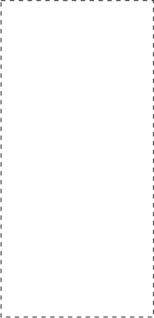 | Camera configuration description |  |  |  | 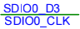 K 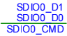NC4  U10  1  DAT2  SDIO0 D3  _  2 CD/DAT3  C53  3 CMD  13 13  4  12  VDD  SDIO0 CLK  5 CLK  12  11  _  6 VSS  11  10 10  7 DAT0  GND  SDIO0_D1  8 DAT1  GND  GND  SDIO0 D2 1 SDD2 VCC 8  GND  SD NAND （PU by SOC）  100nF  SDIO0 D0  SDIO0_D2  SDIO0 CMD  GND  VDD3V3_SYS  9 SWITCH    U9 VDD3V3_SYS |  | EN  INP  INN  GND  C56  _  33K  100nFR38  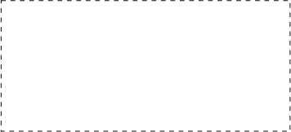  PA  VSYS U11  2.2uF  VDD3V3_SYS R36 10K  C55 100nFR37  33K  AUD OUT  C58  GND |  |  |  | A
  9
  10
  11
  30
  31
  9
  10
  11
  1
  2
  3
  4
  5
  6
  7
  8
  9
  10
  11
  12
  13
  14
  15
  16
  17
  18
  19
  20
  21
  22
  Camare + FPC | CAM_IO0 | CAM_IO1
  Sipeed GC4653 + 70416 FPC | RESET | MCLK(connect to MIPI  0N with R72 by default)
  Sipeed OS04A10 + same direction FPC | RESET | NC
  Raspberry Pi camera (level matching required) | Power EN | LED Indicator
  AVDD
  PVDD
  VOP
  VON
  GND
B |  |  |  |  |  |  |  |  |  |  |  |  |  | B
 |  |  |  |  |  |  |  |  |  | _  MIC VDD3V3_SYS  U12  AUD IN C57  C59 100nF  2.2uF 1 4  2 GND GND 3  GND |  |  |  | B
B |  |  |  | 10  _ _ _  EPHY CON T N 2  EPHY CON R P 3 4  5  GND  EPHY CON R N 6  7  GND  8  _ _ _  _ _  _ _  _ _  9    10/100M PHY  RJ1 EPHY CON T P 1  U7 EPHY CON T P 1  4  GND  2 GND  3 EPHY CON T N  _ _ _  3 GND  EPHY CON R P U8  2  EPHY CON R N  GND 1  4  100nF1 L5 2 EPHY CON T N  EPHY TX NC49  _ _ _  100nF4 3 EPHY CON T P  EPHY TX PC50  100nF L6 EPHY CON R N  EPHY RX NC51  _ _ _  4 3  100nF EPHY CON R P  EPHY RX PC52  1 2 |  |  |  |  |  |  |  |  |  | B
 |  |  |  |  |  |  |  | VBUS  VSYS  GPIOA 27  GPIOA 22  _  GPIOA 18  _  _  _  _  SDIO1 D3  _  _  SDIO1 D0  _  _  _  _    Pin  ADC_PIN R610K ADC1 R10 5.1K  GND  GPIOA 17  GPIOA 19  J15 J16 J17 J18 J19 J20 J21 J22 J23 J24 J25 J26 J27 J28  R6910K GPIOA_29  J1 J2 J3 J4 J5 J6 J7 J8 J9 J10 J11 J12 J13 J14  GPIOA_16  GPIOA 15  VDD3V3_SYS  VDD3V3_SYS  VDD3V3_SYS  VDD3V3_SYS  VDD3V3_SYS  VDD3V3_SYS  GPIOA 29  GND  GND  R6810K GPIOA_28  VO P VO N  ADC PIN  R6310K GPIOA_19  GPIOA 28  GPIOA 24  GPIOA_23  GPIOA_25  GPIOA_26  R6210K GPIOA_18  SDIO1 D2  R4010K GPIOA_17  SDIO1 CMD  SDIO1 CLK  R3910K GPIOA_16  SDIO1 D1  GPIOA_14  VSYS  VBUS  VDD3V3_SYS  HOST WAKE WF R580R GPIOA 26  WF_PWR_EN R600R  R65 0R  Fn-Link N240 R58 = 0R |  |  |  |  |  | B
C |  |  |  |  |  |  |  |  |  |  |  |  |  | C
C | GND  Touch Interface USB TypeC  VDD1V8_SYS  USB1  R32 R31 VBUS VBUS  5. 1K 5. 1K FPC1 C25 C26 USB_D_N D+ 1  CAM_SCL 1 10uF 10uF USB_D_N D+ 2  7 7 8 8  D-  VDD3G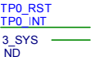 GPOA_16 1  GND 5. 1K GND  GND GND |  |  |  |  |  |  |  |  |  |  |  |  | C
C | CSI D3  MIPI RX 2  CSI D2  CSI D0  CSI CLK  MIPI RX 1  LED  CSI CLK  CSI D0  CSI CLK  MIPI RX 0  LicheRV Nano  CSI D1  CSI D0  MIPI RX 3  Power EN  RST  IO0  NC  IO1（Connect R0N）  RST  MCLK  CSI D1  RPi 2lan Camera  Sipeed GC4653  MIPI RX 4  Sipeed OS04A10  CSI D1 |  |  |  |  |  |  |  |  |  |  |  |  | C
  LicheRV Nano | Sipeed GC4653 | Sipeed OS04A10 | RPi 2lan Camera
  MIPI RX 4 |  | CSI D3 | CSI D0
  MIPI RX 3 |  | CSI D1 | CSI D1
  MIPI RX 2 | CSI CLK | CSI CLK | CSI CLK
  MIPI RX 1 | CSI D0 | CSI D0
  MIPI RX 0 | CSI D1 | CSI D2
  IO0（Connect R4N） | MCLK | RST | Power EN
  IO1 | RST | NC | LED
D |  |  |  |  |  |  |  |  |  |  |  |  |  | D
D | 70405 Camera Interface 70415 Camera Interface |  |  |  |  |  |  |  |  |  |  |  |  | D
D |  |  |  |  |  |  |  |  |  |  | Shenzhen Sipeed Techno. Co,Ltd. |  | Date: 24-2-28 | D
D |  |  |  |  |  |  |  |  |  |  | SCH: LicheeRV Nano 70415 |  | Rev: 1.3 | D
D |  |  |  |  |  |  |  |  |  |  | Page: Interface |  | Id: 4/ 4 | D
1 |  | 2 |  |  | 3 | 4 |  |  | 5 |  |  | 6 |  | D

