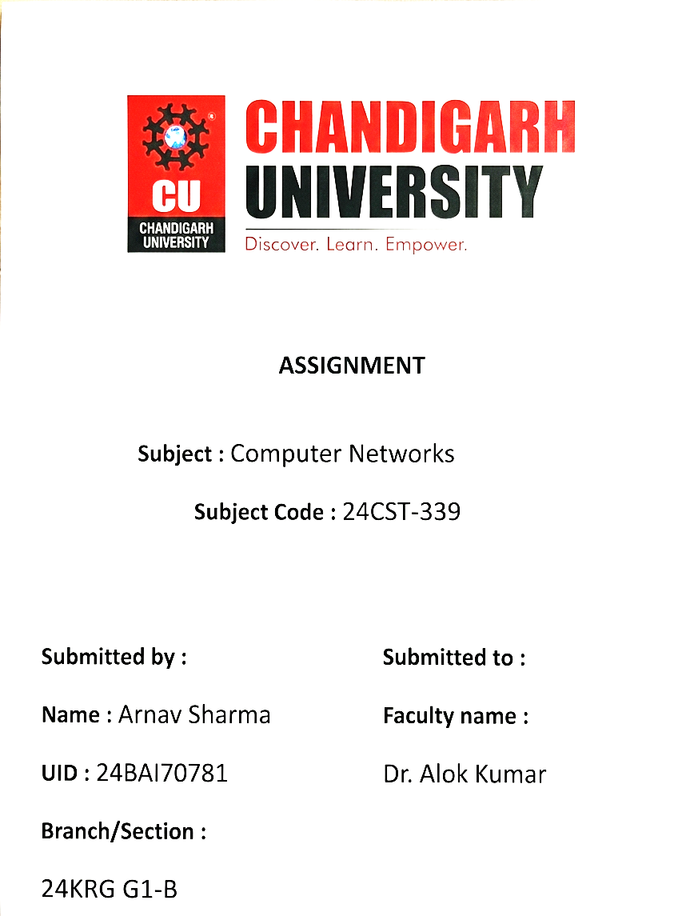

CN ASSIGNMENT - ODD
Name : Arnav Sharma | Subject : Computer Network
Class : 24 KRG – G1-B | UID – 24BAI70781

Q1. Develop Static Routing with 4 routers, 4 Switches & 8 PC's. Make sure to highlight the Networks with their network ID's. IP Addresses should be Written in text format as well. (6 M)
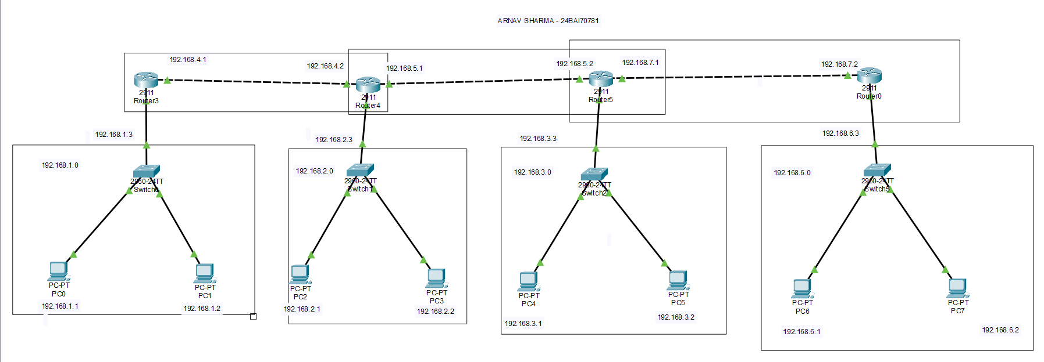
Q2. What is OSI model? What are the different layers of OSI model?
Write the functionality, Data format and Protocols used at each layer. (3 M)
The OSI (Open Systems Interconnection) Model is a reference model developed by the International Organization for Standardization (ISO). It defines how data is transmitted between two devices over a network. The OSI model consists of seven layers, and each layer performs a specific function.
1. Physical Layer:
It is responsible for transmitting raw binary data (0s and 1s) through the physical medium such as cables and wireless signals.
Data Format: Bits
Protocols/Standards: Ethernet, USB, DSL.
2. Data Link Layer:
It provides reliable node-to-node data transfer. It is responsible for framing, MAC addressing and error detection.
Data Format: Frame
Protocols: Ethernet, PPP, Wi-Fi (802.11).
3. Network Layer:
It is responsible for logical addressing and routing packets from the source to the destination across different networks.
Data Format: Packet
Protocols: IP, ICMP, OSPF.
4. Transport Layer:
It provides end-to-end communication, flow control and error control. It can provide reliable or unreliable data delivery.
Data Format: Segment (TCP) / Datagram (UDP)
Protocols: TCP, UDP.
5. Session Layer:
It establishes, manages and terminates communication sessions between applications.
Data Format: Data
Protocols: NetBIOS, RPC.
6. Presentation Layer:
It is responsible for data translation, encryption/decryption and data compression so that different systems can understand the data.
Data Format: Data
Protocols/Standards: SSL/TLS, JPEG, MPEG.
7. Application Layer:
It provides network services directly to end-user applications such as web browsing, file transfer and email.
Data Format: Data
Protocols: HTTP, HTTPS, FTP, SMTP, DNS.
The seven layers of the OSI model are:
Application → Presentation → Session → Transport → Network → Data Link → Physical

Q3. What are the different Error Detection methods, Explain each with the help of proper examples. (3 M)
Error detection methods are techniques used in computer networks to detect whether the data received by the receiver is corrupted during transmission. The main error detection methods are:
1. Parity Check:
A parity bit is added to the data to make the number of 1s either even or odd.
- In even parity, the total number of 1s must be even.
- In odd parity, the total number of 1s must be odd.
Example:
Data = 1011001 → Number of 1s = 4 (even)
For even parity, parity bit = 0
Transmitted data = 10110010
If the receiver gets an odd number of 1s, it detects that an error has occurred.
2. Checksum:
In this method, the sender divides the data into fixed-size blocks and adds them using binary addition. The complement of the sum is sent as the checksum along with the data. The receiver performs the same calculation to detect errors.
Example:
Suppose two 4-bit data blocks are:
1010 + 1100 = 10110
Taking the required 4-bit sum and its complement gives the checksum. The receiver uses this checksum to verify whether the received data is correct.
3. Cyclic Redundancy Check (CRC):
CRC uses binary division to detect errors. The sender divides the data by a predefined generator polynomial and appends the remainder (CRC) to the data. The receiver performs the same division. If the remainder is zero, the data is considered error-free.
Example:
Data = 1101
Generator = 1011
The sender performs modulo-2 binary division and obtains a remainder. This remainder is appended to the original data before transmission. At the receiver, if the division gives a non-zero remainder, an error is detected.
Thus, Parity Check, Checksum and CRC are commonly used error detection methods in computer networks.

