Q1
SELECT d.dept_name,
e.emp_name,
e.salary
FROM employee e
JOIN department d
ON e.dept_id = d.dept_id
WHERE e.salary > (
SELECT AVG(e2.salary)
FROM employee e2
WHERE e2.dept_id = e.dept_id
)
AND e.dept_id IN (
SELECT dept_id
FROM employee
GROUP BY dept_id
HAVING COUNT(*) >= 3
);

OUTUPT ->
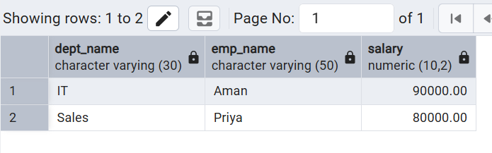

Q2
CREATE OR REPLACE FUNCTION log_customer_changes()
RETURNS TRIGGER
AS $$
BEGIN

IF TG_OP = 'INSERT' THEN

INSERT INTO customer_audit
(customer_id, customer_name, action, action_time)
VALUES
(NEW.customer_id, NEW.customer_name, 'ADDED', CURRENT_TIMESTAMP);

ELSIF TG_OP = 'DELETE' THEN

INSERT INTO customer_audit
(customer_id, customer_name, action, action_time)
VALUES
(OLD.customer_id, OLD.customer_name, 'REMOVED', CURRENT_TIMESTAMP);

END IF;

RETURN NULL;

END;
$$ LANGUAGE plpgsql;

CREATE TRIGGER customer_audit_trigger
AFTER INSERT OR DELETE
ON bank_customer
FOR EACH ROW
EXECUTE FUNCTION log_customer_changes();

INSERT INTO bank_customer
VALUES (3, 'Aman', 60000);

DELETE FROM bank_customer
WHERE customer_id = 1;

SELECT * FROM customer_audit;

OUTPUT ->
