


Student Name: ARNAV SHARMA UID: 24BAI70781
Branch: AIT-CSE-AIML Section/Group: 24AIT_KRG1_B Semester: 5
Subject Name: ADBMS Subject Code: 24CSP-310

Question 1:
A company maintains customer information, product information, and sales order information in three separate tables: customer_master, product_catalog, and sales_orders.
The company wants to provide an order report to an external client. The report must contain the Order ID, Order Date, Customer Name, Product Name, and Final Amount.
For every order, first calculate the Gross Amount using:
Gross Amount = Unit Price × Quantity
Then calculate the Discount Amount using:
Discount Amount = Gross Amount × Discount Percentage / 100
Finally, calculate the Final Amount using:
Final Amount = Gross Amount − Discount Amount
Create a complex view using the three tables to generate this report. The view should expose only the required five columns and should not expose the customer's phone/email, product brand/unit price, or the order's quantity/discount percentage.
The company also wants to provide access to an external client. Create a PostgreSQL user named client_user and give this user only SELECT permission on the view. The client must not have direct access to the three original tables and must not be allowed to modify the view data.

Solution:
CREATE TABLE customer_master (
customer_id VARCHAR(5) PRIMARY KEY, full_name VARCHAR(50) NOT NULL,

city VARCHAR(30)
);

CREATE TABLE product_catalog (
product_id VARCHAR(5) PRIMARY KEY, product_name VARCHAR(50) NOT NULL, unit_price NUMERIC(10,2) NOT NULL
);

CREATE TABLE sales_orders (
order_id SERIAL PRIMARY KEY, product_id VARCHAR(5)
REFERENCES product_catalog(product_id),

quantity INT NOT NULL,

customer_id VARCHAR(5)
REFERENCES customer_master(customer_id),

discount_percent NUMERIC(5,2),

order_date DATE NOT NULL
);

INSERT INTO customer_master (customer_id, full_name, city) VALUES

('C1', 'Amit Sharma', 'Delhi'),
('C2', 'Priya Verma', 'Mumbai'),
('C3', 'Ravi Kumar', 'Bangalore'),
('C4', 'Neha Singh', 'Kolkata'),
('C5', 'Arjun Mehta', 'Hyderabad');

INSERT INTO product_catalog (product_id, product_name, unit_price) VALUES
('P1', 'Smartphone X100', 25000), ('P2', 'Laptop Pro 15', 65000),
('P3', 'Wireless Earbuds', 5000), ('P4', 'Smartwatch Fit', 30000),
('P5', 'Gaming Console', 45000);

INSERT INTO sales_orders
(product_id, quantity, customer_id, discount_percent, order_date) VALUES
('P1', 2, 'C1', 5, '2025-09-01'),
('P2', 1, 'C2', 10, '2025-09-02'),
('P3', 3, 'C3', 0, '2025-09-03'),
('P4', 1, 'C4', 8, '2025-09-04'),
('P5', 1, 'C5', 12, '2025-09-05'),
('P1', 1, 'C2', 5, '2025-09-06'),
('P3', 2, 'C1', 0, '2025-09-07');

--explain analyze

create or replace view vW_FINAL_AMOUNT_CALCULATION as
select o.order_id,o.order_date,c.full_name,p.product_name,
((p.unit_price*o.quantity)-((p.unit_price*o.quantity)*o.discount_percent/100)) as final_amount from sales_orders as o
join customer_master as c on o.customer_id = c.customer_id join product_catalog as p on p.product_id = o.product_id

select * from vW_FINAL_AMOUNT_CALCULATION;

create user CLIENT_123 PASSWORD '12345';

grant select on vW_FINAL_AMOUNT_CALCULATION to CLIENT_123
Output:
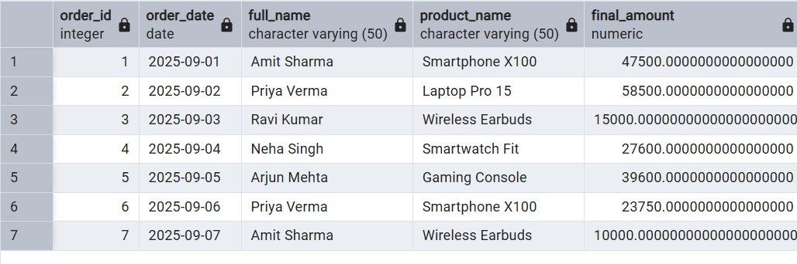

Question 2:
An e-commerce company wants to regularly analyze the performance of its product categories.
The company stores product, category, customer, and order information in separate tables. To generate the category performance report, the database needs to perform multiple JOINs, GROUP BY, aggregate functions, DISTINCT counting, calculated values, and CASE statements.
Since the same report is generated frequently, executing the complete analytical query every time can increase database workload.
Create a PostgreSQL Materialized View named: mv_category_sales
Also demonstrate that when new order data is inserted, the Materialized View does not automatically reflect the change and must be refreshed.
Finally, use EXPLAIN ANALYZE to compare the performance of the original analytical query with the Materialized View query.
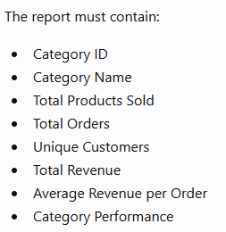
Solution:
CREATE TABLE category_master ( category_id VARCHAR(5) PRIMARY KEY, category_name VARCHAR(50) NOT NULL
);

CREATE TABLE product_master ( product_id VARCHAR(5) PRIMARY KEY,
product_name VARCHAR(50) NOT NULL, category_id VARCHAR(5)
REFERENCES category_master(category_id)
);

CREATE TABLE customer_master ( customer_id VARCHAR(5) PRIMARY KEY, customer_name VARCHAR(50) NOT NULL
);

CREATE TABLE order_details ( order_id VARCHAR(5) NOT NULL, customer_id VARCHAR(5)
REFERENCES customer_master(customer_id), product_id VARCHAR(5)
REFERENCES product_master(product_id), quantity INT NOT NULL,
unit_price NUMERIC(10,2) NOT NULL
);

INSERT INTO category_master (category_id, category_name) VALUES
('C1', 'Electronics'),
('C2', 'Clothing'),
('C3', 'Books');

INSERT INTO product_master (product_id, product_name, category_id) VALUES
('P101', 'Laptop', 'C1'),
('P102', 'Headphones', 'C1'),
('P201', 'Jacket', 'C2'),
('P202', 'Shoes', 'C2'),
('P301', 'SQL Book', 'C3');

INSERT INTO customer_master (customer_id, customer_name) VALUES
('U1', 'Aman'),
('U2', 'Priya'),
('U3', 'Rahul'),
('U4', 'Simran');

INSERT INTO order_details
(order_id, customer_id, product_id, quantity, unit_price) VALUES
('O101', 'U1', 'P101', 1, 5000),
('O102', 'U2', 'P102', 2(', 1000),
('O103', 'U1', 'P201', 1, 3000),
('O104', 'U3', 'P202', 2, 2000),
('O105', 'U4', 'P301', 3, 500),
('O106', 'U2', 'P101', 1, 5000),
('O107', 'U3', 'P201', 1, 3000),
O108', 'U4', 'P102', 1, 1000);

CREATE MATERIALIZED VIEW MV_CATEGORY_SALE AS
SELECT
c.category_id, c.category_name,

SUM(od.quantity) AS total_products_sold,

COUNT(DISTINCT od.order_id) AS total_orders,

COUNT(DISTINCT od.customer_id) AS unique_customers,

SUM(od.quantity * od.unit_price) AS total_revenue,

ROUND(
SUM(od.quantity * od.unit_price)
/ COUNT(DISTINCT od.order_id), 2
) AS avg_revenue_per_order,

CASE
WHEN SUM(od.quantity * od.unit_price) >= 10000 THEN 'Excellent'

WHEN SUM(od.quantity * od.unit_price) >= 6000 THEN 'Good'

WHEN SUM(od.quantity * od.unit_price) >= 3000 THEN 'Average'

ELSE 'Low'
END AS category_performance

FROM category_master c

JOIN product_master p
ON c.category_id = p.category_id

JOIN order_details od
ON p.product_id = od.product_id

GROUP BY
c.category_id,
c.category_name;

EXPLAIN ANALYZE
SELECT * FROM MV_CATEGORY_SALE;

--REFRESH MV
REFRESH MATERIALIZED VIEW MV_CATEGORY_SALE;
Output:
