


Student Name: ARNAV SHARMA UID: 24BAI70781
Branch: AIT-CSE-AIML Section/Group: 24AIT_KRG1_B Semester: 5
Subject Name: ADBMS Subject Code: 24CSP-310

Question 1 Question:
An organization stores employee details in the employee_info table. Create a PostgreSQL stored procedure that accepts an employee's gender as an input parameter and calculates the total number of employees belonging to that gender. The calculated count should be returned through an OUT parameter and displayed using RAISE NOTICE.
Solution:
CREATE OR REPLACE PROCEDURE sp_proc(
IN p_gender VARCHAR, OUT p_tot_cnt INT
)
LANGUAGE plpgsql AS $$

BEGIN
SELECT COUNT(*)
INTO p_tot_cnt FROM employee_info
WHERE gender = p_gender;

RAISE NOTICE 'Total count of % is %', p_gender, p_tot_cnt;

END;

$$;
Calling the procedure:
CALL sp_proc('Male', NULL);
The procedure counts all employees whose gender is Male, returns the count through p_tot_cnt, and displays it using RAISE NOTICE.
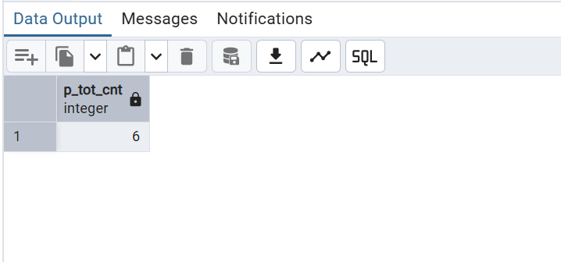

Question 2 Question:
An e-commerce company maintains product stock information in the products table and completed orders in the sales table. Create a PostgreSQL stored procedure that accepts a product name and required quantity as input parameters and processes the purchase only when sufficient stock is available. The procedure should calculate the sale amount as:
Sale Price = Product Price × Quantity Ordered
If sufficient stock is unavailable, the procedure should not modify any data and should display an appropriate notification.
Solution:
CREATE OR REPLACE PROCEDURE buy_products( IN p_product_name VARCHAR,
IN p_quantity INT
)
LANGUAGE plpgsql AS $$

DECLARE

v_product_code VARCHAR(20); v_price FLOAT;
v_count INT; BEGIN

SELECT product_code, price, quantity_remaining INTO v_product_code, v_price, v_count
FROM products
WHERE product_name = p_product_name;

IF v_count >= p_quantity THEN

INSERT INTO sales
(order_date, product_code, quantity_ordered, sale_price) VALUES
(CURRENT_DATE,
v_product_code, p_quantity,
v_price * p_quantity);

UPDATE products
SET quantity_remaining = quantity_remaining - p_quantity, quantity_sold = quantity_sold + p_quantity
WHERE product_code = v_product_code;

RAISE NOTICE

'PRODUCT SOLD. Order placed successfully for % unit(s) of %.', p_quantity, p_product_name;

ELSE

RAISE NOTICE
'INSUFFICIENT QUANTITY. Order cannot be processed for % unit(s) of %.', p_quantity, p_product_name;

END IF;

END;
$$;
Calling the procedure:
CALL buy_products('Samsung Galaxy S23 Ultra', 3);
