Student Name: Arnav Sharma UID: 24BAI70781
Branch: AIT-CSE Section/Group: 24AIT_KRG-G2
Semester: 4
Subject Name: DBMS Subject Code: 24CSH-298

Experiment 6 – Design of a Parameterized PL/SQL Stored Procedure for Employee Count by Gender (CData, Toddle)

Aim
To design and implement a stored procedure that accepts gender as an input parameter and returns the total number of employees based on the gender passed, thereby demonstrating procedural programming and parameterized logic in PL/SQL.

Objective
• To understand the structure and components of a stored procedure.
• To implement IN and OUT parameters in PL/SQL procedures.
• To pass dynamic input values to stored procedures.
• To apply aggregate functions for data analysis.

Software Requirements
Database Management System:
• Oracle Database Express Edition (Oracle XE)
• PostgreSQL Database
Database Administration Tool / Client Tool:
• Oracle SQL Developer (for Oracle XE)
• pgAdmin (for PostgreSQL)

Problem Statement
Organizations often require flexible reporting mechanisms to analyze workforce distribution based on gender for compliance and internal analytics.

Practical / Experiment Steps
• Accepts gender as an input parameter
• Counts the total number of employees matching the given gender
• Returns the count as output
• Create and execute the procedure using dynamic input values

Procedure
1. Open Oracle SQL Developer or pgAdmin and connect to the database.
2. Create an employee table with required fields (emp_id, emp_name, gender, salary).
3. Insert sample records into the table.
4. Create a parameterized stored procedure that accepts gender as input.
5. Use COUNT() function inside the procedure to calculate employee count.
6. Execute the procedure by passing different gender values.
7. Display the output using appropriate statements.

Input / Output Details
Input:
Employee table:
• emp_id (Integer)
• emp_name (Varchar)
• gender (Varchar)
• salary (Numeric)
Parameter passed:
• Gender (Male/Female)

Step-wise Output
Step 1 – Create Employee Table
Step 2 – Insert Data into Employee Table
Step 3 – Create Stored Procedure
Step 4 – Execute Procedure with Input Parameter
Step 5 – Display Output (Employee Count)

Learning Outcome
• Understand the structure and components of a stored procedure.
• Implement IN and OUT parameters in PL/SQL procedures.
• Pass dynamic input values to stored procedures.
• Apply aggregate functions within procedures for data analysis.
• Develop reusable database logic for real-world business scenarios used in companies like CData and Toddle.

Creating the table
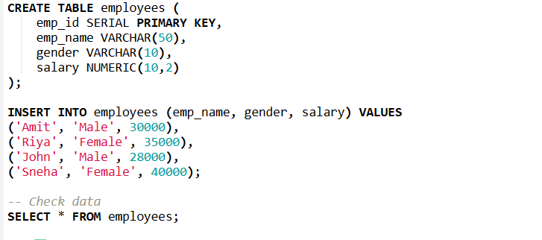
Procedure
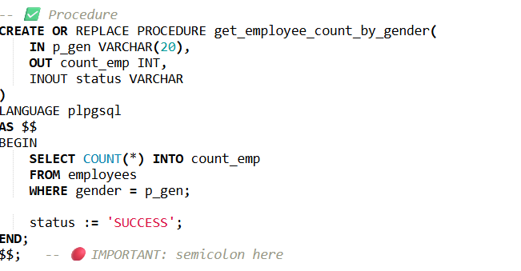
Calling
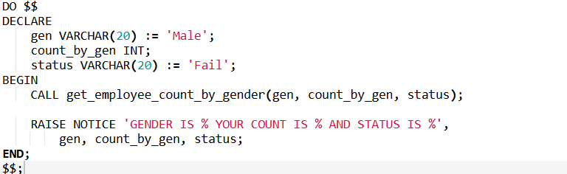
Output
