Pathology Foundation Model for Tumor Region Understanding
David Zhou, Eva Sun
?????????????????????????????????????????????????????????????????????????
?????????????????????MRI???????????????????????????????????????
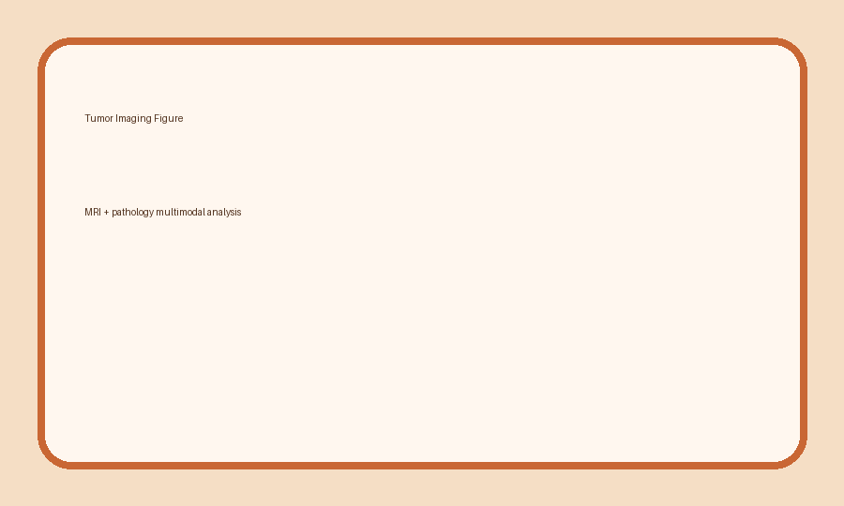
?1 ???????????????

