# Retrieving the source code from GitHub

1. Go to <https://github.com/13Thornes/Spring2024Sprint1Java>

1. Click on the green <> Code dropdown menu

1. Copy the https url that appears

# Cloning the GitHub repository in VSCode

1. Open a new window in VSCode.
2. Select the Source Control symbol in the menu on the left.

1. Select the clone repository option.
2. Paste the GitHub URL that you have previously copied into the address bar on top of the VSCode page.

1. Select Clone from URL.
2. Select which file you would like the code to be stored in on your local computer.

1. Choose Select as Repository Destination

1. Select Open.

# Running the Code in VSCode

1. Select the Explorer option on the left menu.

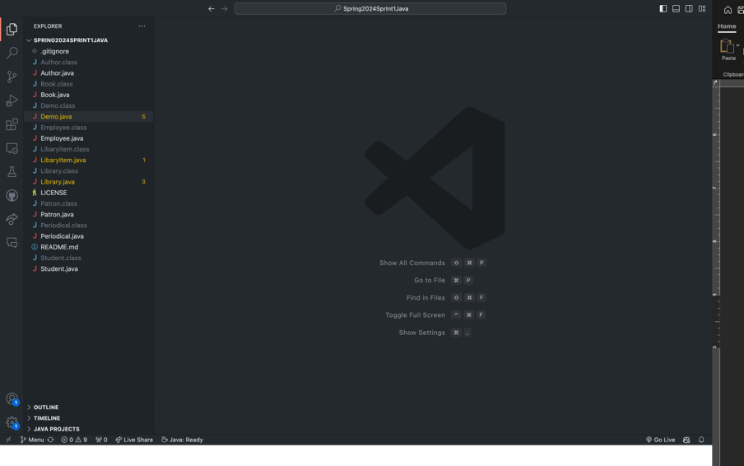

1. Select the Demo.java file from the side menu

1. Select the triangle play symbol in the upper right corner. This will open the terminal and run the program.

Congratulations! You have successfully deployed the Library app