# Library Application

## Index

Overview ……………………………………………………….……………………….……………………Page 2

Class Diagram ………………………………………………………………………………………………Page 3

Instructions ……………………………………………………………….…………………………………Page 3

Adding an Item …………………………………………………………..…………………………………Page 4

Adding a Patron …………..………………………………………………………………………Page 4

Adding a Library Item ……………………………………………………………………………Page 5

Editing an Item ………………………………………………………………………………………………Page 6

Editing a Library Item ……………………………………………………………………………Page 7

Editing a Patron ………………………………………………………………..…………………Page 8

Editing an Author …………………………………………………………………………………Page 9

Deleting an Item ……………………………………………………………………………………………Page 9

Deleting a Library Item …………………………………..……………………………………Page 10

Deleting a Patron ………………………………..……………..………………………………Page 11

Deleting an Author …………………………………………………………..…………………Page 12

Borrowing an Item …………………………………………………………………………..……………Page 12

Borrowing by ISBN ………………………………………………………………..……………Page 13

Borrowing by Author …………………………………………………………………..………Page 14

Borrowing by Title ……………………………………………….…………………..…………Page 15

Returning an Item ……………………………………………………………………………..…………Page 16

Exiting the Program …………………………………………………………………………..…………Page 16

## Overview

This application serves as an online library management system. To make it run smoothly, we have created Library, Library Item, Book, Periodical, Author, Patron, Student, Employee, and Demo classes.

* The library class serves as the master list of all Library Items, Patrons and Authors. Use this class to view and edit all the available data in the system.
* The library item class is the main building block for any book or periodical in the library. It’s also how you would borrow or return a library item.
* The book class is a subclass of the library item class. It contains extra information specifically relevant to books.
* The periodical class is a subclass of the library item class. It contains extra information specifically relevant to periodicals.
* The author class allows you to create and edit an author and keep track of each library item the author has written.
* The patron class is the main building block for any library customer. It stores their personal information and the library items they have borrowed.
* The student class is a subclass of the patron class. It stores information relevant to only the patrons who are students.
* The employee class is a subclass of the patron class. It stores information that is relevant only to library employees.
* The demo class is the library application's main menu. You use it to perform all the functions needed by the library management system.

# Class Diagram

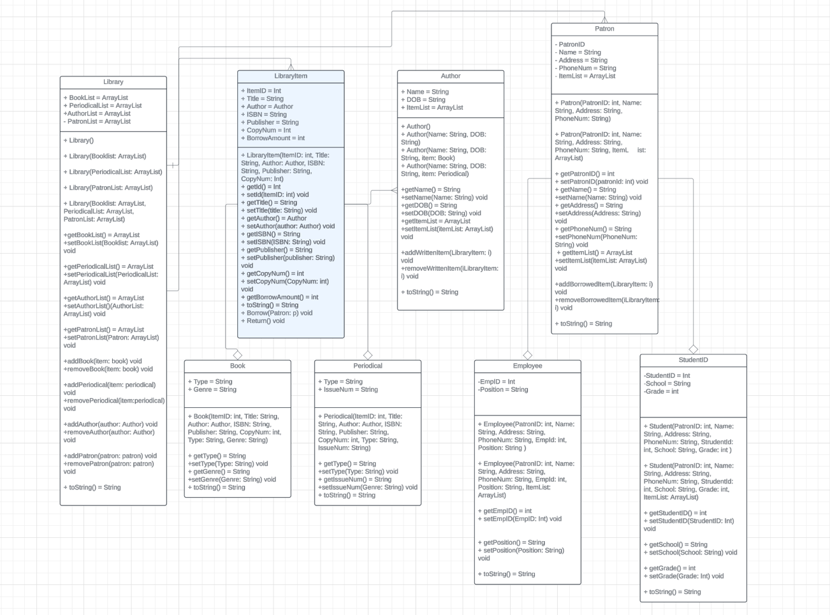

# Instructions

When you run the application’s code, the following menu will appear.

1. Add Library item
2. Edit Library Item
3. Delete Library Item
4. Borrow Library Item
5. Return Library Item
6. Exit

## Adding an item

* To add an item, type the number 1 in the terminal and press enter.
* You can use this feature to add a Library Item or Patron

### 1.1 Adding a Patron

1. Type P into the terminal and press enter
2. Type in the Patron ID and press enter
3. Type in the Patron’s name and press enter
4. Type in the Patron’s address and press enter
5. Type in the Patron’s phone number and press enter
6. Type in if the Patron is a Student (S) or Employee (E) and press enter
   1. For a student:
      1. Type in the Student ID and press enter
      2. Type in the Student’s school and press enter
      3. Type in the Student’s grade and press enter
   2. For an Employee:
      1. Type in the Patron ID and press enter
      2. Type in the Patron’s position and press enter
7. You have successfully added a patron into the library

### 1.2 Adding a Library Item

1. Type LB into the terminal and press enter
2. Type in B for a book or P for a periodical and press enter
3. Type in Y if the author is already in the system, or N for no and press enter
   1. If yes:
      1. Type in the Author’s name and press enter
   2. If no:
      1. Type in the Author’s full name and press enter
      2. Type in the Author’s date of birth and press enter
      3. The Author will be added to the library application
4. Type in the item ID and press enter
5. Type in the item title and press enter
6. Type in ISBN and press enter
7. Type in the publisher and press enter
8. Type in the number of copies and press enter
9. The next prompts depend on whether the item is a book or periodical
   1. For a book:
      1. Type in P for a printed book, E for an eBook or A for an audiobook and press enter
      2. Type in the book genre and press enter
   2. For a periodical:
      1. Type in P for a printed periodical or E for an electronic periodical and press enter
      2. Type in the issue number and press enter
10. You have officially added your library item

## Editing a Library Item

* Type in the number 2 and press enter to select edit Library Item
* You can edit a library item, patron or author

### Editing a Library item

1. Type in LB for and press enter
2. Type in B for book or P for Periodical and press enter
3. Type in the name of what you want to edit, and press enter
4. Type in the new ID and press enter
5. Type in the new title and press enter
6. Type in the new ISBN and press enter
7. Type in the new number of copies and press enter
8. You have successfully edited the library item

### Editing a Patron

1. Type in P for patron and press enter
2. Type in the patron ID and press enter
3. Type in the new patron ID and press enter
4. Type in the new name and press enter
5. Type in the new address and press enter
6. Type in the new phone number and press enter
7. You have now successfully edited a patron

### Editing an author

1. Type in A for author and press enter
2. Type in the author’s name and press enter
3. Type in the author’s new name and press enter
4. Type in the author’s new date of birth and press enter
5. You have successfully edited the author

## Deleting a Library Item

* Type in the number 2 and press enter to select edit Library Item
* You can edit a library item, patron or author

### Deleting a Library Item

1. Type in LB and press enter
2. Type in B for book or P for periodical and press enter
3. Type in the name of the item you want to remove, and press enter
4. You have successfully removed the item

### Deleting a Patron

1. Type in P and press enter
2. Type in the patron ID and press enter
3. You have successfully removed the patron

### Deleting an Author

1. Type in A and press enter
2. Type in the author’s name and press enter
3. You have successfully removed the author

## Borrowing a Library Item

* Type in the number 3 and press enter to select borrow Library Item
* You can borrow by searching by title, author or ISBN

### Borrowing by ISBN

1. Type in I and press enter
2. Type in B for book or P for Periodical and press enter
3. Type in the ISBN of the periodical and press enter
4. The periodical you wish to borrow will be displayed
5. Type in Y to confirm that your want to borrow this periodical and press enter
6. Type in Y if the patron is already in the system, N if they are not and press enter
   1. If patron is not in the system you will be prompted to follow the same steps as you would when creating a patron. Please see those instruction above
   2. If the patron is in the system, type in the patron ID and press enter
7. Type in the number of copies you wish to borrow and press enter
8. You have successfully borrowed an item

## Borrowing by Author

1. Type in A and press enter
2. Type in the author’s name and press enter
3. A list of items the author has written will be displayed
4. Type in the item title press enter
5. Type in Y if the patron is already in the system, N if they are not and press enter
   1. If patron is not in the system you will be prompted to follow the same steps as you would when creating a patron. Please see those instruction above
   2. If the patron is in the system, type in the patron ID and press enter
6. Type in the number of copies you wish to borrow and press enter
7. You have successfully borrowed an item

## Borrowing by Title

1. Type in T and press enter
2. Type in B for book or P for periodical and press enter
3. Type in the title of the item and press enter
4. The item you searched will be displayed
5. Type in yes to confirm this is the correct item, and press enter
6. Type in Y if the patron is already in the system, N if they are not and press enter
   1. If patron is not in the system you will be prompted to follow the same steps as you would when creating a patron. Please see those instruction above
   2. If the patron is in the system, type in the patron ID and press enter
7. Type in the number of copies you wish to borrow and press enter
8. You have successfully borrowed an item

## Returning an item

1. Type in the number 5 to return a library item and press enter
2. Type in the patron ID and press enter
3. A list of all items borrowed by the patron will appear
4. Type in the title of the item you would like to return, and press enter
5. Enter the number of copies you would like to return, and press enter
6. You have successfully returned a library item

## Exiting the Program

1. Type in 6 to exit the program and press enter
2. You have successfully exited the program