NAMES: 24239 MUPAGASI SAMUEL

23855 MUGISHA DONAT

24218 IRAKOZE Tresor Francois Xavier

23855 NSHUTI NTAGANDA Thierry

SOFTWARE ENGINEERING ASSIGNMENT

**A use case diagram** is a graphical representation of the different types of users that interact with a system, as well as the various use cases that these users can perform.

Example of a use case diagram:

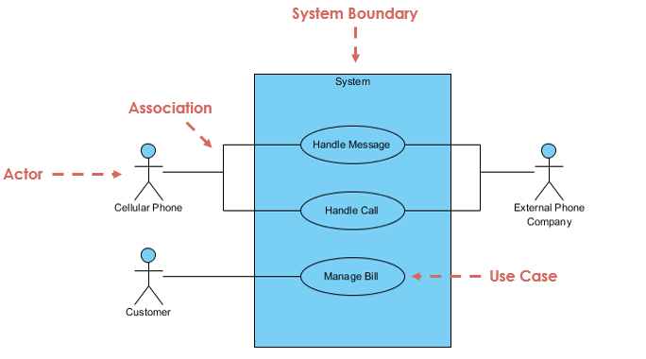

In this diagram, there are three types of users:

1. **External users**, who are the end users of the system

2. **Internal users**, who are the employees or staff who use the system to do their work

3. **System administrators,** who are responsible for managing the system.

**A class diagram** is a graphical representation of the static structure of a system. It shows the relationships between classes, objects, and attributes.

**Example of a class diagram**

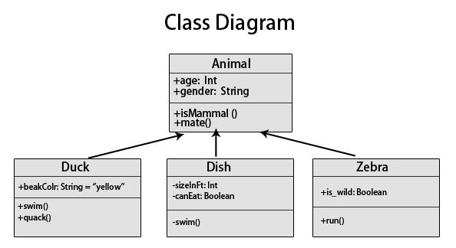

**Sequence diagram:**

A sequence diagram is a graphical representation of the sequence of events that occur in a system. It shows the order in which these events take place and the relationships between them.

**Example of a sequence diagram**