**HL2011: Exercise Set 4**  
Basic Imaging

Carlos Mata

**Q1.** Considering the values of kmax and dk, for obtaining ks; **8** excitations are needed to achieve the k-space sampling.

kmax = 0.5

dk = 0.1250

ks = [-0.500, -0.375, -0.250, -0.125, 0, 0.125, 0.250, 0.375]

**Q2.**

**Q3.** For the amplitudes of the phase encoding gradient the following equation was used:

$Gpexs\left(n\right)=\frac{ks\left(n\right)}{\left(gammabar∗tau\right)}$

Gpexs = [-0.2936, -0.2202, -0.1468, -0.0734, 0, 0.0734, 0.1468, 0.2202] * 1e-5

**Q4.** For the amplitude of the frequency encoding gradient, the following equation was used:

$Gfey1=\frac{−kmax}{gammbar∗tau}=−2.94e-6$

$Gfey2=\frac{kmax}{gammbar∗tau}=2.94e-6$

**Q5.** For finding the required sampling interval $Δt$ the following equation was used:

$dt=\frac{dk}{gammabar∗\left|Gfey\left(1,2\right)\right|}=1ms$

Finally the following images was obtained at:

iv = disc(3,1);

dw = 1;

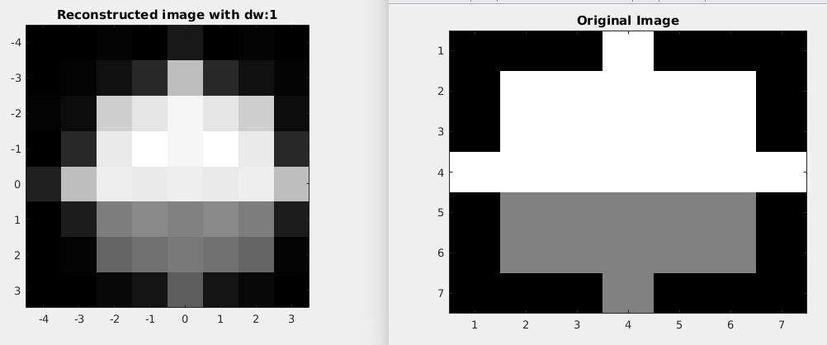

Improving the resolution:

iv = disc(3,0.5)

dw=0.5;

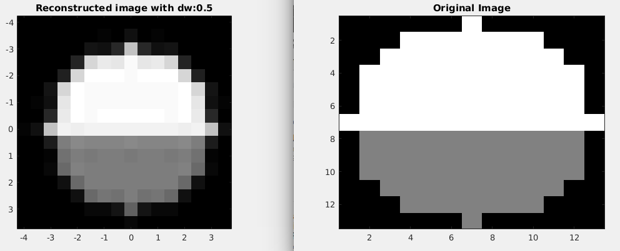iv =

disc(3,0.1)

dw=0.1;

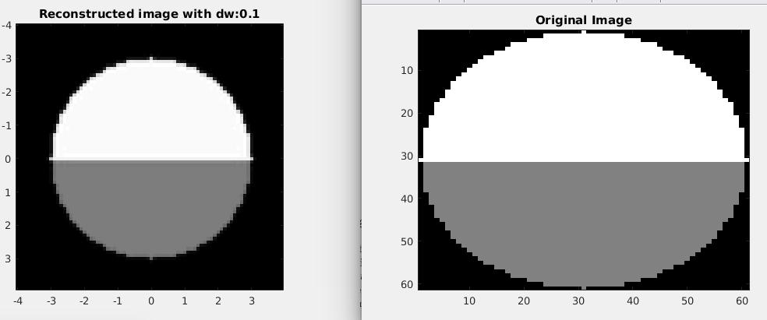

**Brain Imaging**

Using the function **brain_4mm_pixel**

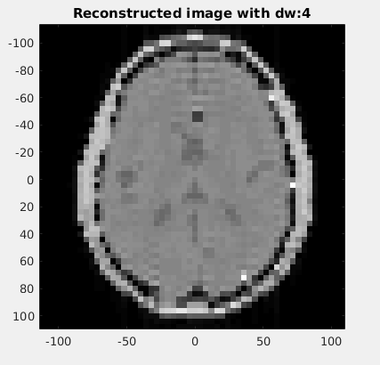

Using the function **brain_2mm_pixel**

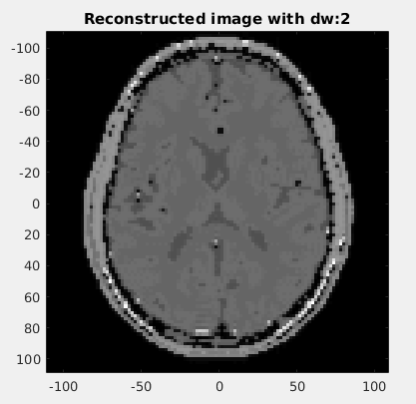

**Code:**

**%% Simulation Exercise number4**

addpath 'seemri'

clear all

close all

%% Preparations

gammabar = 42.58e6;

gamma = 2*pi*gammabar;

%% Basic Gradient Echo Imaging

res = 1;

B0 = 1.5;

tp = 1e-3;

alpha = pi/2;

B1 = alpha / (gamma*tp);

f_rf = gammabar*B0;

rf = RectPulse(B1, f_rf, 0, tp);

iv = disc(3,res);

TE = 10e-3;

TR = 2;

tau = 4e-3;

FOV= 1; %Changed to 220 when using brain* functions

dw = res;

kmax = 1/(2*dw);

dk = 1/FOV;

dk = kmax/ceil(kmax/dk);

ks = -kmax:dk:kmax-dk;

w = gamma*B0;

Gpexs = ks/(gammabar*tau);

gx = Gradient([tp tp+tau], {Gpexs 0});

Gfey1 = -kmax/(gammabar*tau);

Gfey2 = kmax/(gammabar*tau);

gy = Gradient([tp tp+tau TE-tau TE+tau], [Gfey1 0 Gfey2 0]);

%%

dt = dk/(gammabar*Gfey2);

adc = ADC(TE-tau, TE+tau, dt);

[S,ts] = seemri(iv,B0,rf,gx,gy,adc,TR,length(Gpexs),'Plot',false);

%[S1,ts1] = brain_4mm_pixel(B0,rf,gx,gy,adc,TR,length(Gpexs));

%[S1,ts1] = brain_2mm_pixel(B0,rf,gx,gy,adc,TR,length(Gpexs));

%%

figure

mrireconstruct(S,kmax,'Plot',true);

%mrireconstruct(S1,kmax,'Plot',true);

title(['Reconstructed image with dw:',num2str(dw)]);

%% Comment this section if using the brain* functions

figure

imagesc(reshape(iv.Mz0,sqrt(size(iv.Mz0,2)),sqrt(size(iv.Mz0,2))));

title('Original Image');

colormap gray