fStep1: create 2 ec2 instamce with name master and node
Fork this https://github.com/akshu20791/apachewebsite

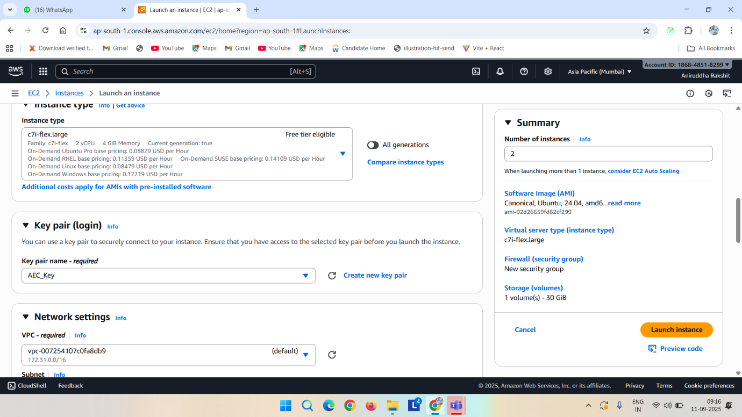

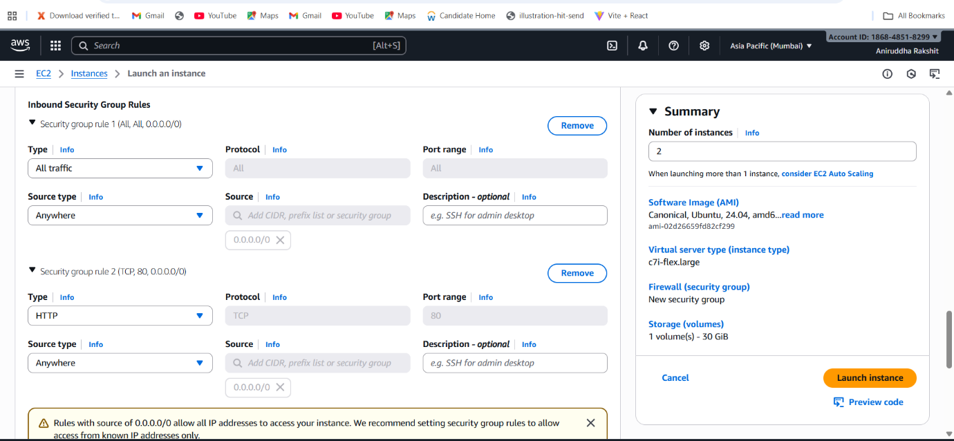

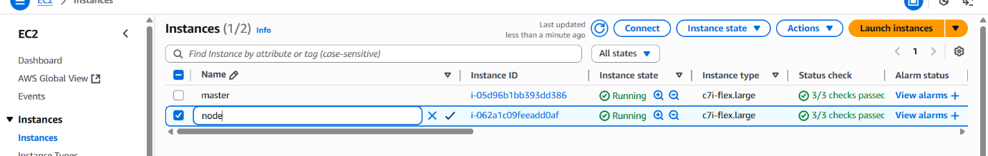

Now Connect it
And do the basic opearation in master and node
Sudo su
Apt update

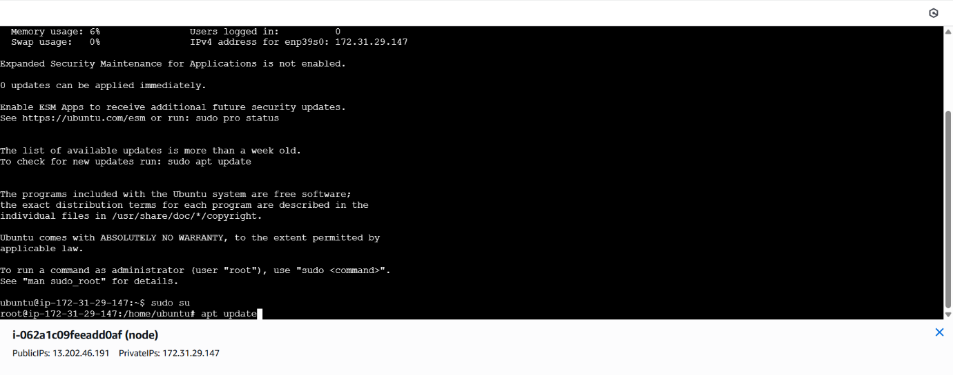

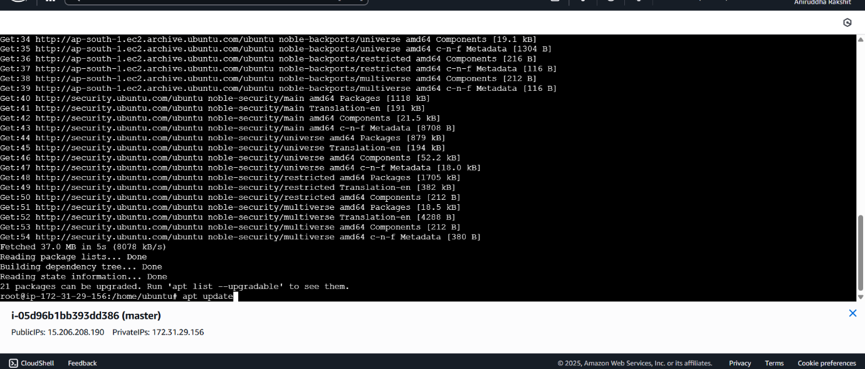
Now install
- Docker (master machine)
- Kubernates
- Jenkins (master machine)
- Ansible
apt install docker.io -y

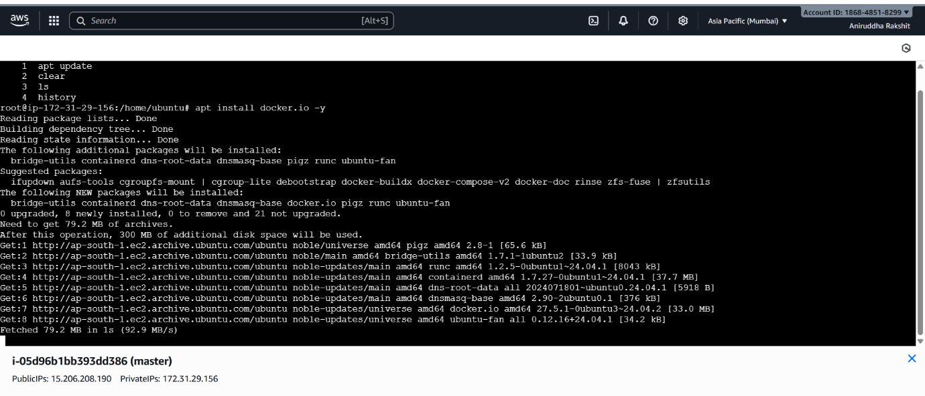
Now for jenkins
wget https://raw.githubusercontent.com/RaksAniruddha/Deployment-script/refs/heads/main/jenkins.sh
ls
chmod +x jenkins.sh
ls
./jenkins.sh

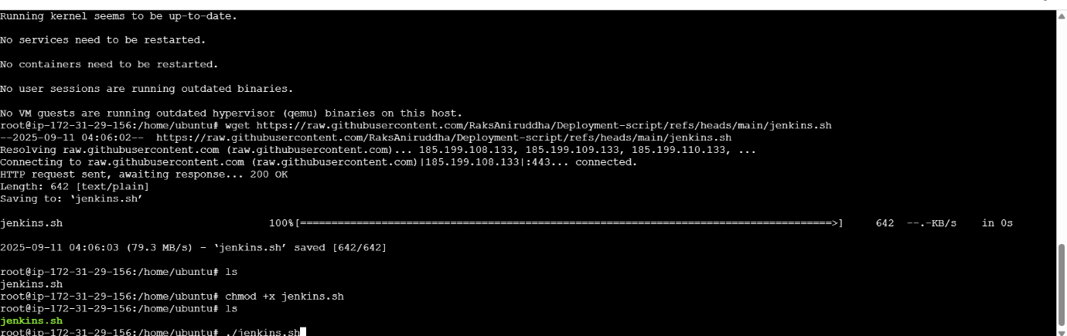

<your_master_machine_public_ip>:8080 paste it on browser

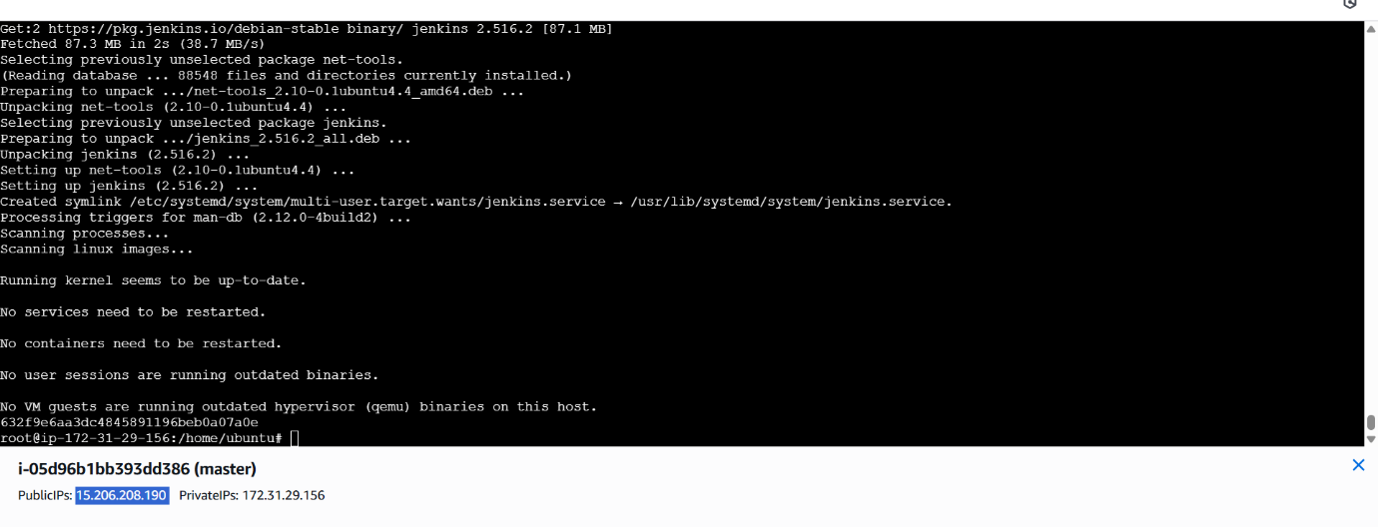

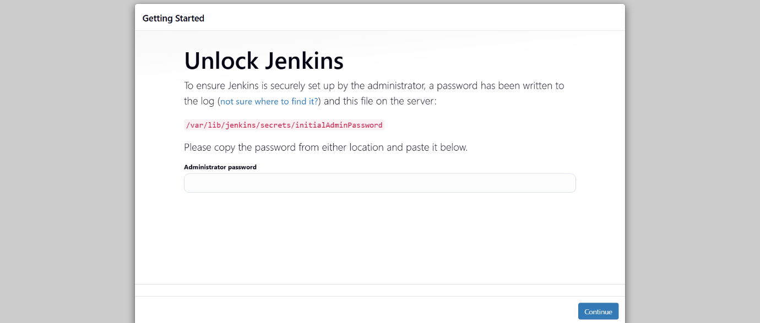
Cat /var/lib/jenkins/secrets/initialAdminPassword
Copy the password and paste it -> install suggested plugin -> set credential

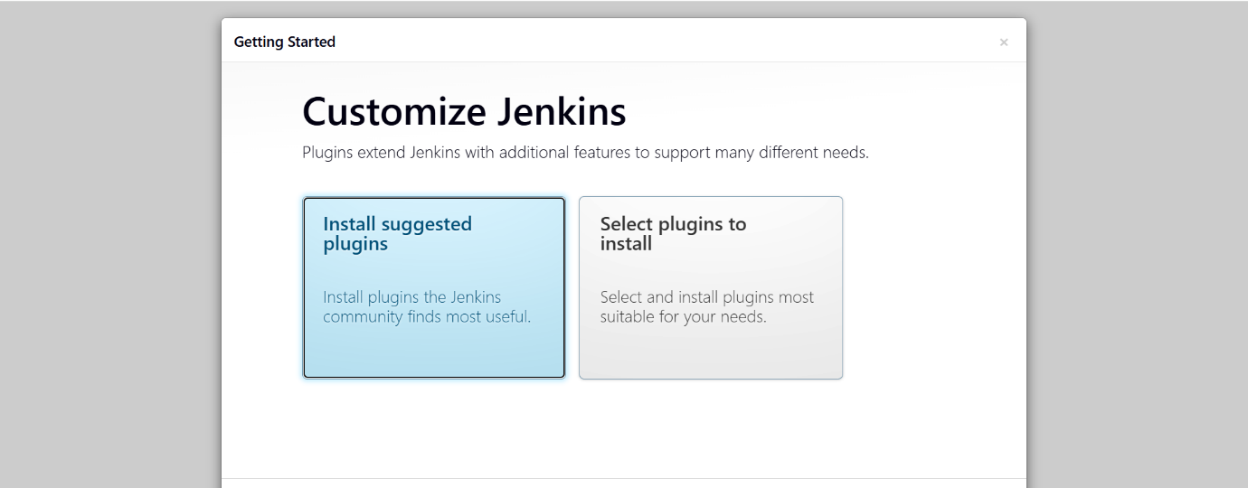

I am giving all as admin
Save and continue -> start jenkins

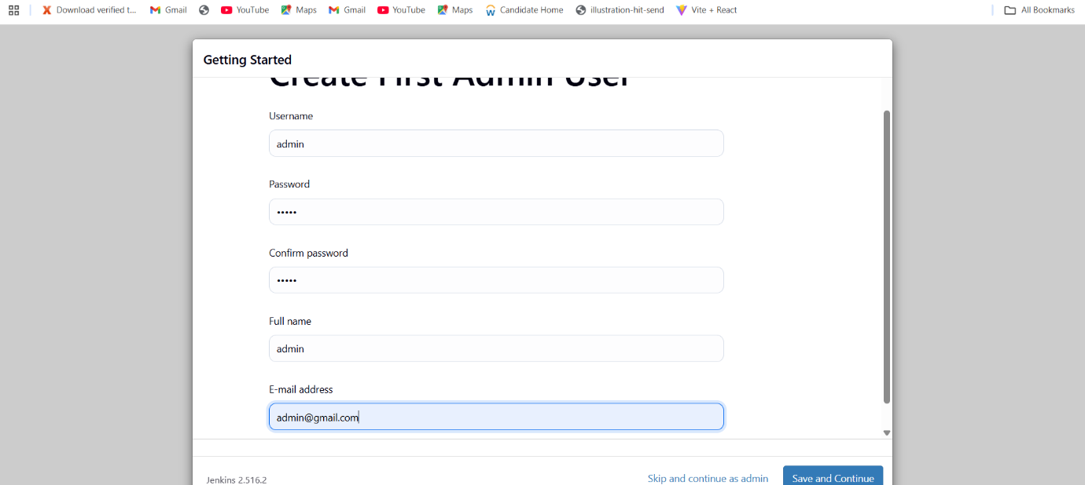

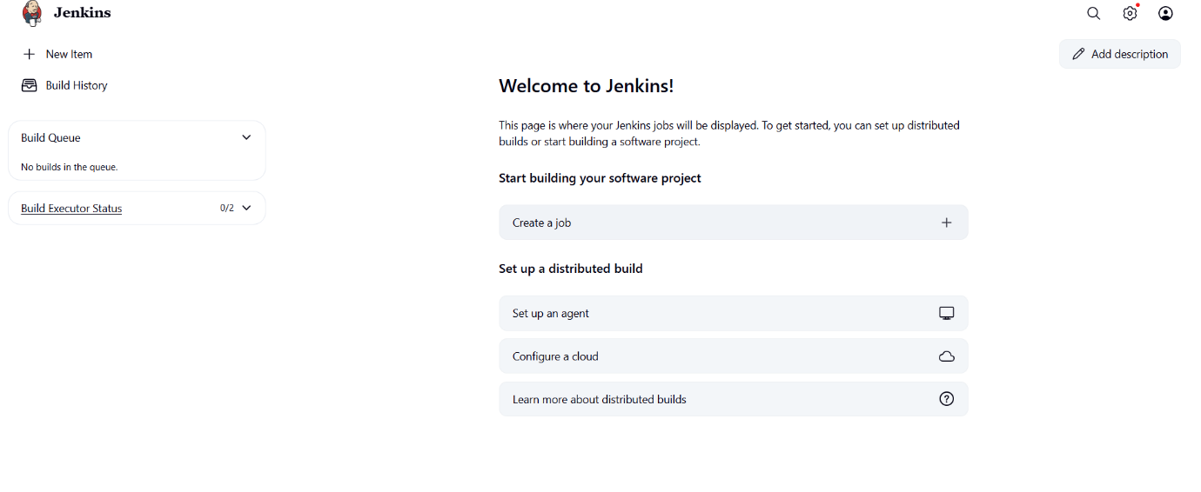

Now install kubernates
https://github.com/akshu20791/Deployment-script/blob/main/k8s-latest-updates

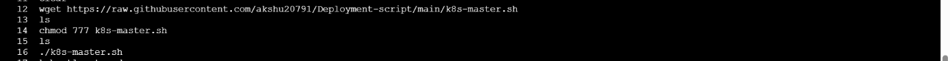

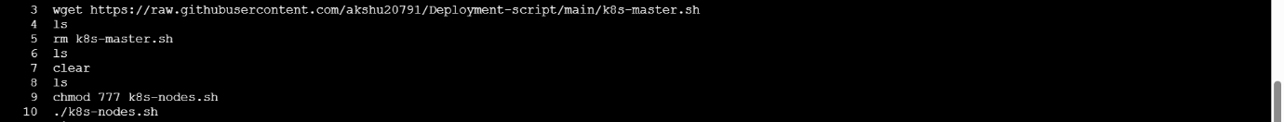

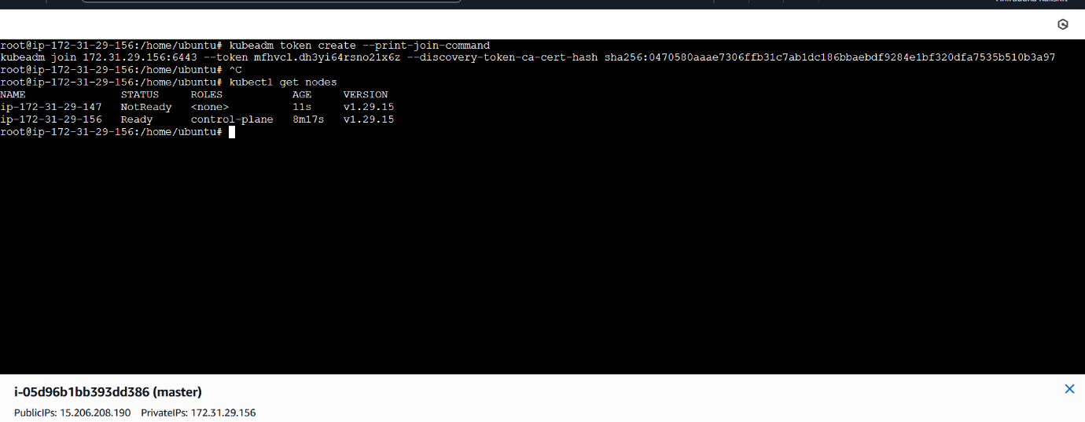

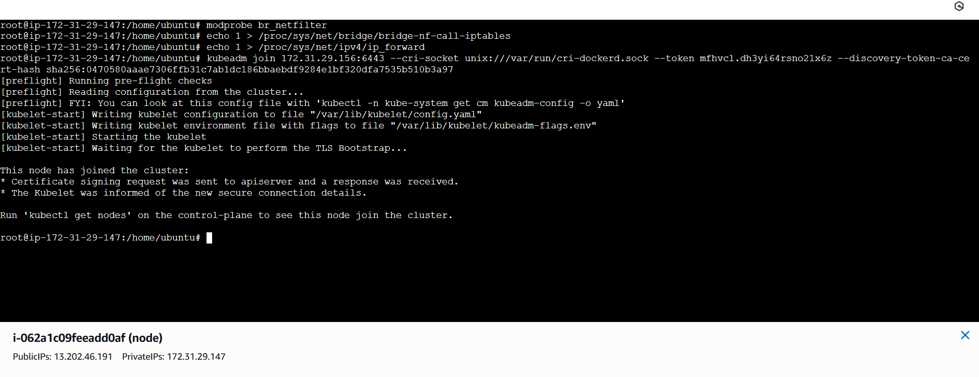

Now install ansible
Do this basic operation
apt update
apt-get install software-properties-common
apt-add-repository ppa:ansible/ansible
apt-get update
apt-get install -y ansible

vi /etc/ansible/hosts

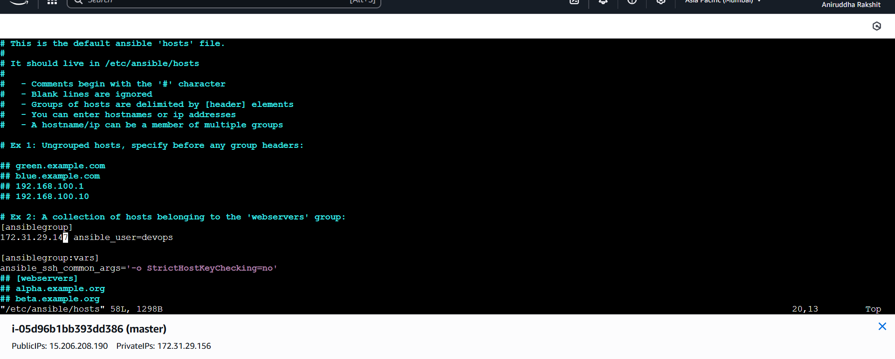
Copy the content and make a inventory.ini file on forked repository and paste it
[ansiblegroup]
<privateipofnode> ansible_user=devops

[ansiblegroup:vars]
ansible_ssh_common_args='-o StrictHostKeyChecking=no'

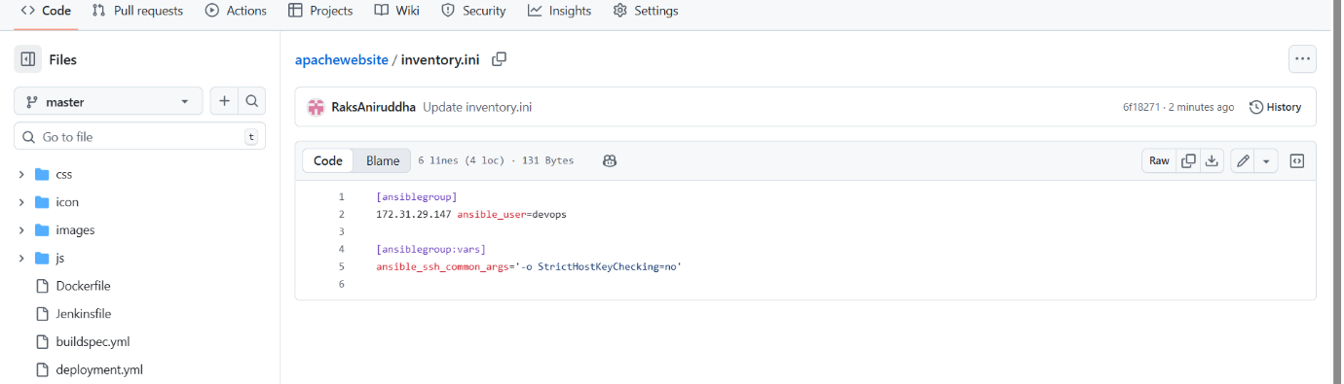

Visudo
vi /etc/ssh/sshd_config
vi /etc/ssh/sshd_config.d/60-cloudimg-settings.conf
service ssh restart

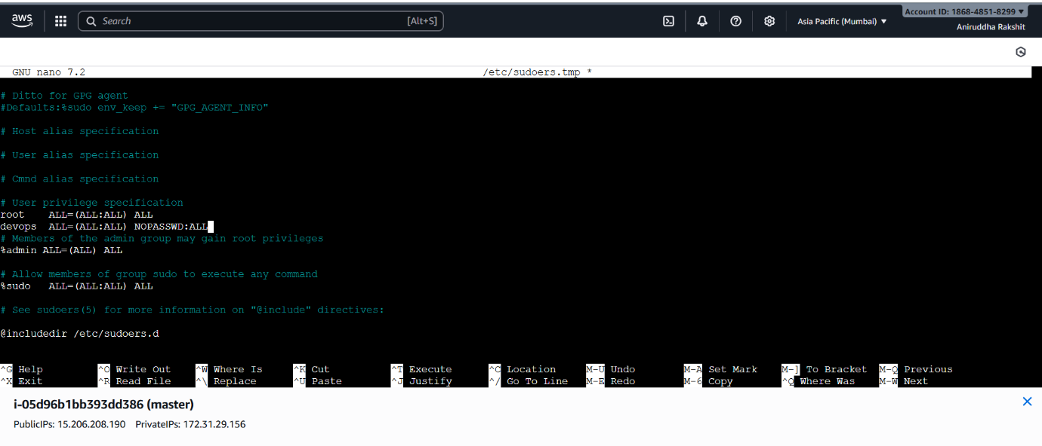
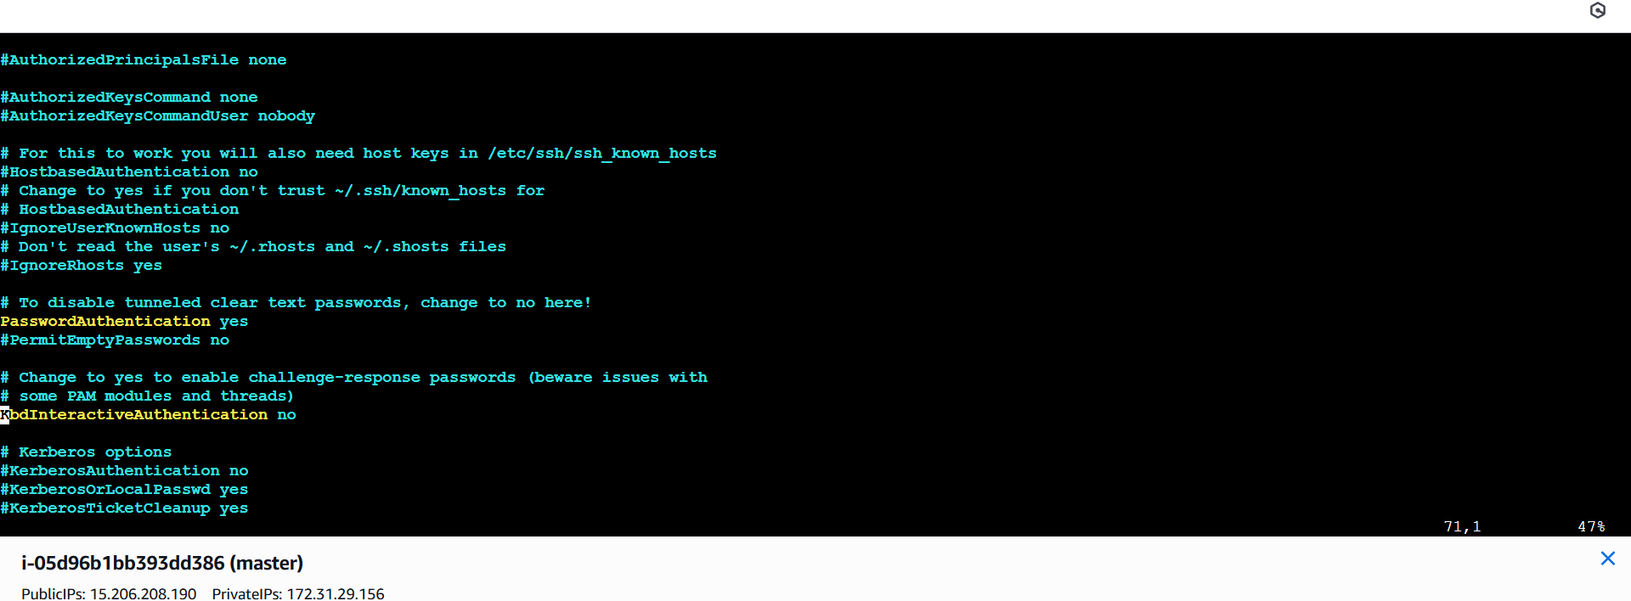

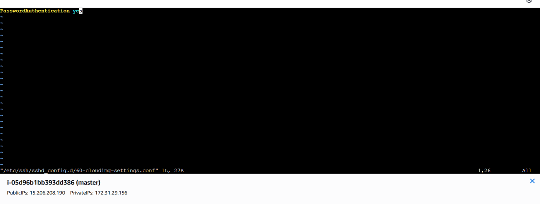

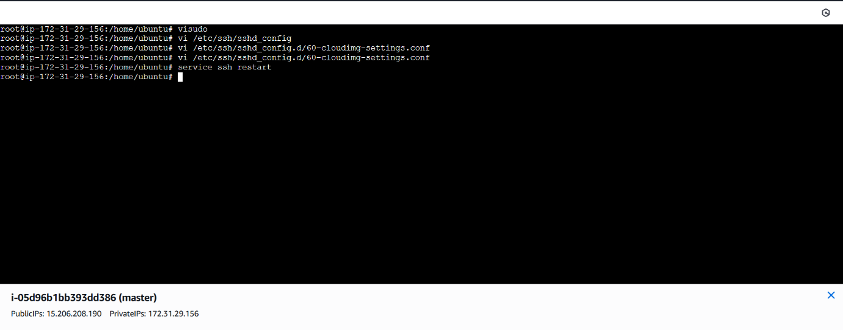

Adduser devops
Su – devops
Ssh -keygen

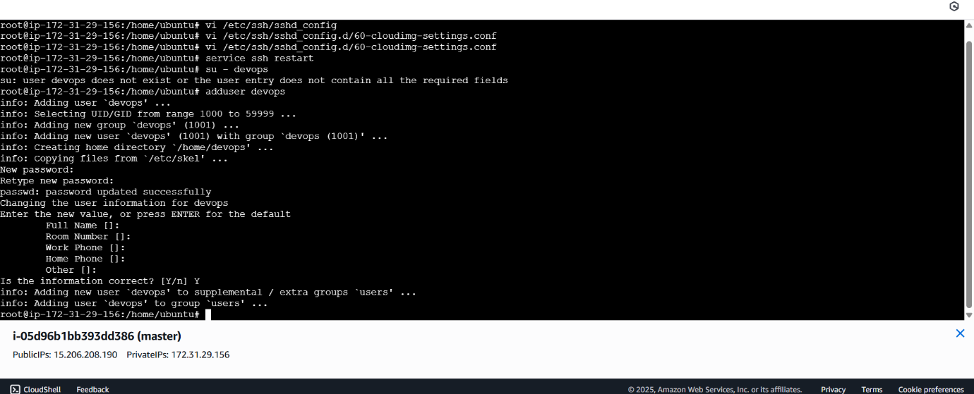

Ls -a
Cd .ssh
Ssh-copy-id devops@<private_ip_of_node2>

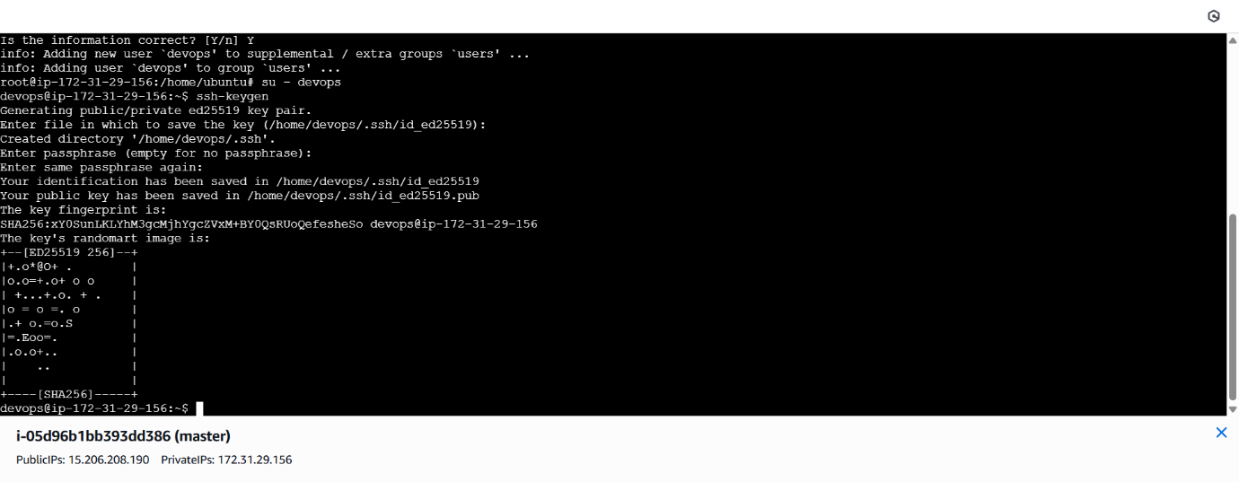

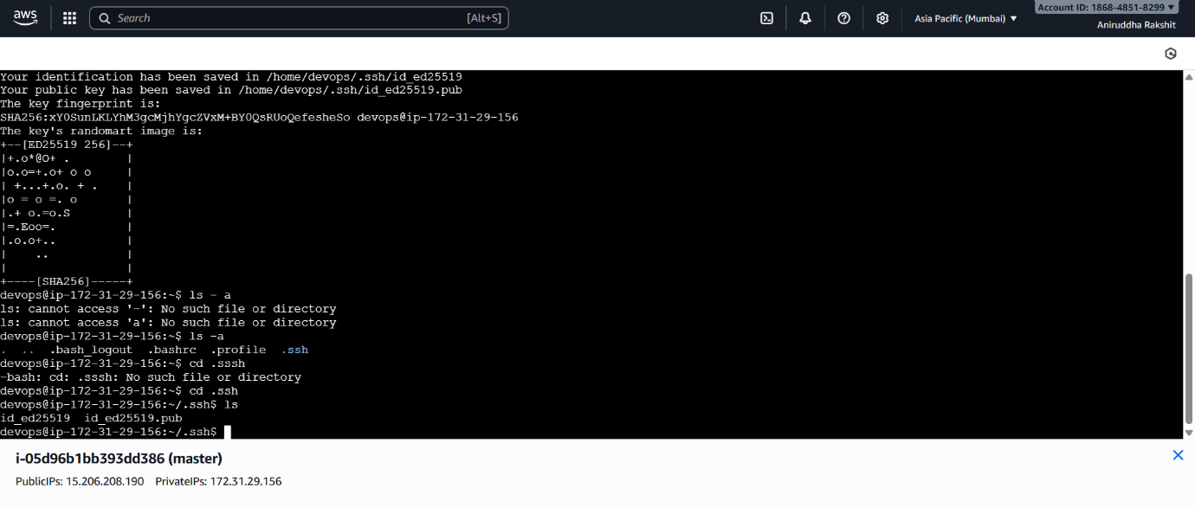

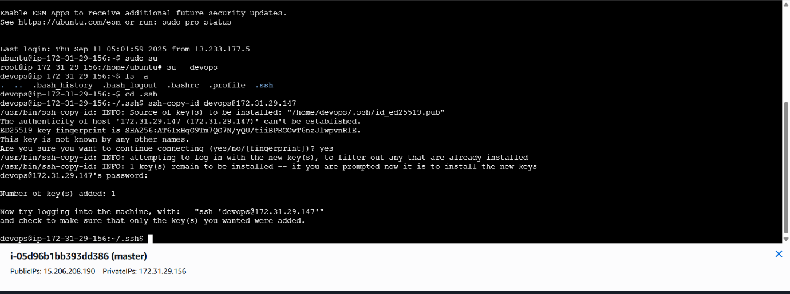

Install plugin

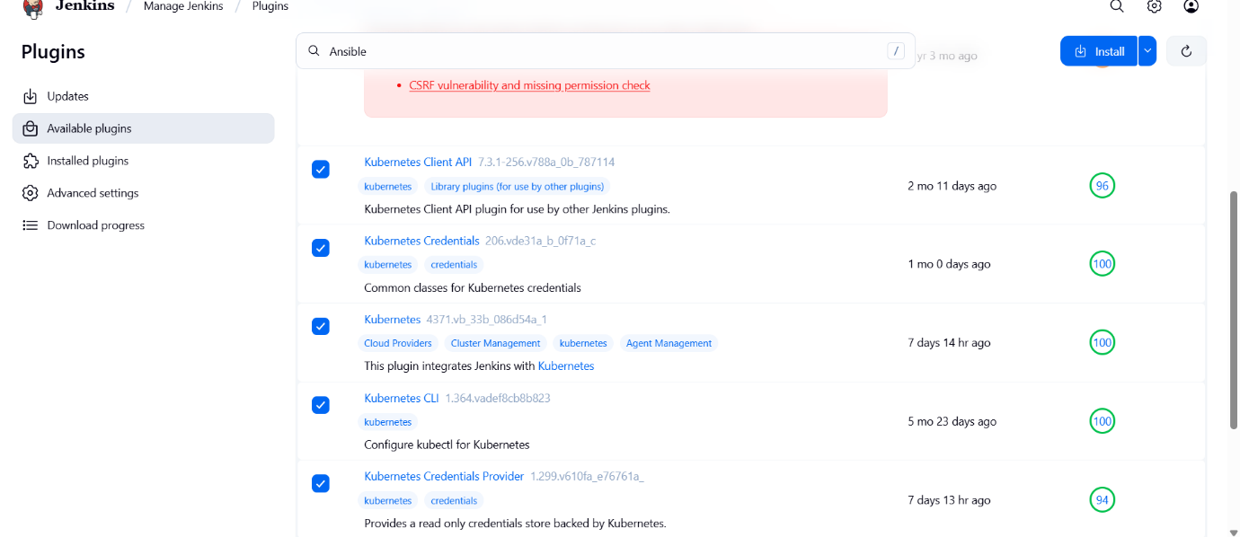

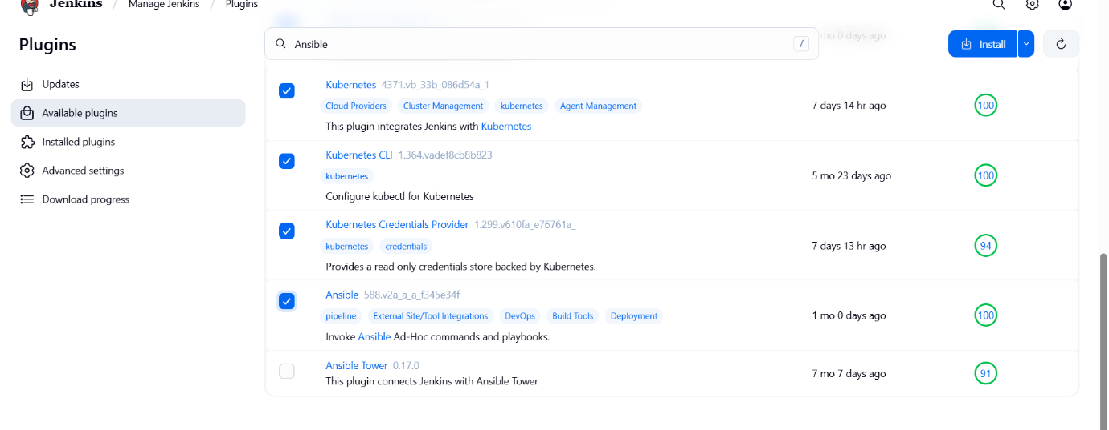

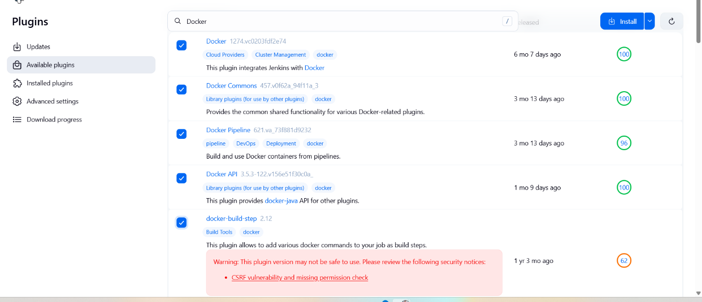
After install restart Jenkins

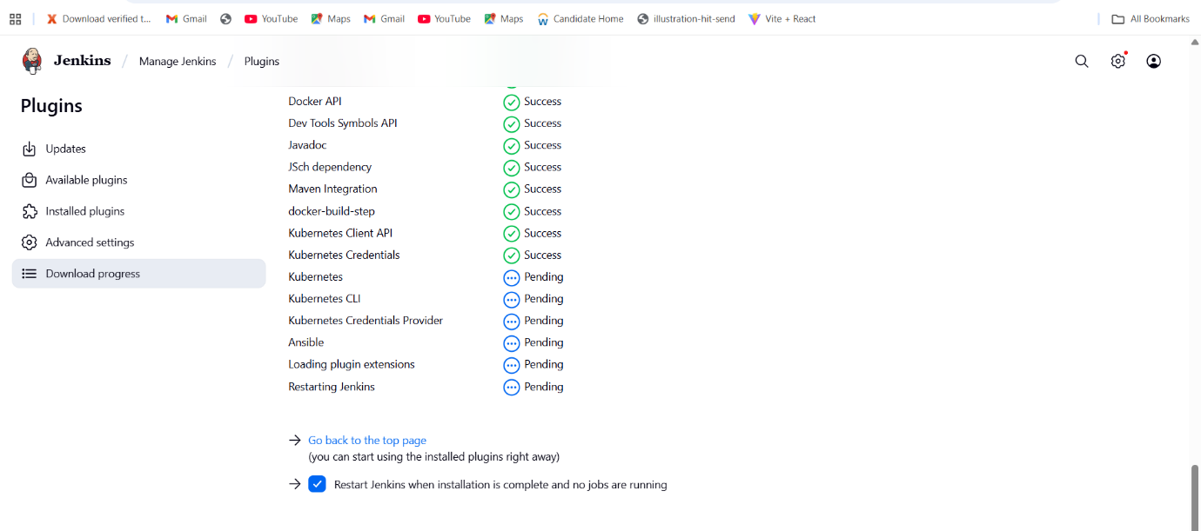
In your terminal write
docker login -u <your_dockerhub_username>
sudo usermod -aG docker jenkins

sudo systemctl restart Jenkins

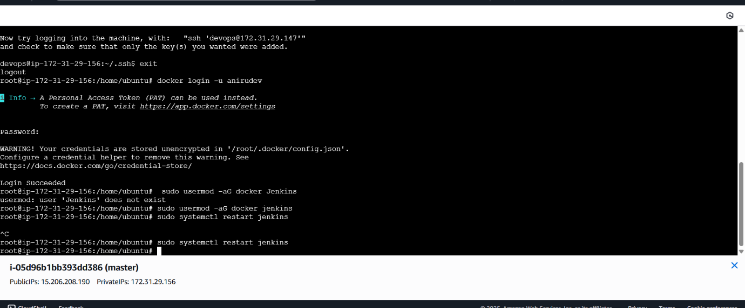

Then login into Jenkins-> go to credentials -> click on global-> add creadentials->username with password (username your dockerhub user name) your docker hub password id : docker-> create

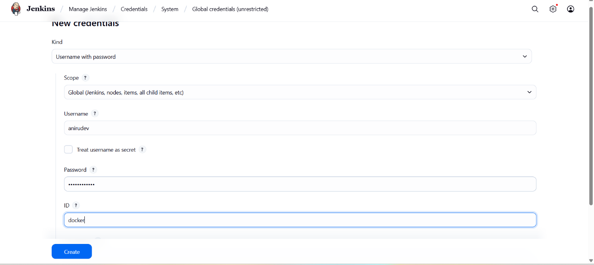

Then again click on add creadential-> kind: ssh username with private key->
For secret text go to your master machine su – devops
Cd .ssh
Cat id_ed25519
Copy it and paste it on secret at Jenkins-> id: ansible-ssh -> create

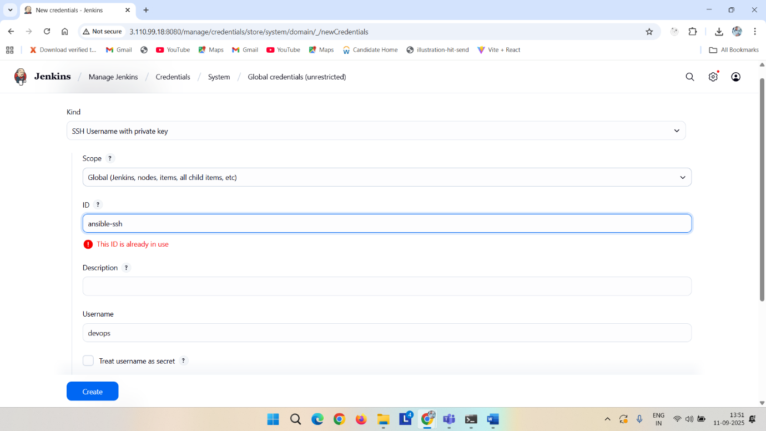

s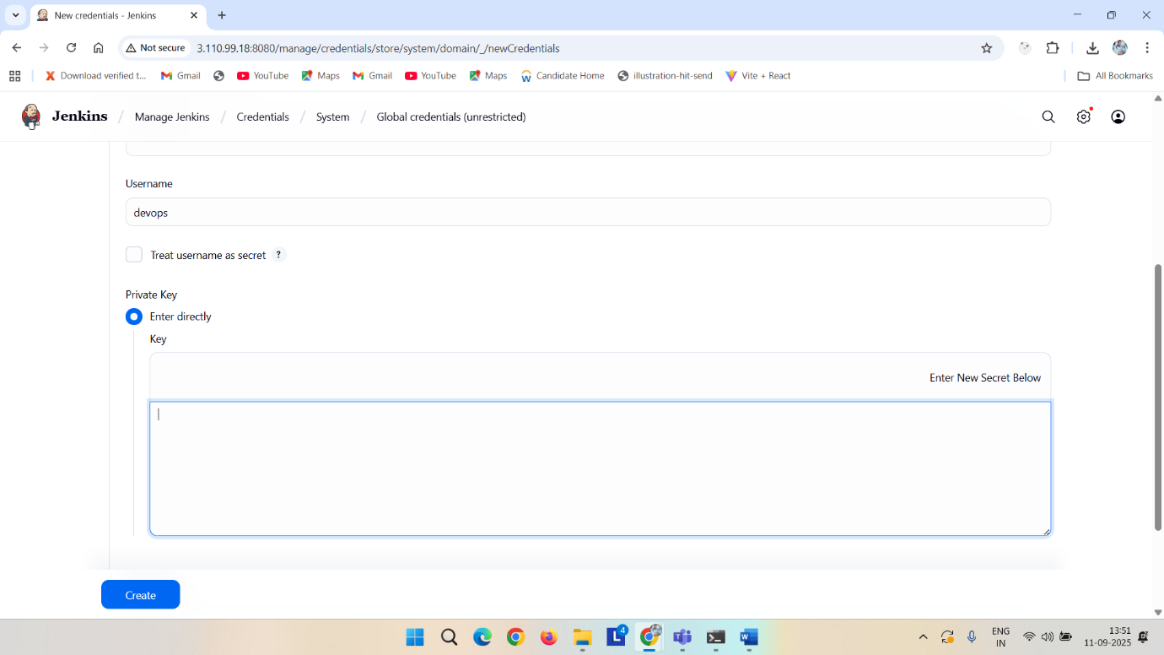
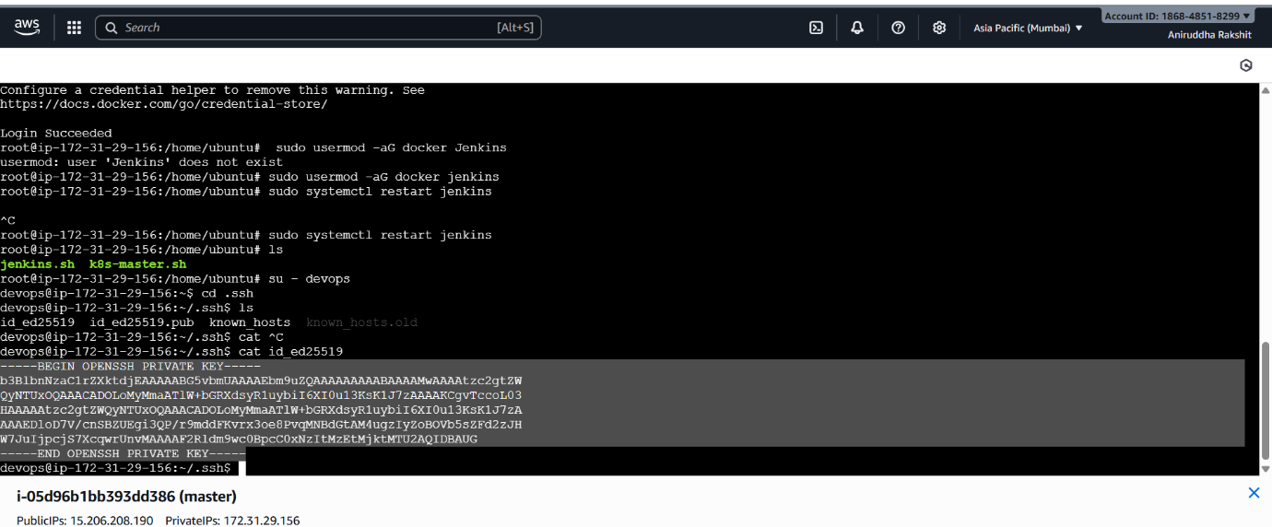

Then again click on add credentials-> kind: secret-file->
On master
cat ~/.kube/config
copy the whole thing end to end and create a file with name kubeconfig with no exrention->
upload the file and id: kubeconfig
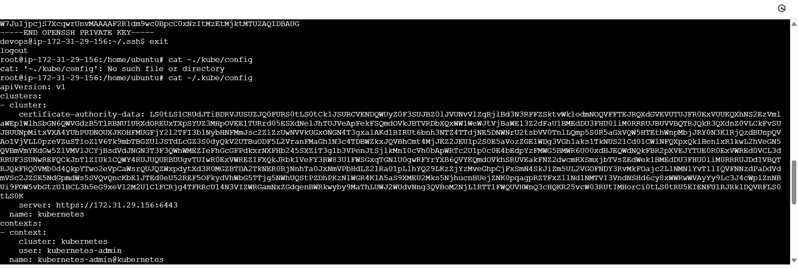

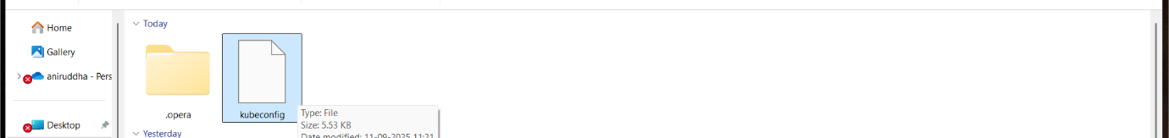

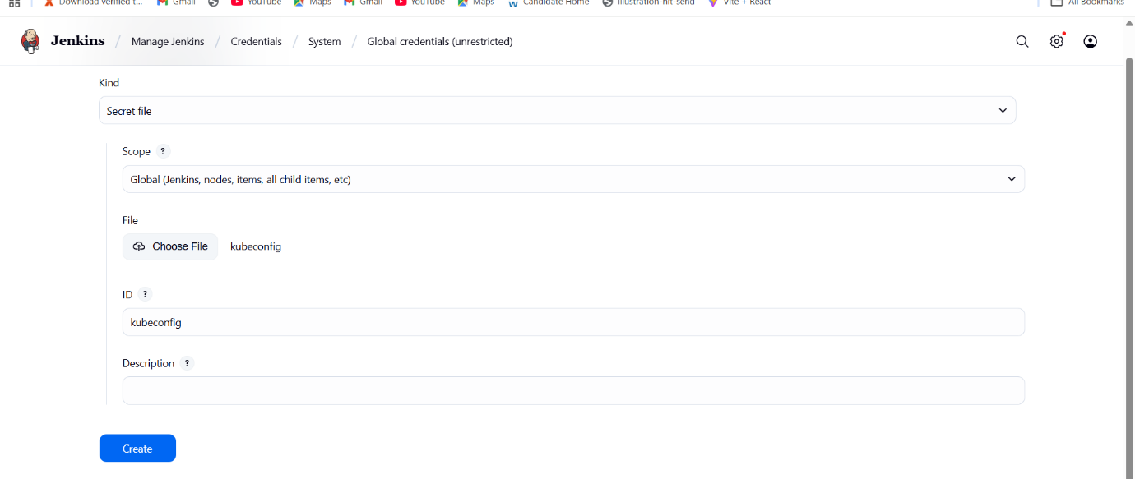

Now write down the deployment script and service script and upload it on git hub foked repo
apiVersion: apps/v1
kind: Deployment
metadata:
name: apachewebsite-deployment
labels:
app: apachewebsite
spec:
replicas: 2 # number of pods
selector:
matchLabels:
app: apachewebsite
template:
metadata:
labels:
app: apachewebsite
spec:
containers:
- name: apachewebsite
image: anirudev/apachewebsite:latest
ports:
- containerPort: 80

Service file

apiVersion: v1
kind: Service
metadata:
name: apachewebsite-service
spec:
selector:
app: apachewebsite
ports:
- protocol: TCP
port: 80 # Service port
targetPort: 80 # Container port
nodePort: 30080 # Optional: fixed NodePort
type: NodePort # Change to LoadBalancer if using cloud provider

and then copy this pipeline code -> at forked repo add a Jenkins file and paste it and change

pipeline {
agent any
environment {
DOCKER_IMAGE = 'anirudev/apachewebsite:latest'
KUBECONFIG = credentials('kubeconfig')
}

stages {
stage('Clone Git repository') {
steps {
git 'https://github.com/RaksAniruddha/apachewebsite.git'
}
}
stage('run ansibleplaybook'){
steps{
ansiblePlaybook credentialsId: 'ansible-ssh', installation: 'ansible2', inventory: 'inventory.ini', playbook: 'installapche.yml', vaultTmpPath: ''
}
}
stage('Docker Build & Push') {
steps {
script {
withDockerRegistry([credentialsId: 'docker', url: 'https://index.docker.io/v1/']) {
sh '''
echo "Building Docker image..."
docker build --no-cache -t $DOCKER_IMAGE -f Dockerfile .
echo "Pushing Docker image to Docker Hub..."
docker push $DOCKER_IMAGE
'''
}
}
}
}
stage('Deploy to Kubernetes') {
steps {
script {
withCredentials([file(credentialsId: 'kubeconfig', variable: 'KUBECONFIG_FILE')]) {
sh '''
echo "Deploying to Kubernetes..."
export KUBECONFIG=$KUBECONFIG_FILE

kubectl apply -f deployment.yml
kubectl apply -f service.yml

echo "Deployment and Service applied successfully!"
'''
}
}
}
}
}
}

Now copy the playbook code from bellow create a file name installapche.yml and paste it in that
---
- name: Install and start Apache on Ubuntu
hosts: all
become: yes
tasks:
- name: Update apt package index
apt:
update_cache: yes

- name: Install Apache2
apt:
name: apache2
state: present

- name: Ensure Apache2 is running and enabled
service:
name: apache2
state: started
enabled: yes

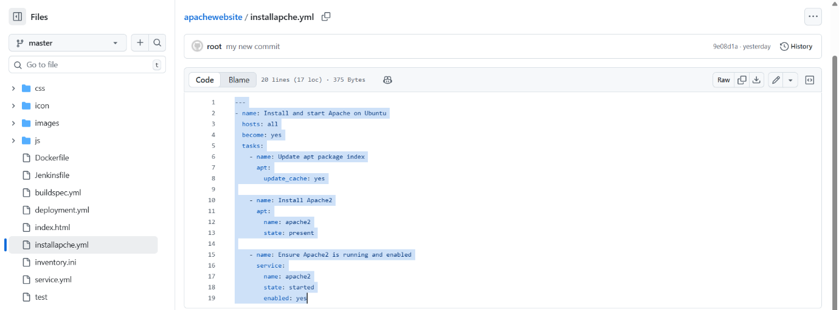

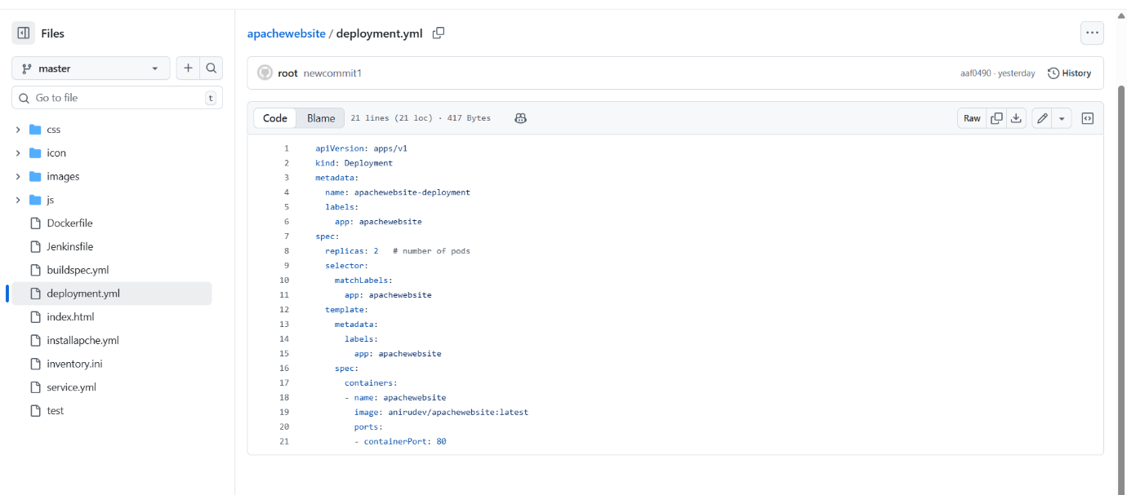

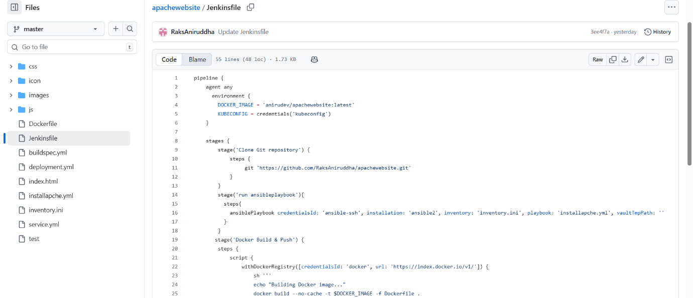
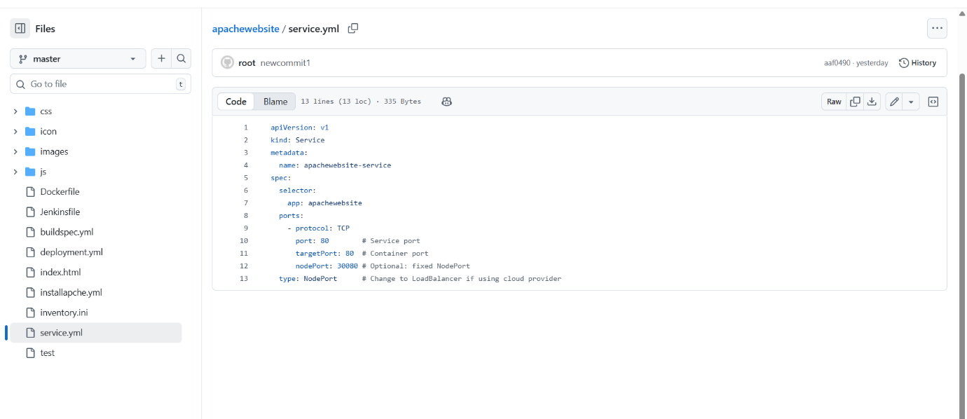

Now go to your jenkins
Clicj on tools -> anisble-> name : ansible-> /usr/bin
Docker-> name : docker-> add installer-> latest->apply save

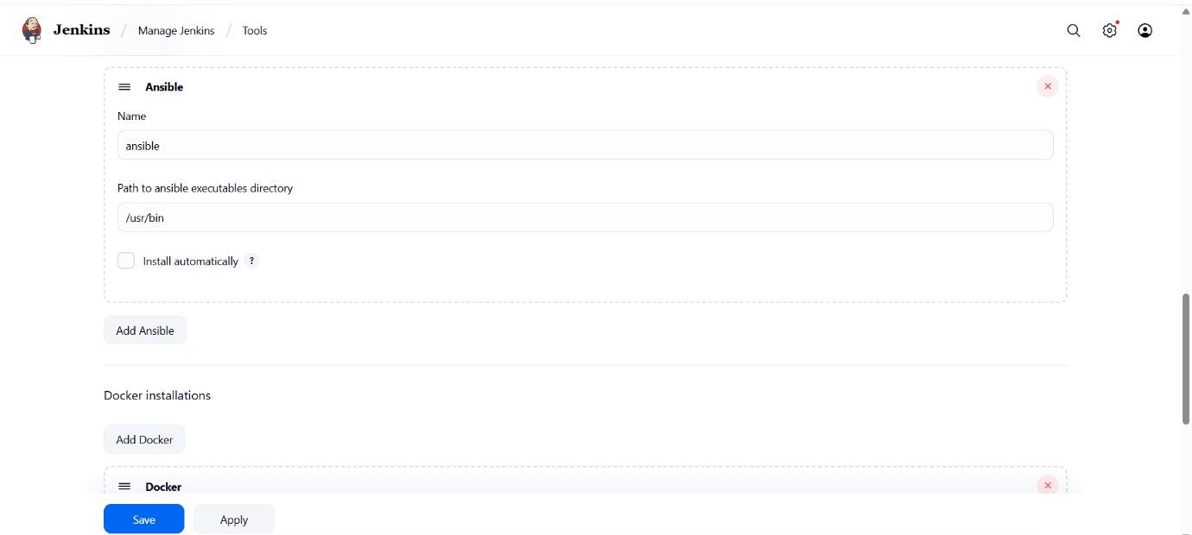

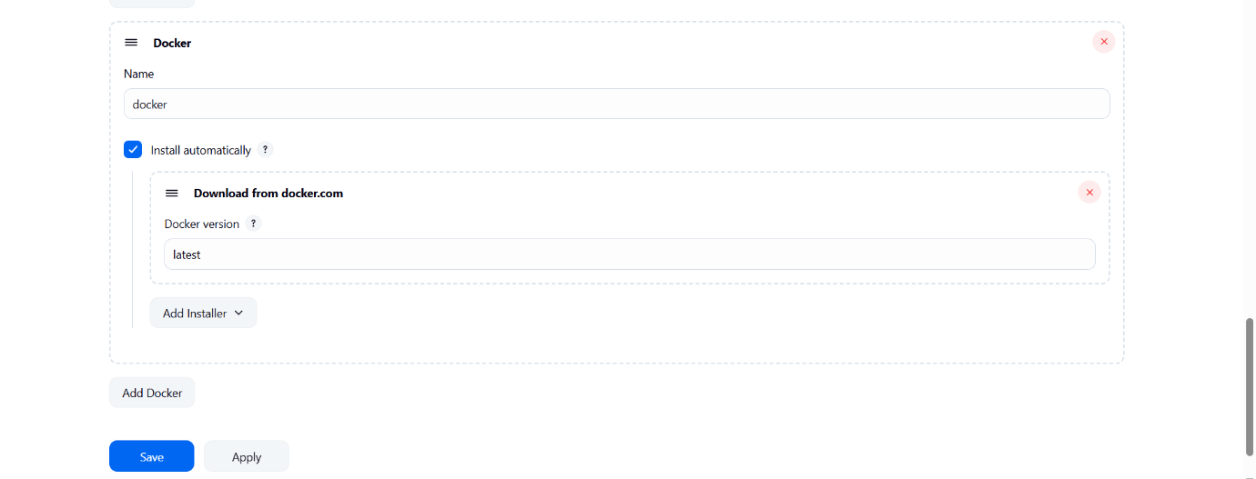

No w go to Jenkins-> go to new item -> pipeline-> ok-> click on pipeline syntax ->click on ansible playbook-> Playbook file path in workspace : give your github playbook filename in my case installpache.yml-> Inventory file path in workspace: inventory.ini (because my github filename is inventory.ini)-> select ssh key-> generate pipeline script-> copy it paste on pipeline{ steps{
ansiblePlaybook credentialsId: 'ansible-ssh', installation: 'ansible2', inventory: 'inventory.ini', playbook: 'installapche.yml', vaultTmpPath: ''
}}

Similary
Again click on pipeline syntax-> select git -> give repo url -> branch (master/main)-> generate pipeline script and paste it at clone stage { stage('Clone Git repository') {
steps {
git 'https://github.com/RaksAniruddha/apachewebsite.git'
}
}
}

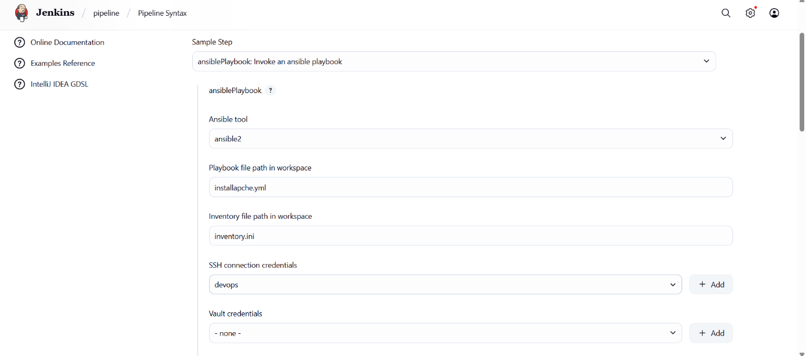

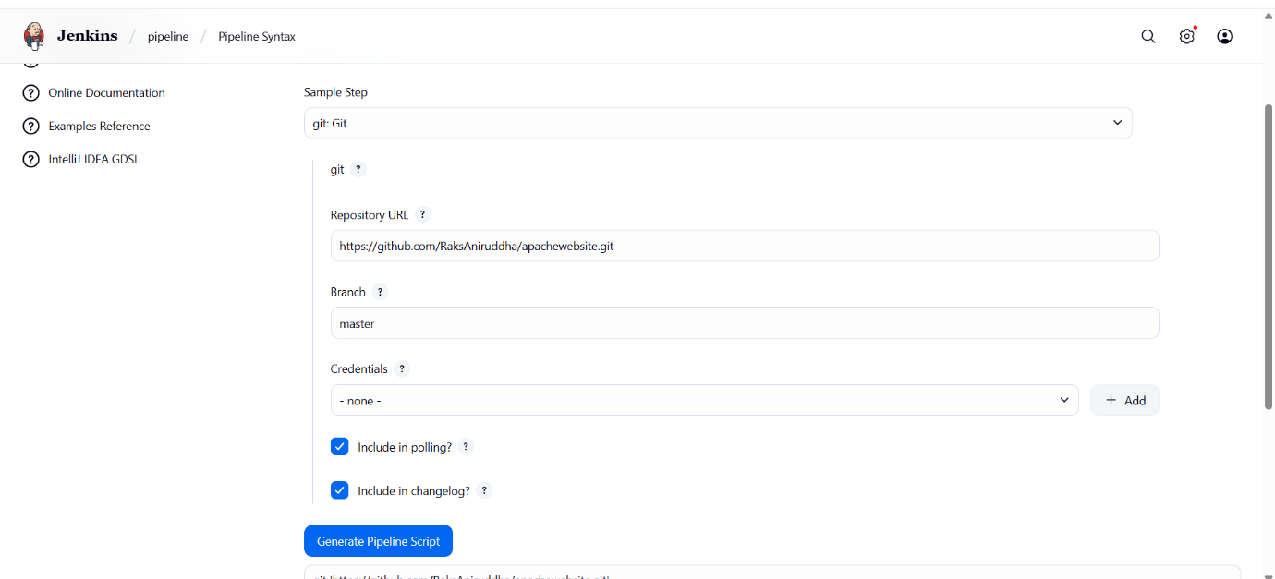

Now in the pipeline slelect checkout from scm -> give repository url-> slect branch master -> apply _> save-> run
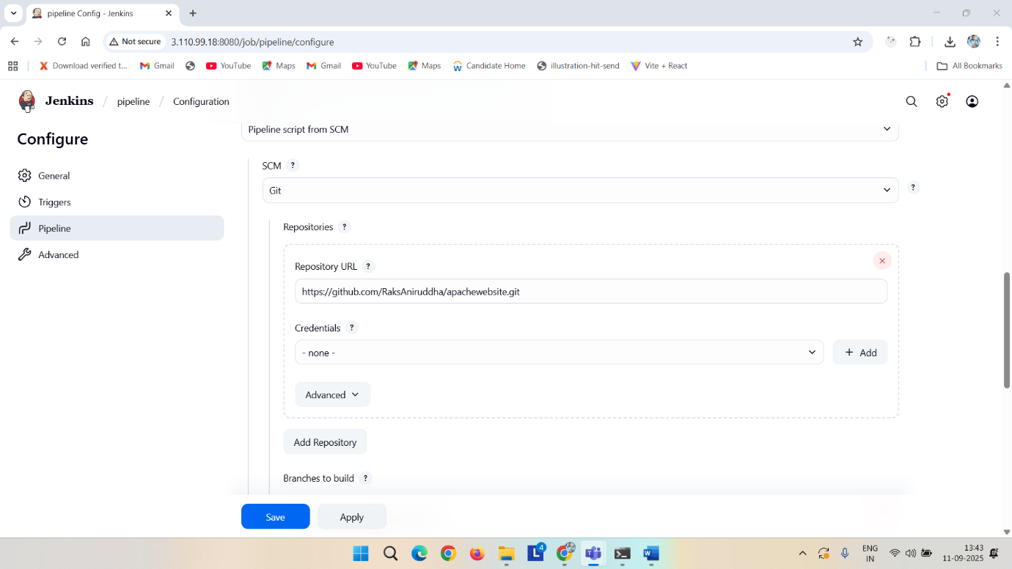
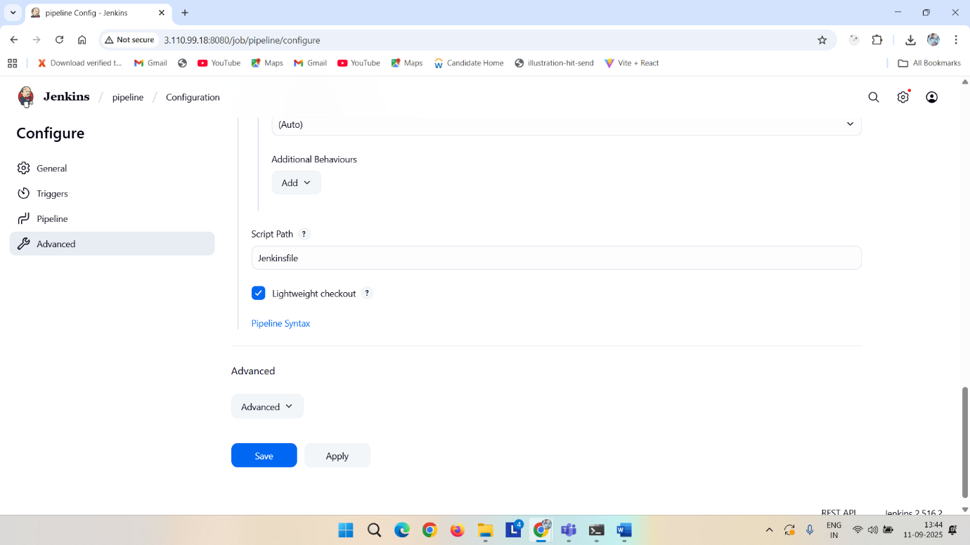

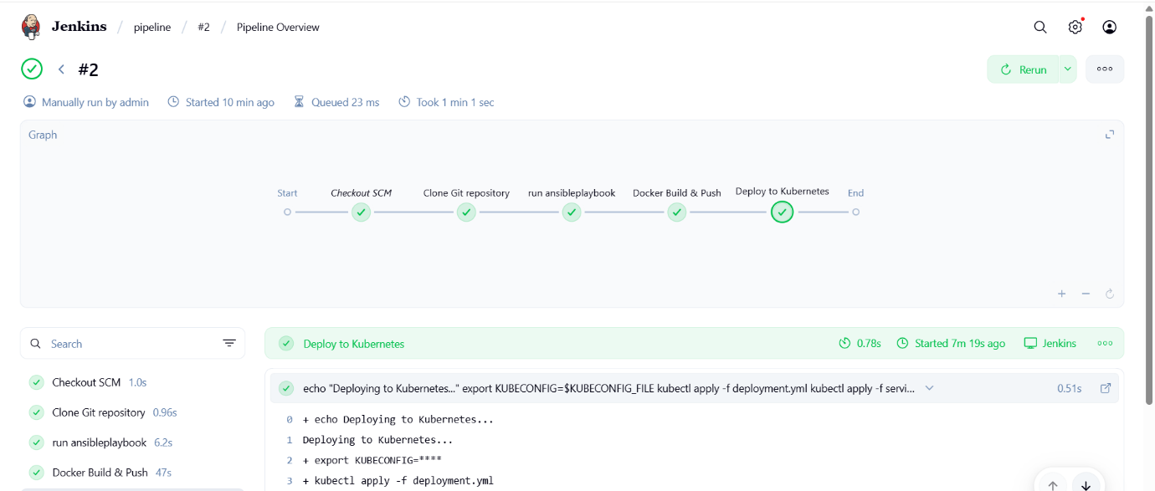

Kubectl get pods -o wide
Kubectl get svc -o wide

You will got at port collum 80:<external_port>
In my case 80:30080 so I copy 30080
Then go to your browser <publicipof node>:30080
