1. **Screenshot of Home Page :**

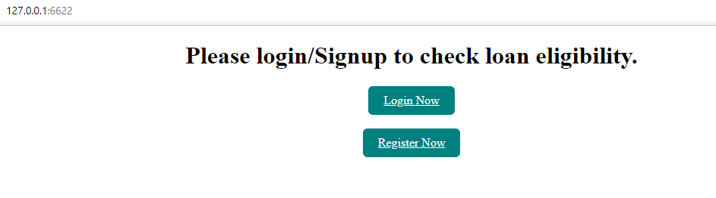

1. **Screenshot of Register Page :**

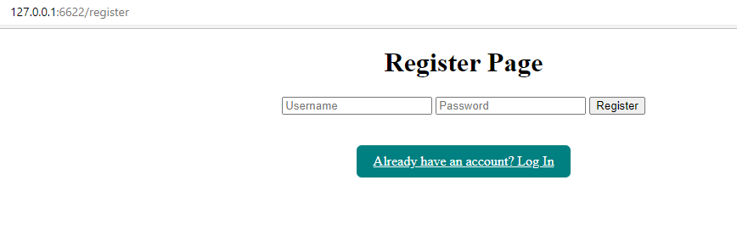

1. **Login Page :**

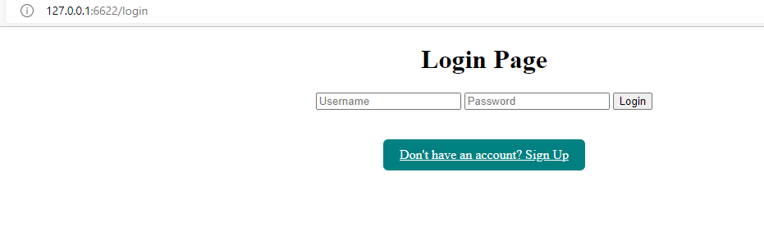

1. **Logout, Statistical Summary, Percentage approved loan Button :**

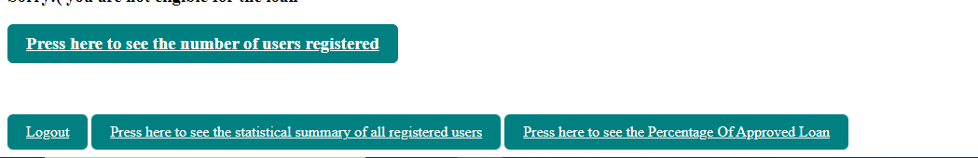

1. **Prediction Page with prediction details :**

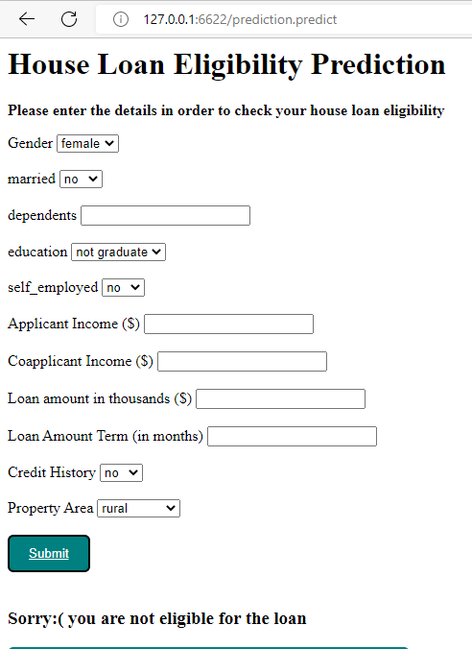

1. **Data Stored in MySQL :**

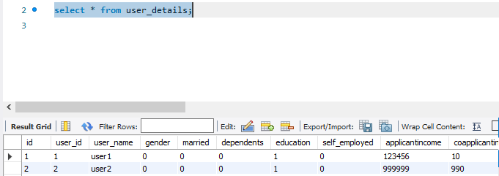

1. **Statistical summary of all registered users:**

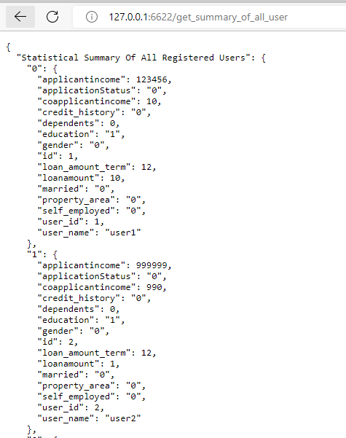

1. **Percentage of approved loan :**

