A PROJECT REPORT

On

**Code Editor**

*Submitter is*

**Mr. Ashish Santosh Patil**

*in partial fulfillment for the award of the degree of*

**BACHELOR OF SCIENCE**

*In*

**COMPUTER SCIENCE**

*Under the guidance of*

**Mrs. Varsha More**

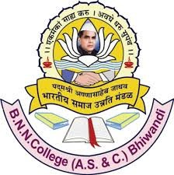

**B.N.N. College of Arts, Science, Commerce Bhiwandi**

**(Sem V)**

**A.Y. 2024-2025**