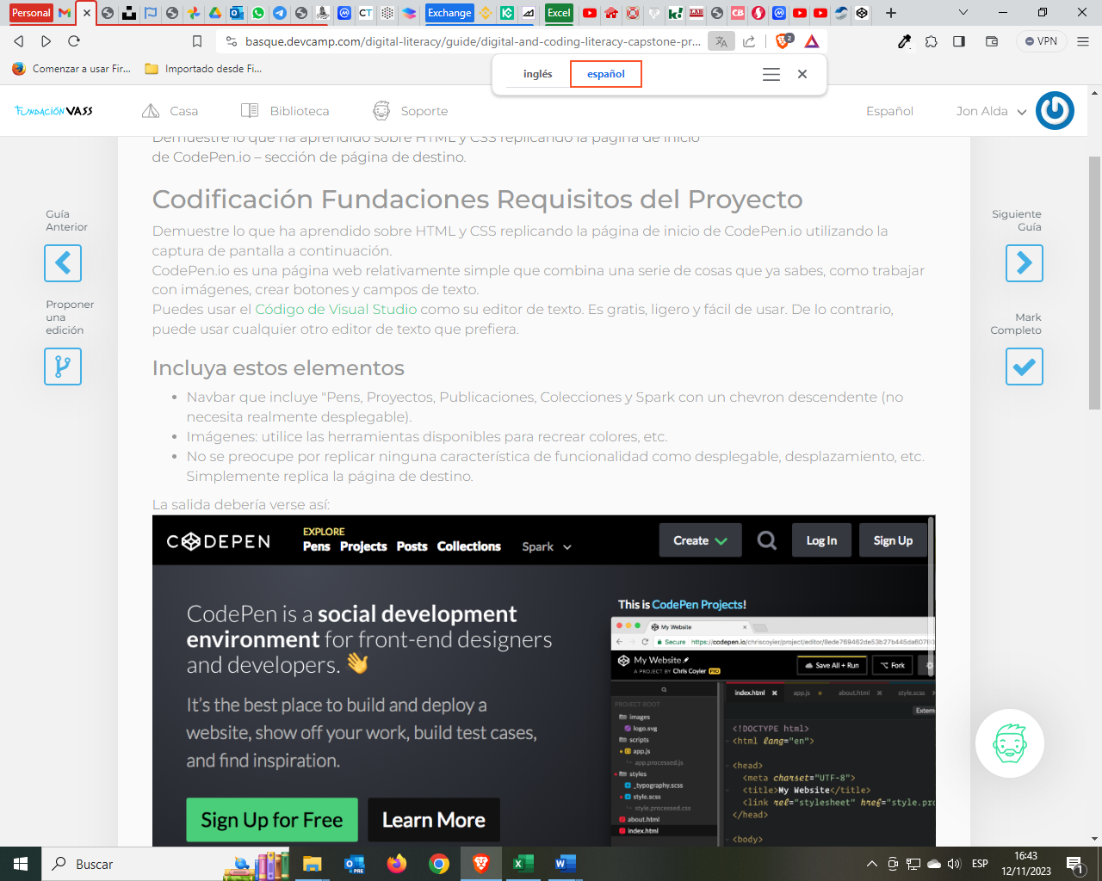

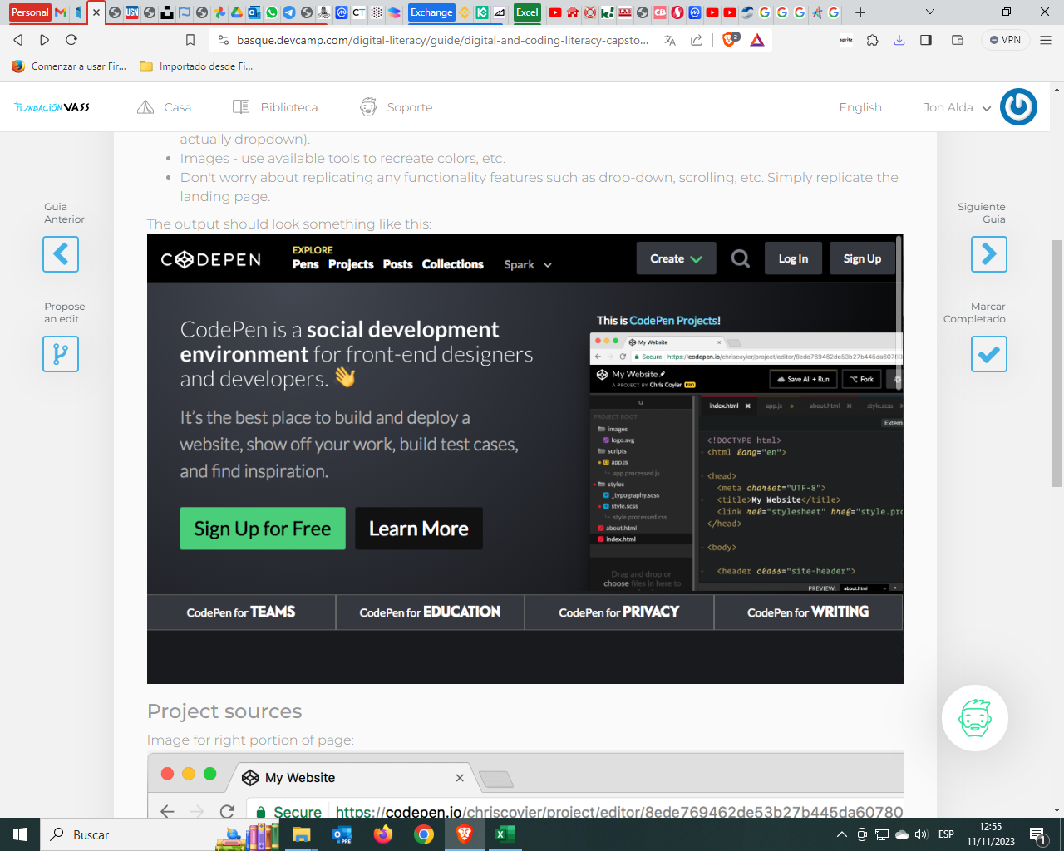

Parte navegación:

Logo

Explore:

Pens

Projects

Posts

Collections

Spark

Create

La lupa

Log In

Sing Up

Parte central

CodePen is a social development environment for front-end designers and developers.

It’s the best place to build and deploy a website, show off your work, build test cases, and find inspiration.

Botones:

Sing Up for Free

Learn More

La imagen.

Footer:

CodePen for TEAMS

CodePen for EDUCATION

CodePen for PRIVACY

CodePen for WRITING