**OVERVIEW**

Database is a collection of related data and data is a collection of facts and figures that can be processed to produce information. Mostly data represents recordable facts. Data aids in producing information, which is based on facts. For example, if we have data about marks obtained by all students, we can then conclude about toppers and average marks. A database management system stores data in such a way that it becomes easier to retrieve, manipulate, and produce information.

**Characteristics**

* **Real-world entity**: A modern DBMS is more realistic and uses real-world entities to design its architecture. It uses the behavior and attributes too. For example, a school database may use students as an entity and their age as an attribute.
* **Isolation of data and application**: A database system is entirely different than its data. A database is an active entity, whereas data is said to be passive, on which the database works and organizes. DBMS also stores metadata, which is data about data, to ease its own process.
* **Relation-based tables**: DBMS allows entities and relations among them to form tables. A user can understand the architecture of a database just by looking at the table names.
* **Less redundancy**: DBMS follows the rules of normalization, which splits a relation when any of its attributes is having redundancy in values. Normalization is a mathematically rich and scientific process that reduces data redundancy.
* **Consistency**: Consistency is a state where every relation in a database remains consistent. There exist methods and techniques, which can detect attempt of leaving database in inconsistent state. A DBMS can provide greater consistency as compared to earlier forms of data storing applications like file-processing systems.
* **Multiple views**: DBMS offers multiple views for different users. A user who is in the Sales department will have a different view of database than a person working in the Production department. This feature enables the users to have a concentrate view of the database according to their requirements.
* **Query Language**: DBMS is equipped with query language, which makes it more efficient to retrieve and manipulate data. A user can apply as many and as different filtering options as required to retrieve a set of data. Traditionally it was not possible where file-processing system was used.
* **ACID Properties**: DBMS follows the concepts of Atomicity, Consistency, Isolation, and Durability (normally shortened as ACID). These concepts are applied on transactions, which manipulate data in a database. ACID properties help the database stay healthy in multi-transactional environments and in case of failure.
* **Multiuser and Concurrent Access**: DBMS supports multi-user environment and allows them to access and manipulate data in parallel. Though there are restrictions on transactions when users attempt to handle the same data item, but users are always unaware of them.
* **Security**: Features like multiple views offer security to some extent where users are unable to access data of other users and departments. DBMS offers methods to impose constraints while entering data into the database and retrieving the same at a later stage. DBMS offers many different levels of security features, which enables multiple users to have different views with different features. For example, a user in the Sales department cannot see the data that belongs to the Purchase department. Additionally, it can also be managed how much data of the Sales department should be displayed to the user. Since a DBMS is not saved on the disk as traditional file systems, it is very hard for miscreants to break the code.

**ARCHITECTURE**

The design of a DBMS depends on its architecture. It can be centralized or decentralized or hierarchical. The architecture of a DBMS can be seen as either single tier or multi-tier. An n-tier architecture divides the whole system into related but independent n modules, which can be independently modified, altered, changed, or replaced.

In **1-tier** architecture, the DBMS is the only entity where the user directly sits on the DBMS and uses it. Any changes done here will directly be done on the DBMS itself. It does not provide handy tools for end-users. Database designers and programmers normally prefer to use single-tier architecture.

If the architecture of DBMS is **2-tier**, then it must have an application through which the DBMS can be accessed. Programmers use 2-tier architecture where they access the DBMS by means of an application. Here the application tier is entirely independent of the database in terms of operation, design, and programming.

**3-tier Architecture**

A 3-tier architecture separates its tiers from each other based on the complexity of the users and how they use the data present in the database. It is the most widely used architecture to design a DBMS.

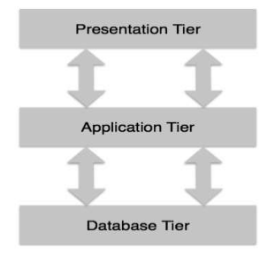

**Database (Data) Tier**: At this tier, the database resides along with its query processing languages. We also have the relations that define the data and their constraints at this level.

**Application (Middle) Tier**: At this tier reside the application server and the programs that access the database. For a user, this application tier presents an abstracted view of the database. End-users are unaware of any existence of the database beyond the application. At the other end, the database tier is not aware of any other user beyond the application tier. Hence, the application layer sits in the middle and acts as a mediator between the end-user and the database.

**User (Presentation) Tier**: End-users operate on this tier and they know nothing about any existence of the database beyond this layer. At this layer, multiple views of the database can be provided by the application. All views are generated by applications that reside in the application tier.

**DATA MODELS**

Data models define how the logical structure of a database is modeled. Data Models are fundamental entities to introduce abstraction in a DBMS. Data models define how data is connected to each other and how they are processed and stored inside the system.

The very first data model could be flat data-models, where all the data used are to be kept in the same plane. Earlier data models were not so scientific, hence they were prone to introduce lots of duplication and update anomalies.

**Entity-Relationship Model**

Entity-Relationship (ER) Model is based on the notion of real-world entities and relationships among them. While formulating real-world scenario into the database model, the ER Model creates entity set, relationship set, general attributes, and constraints.

ER Model is best used for the conceptual design of a database and is based on:

1. Entities and their attributes
2. Relationships among entities

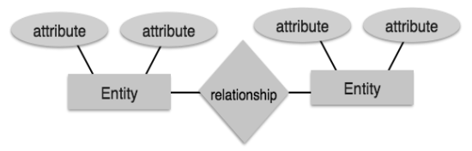

**Entity**

An entity in an ER Model is a real-world entity having properties called attributes. Every attribute is defined by its set of values called domain.

For example, in a school database, a student is considered as an entity. Student has various attributes like name, age, class, etc.

**Relationship**

The logical association among entities is called relationship. Relationships are mapped with entities in various ways. Mapping cardinalities define the number of association between two entities.

Mapping cardinalities:

* one to one
* one to many
* many to one
* many to many

**Relational Model**

The most popular data model in DBMS is the Relational Model. It is more scientific a model than others. This model is based on first-order predicate logic and defines a table as an n-ary relation.

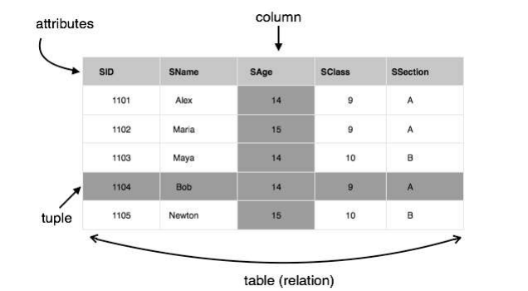

The main highlights of this model are:

* Data is stored in tables called relations.
* Relations can be normalized.
* In normalized relations, values saved are atomic values.
* Each row in a relation contains a unique value.
* Each column in a relation contains values from a same domain.

**DATA SCHEMAS**

**Database Schema**

A database schema is the skeleton structure that represents the logical view of the entire database. It defines how the data is organized and how the relations among them are associated. It formulates all the constraints that are to be applied on the data.

A database schema defines its entities and the relationship among them. It contains a descriptive detail of the database, which can be depicted by means of schema diagrams. It’s the database designers who design the schema to help programmers understand the database and make it useful.

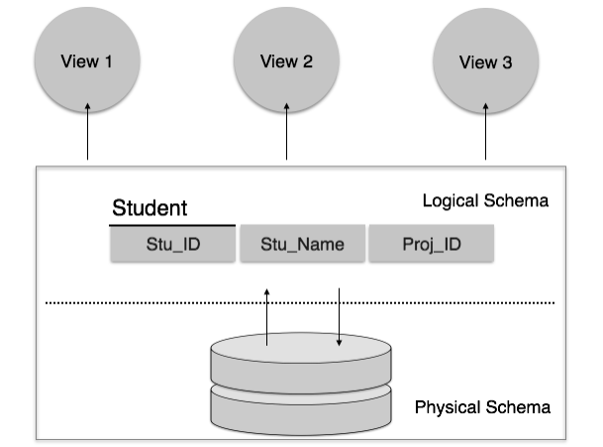

A database schema can be divided broadly into two categories:

* **Physical Database Schema**: This schema pertains to the actual storage of data and its form of storage like files, indices, etc. It defines how the data will be stored in a secondary storage.
* **Logical Database Schema**: This schema defines all the logical constraints that need to be applied on the data stored. It defines tables, views, and integrity constraints.

**Database Instance**

It is important that we distinguish these two terms individually. Database schema is the skeleton of database. It is designed when the database doesn't exist at all. Once the database is operational, it is very difficult to make any changes to it. A database schema does not contain any data or information.

A database instance is a state of operational database with data at any given time. It contains a snapshot of the database. Database instances tend to change with time. A DBMS ensures that its every instance (state) is in a valid state, by diligently following all the validations, constraints, and conditions that the database designers have imposed.

**DATA INDEPENDENCE**

A database system normally contains a lot of data in addition to users’ data. For example, it stores data about data, known as metadata, to locate and retrieve data easily. It is rather difficult to modify or update a set of metadata once it is stored in the database. But as a DBMS expands, it needs to change over time to satisfy the requirements of the users. If the entire data is dependent, it would become a tedious and highly complex job.

**Metadata** itself follows a layered architecture, so that when we change data at one layer, it does not affect the data at another level. This data is independent but mapped to each other.

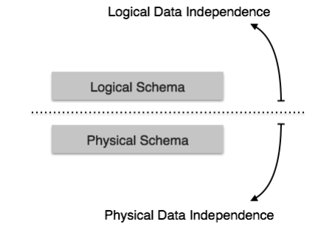

**Logical Data Independence**

Logical data is data about database, that is, it stores information about how data is managed inside. For example, a table (relation) stored in the database and all its constraints applied on that relation.

Logical data independence is a kind of mechanism, which liberalizes itself from actual data stored on the disk. If we do some changes on table format, it should not change the data residing on the disk.

**Physical Data Independence**

All the schemas are logical, and the actual data is stored in bit format on the disk. Physical data independence is the power to change the physical data without impacting the schema or logical data.

For example, in case we want to change or upgrade the storage system itself — suppose we want to replace hard-disks with SSD — it should not have any impact on the logical data or schemas.

**ER MODEL**

The ER model defines the conceptual view of a database. It works around real world entities and the associations among them. At view level, the ER model is considered a good option for designing databases.

**Entity**

An entity can be a real-world object, either animate or inanimate, that can be easily identifiable. For example, in a school database, students, teachers, classes, and courses offered can be considered as entities. All these entities have some attributes or properties that give them their identity.

An entity set is a collection of similar types of entities. An entity set may contain entities with attribute sharing similar values. For example, a Students set may contain all the students of a school; likewise a Teachers set may contain all the teachers of a school from all faculties. Entity sets need not be disjoint.

**Attributes**

Entities are represented by means of their properties called attributes. All attributes have values. For example, a student entity may have name, class, and age as attributes.

There exists a domain or range of values that can be assigned to attributes. For example, a student's name cannot be a numeric value. It has to be alphabetic. A student's age cannot be negative, etc.

**Types of Attributes**

* **Simple attribute**: Simple attributes are atomic values, which cannot be divided further. For example, a student's phone number is an atomic value of 10 digits.
* **Composite attribute**: Composite attributes are made of more than one simple attribute. For example, a student's complete name may have first_name and last_name.
* **Derived attribute**: Derived attributes are the attributes that do not exist in the physical database, but their values are derived from other attributes present in the database. For example, average_salary in a department should not be saved directly in the database, instead it can be derived. For another example, age can be derived from data_of_birth.
* **Single-value attribute**: Single-value attributes contain single value. For example: Social_Security_Number.
* **Multi-value attribute**: Multi-value attributes may contain more than one values. For example, a person can have more than one phone number, email_address, etc.

**Entity-Set and Keys**

Key is an attribute or collection of attributes that uniquely identifies an entity among entity set. For example, the roll_number of a student makes him/her identifiable among students.

**Super Key**: A set of attributes (one or more) that collectively identifies an entity in an entity set.

**Candidate Key**: A minimal super key is called a candidate key. An entity set may have more than one candidate key.

**Primary Key**: A primary key is one of the candidate keys chosen by the database designer to uniquely identify the entity set.

**Relationship**

The association among entities is called a relationship. For example, an employee works_at a department, a student enrolls in a course. Here, Works_at and Enrolls are called relationships.

**Relationship Set**

A set of relationships of similar type is called a relationship set. Like entities, a relationship too can have attributes. These attributes are called descriptive attributes.

**Degree of Relationship**

The number of participating entities in a relationship defines the degree of the relationship.

* Binary = degree 2
* Ternary = degree 3
* n-ary = degree

**Mapping Cardinalities**

**Cardinality** defines the number of entities in one entity set, which can be associated with the number of entities of other set via relationship set.

* **One-to-one**: One entity from entity set A can be associated with at most one entity of entity set B and vice versa.

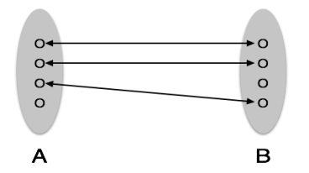

* **One-to-many**: One entity from entity set A can be associated with more than one entities of entity set B, however an entity from entity set B can be associated with at most one entity.

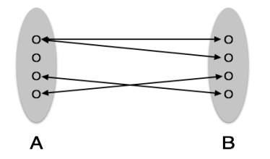

* **Many-to-one**: More than one entities from entity set A can be associated with at most one entity of entity set B, however an entity from entity set B can be associated with more than one entity from entity set A.

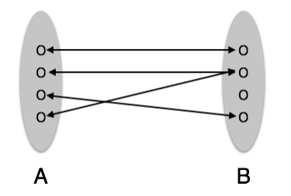

* **Many-to-many**: One entity from A can be associated with more than one entity from B and vice versa.

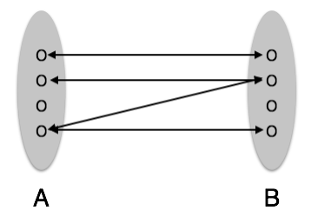

**ER DIAGRAM REPRESENTATION**

**Entity**: These are represented by means of rectangles. Rectangles are named with the entity set they represent.



**Attributes**: These are the properties of entities. Attributes are represented by means of ellipses. Every ellipse represents one attribute and is directly connected to its entity (rectangle).

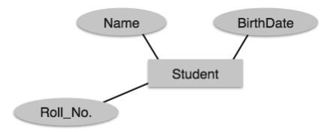

If the attributes are **composite**, they are further divided in a tree like structure. Every node is then connected to its attribute. That is, composite attributes are represented by ellipses that are connected with an ellipse.

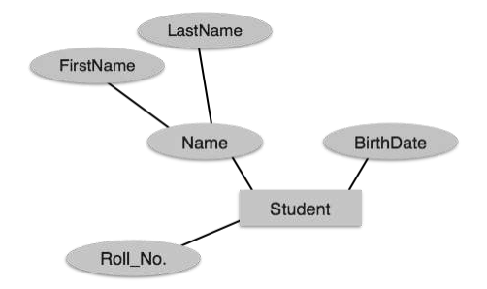

**Multivalued attributes** are depicted by double ellipse.

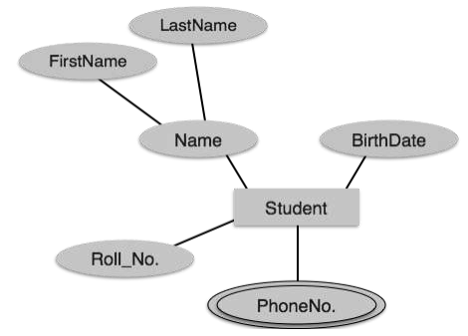

**Derived attributes** are depicted by dashed ellipse.

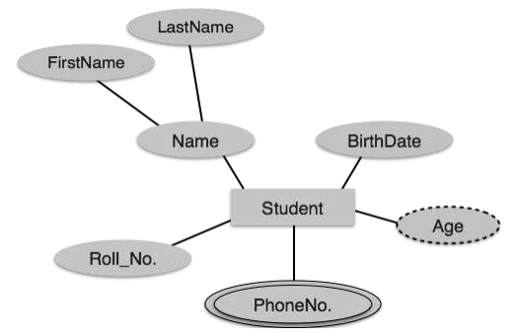

**Relationship**

Relationships are represented by diamond-shaped box. Name of the relationship is written inside the diamond-box. All the entities (rectangles) participating in a relationship are connected to it by a line.

**Binary Relationship and Cardinality**

A relationship where two entities are participating is called a **binary relationship**.

**Cardinality** is the number of instance of an entity from a relation that can be associated with the relation.

* **One-to-one**: When only one instance of an entity is associated with the relationship, it is marked as '1:1'. The following image reflects that only one instance of each entity should be associated with the relationship. It depicts one-to-one relationship.

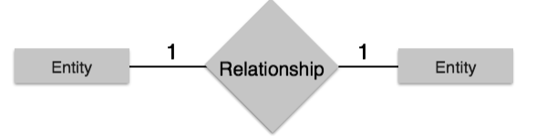

* **One-to-many**: When more than one instance of an entity is associated with a relationship, it is marked as '1:N'. The following image reflects that only one instance of entity on the left and more than one instance of an entity on the right can be associated with the relationship. It depicts one-to-many relationship.

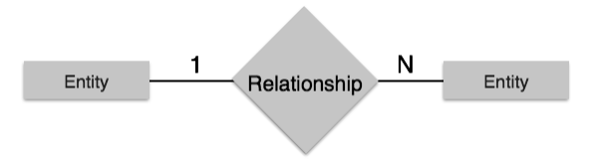

* **Many-to-one**: When more than one instance of entity is associated with the relationship, it is marked as 'N:1'. The following image reflects that more than one instance of an entity on the left and only one instance of an entity on the right can be associated with the relationship. It depicts many-to-one relationship.

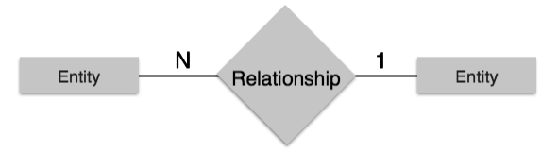

* **Many-to-many**: The following image reflects that more than one instance of an entity on the left and more than one instance of an entity on the right can be associated with the relationship. It depicts many-to-many relationship.

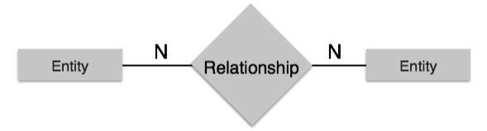

**Generalization and Specialization**

The ER Model has the power of expressing database entities in a conceptual hierarchical manner. As the hierarchy goes up, it generalizes the view of entities, and as we go deep in the hierarchy, it gives us the detail of every entity included.

Going up in this structure is called **generalization**, where entities are clubbed together to represent a more generalized view. For example, a particular student named Mira can be generalized along with all the students. The entity shall be a student, and further, the student is a person. The reverse is called **specialization** where a person is a student, and that student is Mira.

**Generalization**

As mentioned above, the process of generalizing entities, where the generalized entities contain the properties of all the generalized entities, is called generalization.

In generalization, a number of entities are brought together into one generalized entity based on their similar characteristics. For example, pigeon, house sparrow, crow, and dove can all be generalized as Birds.

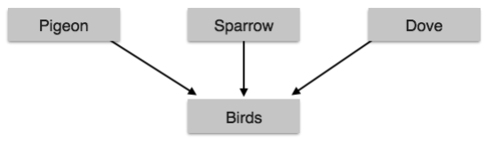

**Specialization**

Specialization is the opposite of generalization. In specialization, a group of entities is divided into sub-groups based on their characteristics. Take a group ‘Person’ for example. A person has name, date of birth, gender, etc. These properties are common in all persons, human beings. But in a company, persons can be identified as employee, employer, customer, or vendor, based on what role they play in the company.

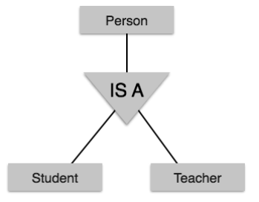

**CODD’S 12 RULES**

Dr Edgar F. Codd, after his extensive research, came up with twelve rules of his own that a database must obey in order to be regarded as a true relational database.

These rules can be applied on any database system that manages stored data using only its relational capabilities. This is a foundation rule, which acts as a base for all the other rules.

**Rule 1: Information Rule**

The data stored in a database, may it be user data or metadata, must be a value of some table cell. Everything in a database must be stored in a table format.

**Rule 2: Guaranteed Access Rule**

Every single data element (value) is guaranteed to be accessible logically with a combination of table-name, primary-key (row value), and attribute-name (column value). No other means, such as pointers, can be used to access data.

**Rule 3: Systematic Treatment of NULL Values**

The NULL values in a database must be given a systematic and uniform treatment. This is a very important rule because a NULL can be interpreted as one the following: data is missing, data is not known, or data is not applicable.

**Rule 4: Active Online Catalog**

The structure description of the entire database must be stored in an online catalog, known as data dictionary, which can be accessed by authorized users. Users can use the same query language to access the catalog which they use to access the database itself.

**Rule 5: Comprehensive Data Sub-Language Rule**

A database can only be accessed using a language having linear syntax that supports data definition, data manipulation, and transaction management operations. This language can be used directly or by means of some application. If the database allows access to data without any help of this language, then it is considered as a violation.

**Rule 6: View Updating Rule**

All the views of a database, which can theoretically be updated, must also be updatable by the system.

**Rule 7: High-Level Insert, Update, and Delete Rule**

A database must support high-level insertion, updation, and deletion. This must not be limited to a single row, that is, it must also support union, intersection and minus operations to yield sets of data records.

**Rule 8: Physical Data Independence**

The data stored in a database must be independent of the applications that access the database. Any change in the physical structure of a database must not have any impact on how the data is being accessed by external applications.

**Rule 9: Logical Data Independence**

The logical data in a database must be independent of its user’s view (application). Any change in logical data must not affect the applications using it. For example, if two tables are merged or one is split into two different tables, there should be no impact or change on the user application. This is one of the most difficult rule to apply.

**Rule 10: Integrity Independence**

A database must be independent of the application that uses it. All its integrity constraints can be independently modified without the need of any change in the application. This rule makes a database independent of the front-end application and its interface.

**Rule 11: Distribution Independence**

The end-user must not be able to see that the data is distributed over various locations. Users should always get the impression that the data is located at one site only. This rule has been regarded as the foundation of distributed database systems.

**Rule 12: Non-Subversion Rule**

If a system has an interface that provides access to low-level records, then the interface must not be able to subvert the system and bypass security and integrity constraints.

**RELATIONAL DATA MODEL**

Relational data model is the primary data model, which is used widely around the world for data storage and processing. This model is simple and it has all the properties and capabilities required to process data with storage efficiency.

**Concepts**

**Tables**: In relational data model, relations are saved in the format of Tables. This format stores the relation among entities. A table has rows and columns, where rows represent records and columns represent the attributes.

**Tuple**: A single row of a table, which contains a single record for that relation is called a tuple.

**Relation instance**: A finite set of tuples in the relational database system represents relation instance. Relation instances do not have duplicate tuples.

**Relation schema**: A relation schema describes the relation name (table name), attributes, and their names.

**Relation key**: Each row has one or more attributes, known as relation key, which can identify the row in the relation (table) uniquely.

**Attribute domain**: Every attribute has some predefined value scope, known as attribute domain.

**Constraints**

Every relation has some conditions that must hold for it to be a valid relation. These conditions are called Relational Integrity Constraints. There are three main integrity constraints:

* Key constraints
* Domain constraints
* Referential integrity constraints

**Key Constraints**

There must be at least one minimal subset of attributes in the relation, which can identify a tuple uniquely. This minimal subset of attributes is called key for that relation. If there are more than one such minimal subsets, these are called candidate keys.

Key constraints force that:

* in a relation with a key attribute, no two tuples can have identical values for key attributes.
* a key attribute cannot have NULL values.

Key constraints are also referred to as **Entity Constraints**.

**Domain Constraints**

Attributes have specific values in real-world scenario. For example, age can only be a positive integer. The same constraints have been tried to employ on the attributes of a relation. Every attribute is bound to have a specific range of values. For example, age cannot be less than zero and telephone numbers cannot contain a digit outside 0-9.

**Referential Integrity Constraints**

Referential integrity constraints work on the concept of Foreign Keys. A foreign key is a key attribute of a relation that can be referred in other relation. Referential integrity constraint states that if a relation refers to a key attribute of a different or same relation, then that key element must exist.

**Structured Query Language**

<https://www.w3schools.com/sql/>