Q1: What are the various constraints in SQL? Exaplin any five?

ANS-SQL constraints are used to specify rules for the data in a table.

Constraints are used to limit the type of data that can go into a table. This ensures the accuracy and reliability of the data in the table. If there is any violation between the constraint and the data action, the action is aborted.

Constraints can be column level or table level. Column level constraints apply to a column, and table level constraints apply to the whole table.

The following constraints are commonly used in SQL:

* [**NOT NULL**](https://www.w3schools.com/sql/sql_notnull.asp) - Ensures that a column cannot have a NULL value
* [**UNIQUE**](https://www.w3schools.com/sql/sql_unique.asp) - Ensures that all values in a column are different
* [**PRIMARY KEY**](https://www.w3schools.com/sql/sql_primarykey.asp) - A combination of a NOT NULL and UNIQUE. Uniquely identifies each row in a table
* [**FOREIGN KEY**](https://www.w3schools.com/sql/sql_foreignkey.asp) - Uniquely identifies a row/record in another table
* [**CHECK**](https://www.w3schools.com/sql/sql_check.asp) - Ensures that all values in a column satisfies a specific condition

Q2: What is Pattern matching in SQL and how it is done?

ANS-SQL pattern matching enables you to use _ to match any single character and % to match an arbitrary number of characters (including zero characters). In MySQL, SQL patterns are case-insensitive by default.

## SQL Server LIKE examples

See the following customers table from the [sample database](https://www.sqlservertutorial.net/sql-server-sample-database/):

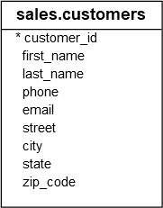

### The % (percent) wildcard examples

The following example finds the customers whose last name starts with the letter z:

SELECT

customer_id,

first_name,

last_name

FROM

sales.customers

WHERE

last_name LIKE 'z%'

ORDER BY

first_name;

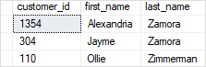

Q3: What is a checkpoint and when does it occur?

ANS- When more than one transaction are being executed in parallel, the logs are interleaved. At the time of recovery, it would become hard for the recovery system to backtrack all logs, and then start recovering. To ease this situation, most modern DBMS use the concept of 'checkpoints'.

Keeping and maintaining logs in real time and in real environment may fill out all the memory space available in the system. As time passes, the log file may grow too big to be handled at all. Checkpoint is a mechanism where all the previous logs are removed from the system and stored permanently in a storage disk. Checkpoint declares a point before which the DBMS was in consistent state, and all the transactions were committed.

**Checkpoint automatically occurs at:**

1.Checkpoint automatically occurs at a log switch.

2.When we will specify the parameter fast_start_mttr_target=<No of Seconds>.

3.When Normally forced by the Database Administrator.

4.If the datafile is offline checkpoint will occur.

Q4: What is E-R model?

An **Entity–relationship model (ER model)**describes the structure of a database with the help of a diagram, which is known as **Entity Relationship Diagram (ER Diagram)**. An ER model is a design or blueprint of a database that can later be implemented as a database. The main components of E-R model are: entity set and relationship set. An ER diagram shows the relationship among entity sets. An entity set is a group of similar entities and these entities can have attributes. In terms of DBMS, an entity is a table or attribute of a table in database, so by showing relationship among tables and their attributes, ER diagram shows the complete logical structure of a database. Lets have a look at a simple ER diagram to understand this concept. 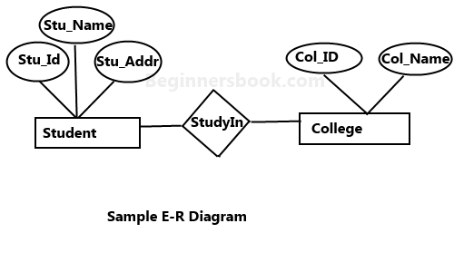

Q5: What is denormalization in DBMS?

ANS- Denormalization is a database optimization technique in which we add redundant data to one or more tables. This can help us avoid costly joins in a relational database. Note that denormalization does not mean not doing normalization. It is an optimization technique that is applied after doing normalization.

In a traditional normalized database, we store data in separate logical tables and attempt to minimize redundant data. We may strive to have only one copy of each piece of data in database.  
For example, in a normalized database, we might have a Courses table and a Teachers table.Each entry in Courses would store the teacherID for a Course but not the teacherName. When we need to retrieve a list of all Courses with the Teacher name, we would do a join between these two tables.

Q6: What is normalization in DBMS?

ANS-Normalization is the process of minimizing redundancy from a relation or set of relations. Redundancy in relation may cause insertion, deletion and updation anomalies. So, it helps to minimize the redundancy in relations. Normal forms are used to eliminate or reduce redundancy in database tables.