resource "aws_iam_user" "users" {
name = var.project-sapphire-users[count.index]
count = length(var.project-sapphire-users)
}

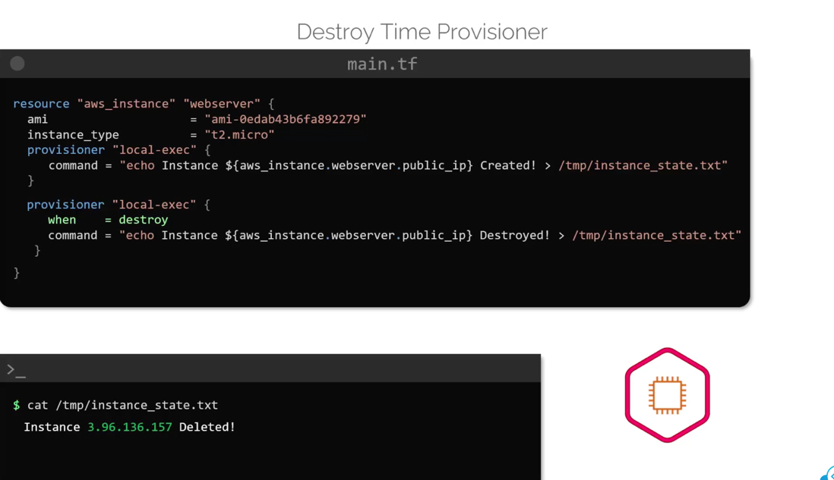

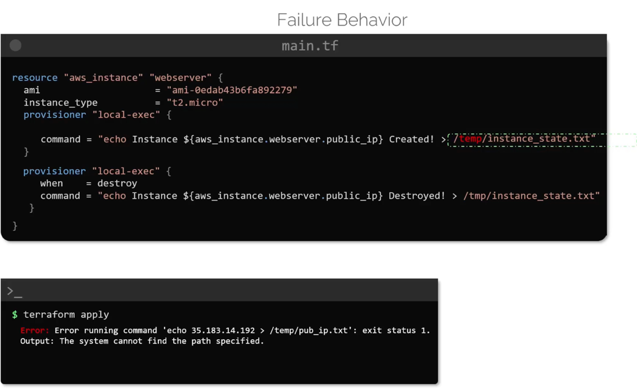

In this case incorrect path is used

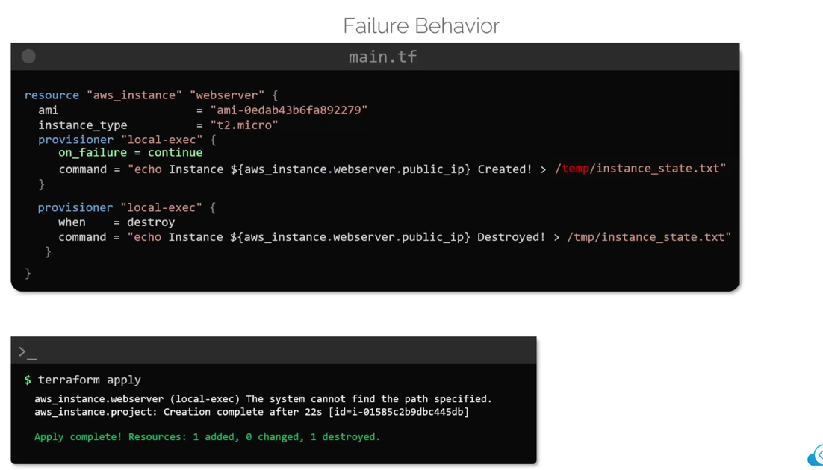

Even if the proviisoner fails the resource will be created successfully

User data scripts only run at first boot whereas the instance modification causes a reboot.

Provisioner block -> inside resource block

Terraform taint

Terraform log levels

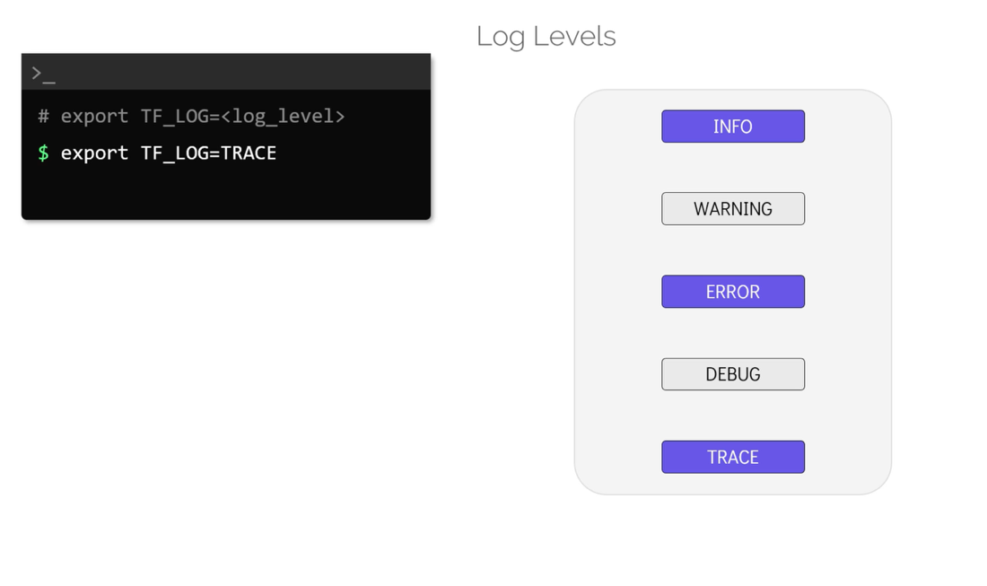

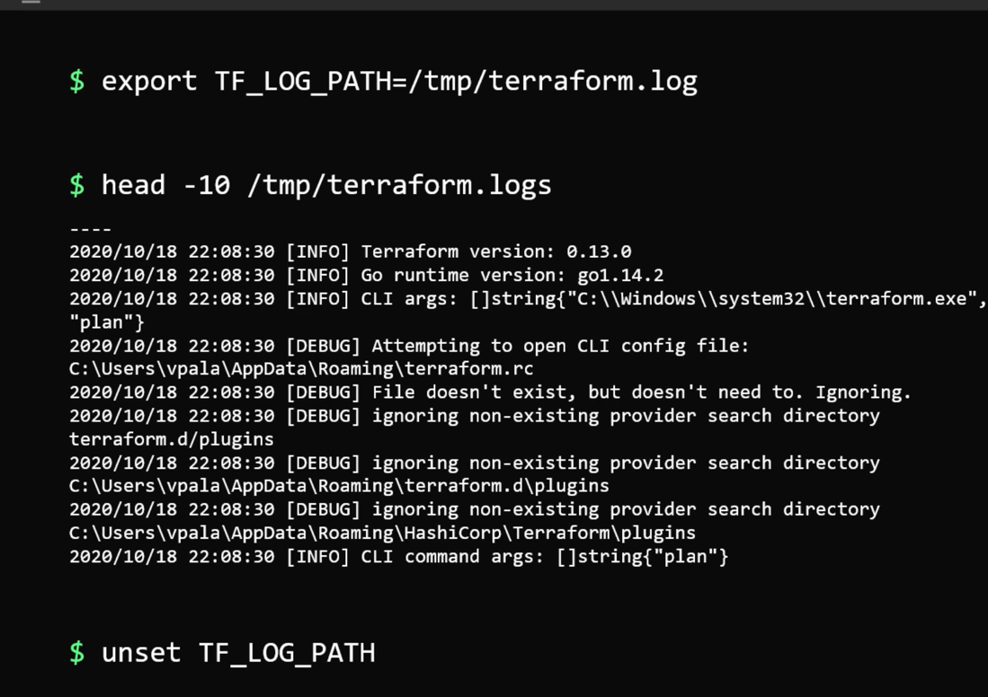

To disable logging above unset is used

export TF_LOG=ERROR -> is used to set the Terraform logging level to ERROR in your current shell session.
By setting this Terraform will display only error logs

export TF_LOG_PATH=/tmp/ProjectA.log is used to tell Terraform where to write its logs

What happens?
- Terraform writes logs to /tmp/ProjectA.log.
- The log level is controlled by TF_LOG.
- Console output remains cleaner because detailed logs go to the file

Terraform import -> it does not update the configuration file, it only updates the state file

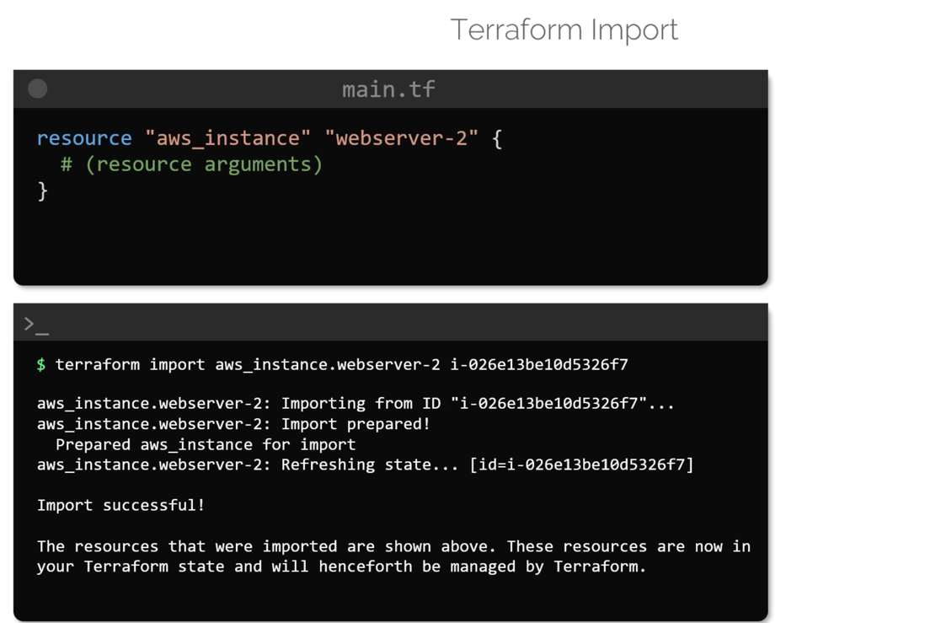

user_data_replace_on_change

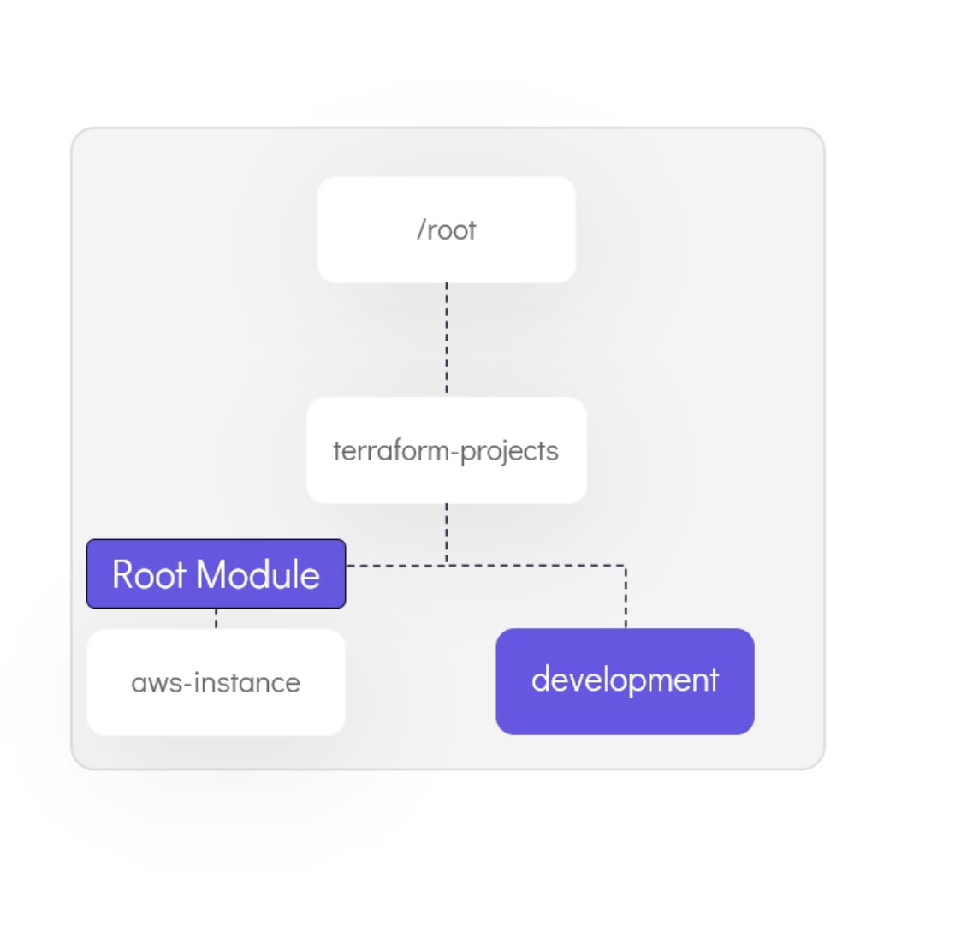
Root module and child module
Adv -> Simpler configuration files, Reusability, Lower Risk, Standarized configuration
Local module -> from local machine in files

# terraform get -> downloads latest modules from registry

Terraform functions
file() length() toset() index()

# terraform console -> provides interactive console

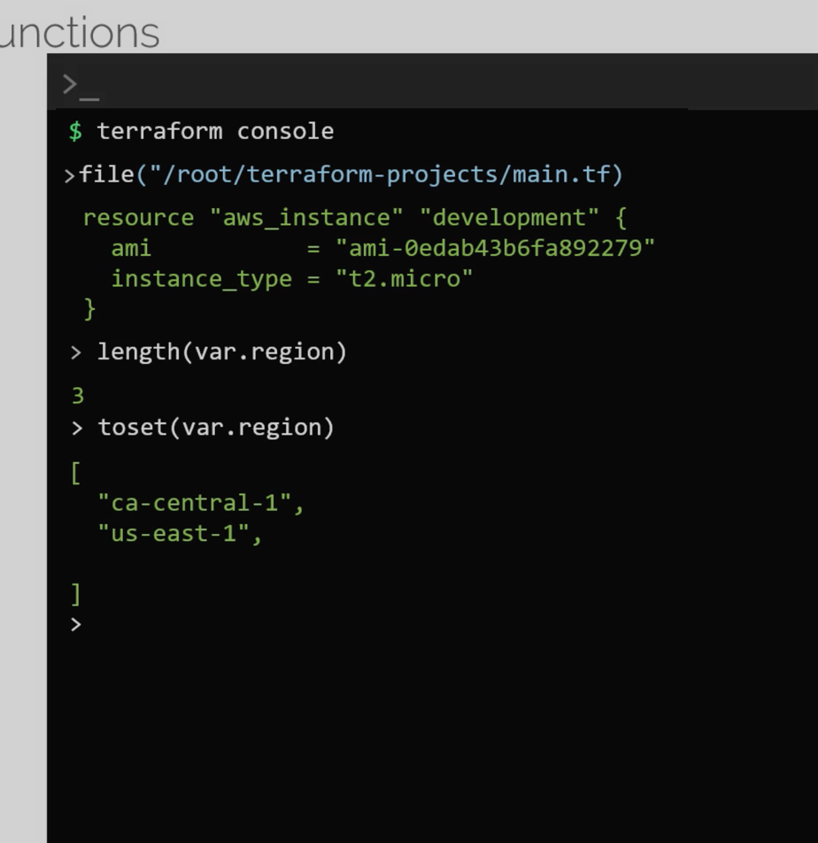

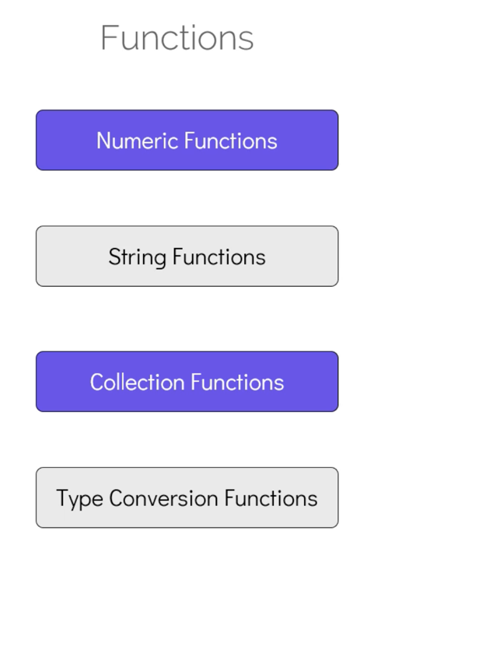

Operators and conditional expression

Lookup function -> works with map
what are meta-arguments ?

resource "aws_iam_user" "cloud" {
name = split(":",var.cloud_users)[count.index]
count = length(split(":",var.cloud_users))

}
Output :
aws_iam_user.cloud[0]: Creation complete after 1s [id=andrew]

====

Create an additional resource called upload_sonic_media to upload the files listed in the variable called media to this bucket.

Use the following specifications:

Use the for_each meta-argument to upload all the elements of the media variable.
bucket: Use reference expression to the bucket sonic-media.
source: Each element in the variable called media.
key: Should be the name of the files being uploaded (minus the /media/). For an example, eggman.jpg, shadow.jpg e.t.c.

====

Create an EC2 Instance with the resource name mario_servers.
Use the following specifications:
AMI: Use variable called ami.
Tags: Create a tag with key Name and value set to the variable called name.

Instance_type: Use a conditional expression so that - If the instance is created with a tag Name = "tiny", it should use the variable called small else the variable called large.
We will supply the variable called name using the -var command line flag.

resource "aws_instance" "mario_servers" {
ami = var.ami
instance_type = var.name == "tiny" ? var.small : var.large
tags = {
Name = var.name

}

}

====

# terraform workspace new projectA
# terraform workspace list

Workspace

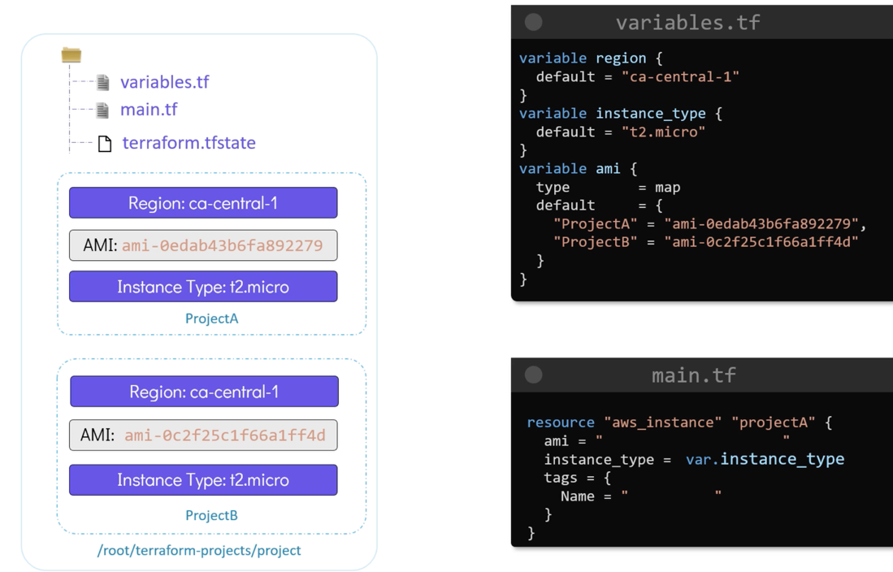

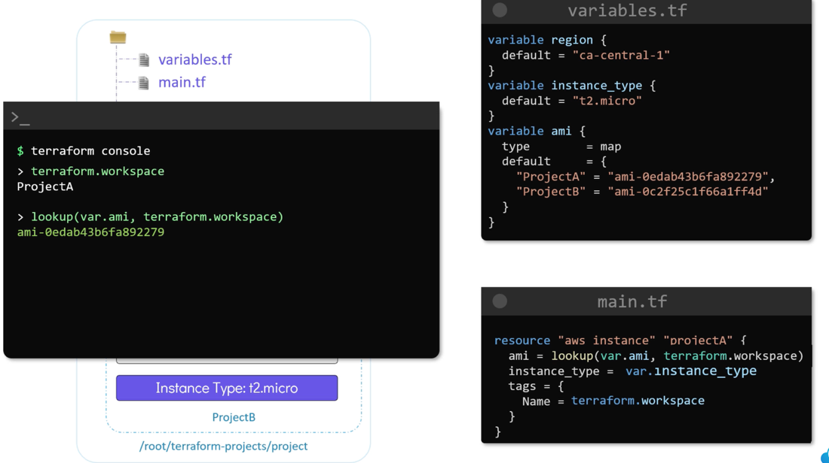

# terraform workspace select ProjectA

For workspaces state file is -> terraform.tfstate.d
tree terraform.tfstate.d

======

update the main.tf of the root module to call the child module located at /root/terraform-projects/modules/payroll-app. Adhere to the following specifications:
- module name: payroll_app
- This module expects two mandatory arguments:
a. app_region - use the values from variable called region
b. ami - use the values from the variable called ami
- The values for these two arguments should be selected based on the workspace you are on
For example, if on us-payroll workspace, the app_region should be us-east-1 and the ami ami-24e140119877avm OR for uk-payroll, the app_region should be eu-west-2 and the ami ami-35e140119877avm e.t.c .

module "payroll_app" {
source = "/root/terraform-projects/modules/payroll-app"
app_region = lookup(var.region, terraform.workspace)
ami = lookup(var.ami, terraform.workspace)
}

