Content tracker
Distributed version control system

Working Directory --> Staging Area (Index) --> Repository (Commit)
git add git commit

1. Working Area (Working Directory)
- The files you are currently editing on your local machine.
- Changes here are not tracked for the next commit until staged.
- Example:
  - Edit app.py
  - The modification exists only in the working directory.

# git status -> Check status

2. Staging Area (Index)
- A temporary area where you place changes that you want to include in the next commit.
- Use git add to move changes from the working directory to the staging area.

# git add app.py -> Stage a file

# git add . -> Stage all changes

3. Committed Files (Local Repository)
- Files whose changes have been permanently saved in Git history.
- After staging, use git commit to create a snapshot.

# git commit -m "Added new feature" -> Commit staged changes:

Useful commands

Command | Purpose
git status | Show working/staged changes
git add <file> | Move changes to staging area
git restore <file> | Discard changes from working area
git restore --staged <file> | Remove from staging area
git commit -m "msg" | Commit staged changes
git log --oneline | View commit history

# git branch -> List, create, or delete branches
# git fetch -> Download objects and refs from another repository
# git init -> Create an empty Git repository or reinitialize an existing one
# git status

# git config user.name "Sarah"
# git config user.email "sarah123@gmail.com"
# git commit

With git commit , git stores a copy of file that we commited

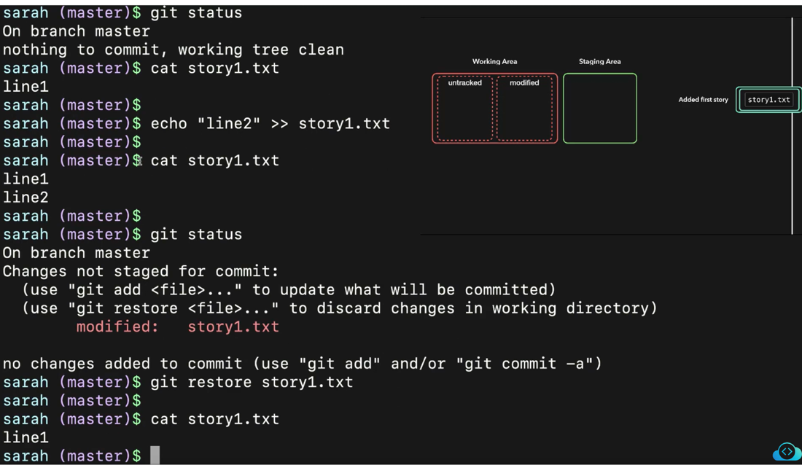

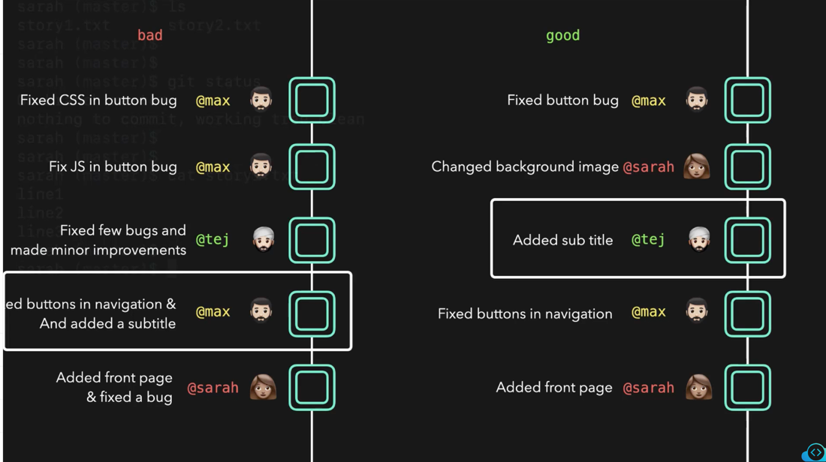

# git rm <filename>
# git rm --cached <filename>
# echo"notes.txt" >> .gitignore

Which area of a local Git repository contains files with active (uncommitted) changes immediately after initializing the repository?
-> Working area

# git log --name-only
# git log -n 1
# git log --name-only

# git checkout -b Sarah -> Create and switch to new branch
# git branch -> to list all new branches
# git branch <branch-name> to switch to an existing branch
# git branch -d <branch-name>
In Git, HEAD is a special pointer that refers to the currently checked-out commit (usually the tip of the current branch).

git diff HEAD~1 HEAD #Compare current commit with the previous commit.

What is the default branch of a git repository? -> Master

git log --graph --decorate to see previous commit history along with the branch they were committed on.

Types of merge in git

git remote add origin https://.../.../[namel.git

git fetch origin master -> to fetch remote changes

git fetch → Download changes from a remote repository.
origin → The remote repository name (usually the default remote).
master → The specific branch to fetch.

sarah@dev01 story-blog on  master ➜ git branch -a
* master
story/frogs-and-ox
remotes/origin/HEAD -> origin/master
remotes/origin/master

===
we can update our local master branch with the latest changes made on origin/master branch.
Merge the remote master branch to local master

# git merge origin/master

# git pull origin master
does two things:
- Fetches the latest changes from the remote repository origin for the master branch.
- Merges those changes into your current local branch.

It is equivalent to below 2 commands
git fetch origin master
git merge origin/master

Merge conflict

it log origin/master

Rebasing in Git is the process of moving or replaying commits from one branch onto another base commit.
In simple terms, instead of merging branches together with a merge commit, Git re-applies your branch's commits on top of the latest branch history, creating a cleaner, linear commit history.

Interactive rebasing

# git rebase -i HEAD~4

What is git cherry-pick?
git cherry-pick lets you apply a specific commit from one branch onto another branch without merging the entire branch.

# git revert <commit-id>

# git reset --soft HEAD~1

Stashing

Git stash is a Git feature that lets you temporarily save your uncommitted changes without committing them to the repository.
Think of it as putting your current work aside so you can switch branches, pull updates, or work on something else, and then come back later.

# git stash ls
# git stash show stash@{}
# git stash popstash@{}

What is git reflog?
git reflog (reference log) records changes to the tips of branches and HEAD in your local repository. It acts like a history of where your branch pointers have been, even if commits are no longer visible in the normal commit history.
It's extremely useful for recovering lost commits after operations such as:
- git reset --hard
- git rebase
- git commit --amend
- Deleting a branch accidentally

# git reset --hard HEAD~1
# git reflog
# git reset --hard <commit id>

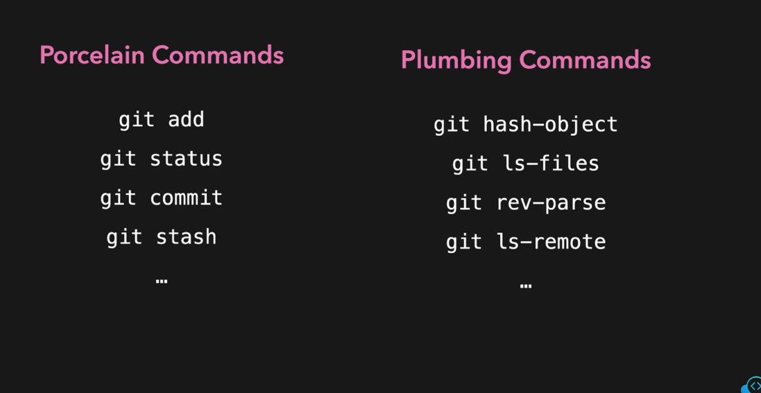

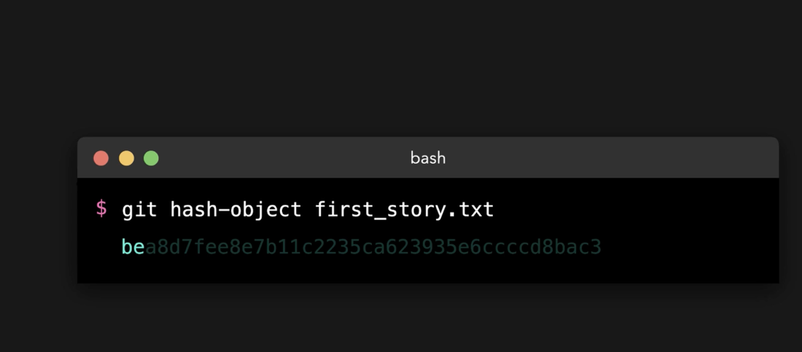

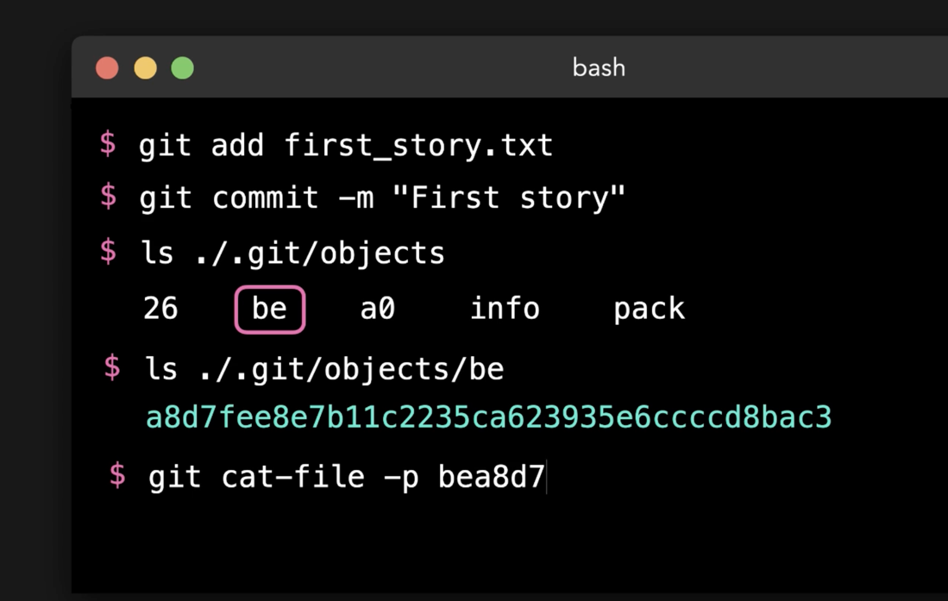

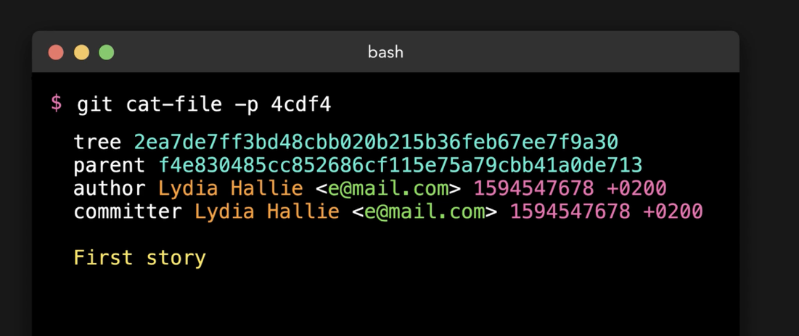

Git Object contents
-> Commit
-> Tree
-> Blob

Which flag of the git reset command can be used to retain changes that were made on target commit after the reset operation?
--soft

Which flag of git reset command can be used to drop changes that were made on target commit after the reset operation?
--hard

Sarah has been adding additional content to the Hare and Tortoise story. She accidentally commits the current version before actually finishing the story.
Help Sarah revert the last commit but retain the unfinished changes so that she can continue to finish her story. The last commit must not be part of the GIT history.

git reset --soft HEAD~1

She takes a short break, and then reads through the new version of her story. But she does not like it 😕. The old version was so much better.
She is so embarrassed 😦 with the new version that she does not want it to be in the commit history at all. Help Sarah reset her story to the previous good version of the story and remove all commits and changes she made since the commit Finish hare-and-tortoise story

sarah@dev01 story-blog on  master ➜ git log --oneline
83bc95b (HEAD -> master) Improve story one final time
57f0398 Improve story again
2c2f73c Improve story
496c2f6 Finish hare-and-tortoise story
c3e9b75 Revert "Add author info to stories"
e394323 Reapply "Add author info to stories"
4c6bd84 Revert "Add author info to stories"
d1ed0f9 Add author info to stories
daf69bf Add stories

# git stash pop
# git stash list

Run git stash show stash@{0} ; git stash show stash@{1}; git stash show stash@{2} to check corresponding files.

Try to figure out what files are stashed in which of these stashes stash@{0}, stash@{1}, stash@{2} respectively.

# git stash show stash@{0}

