Difference between #!/bin/bash and #!/bin/sh

./file.sh
Or
sh file.sh

4 -> read
2 -> write
1 -> execute

User group everyone

chmod 777

nproc -> cpu
free -> memory
Instaed of above can use top

set -x -> debug mode (it will show you the command what it is executing and better than echo statement)
df -h -> disk space
free -g
nproc

# ps -ef -> to show the process running

Stdin stdout stderr

# date | echo "today is" -> wont work (int question)

Learn about awk

ps -ef | grep amazon | awk -F" " '{print $2}'

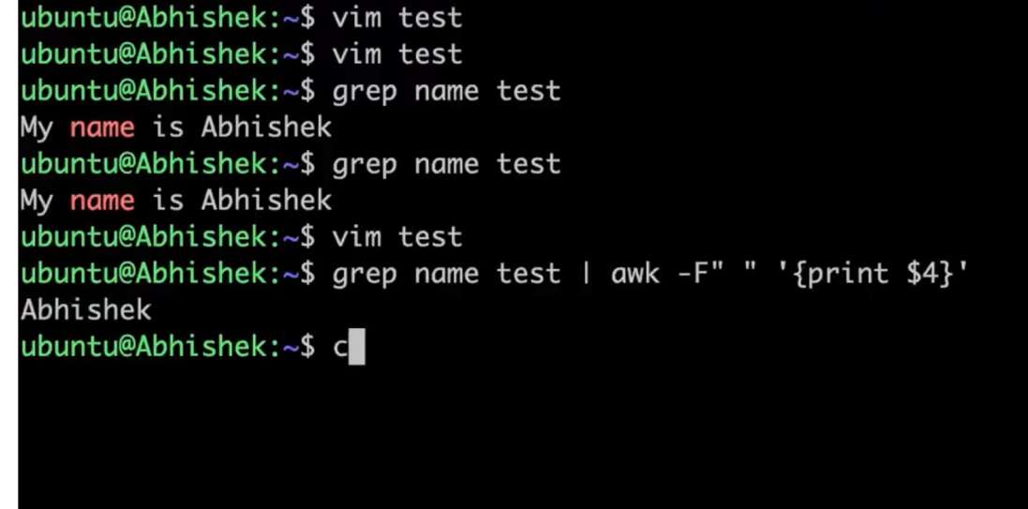

set -e -> exit the script when there is an error
set -o pipeline

Wget url downloads thr file where curl just shows o/p

sudo su -

sudo find / -name <filename>

Variables -> alphanumeric or underscores, case sensitive



i) List some of the commonly used shell commands ?
ii) Write a simple script to list all process
ps -ef | awk F"" '{print $2}
iii) Write a script to print only errors from a remote log
curl url | grep
iv) Write a shell script to print numbers divided by 3 and 5 and not 15
confirm for how much range (range)
divisible by 3 (if) divisible by 5 (if) not divisible by 15 (not if )
v) Write a script to print number of "s" in mississippi
#!/bin/bash
x=mississipi
grep -o "s" <<"$x" | wc -l
vi) How do you debug the shell script
set -x
vii) What is crontab in Linux ? Can you provide an example of usage ?
viii) what is the difference between soft and hard link ?
Ix) What is the difference between break and continue statements ?

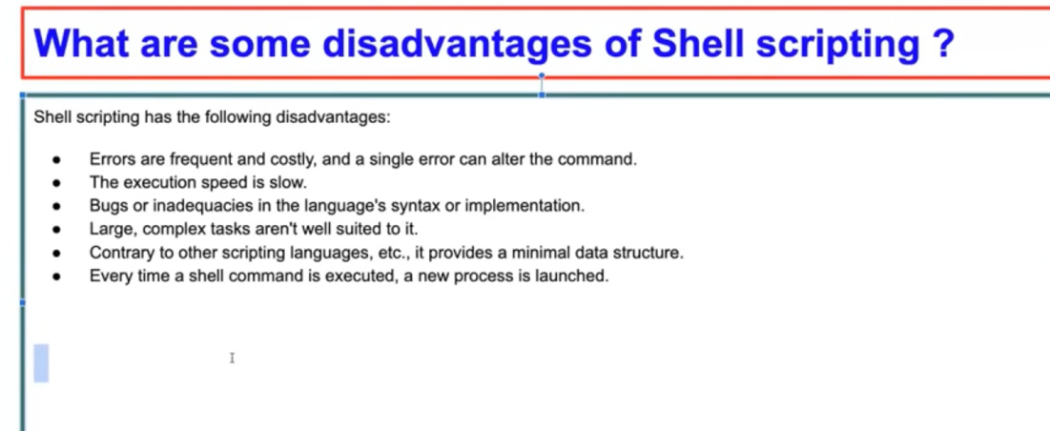

What are the different types of loops and when to use it ?
Is bash dynamic or statically typed and why ?
Explain about a network troubleshooting utility ?
How will you sort list of names in a file ?
How will you manage logs of a system that generate huge files everyday?
Logrotate

Variable should be encapsulated in { }. Change variable to ${file_name}_bkp



Read inputs

read -p "Enter mission name: " mission_name

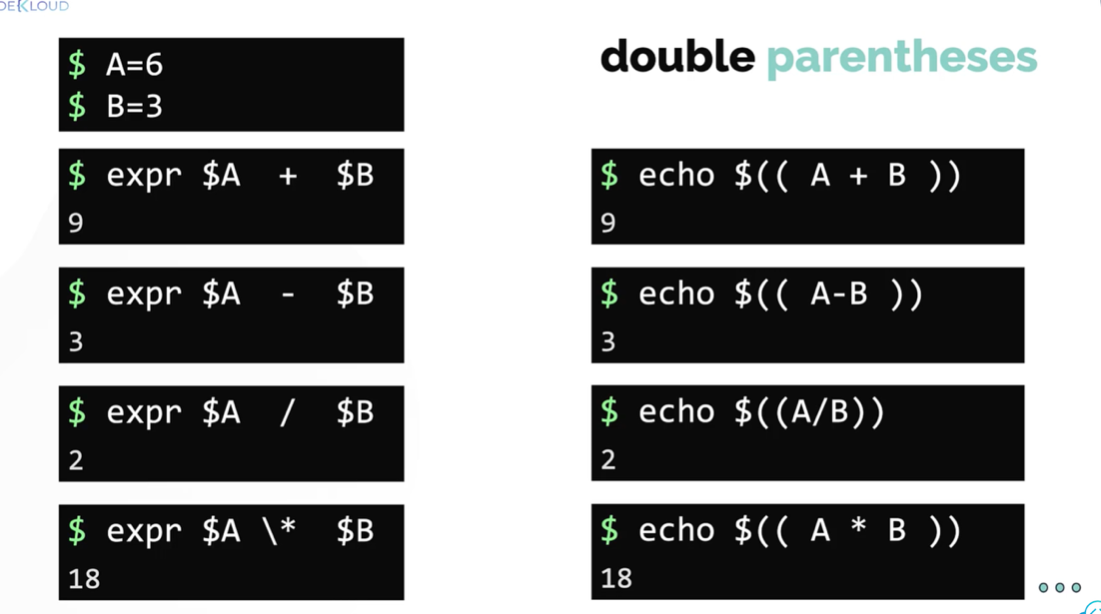

Parenthesis does not support floating numbers

Create a new script called calculate-average.sh. The script should accept exactly 3 command-line arguments and calculate the average.
The result should not round the value to the nearest integer.

num1=$1
num2=$2
num3=$3
sum=$(( num1 + num2 + num3 ))
average=$(echo "$sum / 3" | bc -l)
echo $average

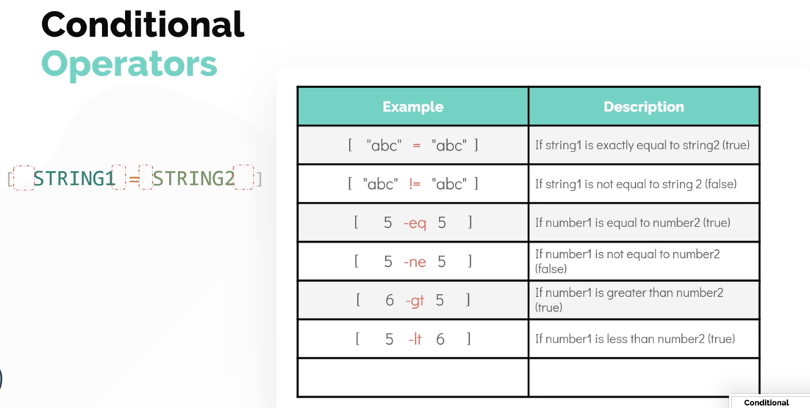

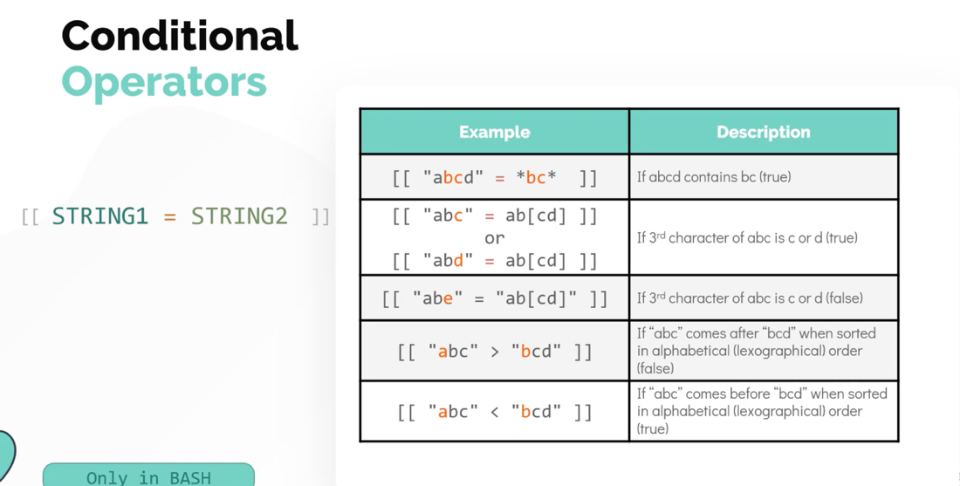

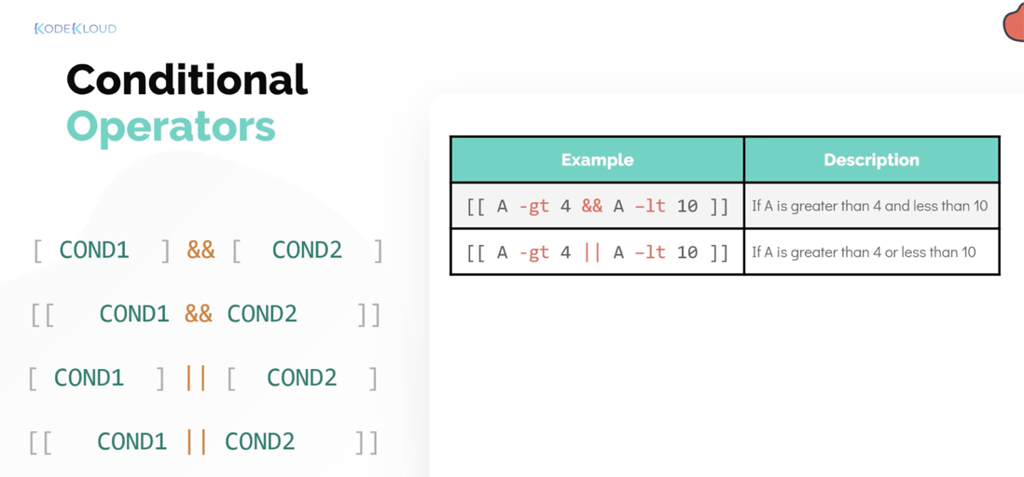

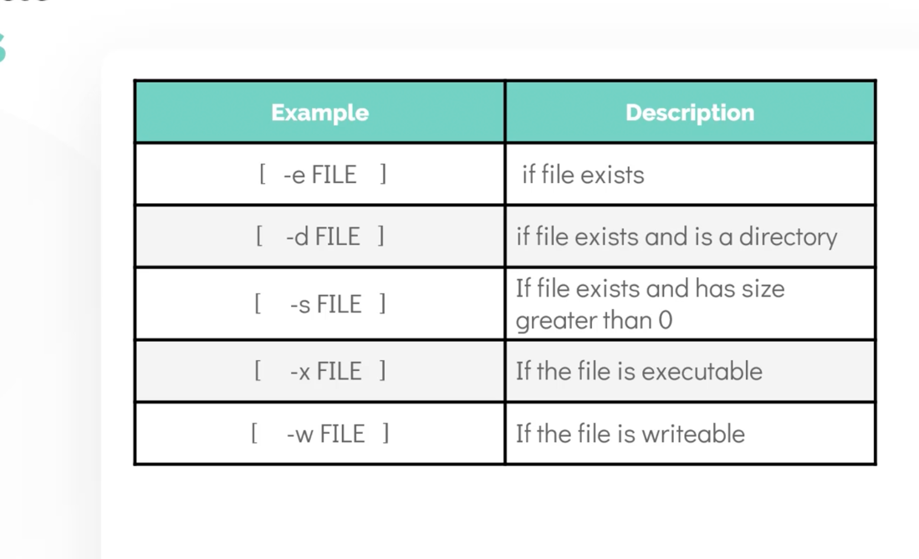

for loop

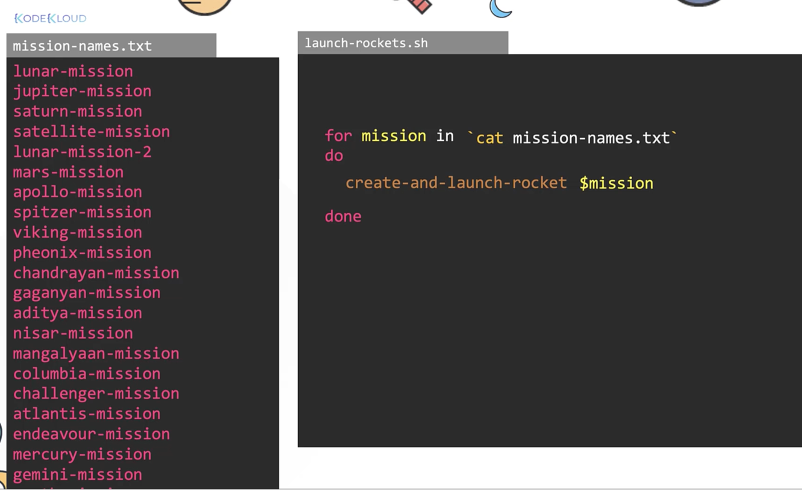

do and done -> start and end

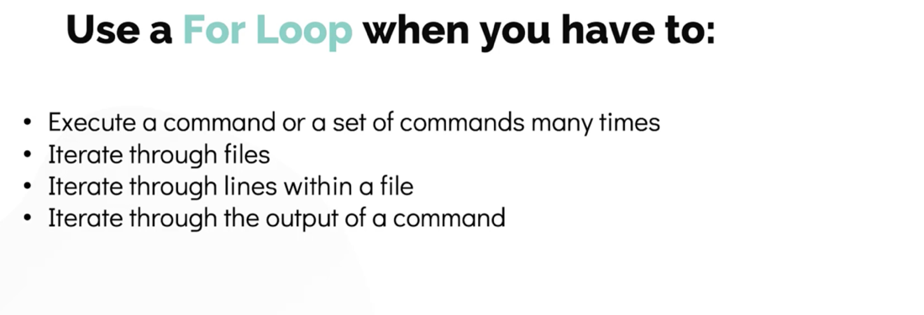

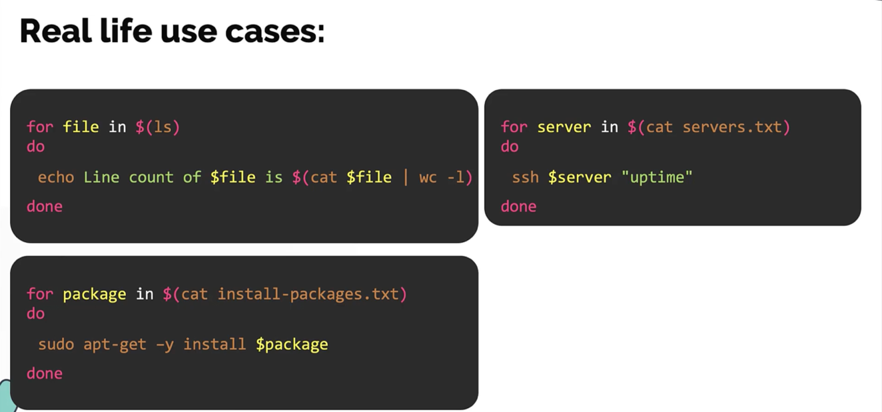

While -> executes the loop as long as the condition is true


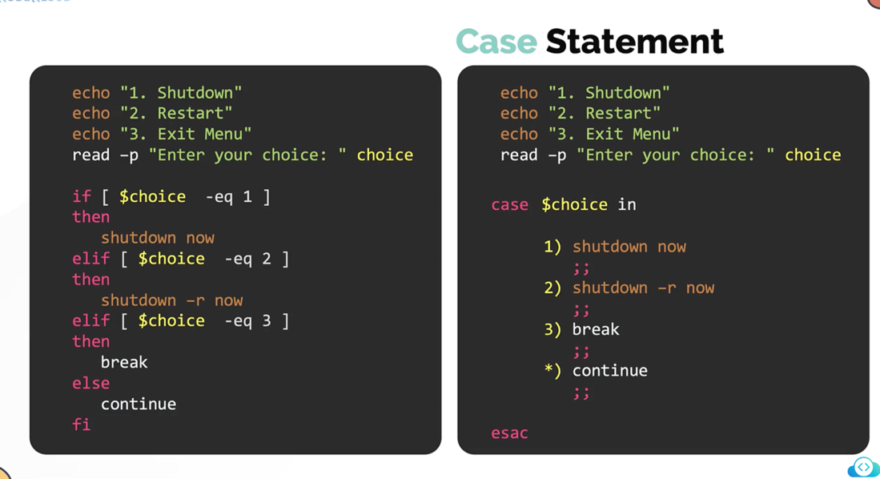

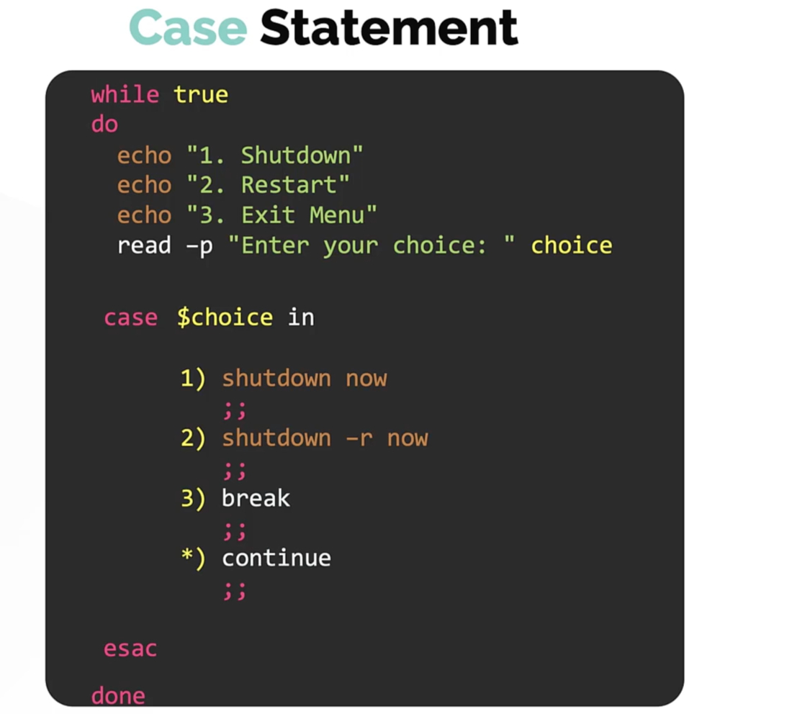

=========

Create a shell script in the home directory called check_greater.sh. The script should check the greater of the two command line arguments $1 and $2 and print which ever is greater

if [ $1 -gt $2 ]
then
echo "$1"
else
echo "$2"
fi

============

if [ -d "/home/bob/caleston" ]
then
echo "Directory exists"
else
echo "Directory not found"
fi

============

Develop a shell script /home/bob/print-month-name.sh that accepts the number of a month as input and prints the name of the respective month. eg ./print-month-name.sh 1 should print January and ./print-month-name.sh 5 should print May. Also keep these in mind.
- The script must accept a month number as a command line argument.
- If a month number is not provided as command line argument, the script must exit with the message No month number given.
- The script must not accept a value other than 1 to 12. If not the script must exit with the error Invalid month number given.

month_number=$1

if [ -z $month_number ]
then
echo "No month number given. Please enter a month number as a command line argument."
echo "eg: ./print-month-number 5"
exit
fi

if [[ $month_number -lt 1 ]] || [[ $month_number -gt 12 ]]
then
echo "Invalid month number given. Please enter a valid number - 1 to 12."
exit
fi

if [ $month_number -eq 1 ]
then
echo "January"
elif [ $month_number -eq 2 ]
then
echo "February"
elif [ $month_number -eq 3 ]
then
echo "March"
elif [ $month_number -eq 4 ]
then
echo "April"
elif [ $month_number -eq 5 ]
then
echo "May"
elif [ $month_number -eq 6 ]
then
echo "June"
elif [ $month_number -eq 7 ]
then
echo "July"
elif [ $month_number -eq 8 ]
then
echo "August"
elif [ $month_number -eq 9 ]
then
echo "September"
elif [ $month_number -eq 10 ]
then
echo "October"
elif [ $month_number -eq 11 ]
then
echo "November"
elif [ $month_number -eq 12 ]
then
echo December
fi

bob@caleston-lp10:~$ ./print-month-name.sh
No month number given. Please enter a month number as a command line argument.
eg: ./print-month-number 5
bob@caleston-lp10:~$ ./print-month-name.sh 1
January

=====

for mission in lunar-mission mars-mission jupiter-mission saturn-mission mercury-mission
do
bash /home/bob/create-and-launch-rocket $mission
done

====
Create a simple script called loop.sh at /home/bob. The script should make use of a loop and print the numbers 31 to 40 with each number in a new line.

for i in {31..40}
do
echo $i
done

====

We have a few different applications running on this system. The list of applications is stored in the /home/bob/apps.txt file. Each application has it's logs stored in the /var/log/apps directory under a file with its name. Check it out!
A simple version of the script has been developed for you named /home/bob/count-requests.sh, which inspects the log file of an application and prints the number of GET, POST, and DELETE requests. Update the script to use a for loop to read the list of applications from the apps.txt file, and count the number of requests for each application, and display it in a tabular format like this.

echo -e " Log name \t GET \t POST \t DELETE "
echo -e "------------------------------------------------------------"

for app in $(cat /home/bob/apps.txt)
do
get_requests=$(cat /var/log/apps/${app}_app.log | grep "GET" | wc -l)
post_requests=$(cat /var/log/apps/${app}_app.log | grep "POST" | wc -l)
delete_requests=$(cat /var/log/apps/${app}_app.log | grep "DELETE" | wc -l)
echo -e " ${app} \t ${get_requests} \t ${post_requests} \t ${delete_requests}"
done

====

We have some images under the directory /home/bob/images. Develop a script /home/bob/rename-images.sh to rename all files within the images folder that has extension jpeg to jpg. A file with any other extension should remain the same.
Tip: Use a for loop to iterate over the files within /home/bob/images
Tip: Use an if conditional to check if the file extension is jpeg.
Tip: Use mv to rename a file.
To replace jpeg to jpg in a filename use echo user1.jpeg | sed 's/jpeg/jpg/g'.

for file in $(ls images)
do
if [[ $file = *.jpeg ]]
then
new_name=$(echo $file| sed 's/jpeg/jpg/g')
mv images/$file images/$new_name
fi
done

=====

- s → substitute (replace)
- jpeg → text to find
- jpg → replacement text
- g → replace all occurrences on the line

function()
return 1

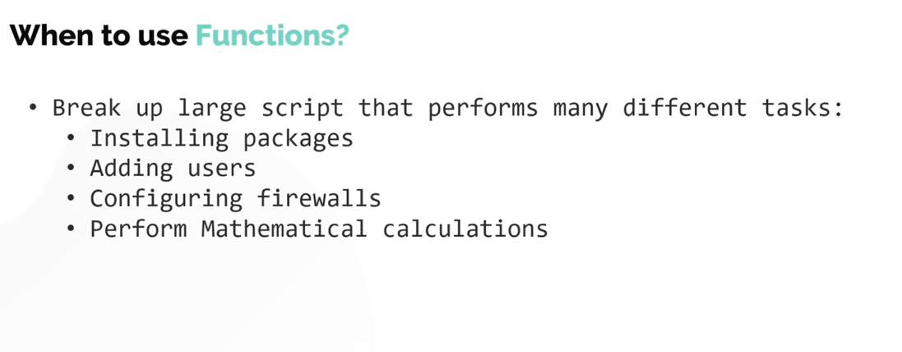
In return , you cannot return a text



shellcheck utility
shellcheck script.sh

pycharm

Difference between #!/bin/bash and #!/bin/sh

./file.sh
Or
sh file.sh

4 -> read
2 -> write
1 -> execute

User group everyone

chmod 777

nproc -> cpu
free -> memory
Instaed of above can use top

set -x -> debug mode (it will show you the command what it is executing and better than echo statement)
df -h -> disk space
free -g
nproc

# ps -ef -> to show the process running

Stdin stdout stderr

# date | echo "today is" -> wont work (int question)

Learn about awk

ps -ef | grep amazon | awk -F" " '{print $2}'



set -e -> exit the script when there is an error
set -o pipeline

Wget url downloads thr file where curl just shows o/p

sudo su -

sudo find / -name <filename>

Variables -> alphanumeric or underscores, case sensitive



i) List some of the commonly used shell commands ?
ii) Write a simple script to list all process
ps -ef | awk F"" '{print $2}
iii) Write a script to print only errors from a remote log
curl url | grep
iv) Write a shell script to print numbers divided by 3 and 5 and not 15
confirm for how much range (range)
divisible by 3 (if) divisible by 5 (if) not divisible by 15 (not if )
v) Write a script to print number of "s" in mississippi
#!/bin/bash
x=mississipi
grep -o "s" <<"$x" | wc -l
vi) How do you debug the shell script
set -x
vii) What is crontab in Linux ? Can you provide an example of usage ?
viii) what is the difference between soft and hard link ?
Ix) What is the difference between break and continue statements ?



What are the different types of loops and when to use it ?
Is bash dynamic or statically typed and why ?
Explain about a network troubleshooting utility ?
How will you sort list of names in a file ?
How will you manage logs of a system that generate huge files everyday?
Logrotate

Variable should be encapsulated in { }. Change variable to ${file_name}_bkp



Read inputs

read -p "Enter mission name: " mission_name



Parenthesis does not support floating numbers

Create a new script called calculate-average.sh. The script should accept exactly 3 command-line arguments and calculate the average.
The result should not round the value to the nearest integer.

num1=$1
num2=$2
num3=$3
sum=$(( num1 + num2 + num3 ))
average=$(echo "$sum / 3" | bc -l)
echo $average









for loop



do and done -> start and end





While -> executes the loop as long as the condition is true






=========

Create a shell script in the home directory called check_greater.sh. The script should check the greater of the two command line arguments $1 and $2 and print which ever is greater

if [ $1 -gt $2 ]
then
echo "$1"
else
echo "$2"
fi

============

if [ -d "/home/bob/caleston" ]
then
echo "Directory exists"
else
echo "Directory not found"
fi

============

Develop a shell script /home/bob/print-month-name.sh that accepts the number of a month as input and prints the name of the respective month. eg ./print-month-name.sh 1 should print January and ./print-month-name.sh 5 should print May. Also keep these in mind.
- The script must accept a month number as a command line argument.
- If a month number is not provided as command line argument, the script must exit with the message No month number given.
- The script must not accept a value other than 1 to 12. If not the script must exit with the error Invalid month number given.

month_number=$1

if [ -z $month_number ]
then
echo "No month number given. Please enter a month number as a command line argument."
echo "eg: ./print-month-number 5"
exit
fi

if [[ $month_number -lt 1 ]] || [[ $month_number -gt 12 ]]
then
echo "Invalid month number given. Please enter a valid number - 1 to 12."
exit
fi

if [ $month_number -eq 1 ]
then
echo "January"
elif [ $month_number -eq 2 ]
then
echo "February"
elif [ $month_number -eq 3 ]
then
echo "March"
elif [ $month_number -eq 4 ]
then
echo "April"
elif [ $month_number -eq 5 ]
then
echo "May"
elif [ $month_number -eq 6 ]
then
echo "June"
elif [ $month_number -eq 7 ]
then
echo "July"
elif [ $month_number -eq 8 ]
then
echo "August"
elif [ $month_number -eq 9 ]
then
echo "September"
elif [ $month_number -eq 10 ]
then
echo "October"
elif [ $month_number -eq 11 ]
then
echo "November"
elif [ $month_number -eq 12 ]
then
echo December
fi

bob@caleston-lp10:~$ ./print-month-name.sh
No month number given. Please enter a month number as a command line argument.
eg: ./print-month-number 5
bob@caleston-lp10:~$ ./print-month-name.sh 1
January

=====

for mission in lunar-mission mars-mission jupiter-mission saturn-mission mercury-mission
do
bash /home/bob/create-and-launch-rocket $mission
done

====
Create a simple script called loop.sh at /home/bob. The script should make use of a loop and print the numbers 31 to 40 with each number in a new line.

for i in {31..40}
do
echo $i
done

====

We have a few different applications running on this system. The list of applications is stored in the /home/bob/apps.txt file. Each application has it's logs stored in the /var/log/apps directory under a file with its name. Check it out!
A simple version of the script has been developed for you named /home/bob/count-requests.sh, which inspects the log file of an application and prints the number of GET, POST, and DELETE requests. Update the script to use a for loop to read the list of applications from the apps.txt file, and count the number of requests for each application, and display it in a tabular format like this.

echo -e " Log name \t GET \t POST \t DELETE "
echo -e "------------------------------------------------------------"

for app in $(cat /home/bob/apps.txt)
do
get_requests=$(cat /var/log/apps/${app}_app.log | grep "GET" | wc -l)
post_requests=$(cat /var/log/apps/${app}_app.log | grep "POST" | wc -l)
delete_requests=$(cat /var/log/apps/${app}_app.log | grep "DELETE" | wc -l)
echo -e " ${app} \t ${get_requests} \t ${post_requests} \t ${delete_requests}"
done

====

We have some images under the directory /home/bob/images. Develop a script /home/bob/rename-images.sh to rename all files within the images folder that has extension jpeg to jpg. A file with any other extension should remain the same.
Tip: Use a for loop to iterate over the files within /home/bob/images
Tip: Use an if conditional to check if the file extension is jpeg.
Tip: Use mv to rename a file.
To replace jpeg to jpg in a filename use echo user1.jpeg | sed 's/jpeg/jpg/g'.

for file in $(ls images)
do
if [[ $file = *.jpeg ]]
then
new_name=$(echo $file| sed 's/jpeg/jpg/g')
mv images/$file images/$new_name
fi
done

=====

- s → substitute (replace)
- jpeg → text to find
- jpg → replacement text
- g → replace all occurrences on the line

function()
return 1


In return , you cannot return a text



shellcheck utility
shellcheck script.sh

pycharm

Shell scripting tasks

Let's update our script to take into consideration the time a rocket spends in a launching state.
The script is available at the path /home/bob/create-and-launch-rocket. Add a while loop before the if conditional statements that checks the status of rocket to wait until the rocket is in a launching state

mission_name=$1

mkdir $mission_name

rocket-add $mission_name

rocket-start-power $mission_name
rocket-internal-power $mission_name
rocket-start-sequence $mission_name
rocket-start-engine $mission_name
rocket-lift-off $mission_name

rocket_status=$(rocket-status $mission_name)

echo "The status of launch is $rocket_status"

while [ $rocket_status = "launching" ]
do
sleep 2
rocket_status=$(rocket-status $mission_name)
done

if [ $rocket_status = "failed" ]
then
rocket-debug
fi

=====

A script called print-numbers.sh is created in the home directory. There is a syntax error in the script. Identify it and fix it so that it works
Execute the script with a number as an argument - ./print-numbers.sh 10. Do not make any other changes to the script other than fixing the error.

Note :- Run the command chmod +x to make it script executable .

to_number=$1
number=0
while [ $number -lt $to_number ]
do
echo $(( number++ ))
done

=====

Let us now build a menu driven calculator program. Develop a script /home/bob/calculator.sh that when run:
- Shows a menu-driven program with the following options:
- Add
- Subtract
- Multiply
- Divide
- Quit
- Depending on the input, the program must ask for 2 numbers - Number1 and Number2 and then print the result in the form Answer=6.
- The program must show the menu again until the user selects option 5 to quit.
while true
do
echo "1. Add"
echo "2. Subtract"
echo "3. Multiply"
echo "4. Divide"
echo "5. Quit"

read -p "Enter your choice: " choice

if [ $choice -eq 1 ]
then
read -p "Enter Number1: " number1
read -p "Enter Number2: " number2
echo Answer=$(( $number1 + $number2 ))
elif [ $choice -eq 2 ]
then
read -p "Enter Number1: " number1
read -p "Enter Number2: " number2
echo Answer=$(( $number1 - $number2 ))
elif [ $choice -eq 3 ]
then
read -p "Enter Number1: " number1
read -p "Enter Number2: " number2
echo Answer=$(( $number1 * $number2 ))
elif [ $choice -eq 4 ]
then
read -p "Enter Number1: " number1
read -p "Enter Number2: " number2
echo Answer=$(( $number1 / $number2 ))
elif [ $choice -eq 5 ]
then
break
fi

done

====

os=Fedora

case $os in
"Fedora") echo "Uses RPM package manager" ;;

"RHEL") echo "Uses RPM package manager" ;;

"CentOS") echo "Uses RPM package manager" ;;

"Debian") echo "Uses DEB package manager" ;;

"Ubuntu")
echo "Uses DEB package manager" ;;
esac

=====

month_number=$1

if [ -z $month_number ]
then
echo "No month number given. Please enter a month number as a command line argument."
echo "eg: ./print-month-number 5"
exit
fi

if [[ $month_number -lt 1 || $month_number -gt 12 ]]
then
echo "Invalid month number given. Please enter a valid number - 1 to 12."
exit
fi

case $month_number in
1) echo "January" ;;
2) echo "February" ;;
3) echo "March" ;;
4) echo "April" ;;
5) echo "May" ;;
6) echo "June" ;;
7) echo "July" ;;
8) echo "August" ;;
9) echo "September" ;;
10) echo "October" ;;
11) echo "November" ;;
12) echo "December" ;;
esac

Same script with case

while true
do
echo "1. Add"
echo "2. Subtract"
echo "3. Multiply"
echo "4. Divide"
echo "5. Quit"

read -p "Enter your choice: " choice

case $choice in
1)
read -p "Enter Number1: " number1
read -p "Enter Number2: " number2
echo Answer=$(( $number1 + $number2 ))
;;
2)
read -p "Enter Number1: " number1
read -p "Enter Number2: " number2
echo Answer=$(( $number1 - $number2 ))
;;

3)
read -p "Enter Number1: " number1
read -p "Enter Number2: " number2
echo Answer=$(( $number1 * $number2 ))
;;
4)
read -p "Enter Number1: " number1
read -p "Enter Number2: " number2
echo Answer=$(( $number1 / $number2 ))
;;
5)
break
;;
esac

done

====

the script even further by adding another option to calculate the average of two numbers.

while true
do
echo "1. Add"
echo "2. Subtract"
echo "3. Multiply"
echo "4. Divide"
echo "5. Average"
echo "6. Quit"

read -p "Enter your choice: " choice

case $choice in
1)
read -p "Enter Number1: " number1
read -p "Enter Number2: " number2
echo Answer=$(( $number1 + $number2 ))
;;
2)
read -p "Enter Number1: " number1
read -p "Enter Number2: " number2
echo Answer=$(( $number1 - $number2 ))
;;

3)
read -p "Enter Number1: " number1
read -p "Enter Number2: " number2
echo Answer=$(( $number1 * $number2 ))
;;
4)
read -p "Enter Number1: " number1
read -p "Enter Number2: " number2
echo Answer=$(( $number1 / $number2 ))
;;
5)
read -p "Enter Number1: " number1
read -p "Enter Number2: " number2
sum=$(( number1 + number2 ))
echo Answer=$(echo "$sum / 2" | bc -l)
;;
6)
break
;;
esac

done

===

A script called print-color.sh is created in the home directory. This script accepts a single command-line variable, which, if set to red or green, prints a colored sentence accordingly.

Update this script so that if we input any other color or value besides red or green, it should print the sentence red and green are the only choices.

color=$1
red=`tput setaf 1`
green=`tput setaf 2`
reset=`tput sgr0`

case $color in
red) echo "${red}this is red${reset}";;
green) echo "${green}this is green${reset}";;
*) echo "red and green are the only choices"
esac

=====

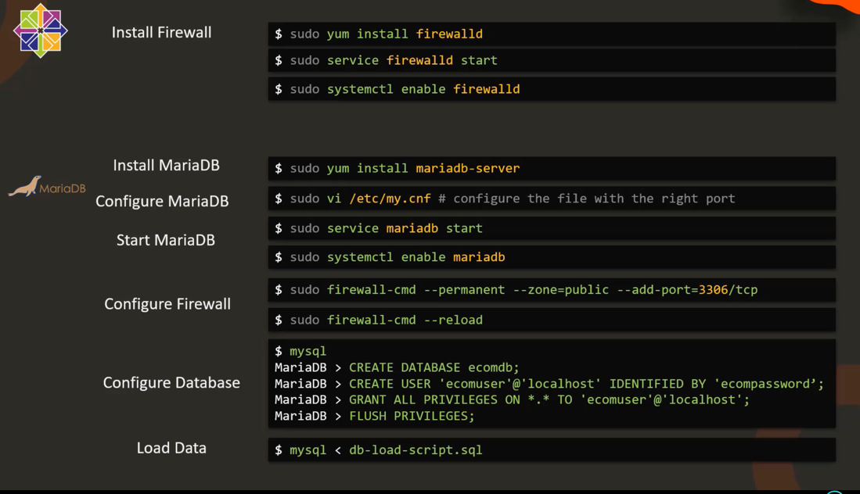

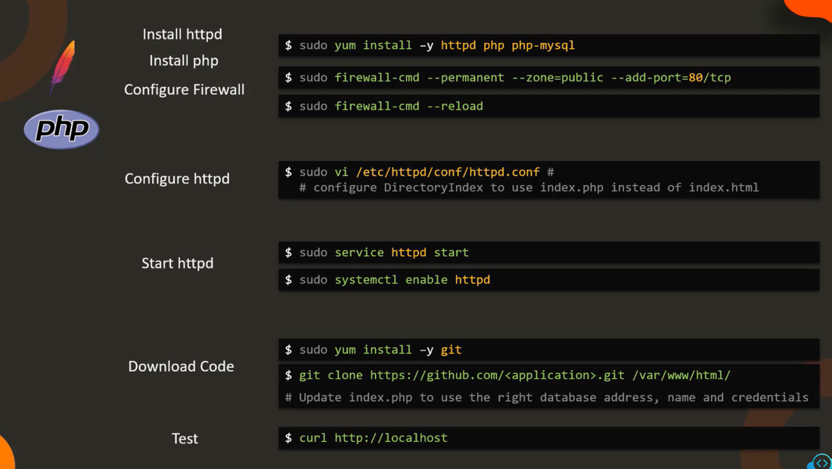

Project

#!/bin/bash
#
# Automate ECommerce Application Deployment
# Author: Mumshad Mannambeth

#######################################
# Print a message in a given color.
# Arguments:
# Color. eg: green, red
#######################################
function print_color(){
NC='\033[0m' # No Color

case $1 in
"green") COLOR='\033[0;32m' ;;
"red") COLOR='\033[0;31m' ;;
"*") COLOR='\033[0m' ;;
esac

echo -e "${COLOR} $2 ${NC}"
}

#######################################
# Check the status of a given service. If not active exit script
# Arguments:
# Service Name. eg: firewalld, mariadb
#######################################
function check_service_status(){
service_is_active=$(sudo systemctl is-active $1)

if [ $service_is_active = "active" ]
then
echo "$1 is active and running"
else
echo "$1 is not active/running"
exit 1
fi
}

#######################################
# Check the status of a firewalld rule. If not configured exit.
# Arguments:
# Port Number. eg: 3306, 80
#######################################
function is_firewalld_rule_configured(){

firewalld_ports=$(sudo firewall-cmd --list-all --zone=public | grep ports)

if [[ $firewalld_ports == *$1* ]]
then
echo "FirewallD has port $1 configured"
else
echo "FirewallD port $1 is not configured"
exit 1
fi
}

#######################################
# Check if a given item is present in an output
# Arguments:
# 1 - Output
# 2 - Item
#######################################
function check_item(){
if [[ $1 = *$2* ]]
then
print_color "green" "Item $2 is present on the web page"
else
print_color "red" "Item $2 is not present on the web page"
fi
}

echo "---------------- Setup Database Server ------------------"

# Install and configure firewalld
print_color "green" "Installing FirewallD.. "
sudo yum install -y firewalld

print_color "green" "Installing FirewallD.. "
sudo systemctl start firewalld
sudo systemctl enable firewalld

# Check FirewallD Service is running
check_service_status firewalld

# Install and configure Maria-DB
print_color "green" "Installing MariaDB Server.."
sudo yum install -y mariadb-server

print_color "green" "Starting MariaDB Server.."
sudo systemctl start mariadb
sudo systemctl enable mariadb

# Check FirewallD Service is running
check_service_status mariadb

# Configure Firewall rules for Database
print_color "green" "Configuring FirewallD rules for database.."
sudo firewall-cmd --permanent --zone=public --add-port=3306/tcp
sudo firewall-cmd --reload

is_firewalld_rule_configured 3306

# Configuring Database
print_color "green" "Setting up database.."
cat > setup-db.sql <<-EOF
CREATE DATABASE ecomdb;
CREATE USER 'ecomuser'@'localhost' IDENTIFIED BY 'ecompassword';
GRANT ALL PRIVILEGES ON *.* TO 'ecomuser'@'localhost';
FLUSH PRIVILEGES;
EOF

sudo mysql < setup-db.sql

# Loading inventory into Database
print_color "green" "Loading inventory data into database"
cat > db-load-script.sql <<-EOF
USE ecomdb;
CREATE TABLE products (id mediumint(8) unsigned NOT NULL auto_increment,Name varchar(255) default NULL,Price varchar(255) default NULL, ImageUrl varchar(255) default NULL,PRIMARY KEY (id)) AUTO_INCREMENT=1;

INSERT INTO products (Name,Price,ImageUrl) VALUES ("Laptop","100","c-1.png"),("Drone","200","c-2.png"),("VR","300","c-3.png"),("Tablet","50","c-5.png"),("Watch","90","c-6.png"),("Phone Covers","20","c-7.png"),("Phone","80","c-8.png"),("Laptop","150","c-4.png");

EOF

sudo mysql < db-load-script.sql

mysql_db_results=$(sudo mysql -e "use ecomdb; select * from products;")

if [[ $mysql_db_results == *Laptop* ]]
then
print_color "green" "Inventory data loaded into MySQl"
else
print_color "green" "Inventory data not loaded into MySQl"
exit 1
fi

print_color "green" "---------------- Setup Database Server - Finished ------------------"

print_color "green" "---------------- Setup Web Server ------------------"

# Install web server packages
print_color "green" "Installing Web Server Packages .."
sudo yum install -y httpd php php-mysqlnd

# Configure firewalld rules
print_color "green" "Configuring FirewallD rules.."
sudo firewall-cmd --permanent --zone=public --add-port=80/tcp
sudo firewall-cmd --reload

is_firewalld_rule_configured 80

# Update index.php
sudo sed -i 's/index.html/index.php/g' /etc/httpd/conf/httpd.conf

# Start httpd service
print_color "green" "Start httpd service.."
sudo systemctl start httpd
sudo systemctl enable httpd

# Check FirewallD Service is running
check_service_status httpd

# Download code
print_color "green" "Install GIT.."
sudo yum install -y git
sudo git clone https://github.com/kodekloudhub/learning-app-ecommerce.git /var/www/html/
sudo sed -i 's#// \(.*mysqli_connect.*\)#\1#' /var/www/html/index.php
sudo sed -i 's#// \(\$link = mysqli_connect(.*172\.20\.1\.101.*\)#\1#; s#^\(\s*\)\(\$link = mysqli_connect(\$dbHost, \$dbUser, \$dbPassword, \$dbName);\)#\1// \2#' /var/www/html/index.php

print_color "green" "Updating index.php.."
sudo sed -i 's/172.20.1.101/localhost/g' /var/www/html/index.php

print_color "green" "---------------- Setup Web Server - Finished ------------------"

# Test Script
web_page=$(curl http://localhost)

for item in Laptop Drone VR Watch Phone
do
check_item "$web_page" $item
done

