Azure | AWS | IBM Cloud
Virtual Machine Scale Set (VMSS) | Auto Scaling Group (ASG) | Instance Group
VM | EC2 Instance | VSI
Scale-out / Scale-in | Scale-out / Scale-in | Scale-out / Scale-in
Load Balancer | ELB/ALB/NLB | VPC Load Balancer
Autoscale Rules | Scaling Policies | Autoscaling Policies

Scalability
Elasticity
High availability
Disaster recovery
Resources, Resource group, Azure Resource manager

Azure Resource Manager (ARM) is the deployment and management service for Microsoft Azure. It provides a consistent management layer that enables you to create, update, organize, and delete Azure resources such as Virtual Machines, Storage Accounts, Databases, and Virtual Networks.

- Resource: An Azure service instance, such as a VM, Storage Account, or Web App.
- Resource Group: A logical container that holds related Azure resources managed together.
- Resource Provider: A service that supplies Azure resources (for example, Microsoft.Compute for VMs and Microsoft.Storage for Storage Accounts)
- ARM Template: A JSON-based Infrastructure as Code (IaC) template used to deploy Azure resources consistently and repeatedly

Benefits of ARM
- Infrastructure as Code (IaC) using ARM Templates or Bicep.
- Role-Based Access Control (RBAC) for secure resource access management
- Resource Tagging for organization and cost tracking.
- Resource Locks to prevent accidental deletion or modification.
- Consistent Deployment across development, test, and production environments.

While creating vm -> Run with Azure spot discount , read more on this

Appgateway -> LB -> Layer 7
Azure load balancer -> Layer 4
A Network Interface (NIC) in Azure is a core resource that connects a virtual machine (VM) to a virtual network (VNet), managing communication, IP configurations, and traffic rules

Custom data -> executes during the VM creation
User data -> persists throughout its lifetime

DNAT rules
priority -> 100 is least

IN AZURE, BY DEFAULT EACH INSTANCE WILL BE ATTACHED WITH "ALLOWVnetInBound" Inbound rule in NSG. THAT ALLOWS DEFAULT ACCESS TO FIREWALL AND OTHER RESOURCES WITH IN THE VNET. YOU CAN BLOCK THIS BY CREATING A NEW INBOUND RULE WITH MORE

AWS user data -> Azure custom data

Blob - Unstructured information such as CI/CD log files, CI/CD artifacts, Terraform Statefile e.t.c.,.
File - Kubernetes volume that is accessed by multiple Kubernetes pods.
Queues - Store the messages to send out notifications to report failures, success of pipelines or serverless functions.
Tables - Any kind of key-value pair data that has to be stored.

Storage account
Containers -> Blob storage (Large file, unstructured data, images, video, cose wise cheap)
File storage

Protocol used by Azure file share

# az deployment create --resource-group <rg-name> --template-file <file-name>

Storage account names should be unique

To write ARM template we need to provide basic details as below

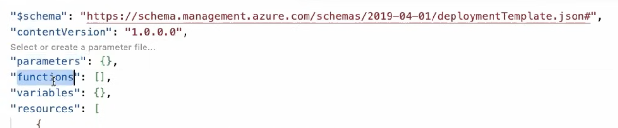

$schema
- Purpose: Defines the location of the JSON schema file that describes the structure of the template.
- Function: Tells your editor (like VS Code) and the Azure deployment engine how to validate the template syntax.
- Benefit: Enables autocomplete, error detection, and linting while writing code

🔢 contentVersion
- Purpose: Tracks the internal version of your specific template design (e.g., 1.0.0.0 or 2.1.0.3).
- Function: You provide this value to document changes to your template over time.
- Benefit: Distinguishes between different iterations of your deployment files; Azure does not use this value for deployment logic.

📥 parameters
- Purpose: Accepts custom inputs during deployment to make the template reusable across environments.
- Function: Defines variables that must be supplied when the deployment starts, such as usernames or VM sizes.
- Benefit: Allows you to use the exact same template file for Development, Staging, and Production by changing only the input values.

⚙️ variables
- Purpose: Stores reusable, calculated values internally within the template to simplify your code.
- Function: Combines strings, parameters, or functions into a single named entity (e.g., creating a unique storage account name).
- Benefit: Reduces code repetition across your resources and makes complex templates easier to read. [1, 2, 3, 4, 5]

🛠️ functions
- Purpose: Creates custom, user-defined functions to handle complex logic that built-in features cannot do natively.
- Function: Groups template functions into a custom namespace to perform calculations, string manipulation, or data parsing.
- Benefit: Keeps your main template clean by isolating repetitive or messy logical statements. [1, 2, 3, 4, 5]
🏗️ resources
- Purpose: Declares the actual Azure infrastructure components you want to deploy or update.
- Function: Specifies resource types, API versions, locations, and configurations (e.g., Virtual Networks, SQL databases).
- Benefit: Executes the core deployment, creating dependencies between resources so they spin up in the correct order.

The primary difference is that Azure ExpressRoute connects over a private, dedicated network circuit, while an Azure VPN connects over the public internet using encryption

Choose Azure VPN if:
- You have a tight budget or low data transfer needs.
- You need a fast setup completed within a few hours.
- You are connecting remote workers or small branch offices.
Choose ExpressRoute if:
- You require strict compliance and data privacy (no internet exposure).
- You regularly migrate massive volumes of data.
- Your business operations demand guaranteed network latency
- ====

Azure Management Groups are governance containers that help you organize and manage multiple Azure subscriptions in a hierarchy. They sit above subscriptions in the Azure resource hierarchy and allow you to apply policies, access controls, and compliance settings centrally.

Tenant Root Group
│
├── Management Group (Production)
│ ├── Subscription A
│ └── Subscription B
│
└── Management Group (Development)
├── Subscription C
└── Subscription D

Why Use Management Groups?
- Centralized Governance: Apply Azure Policies across multiple subscriptions from one place.
- RBAC Inheritance: Assign roles at the management group level and inherit permissions to child subscriptions
- Organize at Scale: Structure subscriptions by business unit, environment, geography, or application.
- Compliance Enforcement: Ensure standards such as allowed regions, tagging, and security requirements across all subscriptions.

Azure Landing Zone is a pre-designed, scalable Azure environment that provides the foundation for securely deploying and operating workloads in Azure. Think of it as a "ready-to-use Azure blueprint" that includes governance, security, networking, identity, and management best practices.
Why Do We Need a Landing Zone?
Without a landing zone:
- Teams create subscriptions independently.
- Security settings vary.
- Network connectivity becomes complex.
- Compliance and governance are difficult to enforce.
With a landing zone:
- Governance is standardized.
- Security controls are built in.
- Azure policies are enforced automatically.
- New applications can be onboarded quickly.

=====

Azure ExpressRoute is a networking service that provides a private, dedicated connection between your on-premises network (data center, office, or colocation facility) and Microsoft cloud services such as Azure and Microsoft 365. Unlike a VPN, ExpressRoute traffic does not travel over the public Internet

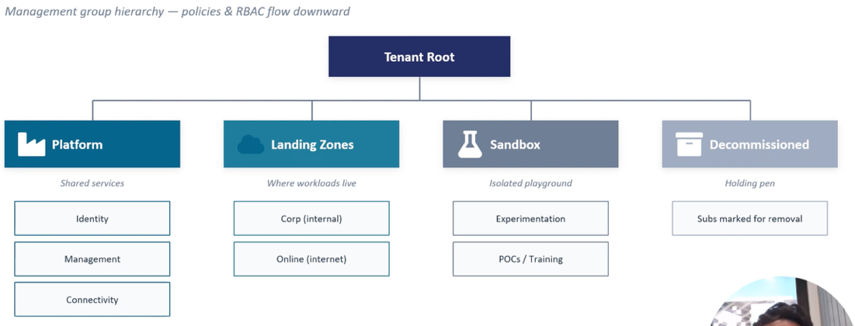

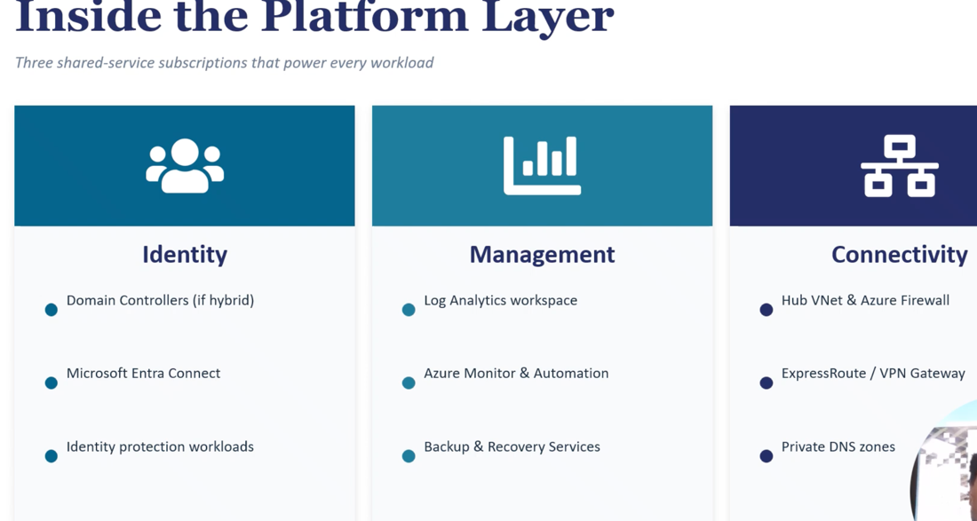

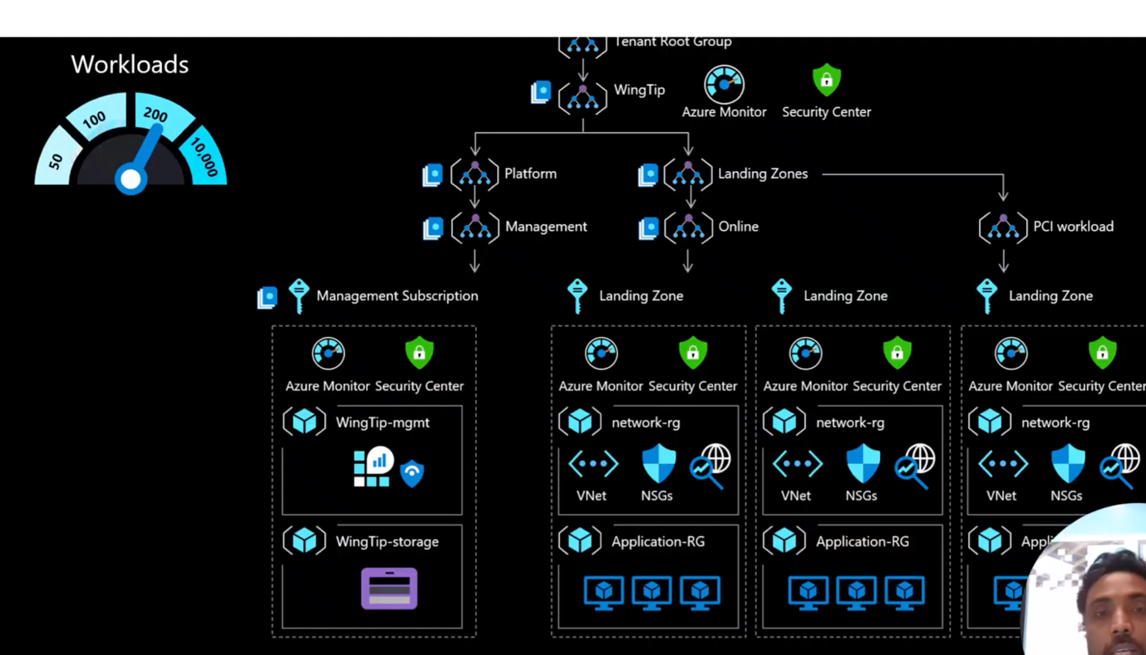

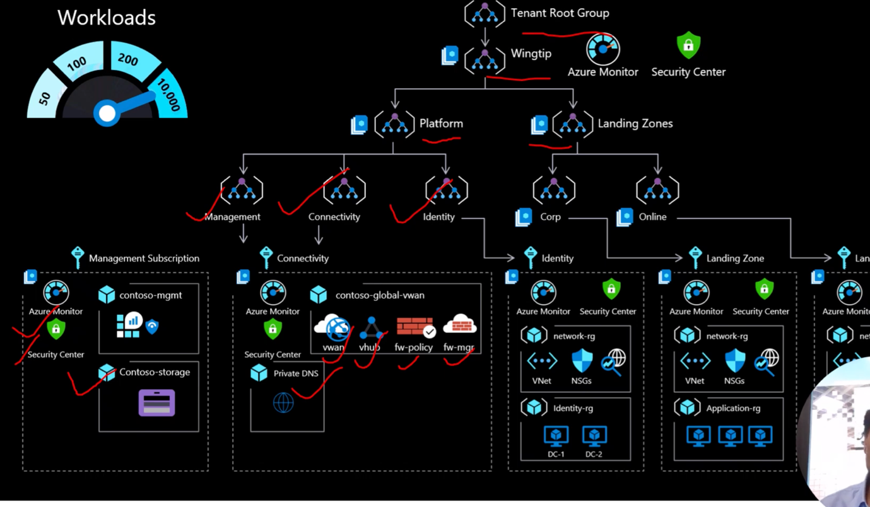

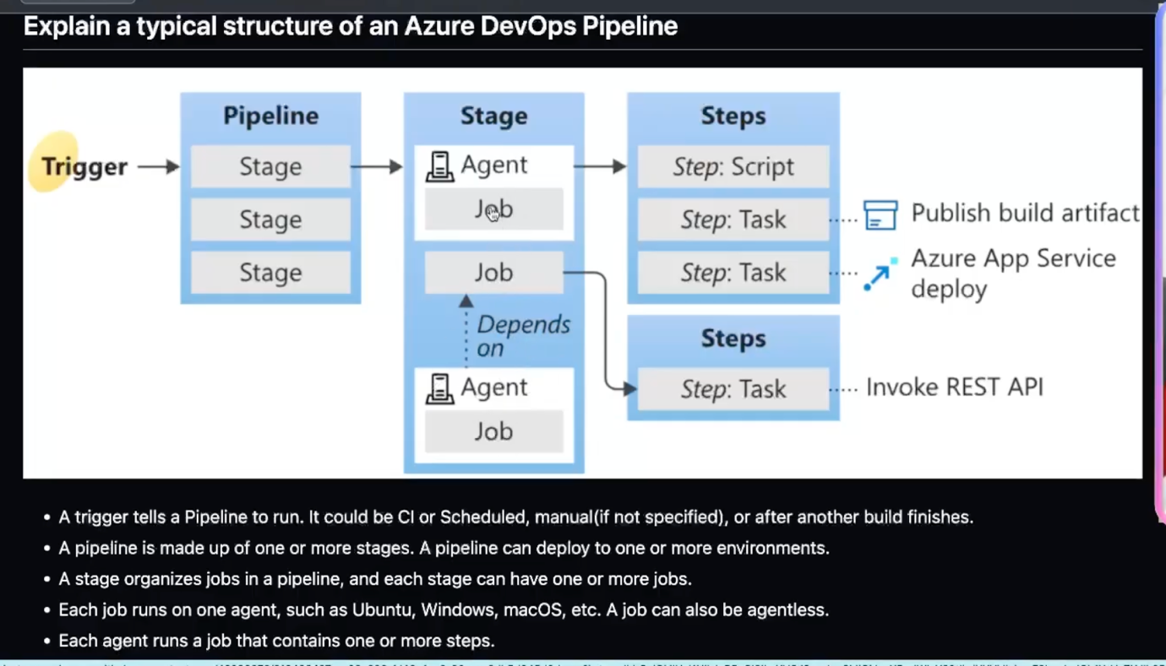

A step can be a task or script and it is smallest building block of pipeline

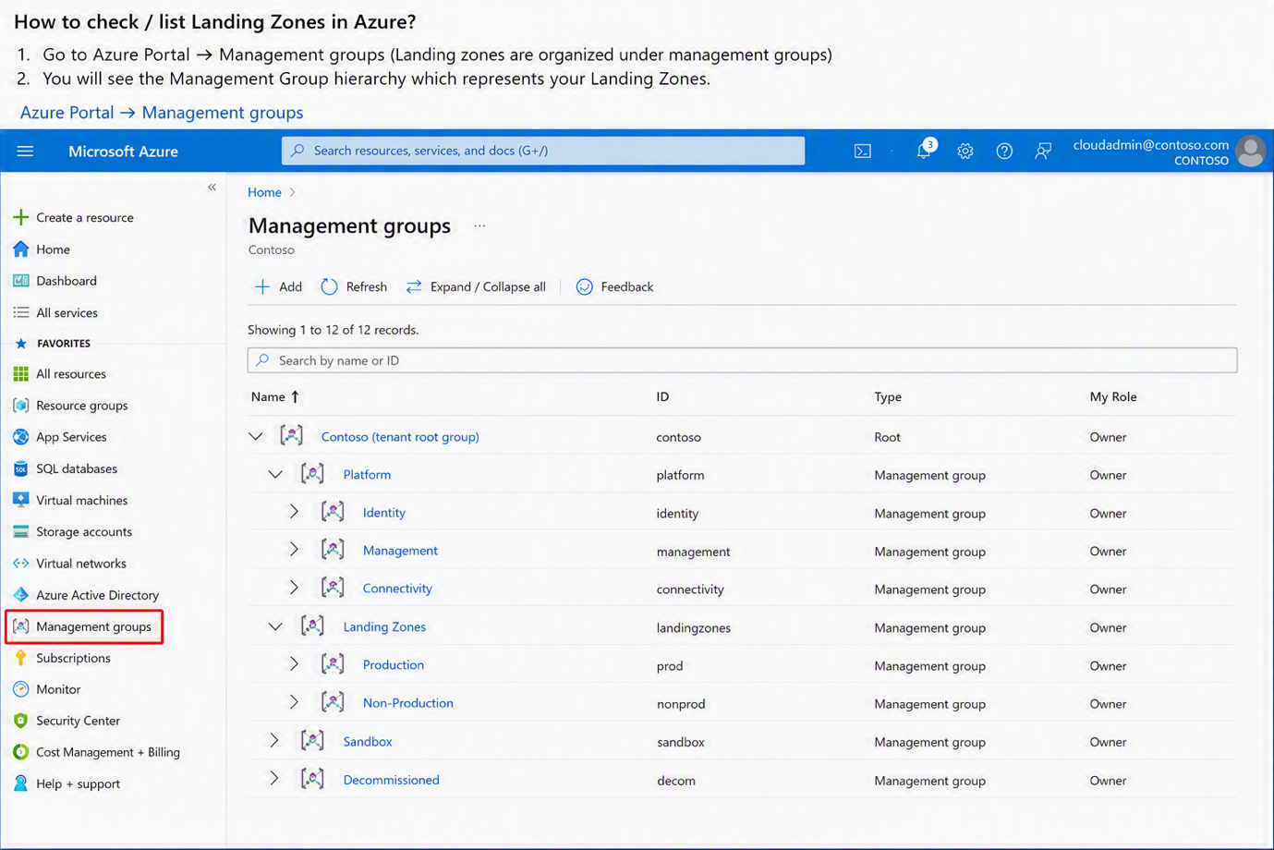

Tenant Root Group
│
├── Platform
│ ├── Identity
│ ├── Management
│ └── Connectivity
│
├── Landing Zones
│ ├── Production
│ └── Non-Production
│
└── Sandbox

az account management-group list --output table

az account subscription list --output table

az account management-group show --name "LandingZones"

How can you migrate a legacy on prem application to azure ?

