**Arctic Navigation System**

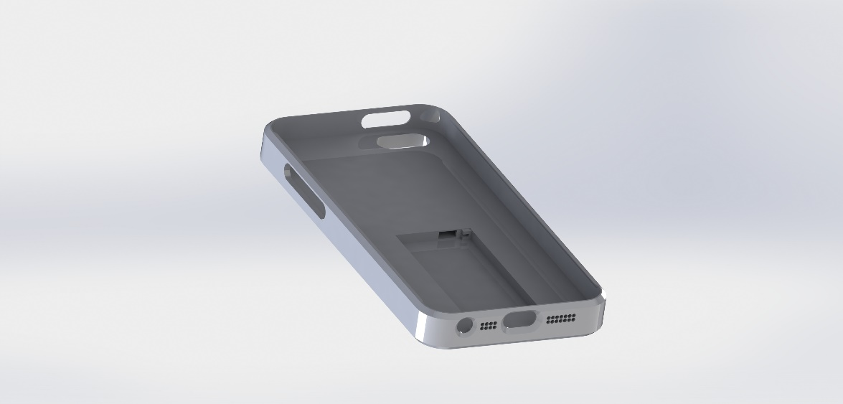**P2: Final Report**

Presented to: David Waller

P2 Final Project Report

APSC 200

Computer

Faculty of Applied Science

Queen’s University

**Prepared by Team 02, Section 205**

[Paritosh Arya, 10143394]

[Joseph Kachura, 10182090]

[Nathan Lee, 10179488]

[Monet Slinowsky, 10178218]

***December 4th 2016***

Statement of Originality

Our signatures below attest that this submission is our original work.

Following professional engineering practice, we bear the burden of proof for original work. We have read the Policy on Academic Integrity posted on the Faculty of Engineering and Applied Science web site (<http://engineering.queensu.ca/policy/Honesty.html>) and confirm that this work is in accordance with the Policy.

**Individual 1:**

Signature:  *Monet Slinowsky* Date: December 4th 2016

Name: Monet Slinowsky ID #: 10178218

**Individual 2:**

Signature: *Paritosh Arya* Date: December 4th 2016

Name: Paritosh Arya ID #: 10143394

**Individual 3:**

Signature: *Nathan Lee* Date: December 4th 2016

Name: Nathan Lee ID #: 10179488

**Individual 4:**

Signature: *Joseph Kachura*  Date: December 4th 2016

Name: Joseph Kachura ID #: 10182090

*Space below is for a table showing which portions of this report each individual made a significant contribution toward.*

|  |  |  |  |
| --- | --- | --- | --- |
|  | **Content**  Identify here the sections of the report for which you personally contributed content. | **Write-up**  Identify the sections of the report that you personally wrote or edited. | **Editing** Identify the sections of the report that you personally edited. |
| Paritosh Arya | Social/Economic Considerations, Executive Summary, SBAS concept, Introduction | Social/Economic Considerations, Executive Summary, SBAS concept, Introduction | Entirety of report |
| Joseph Kachura | SolidWorks CAD Models, Drop Test Simulations, Detailed Design, Environmental Considerations | Detailed Design: Functionality, Circuitry, Material, Environmental Considerations | Entirety of report |
| Nathan Lee | Conceptual Solutions: Iridium, Final Design, Health and Safety Considerations, FInal Design Evaluation | Conceptual Solutions: Iridium, Final Design, Health and Safety Considerations, Design Evaluation | Entirety of report |
| Monet Slinowsky | Problem Definition, Conceptual Navigation Solutions, Concept Evaluation, Product Design, Product Design Evaluation, Final Design Evaluation, Final Design, Recommendations | Problem Definition, Conceptual Navigation Solutions, Concept Evaluation, Product Design, Product Design Evaluation, Final Design Evaluation, Recommendations | Entirety of report |

# Executive Summary

As innovations in technology continue, the world is made smaller through numerous breakthroughs in travel and information sharing. Another highly impactful invention has been the Global Positioning System (GPS) network. Initially established as a military tool in the cold war, its range has expanded far beyond its original mission to provide services for users worldwide. However, GPS navigation becomes unavailable as a user approaches the northern pole due to ionospheric delays, limited infrastructure, and poor satellite positioning. This creates a challenge for users and an opportunity for Northern Solutions to provide feasible GPS navigation in the Arctic regions. Since tourism in the Arctic is also on the rise, tourists need a reliable personal navigation system to ensure the safety and ease of their trips.

After idea generation and evaluation on the criteria cost, accuracy, reliability, coverage, environmental impact, durability, and aesthetic of potential designs, a transmitting phone case was selected as the ideal device to provide navigation to tourists. The device will operate by receiving data from an already-established array of Iridium satellites in Low Earth Orbit. Particularly, Iridium satellites were selected because they do not require construction of extensive infrastructure networks. The satellite data will then be transmitted to the tourist’s smartphone via Bluetooth signals. An application will receive the data and display the user’s location. The application will also provide fall-back should the satellite signal be lost, by utilizing the phone’s sensors to continually orient the user.

The overall cost of manufacturing and shipping 1000 phone cases was found to be $154 259.41. With a profit margin of 15%, the proposed price of the product is $177 per phone case, which will allow it to be competitive amongst other navigation devices. Moreover, the final design met five of seven performance specifications. It did not provide the sufficient level of accuracy and will not function in extreme Arctic temperatures. Given this, future work must include augmenting GPS location data with information from the cell phone’s sensors to increase its location accuracy. Additionally, automated temperature control technology should be integrated with the Iridium chip in the phone case to ensure the phone will function in sub-zero weather. There are additional opportunities for the application to provide advertising for local businesses, information about areas that should not be accessed, and for partnership with Arctic travel companies.

Table of Contents

Executive Summary i

List of Figures iii

List of Tables iv

Introduction 1

Problem Definition 2

Stakeholders 2

Tourists 2

Travel companies 3

Northern Communities 3

Government 4

Environmental Non-Profit Organizations 4

Design criteria 4

Cost 4

Accuracy 5

Reliability 5

Coverage 5

Environmental impact 5

Durability and Strength 5

Aesthetic 6

Performance Specifications 6

Problem Statement 6

Environmental and Social Considerations 7

Conceptual Navigation Solutions 7

Quadrotors with Relative Navigation 8

SBAS and Differential GPS 9

Iridium Satellites 9

10

*Figure 4: LBS / SBD transmission process* [12] 10

Concept Evaluation 10

Social and Environmental Considerations in the Scoring 11

Evaluation Matrix Analysis 11

Health and Safety Considerations 11

Product Design 12

Product Idea Generation 12

Product Design Concepts 12

Design Concept Evaluation 13

Detailed Design 15

Iridium Satellites 15

Functionality 16

Circuitry 16

17

17

Material 17

Software 18

Economics 19

Implementation Challenges 21

Design Evaluation 22

23

Project Conclusions 23

Recommendations 24

References 25

Appendix A: Idea Generation 29

Appendix B: Concept Evaluation 33

Appendix C 36

Appendix D 37

# List of Figures

Figure 1: Dilution of Precision. The first image from the left illustrates the reality of the Arctic situation; its poor VDOP. 2

Figure 2: Population of Nunavut on social assistance by year [9]. 7

*Figure 3: Block diagram of data flow in the quadrotors.* 8

*Figure 4: LBS / SBD transmission process* [12] 10

Figure 5: A handheld GPS unit from Garmin manufacturing [14] 13

Figure 6: Transparent model of the phone case receiver with the battery in its slot 16

Figure 7: 3D model of the 2440mAh Rechargeable Li-ion battery 17

Figure 8: A simple circuit diagram of the components embedded in the phone case receiver 17

Figure 9: Pseudo code showing functionality of the navigation application. 19

Figure 10: The phone case after a drop of 7 feet. The red areas indicate where the most stress was incurred. 23

# List of Tables

*Table 1: Evaluation matrix for potential navigation technologies to be used in the solution* 10

Table 2: Matrix used to evaluate design concepts 14

Table 3: The cost estimation for device components. 19

Table 4: The cost estimation for device construction. 20

Table 5: The cost estimation for miscellaneous and shipping costs. 21

Introduction

The Arctic region spans 20 million km2 [1]. Countries such as U.S.A, Russia, Canada, Norway and Sweden each claim a portion of Arctic territory. Additionally, the Arctic is one of the most pristine regions on the planet having been relatively untouched by human development. This unique feature lures many thrill seekers and tourists from across the globe to venture into Arctic lands.

Due to climate change, the Arctic tourism industry is experiencing radical changes. Climate change is causing northern summers to last longer, and reducing the size of sea ice that forms every winter in the Arctic Ocean. These effects essentially create an environment for a sizeably larger tourism industry. Less sea ice means more cruise ships carrying tourists will attempt to traverse the beautiful and dangerous Artic waters [2]. Additionally, the warmer weather lessens the harshness of the terrain and makes it more appealing to visitors. With more tourists, effective personal navigation systems are needed to allow tourists to keep track of their position while hiking, skiing, fishing, or touring villages. Navigation is extremely difficult due to the lack of landmarks, rough weather, drifting sea ice, icebergs, remote areas, poor maps, poor GPS functionality, and low accuracy of magnetic and gyroscopic compasses [3].

In addition to tourists, the number of search and rescue operations required is expected to rise. Governments and tour operators currently expend millions of dollars in emergencies such as the 2013 rescue of 10 tourists stranded on an ice floe by the Canadian Military that cost $2.7 million [4]. If tourists were equipped with a device that provided precise location information, the search process could be made more efficient as location information could be sent to family or rescue workers. Better yet, a personal navigation device would prevent tourists from becoming lost. Thus, there is a great need for a mobile solution that could provide tourists with clear and accurate information of their location. This would allow tourists more freedom to explore, prevent them from losing their way, and allow them to broadcast their exact location in an emergency.

Unfortunately, the current navigation infrastructure in the Arctic does not provide the functionality necessary to create such an application. Global Positioning System (GPS) technology in the Arctic is unreliable. Firstly, unpredictable ionosphere activity causes delays in signals. Depending on the time of day and random variations is solar activity this delay can vary between 1-15 metres. Unfortunately, the delay cannot be predicted and it is therefore difficult to correct [3]. Next, there is dilution of precision that results in an inaccurate altitude measurement. For a GPS signal to be accurate, satellites must be arranged horizontally (HDOP) and vertically (VDOP) around the region. This necessity is illustrated in Figure 2. The Arctic region has acceptable HDOP due to low elevation angles, but poor VDOP, which leads to poor altitude information. The low elevation of the satellites also increases the negative effects of the ionosphere [3].

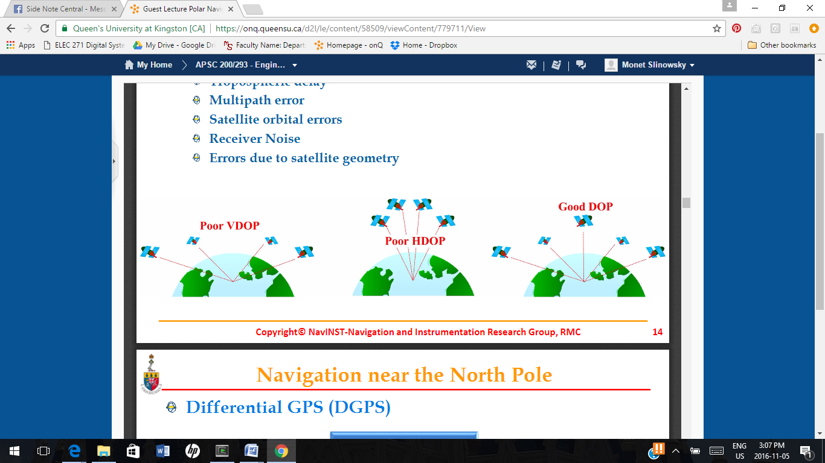

Figure 1: Dilution of Precision. The first image from the left illustrates the reality of the Arctic situation; its poor VDOP.

Additionally, when signals reach antenna from different paths, GPS accuracy is diminished. This issue, called multipath, arises when signals are reflected or redirected around mountains, ice, or buildings. Since the Arctic is bounded by ice and ocean, multipath occurs frequently.

In more Southern areas, technology like Wide Area Augmentation System (WAAS) overcomes some drawbacks of GPS [3]. However, WAAS does not solve the Arctic problem. There are few geo-stations in the region, poor real-time communication due to the ionosphere, and poor satellite visibility due to the low elevation angle [3]. Overall, these factors lead to large errors in Arctic navigation that would be unacceptable in a device distributed to Arctic tourists.

Problem Definition

Stakeholders

A personal navigation system for tourists has the potential to impact a multitude of groups with diverse needs. The navigation system must take into consideration the interests of the following stakeholders:

Tourists

As tourists would be directly using the navigation system, their needs are paramount. All tourists require safe travel, however, there are four widely accepted segments of Arctic tourists with different needs [1]:

1. Those who wish to see the Northern Lights and landmasses in comfortable (and even luxurious) accommodation and transportation. These tourists must be able to see their location on a map as their cruise ship or bus travels. They must be able to use the system to navigate small villages or to send their location to a tour director should they become separated from the group. They require a highly accurate navigation system, detailed enough to incorporate village names and port locations. They would pay for an application, but are less likely to purchase a device for navigation. They would be interested in the device’s aesthetic appearance.
2. Adventure-seekers, who go to the Arctic to ski, snowmobile, fish, and partake in other adrenaline-inducing activities. Snowmobile breakdowns make up the majority of Arctic search and rescue operations. Additionally, hiking and skiing trails can be poorly marked. These tourists need a navigation system that will help them stay on marked trails or allow them to navigate back to one should they become lost. To help these tourists, the system must provide continuous, reliable coverage. They are likely to pay for an expensive navigation device, proved by the popularity of Delorme’s Earthmate PN-60 [5].
3. Those who want to learn about and experience Inuit culture and local history. Similar to tourists interested in a luxury experience, they require a highly accurate system that will allow them to navigate to places of interest. They are unlikely to purchase a separate navigation device due to the nature of their travel.
4. Eco-tourists who want to observe wildlife while conserving both the environment and local culture. Eco-tourists have similar needs to the sport fishers and adventure-seekers. However, they also require a system from which local Arctic communities can benefit and a system that does not increase the pressure on Arctic eco-systems to suit their sustainable-focused mindsets [1].

Travel companies

Travel companies require a means to minimize accidents while their patrons explore the Arctic. Thus, they are invested in the safety the navigation system could provide; including its accuracy and reliability. Additionally, they do not want to lose business because tourists feel comfortable navigating the Arctic by themselves. If they were to purchase the device to distribute it to tourists, they may want it to display their company logo.

Northern Communities

Northern communities see tourism as a better economic boost than oil and gas exploration [1]. Locals benefit economically from tourists when they are used as guides and when their businesses are visited by the tourists. It’s important that a better navigation system does not make their roles in tourism obsolete. They need the tourists to navigate to their communities where they can seek local-provided accommodation and guides rather than relying on travel companies. Thus, the system must have coverage across the entirety of the Arctic to ensure visitors can reach any tourist-welcoming community. Although there are economic benefits to tourism [6], it does put a strain on local culture. The navigation system should include functionality that would allow an application to indicate both where tourists should go and where they should not. For example, the introduction of a geo-satellite that intrudes on sacred Inuit grounds or that was near a strained ecosystem would be against their interests.

Government

The Canadian government benefits economically from Arctic tourism and thus has similar needs to the northern communities [6]. Additionally, they require a navigation system that will prevent tourists from becoming lost in the Arctic. One search and rescue operation can cost as much as $2.7 million [4]. Additionally, the number of tourists in the Arctic is increasing and Canada does not have the resources to undertake large scale search and rescue operations. They require the navigation system to function under all conditions, including severe weather when search and rescue is more likely to be needed, and for the navigation system to make it easier to find lost users.

Environmental Non-Profit Organizations

These organizations stand for the environment’s needs. Tourism puts extra pressure on the Arctic wildlife. Ship traffic increases risk of groundings and oil spills, hunting places pressure on region’s resources, and tourists bring garbage and pollution with them. In some cases, simply trudging on top of permafrost damages it. To accommodate the needs to this group, the navigation system must be non-invasive to Arctic wildlife. It must also be sustainable; requiring few natural resources and conserving energy. Finally, it could have functionality that would allow an application to alert tourists when they’re entering a fragile area.

Design criteria

The stakeholder needs above were analyzed to create criteria on which potential designs could be evaluated.

Cost

The cost of the solution is derived from the needs of the tourists and travel companies. Additions to navigation infrastructure are expensive undertakings. If the solution were to simply be an application for phones, it would be distributed for free and thus costs would have to be kept low so adding to the navigation infrastructure would be infeasible. If a physical device was to be used, it would not be free, but cost must be kept low to ensure a profit can be made. A rugged handheld navigation device is currently being sold for $300 [5] so the solution should have a comparable cost.

Accuracy

Tourists would use the solution while walking or hiking, thus the system must be extremely accurate to instruct the tourist when to turn down a street corner. Additionally, in the interests of the tourists, travel companies, and governments, better accuracy would lead to faster retrieval in a search and rescue operation. This will be determined by researching the maximum error in similar systems.

Reliability

Arctic weather can be unpredictable and turbulent. It is under adverse conditions that the navigation system could provide the most value to tourists and governments. Thus, the system must function under adverse conditions. This will be measured by assessing the number of fallbacks and thereby the redundancy in the solution.

Coverage

The system must provide uniform functionality from 66 degrees North latitude to 90 degrees North latitude, and from 150 degrees to 60 degrees longitude in the area that is disputably Canada.

Environmental impact

The Arctic region is under significant strain due to climate change, oil exploration, trade operations, and increased tourism. Thus, the impact of the system on the Arctic’s natural ecosystem must be minimal in keeping with the local peoples’ and environmental organizations’ needs. Additionally, any materials incorporated into a physical device should be recyclable or reusable. Should the device be dropped in the ocean or onto the tundra, its impact on the environment should be minimal. This will be measured by evaluating the new infrastructure that must be introduced in the Arctic to facilitate the system, and by analyzing the sustainability and biodegradability of the materials in the device.

Durability and Strength

If a physical device is used in the solution, it must withstand low temperatures and falls onto hard surfaces such as ice. It must resist cracking and scratching to ensure it doesn’t break if dropped on a hike or ski excursion to ensure the tourist can still use it. The durability of a physical device will be measured with a drop-test on Computer Aided Design (CAD) tools.

Aesthetic

If the solution is a physical device, tourists (the users) will appreciate an aesthetically pleasing, user-friendly interface, particularly tourists who visit the Arctic to enjoy the picturesque landscape and the local culture. The aesthetic will be measured by distributing a survey to a diverse group of people, asking them to evaluate the device or interface.

Performance Specifications

The navigation system must first adhere to the Global Positioning System standards as set out by governing bodies. Per the “Global Positioning System Standard Positioning Service Performance Standard,” the navigation system must provide a positioning error of less than or equal to 7.8 m neglecting ionospheric delay [7]. Another specification is the system’s integrity, which is the trust that can be placed in the correctness of the positioning information. The system must provide an alert no later than 10 seconds after an instantaneous error to indicate that the GPS should not be used for positioning information. Finally, if an interruption in satellite signal occurs, it should be remedied within 72 hours. Additionally, there must be fallbacks in the solution to ensure the user is never without navigation information.

The system must provide coverage across 90% of the Arctic region [2]. It must be able to give positioning information within 300 metres under adverse conditions such as heavy snow. The error is 300 metres because, under severe conditions, current GPS technology in the Arctic may fail completely. This system should not fail completely and 300 metres will give tourists an idea of their location. Additionally, 300 metres can be searched quickly by a search and rescue team.

The solution must be able to function under an extreme temperature of –50 degrees Celsius as the lowest average temperature in Nunavut from 1981 to 2010 was -39 degrees Celsius [8]. The specification is set at -50 degrees to account for extreme cold temperatures that may occur. It must also survive a seven foot (taller than the height of an average person) drop onto a surface.

Problem Statement

As Arctic tourism increases, a system that allows tourists to reliably navigate around the Arctic is needed. Particularly, this system must prevent disorientation and allow tourists to broadcast their location in an emergency. Currently, navigation systems do not have the accuracy or reliability required for this small-scale, personal navigation. Thus, an accurate, reliable, large-coverage navigation system must be designed to minimize the limitations the current technology imposes on consumers.

Environmental and Social Considerations

Developing a solution requires considering how it will interact with and affect the social structure and environment of the Arctic. Firstly, the Arctic is home to vulnerable populations; the unemployment rate in Nunavut is 14.9%, more than double the national average of 6.9%, and 11.8% of the population is on social assistance, a number that is rising as seen in Figure 2 [9].

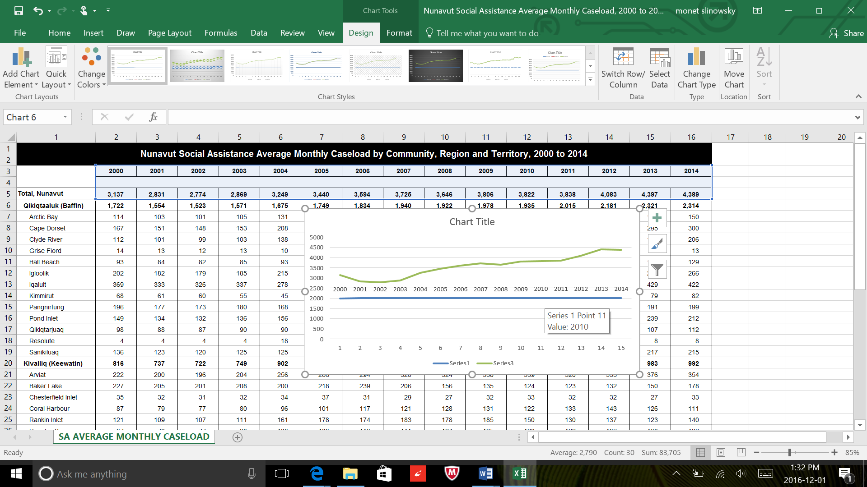

Figure 2: Population of Nunavut on social assistance by year [9].

The Arctic needs economic stimulus and thus the solution cannot take jobs away from locals. However, there is an opportunity for the solution to provide some of this economic stimulus if locals could be involved in the solution. For example, it could provide an opportunity for locals to market their small businesses or showcase their cities to encourage tourists to visit. In the same vein, the solution should be made accessible to all segments of tourists by keeping costs low. Potentially, the solution could be integrated with user’s other personal devices. The trend of providing electronics that connect seamlessly to each other is popular and enhances a user’s overall experience.

Additionally, Northern Solutions carries an ethical responsibility to conduct business that factors in the environmental concerns in its area of operation. In the Arctic region, this calls for strict policies that ensure the safekeeping of the fragile environment. The firm aims to strive for a low carbon footprint, which this means conducting operations with as little environmental alteration as possible. Building and maintaining infrastructure in the Arctic would rely on fossil fuel sources that add to emissions and damage the environment.

The environmental risk must be minimized in the implemented solution. Risk is defined as the product of the probability of an event occurring with the consequences it would create. The solution that would cause the least risk to the environment should be the favourable choice for Northern Solutions.

Conceptual Navigation Solutions

The problem can be divided into two parts; the technology used to improve Arctic navigation and the product incorporating the technology that will be sold to consumers. First, solutions for overcoming the weaknesses of navigation in the Arctic were explored. These potential solutions were generated through research and recorded onto post-it notes. The contents of these post-it notes can be seen in Table A-1 of Appendix A. The ideas were abated and the following three concepts were formulated:

Quadrotors with Relative Navigation

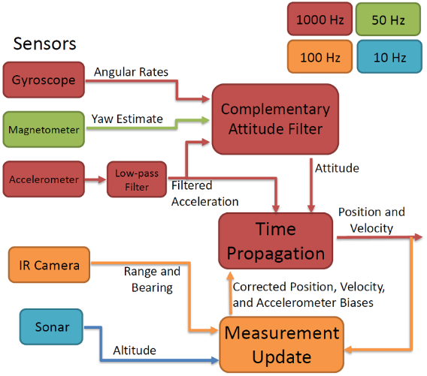This solution is based off research on autonomous quadrotor navigation done by Mark Cutler et al. at the Massachusetts Institute of Technology [10]. It would involve deploying a robotic flock where certain members, called the leaders, would navigate with respect to the ground while the other members, the followers, would navigate with respect to the leaders. This navigation would be accomplished with an infrared camera, sonar, magnetometer, gyroscope, and accelerometer as in *Figure 3*. These signals would be processed by an onboard microprocessor and sent out with radio waves.

*Figure 3: Block diagram of data flow in the quadrotors.*

The product would be a handheld device that would act as a follower in the robotic flock. Equipped with its own infrared camera and sensors, it would do the necessary relative calculations to display its location to the user. In addition to determining the user’s location, infrared cameras allow for ice to be detected, adding functionality to the device. The system would allow for position corrections to be sent in every 0.01s. In testing, the device could measure altitude within 3 metres and the position within 8 metres [10]. However, this evaluation was for a small-scale system and a large-scale exterior system would have significantly more error. Hundreds of quadrotors would have to be deployed to cover the Arctic region and because the technology has not been developed, about three years [10] of research would be required before a product could be developed. Additionally, the cold temperatures and fog would create a hostile environment for quadrotors.

SBAS and Differential GPS

Satellite Based Augmentation System (SBAS) is a more refined form of Local Based Augmentation System (LBAS). Both systems are a form of differential GPS. All forms of differential GPS correct errors in GPS data. Once the corrections are rectified, the proper data is transmitted to users in the operating radius. SBAS incorporates a space segment consisting of geostationary satellites and a larger earth segment made up of correction centers perform data correction. Where previously in LBAS systems, data was corrected in one large package, the newer SBAS system performs modular corrections, ensuring each different error is rectified one at a time. Airlines and ships navigating tight routes benefit the most from the precision SBAS provides. However, correction stations must be built and maintained to increase the range of operations. Thus, five stations could be built in strategic places across the Arctic to provide this service to tourists.

Iridium Satellites

The integration and utilization of the Iridium satellite constellation creates a potential solution for GPS navigation in the Arctic. The Iridium network consists of 66 cross-linked, low-earth orbit satellites that deliver service to any location on the planet [11]. The Iridium network has two technologies that can implement location tracking and awareness: Location Based Services (LBS) and Satellite Time and Location service [11].

The LBS service utilizes a Short Burst Data (SBD) transmission protocol to provide up to 1000 bits of data [2]. The device will send a data transmission to the satellites, which is processed and made available to the end user. The process is depicted in Figure 4. The data provided using LBS is effective in tracking the locations all over the world; however, the individual requesting location information must have access to a third-party service that interprets the transmitted data, and an internet connection. Thus, the sole utilization of LBS for location tracking in the Arctic is not plausible, but it could be combined with STL.

STL is a service launched on May 26, 2016 by Iridium, that works to verify, augment, and toughen GPS, Glonass, Galileo, and other navigation services, and substitute for these services should they become unavailable [11]. Iridium's satellites deliver a unique code to each position on the ground (end user) that, once authenticated, prove that the device is in a specific location [11]. This allows applications to be aware of and track their location, which is required for tourists navigating the Artic.

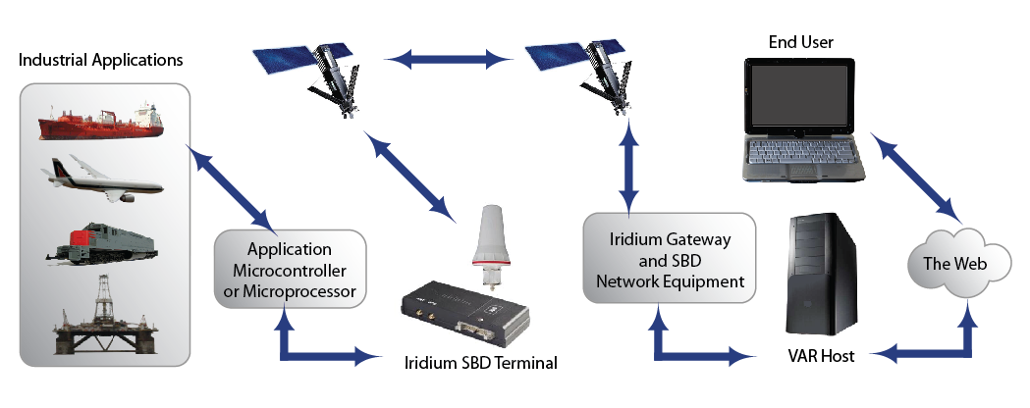

*Figure 4: LBS / SBD transmission process* [12]

Concept Evaluation

A matrix was developed to evaluate the solutions on five of the design criteria. The remaining design criteria from the Problem Definition were not applicable to this design decision and were applied later in the design process. The first criteria, cost, was given a weight of 8 because the cost must be kept low to ensure a profit can be made. The next criteria, accuracy, was given a weight of 9 because the value of the new system lies in its correction of the current system’s inaccuracy. Reliability was given a weight of 10 because the device cannot fail without warning. If it failed and tourists were using it to navigate on a hike, they would become lost and could be put in severe danger. Coverage was given a weight of 6 because, while the product would be more successful if it were available across all the Arctic, the coverage could be advertised and no one would be put in danger due to the lack of coverage. Environmental impact was given a weight of 4 because it is important to the stakeholders, but not critical as it does not impact the functionality of the device.

To eliminate bias in the matrix, the rubric in Appendix A was used to score the solutions. The results of the evaluation can be seen in Table 1.

*Table 1: Evaluation matrix for potential navigation technologies to be used in the solution*

|  |  |  |  |  |  |  |  |  |  |  |  |
| --- | --- | --- | --- | --- | --- | --- | --- | --- | --- | --- | --- |
| Solution | Cost (8) | | Accuracy (9) | | Reliability (10) | | Coverage (6) | | Environmental Impact (4) | | Total |
| Quadrotor Flock | Score  1 | Weight  8 | Score  1 | Weight  10 | Score  2 | Weight  20 | Score  1 | Weight  6 | Score  3 | Weight  12 | 56 |
| SBAS and Differential GPS | Score  1 | Weight  8 | Score  4 | Weight  36 | Score  4 | Weight  40 | Score  5 | Weight  30 | Score  2 | Weight  8 | 122 |
| Iridium Satellites | Score  3 | Weight  24 | Score  1 | Weight  10 | Score  4.5 | Weight  45 | Score  5 | Weight  30 | Score  4 | Weight  16 | 126 |

Social and Environmental Considerations in the Scoring

As a firm whose business occurs in the environmentally sensitive Arctic, Northern Solutions must use sustainable designs. It would be a challenge to implement SBAS in the Arctic because of its remote terrain. Powering the stations would require carbon based fuels that would be detrimental to the surrounding eco-systems. Moreover, to implement the quadrotor solution, facilities would have to be constructed to launch and recover the drones. Construction would damage permafrost and Arctic fauna. Additionally, the loss of any aircraft would contaminate the area with harmful pollutants. Notably, the iridium solution does not require any construction. The satellites required to implement the solution are already in place in Low Earth Orbit. For operations in the Arctic, the Iridium system is the clear choice from an environmental standpoint.

Evaluation Matrix Analysis

One disadvantage of the matrix is it does not explicitly evaluate the level of advancement of the technology. The performance scores for the quadrotor in Table 1 were strictly estimates based on preliminary testing. Overall, in addition to its low score, the quadrotor concept is not developed enough to be chosen as the solution. Over the next few years and with more research, the quadrotor concept may become a possibility, but it is not feasible to pursue it in this project.

Next, the SBAS and iridium satellite solutions scored similarly. However, the SBAS would require constructing new geo-satellite stations, putting extra pressure on the environment. Since the solution received the highest score, is well-developed, and offers many solution options, Iridium satellites will be used as the basis for the navigation system.

Health and Safety Considerations

Safety must always be considered in designing a consumer product. Firstly, navigation standards and regulations from the United States Government were the basis of the project’s functional specifications [7]. Thus, if, under adverse conditions, the Iridium satellite STL transmission is unable to provide the accuracy or coverage required to comply with these standards, the product itself must ensure compliance through back-up protocols.

Risk responsibility is also an important consideration if the solution involves connecting the product to a user’s personal device. In such a case, much of the risk of failure is transferred to the phone manufacturers and the users. For instance, whether the phone can withstand a certain drop and whether the user puts a case on their phone to prevent breaking. However, relying on this transfer of risk to ensure safety is not professionally responsible. In the Professional Engineers Code of Ethics Section 7 O. Reg. 941 line 2.i, it states “a practitioner shall regard the practitioner’s duty to public welfare as paramount.” Thus, because a failure of a product used in parallel with Northern Solution’s product could lead to a user losing their way or dying in the Arctic, there is a duty to consider what the shortcomings of the parallel device may be in the design of the product. For example, if the solution must be used with a mobile phone, Northern Solutions should consider a means of further protecting the user’s phone through the product. Additionally, Northern Solutions must consider how the device might be misused. For example, if it were set beside a fireplace, would the product combust? If it were dropped in water, would it poison the water?

# Product Design

## Product Idea Generation

Once the Iridium satellite network was selected as the means of overcoming navigation challenges, ideas for products to bring the technology to users were generated. They were first generated with post-it note brainstorming. After the first idea generation round, the ideas were organized into three categories; stand-alone navigation devices, phone navigation devices, and transportation navigation devices. These categories inspired a second idea generation round in which the number of ideas was doubled. The results can be seen in Table A- 2, and Table A- 3 of Appendix A. Then, three ideas were put through SCAMPER, seen in Table A- 4 of Appendix A. These ideas were then debated and analyzed. Many of the ideas were either similar in nature or completely infeasible. The ideas were eliminated, modified, and combined into three concepts. The eliminate and combination process is demonstrated with a mind map in Figure A- 1 of Appendix A.

## Product Design Concepts

#### Handheld Device

The first product idea considered was a handheld navigation device like the Earthmate PN-60, a popular product developed by Delorme [5]. It would consist of a STL transmitter and the necessary hardware and software to decode data sent by the satellites. The data sent by the satellites would be used to plot the user’s location on a map on the device’s screen. The device would connect to a computer through a USB port, which would be used to download maps onto the device prior to departure. The device would also consist of an accelerometer, altimeter, and electronic compass. These sensors would provide a fall-back navigation system should the satellite signal be lost. A comparable product is shown in Figure 5.

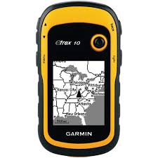

Figure 5: A handheld GPS unit from Garmin manufacturing [13]

#### Back-Pack Transmitter

The second product idea was a transmitter that could be put into a backpack while tourists explore the Arctic. The product would be a black box with an antenna that would transmit the signals from the Iridium satellites and send them to the user’s phone or laptop. It would include both STL and LBS transmitters. The STL would allow users to see their location on a map on their phone. The LBS transmitter would allow tourists’ friends, family, and potentially rescuers to view their location from anywhere in the world. Rather than incorporating fall-back sensors into the device, the sensors already in the user’s phone would provide this redundancy. Since the device would not have its own sensors, there would be real estate for the second (LBS) transmitter.

#### Phone Case Transmitter

The third concept was to place an STL transmitter in a phone case. Satellite phone sleeves are currently sold to users who need satellite communication capability, but these products are not built specifically for GPS or for the Arctic environment. The circuit within the case would send the satellite signal to the cell phone via Bluetooth. The phone would receive the signal, which would then be used in a mapping application, allowing the user to navigate. If the satellite signal was lost, the phone’s sensors would be used to track their location in relation to their last known position.

## Design Concept Evaluation

An evaluation matrix was created to aid design selection. The first criteria in the matrix was cost, which was given a weight of 8. The product’s price must be kept low to make it competitive. Next, the durability of the product was given a weight of 10. If the device was used while hiking or skiing, there would be ample opportunity for the device to be damaged. Thus, it must be rugged to provide the most value to the tourists. The criteria aesthetic was given a weight of 2 because this design criteria only matters to the luxury tourists.

The environmental impact was given a weight of 7 because there is an ethical responsibility to ensure the product does not harm the environment, even if it is misused by tourists. Finally, the universality of the product was given a weight of 9. Universality refers to the product’s ability to appeal to the consumers. For instance, where the adventure tourists would be inclined to use the handheld navigation device, luxury or cultural tourists would be unlikely to purchase it.

The matrix in Table 2 was used in conjunction with Table B- 2 in Appendix B to evaluate the design concepts. Of note is that the product costs were determined by analyzing the market price of similar products. It was assumed that there is a direct relationship between the price of a product and its cost. Through research, it was determined that the average cost of handheld navigation devices is $350 [13]. Thus, to be competitive, the price of the solution must be similar. An average, rough gross profit margin on a product is 15% [14], thus the cost of this product would be about $300 per unit. Similar calculations were made for phone cases, which are priced between $20-$100 [15], and backpack tracking devices, priced at about $150 [16].

Table 2: Matrix used to evaluate design concepts

|  |  |  |  |  |  |  |  |  |  |  |  |
| --- | --- | --- | --- | --- | --- | --- | --- | --- | --- | --- | --- |
| Solution | Cost (8) | | Durability (10) | | Aesthetic (2) | | Environmental Impact (7) | | Universality (9) | | Total |
| Hand held device | Score  3 | Weight  24 | Score  5 | Weight  50 | Score  3 | Weight  6 | Score  4 | Weight  28 | Score  1 | Weight  9 | 117 |
| Backpack transmitter | Score  4 | Weight  32 | Score  1 | Weight  10 | Score  3 | Weight  6 | Score  3 | Weight  21 | Score  2 | Weight  18 | 84 |
| Phone case transmitter | Score  4 | Weight  32 | Score  3 | Weight  30 | Score  5 | Weight  10 | Score  3 | Weight  21 | Score  5 | Weight  45 | 138 |

As seen in Table 2, the phone case concept scored the highest in the evaluation matrix. In addition to receiving the lowest weighted score of 84, the backpack transmitter scored only a 1 in durability, the most important category. This score was given because the user would have to purchase a special case to protect and regulate the temperature of their phone. They would benefit more from purchasing the navigation capability and phone case in one. Hence, the backpack transmitter concept was eliminated from consideration. The handheld navigation device received a score of 117 and is a viable solution. However, there are many handheld navigation devices already on the market. Furthermore, the phone case received a score of 5 in universality; a critical design criteria. Thus, the phone case transmitter was selected as the design solution.

## Detailed Design

### Iridium Satellites

To utilize the Iridium network, the solution requires continuous access to the STL paging channels. A contract would be negotiated with Iridium to obtain access to the STL channels on their network at a reduced rate. Since the current subscriber base is far less than what the satellites are designed for, this constant access should not strain the network or deplete satellite resources, making it possible for the negotiation to occur. Once access is granted, the STL transmitter located in the proposed case will receive constant data transmissions with location information. This information will be sent to the application and processed to plot the location of the end-user. In the unlikely situation that the STL signals are disrupted, back-up protocols have been developed to continue plotting location information until STL signals become available.

Implementing a navigation application with the Iridium satellite constellation and STL technology will be reliable, with satellites continuously providing access to clients. In the case of interruption, Iridium can reposition an in-orbit spare satellite to take over the failed satellite’s functions [17].

The utilization of Iridium satellites is viable for long-term application. The satellites were designed to support traffic from millions of individual satellite phone users, but the current subscriber base is less than 400,000 [17]. Thus, significantly less power is used than expected and there has been less wear and tear on critical hardware components [17]. This is significant in increasing the service life of the satellite’s antennas, which transmit information from the space network to the ground network [17]. Iridium low-earth orbit satellites orbit the Earth at an altitude of 780km above sea-level, and thus are exposed to a fraction of the solar radiation experienced by systems operating at higher altitudes [17], further increasing their longevity.

STL is a new technology, but has already been productized into a chip set about the size of a postage stamp [11]. STL's strong signal strength makes it difficult to "spoof” GPS and transmission signals, and combined with the unique code used in the authentication process, increases the security and reliability of location transmissions [11].

### Functionality

A 3D model of the final product was created on CAD software (Solidworks). The phone case receiver was modelled on the iPhone 5s, a commonly used phone. On the front face of the case is an indentation where the battery will sit. The 2440mAh Rechargeable Li-ion battery supplies power to the circuit which is located within the case, above the battery. The battery sits securely within the case as there is a small notch on the topside of the battery indentation (battery fits like a puzzle piece with small notch). While the case is being used, the battery is covered by the phone itself, which also benefits the overall security of the battery. A small hole located on the top side of the battery indentation is where the battery connects to the rest of the circuit. On the front edges of the right and left sides of the case are small flanges that are directed into the phone. These flanges are required to ensure that the case stays on the phone while still having the ability to removed and reapplied with ease. A transparent model of the phone case receiver can be seen in Figure 8.

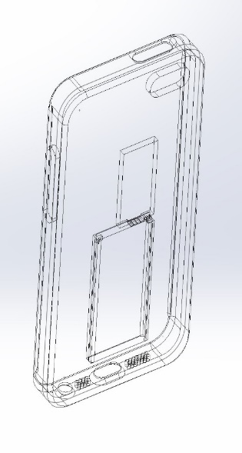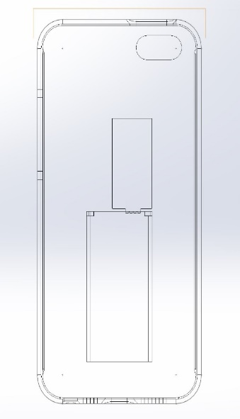

Figure 6: Transparent model of the phone case receiver with the battery in its slot

### Circuitry

Electrical components for the phone case receiver include a 2440mAh Rechargeable Li-ion battery, a CC2640 SimpleLink Bluetooth Wireless MCU [18], an Iridium STL chipset [19], and a printed circuit board (PCB) [20]. The Bluetooth MCU was selected for its small size and its embedded micro controller. The micro controller will be used to operate the circuit and will be programmed before being placed in the case. The STL chipset was selected for its small form as well as its functionality and power efficiency. The battery for the phone case receiver was procured through careful analysis of batteries in similar electronic devices. The Thuraya Satsleeve device functions in a similar manner to the case, communicating with satellites to provide GPS and data coverage for smartphones [21] . This comparable 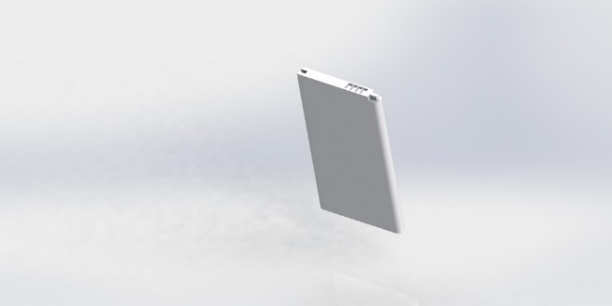device is powered by a 3.7 volt Li-ion battery with a stated current value of 2440 mAh. After thorough search, the charging unit was finalized with the LG BL-59UH Li-ion battery providing the needed 2440 mAh of current to the device. Since a CAD model was not available for the battery, it was designed on SolidWorks, as seen in Figure 9. The battery, located in the battery indentation on the front face of the case, has its terminals facing upwards towards the circuit. Pins that lead to the PCB will connect to both terminals on the battery.

Figure 7: 3D model of the 2440mAh Rechargeable Li-ion battery

Figure 10 displays how the circuit will be connected. Both the Bluetooth chip and the STL chipset will sit on a thin PCB inside the small hollow space in the phone case above the battery.

2440mAh Rechargeable Li-ion battery

Iridium STL chipset

Bluetooth chip with embedded micro controller

### 

Figure 8: A simple circuit diagram of the components embedded in the phone case receiver

### Material

Seven materials were considered as potential materials for the phone case; polyurethane, polycarbonate, metal, wood, leather, carbon fibre, and silicone. The research is summarized in Table C-1 of Appendix C. Most importantly, the material had to withstand the harsh Arctic environment including sub-zero temperatures, snow, and drops onto ice.

The research in Table C-1 indicated that the best materials were polycarbonate and silicone due to their high durability and functionality in sub-zero temperatures. To determine the best material, their respective environmental impacts were examined.

It was discovered that the emissions involved in the production of polycarbonate are low. Polycarbonate also has a very long life expectancy, and can be recovered or recycled at the end of its lifetime [22]. Additionally, silicon does not biodegrade as it is made of petroleum [23] and its production results in chemical pollution consumed by marine organisms and other animals [24]. This indicated that polycarbonate was the more environmentally-sustainable solution. Thus, the phone case will be made of polycarbonate

### Software

With the purchase of the phone case will come an application that can be downloaded onto the user’s phone. The users will navigate through the application’s map interface, which will allow users to both see their location on the map and enter a location and be directed towards it. The application will receive the transmitter’s Bluetooth signal and use it to plot the phone’s position. The application will also provide the fall-back should the satellite signal be lost. It will record the phone’s last known location and use the accelerometer and electronic compass to track the user’s position. The function of the program is illustrated in Figure 11. The preliminary code for the application can be seen in Appendix D. The application will also consist of a “panic” button. When a user presses it, their position will be sent to specified family and friends, and an alert will be sent to rescue services.

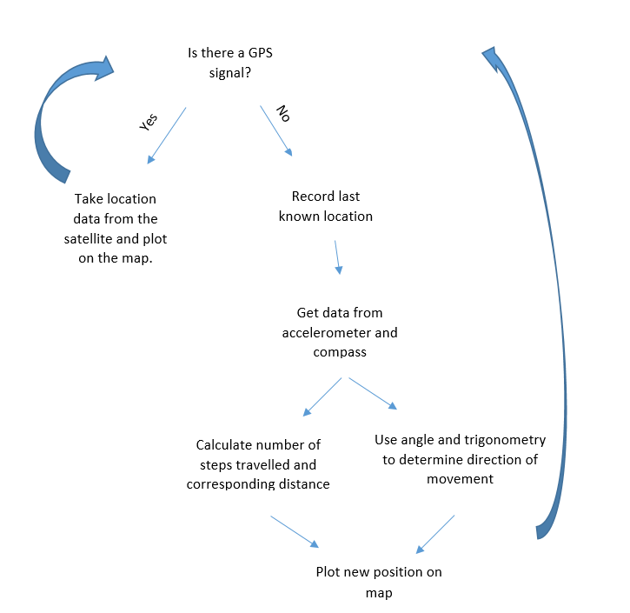

Figure 9: Pseudo code showing functionality of the navigation application.

# Economics

The economic analysis for the phone case factored in numerous sources of cost. They are listed as the cost of device components, cost to build the device, and product shipping and supporting software fees. Through researching suppliers’ pricing policies, manufacturers’ pricing plans, and shipment cost, it was found the optimum quantity per shipment is 1000 units. Thus, the total cost field in Table 3, Table 4, and Table 5 was based on the purchasing, manufacturing, and shipping of 1000 units.

Table 3: The cost estimation for device components.

|  |  |  |  |
| --- | --- | --- | --- |
| Name | Quantity | Price per unit (CAD) | Total cost (CAD) |
| LG BL59-UH Battery | 1000 | $14.36 | $14,360.00 |
| High Quality Luxury Phone Case | 1000 | $1.30 – 2.50 | $2500.00 |
| CC2640 Bluetooth/Micro-controller | 1000 | $2.80 | $2800.00 |
| Iridium Chip (9603N Two Way Satellite Data Transceiver | 1000 | $120.00 | $120,000.00 |
| Total Cost of Components | 1000 | $139.66 | $137 140 |

As seen in Table 3, the LG BL59-UH battery will power the circuit [25]. The mold of the case will be shaped from polycarbonate material and the contract to produce the mold will be given to Chinese merchants in the Hong Kong-Shenzen area of China [26], due to their high-quality reputation and inexpensive molds. The highest-quality molds will be chosen at a price of $2.50 per unit [26]. The CC2640 Bluetooth chip MCU will be procured from Texas Instruments at a cost of $2.80 per unit [18]. It was chosen because it is less costly to purchase the Bluetooth and microcontroller together than to purchase the separate components. Lastly, the Iridium chip antenna that communicates with the satellite will be purchased at a cost of $120.00 [27]. This chip was chosen because it is the only STL chip on the market that will fit inside the phone case.

Table 4: The cost estimation for device construction.

|  |  |  |  |
| --- | --- | --- | --- |
| Name | Quantity | Price per unit (CAD) | Total cost (CAD) |
| PCB Setup Costs | 1 | $100.00 | $100.00 |
| PCB Assembly | 1000 | $0.01 – 0.025 | $25.00 |
| Labour Force (Shenzen workforce) | 100 | $2.50/hour | $2500.00/hour |
| Total | 1000 | $15.025 | $15 125 |

Table 4 estimates the cost to manufacture the phone cases. Complex bureaucratic rules make determining the cost of manufacturing an extensive process. However, information was gathered from Hax.co, an electronic hardware firm that assists start-ups in bringing their products to life. They boast extensive knowledge of the end-to-end manufacturing process in Shenzen, China including the cost of PCB in Table 4. Lastly, the cost of labour was determined by considering the wages of 100 workers who would be paid the standard $2.50 per hour [28]. The wage paid to workers can be justified since it corresponds to the lower cost of living in China. iPhones take approximately 24 hours to manufacture [29]. A phone case is much less complex. However, to provide a large measure of error, it was assumed the phone case will be manufactured in one quarter of that time; 6 hours, giving a labour cost of $15 per case.

Table 5: The cost estimation for miscellaneous and shipping costs.

|  |  |  |  |
| --- | --- | --- | --- |
| Name | Quantity | Price per unity (CAD) | Total cost (CAD) |
| FedEx International Priority | 1 shipment with 1000 units | $1,895.41 | $1,895.41 |
| App Software SDK development fees | 1 | $131.60/year | 99.00 |

After assembly, the products will be shipped to Toronto, Canada for sale and shipping to customers worldwide. The priority air freight delivery charge per 1000 units weighing 50 kg comes out to be $1,895.41 [30] as seen in Table 5. Priority air freight is necessary to ensure the products are not damaged or lost. Also, there will be the $131.60 per year fee that must be paid for the Apple SDK. The Android software development platform is free.

The overall cost per shipment of 1000 devices can be estimated to be $154 259.41. This estimate gives a cost per unit of $154.30. A typical profit margin for start-up companies is 15% [16], thus the target price for the product is expected to be about $177 per unit. This is significantly less expensive than the estimated cost to manufacture a handheld navigation device which, as discussed in Design Concept Evaluation, would be approximately $300 based on comparable products. This analysis confirms that the phone case is the more economically-efficient solution. Additionally, it suggests that an Android application should be developed first since its development is less expensive. The Android application can be used for testing and, once the product’s functionality is confirmed, money can be invested into the IOS application.

# Implementation Challenges

The first challenge will be locating a reputable supplier for the Iridium STL transmitter. A supplier, Cirocomm Technology Corporation, was identified, but was unresponsive when asked for a quote and does not have public data sheets on their website. Since GPS functionality was only added to the Iridium satellites in May 2016, Cirocomm Technology is so-far the only supplier offering the product. Thus, it may be necessary to wait until more chips are on the market or to develop one internally. Next, since Iridium satellites are owned by a private company, they must be rented. The rental fee will add to the cost of the product. Another challenge is the sheer number of phone operating systems and sizes. Not only would the software have to be made compatible for both IOS and Android, but for phones of multiple sizes. Market research must be conducted to determine which phone designs are most feasible for initial production. Should the product sell well, cases for additional phone sizes can be added to the product line.

Additionally, manufacturing the case itself may be problematic as the electrical components must be put inside the case. This means the case must be built as two pieces; the bottom pieces will contain the circuit elements and the top piece will cover them. This may decrease the durability of the phone case. An innovative, optimal method with which to manufacture the case must be devised.

# Design Evaluation

The next step in the design process is to evaluate the proposed design against the original performance specifications. The first specification was that the solution must provide a positioning error of less than or equal to 7.8 m neglecting ionospheric delay [7]. This specification is not met by the design because the accuracy of Iridium satellites under optimal conditions is equal to or less than 10 m. However, Iridium integration with GPS was accomplished only six months before the publication of this report so the accuracy is expected to improve significantly by the time the product is brought to market. Furthermore, the accuracy of the device could be improved by augmenting the satellite data with the phone’s sensors in the application. If the sensor data was considered constantly, it could improve the accuracy by the 2.2 m required to meet the specification [10].

The next specification was that the solution must provide an alert no later than 10 seconds after an instantaneous error. This specification was met because the Iridium satellite network is cross-linked so as soon as an error occurs with one satellite, every satellite and user is aware of it.

Next, satellite interruptions can be remedied within 72 hours, meeting another specification. In 2009 an obsolete Russian satellite collided with one of Iridium’s satellites without warning. Iridium replaced the damaged satellite with an in-orbit spare in 20 days [17]. This is a substantial amount of time for there to be a gap in services; however, three days after the collision, Iridium’s network operators were able to re-route voice and data traffic around the “hole” in the constellation to minimize disruptions [17]. Furthermore, with the sensors as a fall-back, the user will never be without navigation information, ensuring they do not lose their way, even if satellites fail.

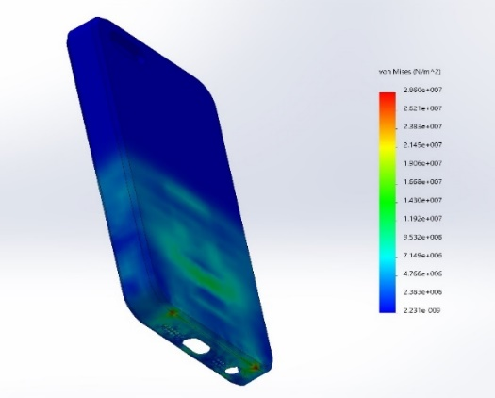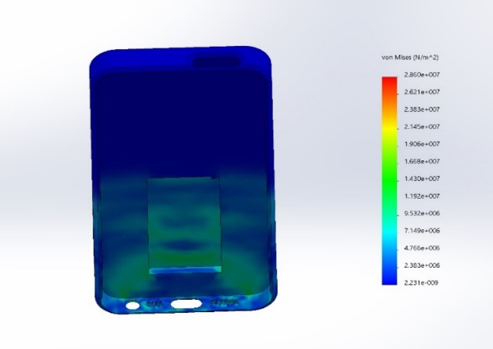 Additionally, the specifications required coverage across 90% of the Arctic. The design solution surpasses this by covering 100% of the Arctic, due to the Iridium network’s worldwide reach. Next, the solution can give positioning information with an error between 20 m and 50 m under adverse conditions, which is well under the 300m specification [11]. Next, a hardware specification required the solution to function in –50 degrees Celsius weather. The phone case itself meets this specification, but cell phones won’t function below zero degrees Celsius [31]. To meet this functional specification, the phone case requires additional design work, which is detailed in the Recommendations. Finally, the last specification was that the case survives a seven foot drop onto a surface. A drop test was done on Solid Edge to ensure the case met this specification; it survived the drop with minimal damage as seen in Figure 12.

# 

Figure 10: The phone case after a drop of 7 feet. The red areas indicate where the most stress was incurred.

# Project Conclusions

In this project, a multitude of methods for implementing GPS navigation in the Artic were researched. Potential design solutions were composed, and the implementation of Iridium STL navigation technology in a consumer product was pursued. The design solution is a phone case equipped with an embedded STL chipset, battery, and Bluetooth MCU. This case enables individuals to navigate the Arctic using a complementary application on their own mobile devices. Though consumers must purchase the case, the proposed solution is less expensive than many competing products. Overall, the phone case meets five out of seven performance specifications. The two specifications it does not meet can be rectified through further development of the design, as discussed in the next section. Importantly, the design requires no modification to the Arctic landscape, ensuring impact on the environment is minimal.

Since the product gives tourists the ability to navigate the Artic independently , it could further increase tourism in the Artic, which will economically benefit northern communities. Furthermore, after seeing the Arctic’s pristine beauty, many tourists work to protect its fragile eco-system after they return home, which benefits both wildlife and local peoples. An increase in tourism could lead to an increase in search and rescue operations. However, with the product’s safety protocols, it could curb this increase, saving lives, time, and money.

# Recommendations

An advantage of the chosen solution is that it can be easily adapted and expanded upon to increase both its functionality and value to the stakeholders. Firstly, the proposed design does not meet the minimum temperature requirement set out in the Performance Specifications. According to Apple, their products operate best in temperatures 0 to 35 degrees Celsius and can be stored between -20 and 45 degrees Celsius [31]. Cold temperatures shorten battery life and could cause the cell phone to turn off prematurely. Clearly, as the Arctic reaches temperatures of -50 degrees Celsius, cell phones will not function. To make the solution viable, heating coils could be added to the phone case to keep the phone at an appropriate temperature.

Unfortunately, if only heating coils were used, the phone could overheat when indoors and it would be incapable of transitioning between environments. Thus, the phone case must be able to sense the ambient temperature and turn the heating mechanism on and off depending on the data from the sensors. This functionality is currently offered in a phone case designed by Amited, which is not yet available to consumers. To create a more viable product, automated temperature-control technology could be integrated with the iridium transmitter in the phone case as part of future work.

Secondly, a mobile application should be designed and built to operate in parallel with the hardware. This application would take the signal from the GPS and display it on a map on the phone’s screen. It would also take data from the phone’s sensors to plot position should the satellite signal be lost and could broadcast the user’s location to specified contacts just before the signal is lost.

Furthermore, the application could be designed to allow for local businesses to advertise. These advertisements would appear when tourists are in proximity to a business and they could be free for Inuit locals to help further stimulate their economy. Additionally, with input from locals, more detailed information about areas to avoid for cultural (for example, sacred grounds) or environmental (for example, delicate permafrost) could be included on the map.

Finally, an innovative manufacturing process for the phone cases must be designed so the circuitry can be put inside the cases and so the cases can be made customizable. The cases could be sold in bulk to Arctic travel companies with the company’s logo embezzled on the case. The application could also be integrated with a tour companies’ existing website or application for their customers. These travel resources usually include information about itinerary, local sights, and excursions. With functional GPS linked or embedded into them, they could decrease some of the travel company’s risk and provide more independent, interactive, and worry-free Arctic travel.

# References

|  |  |
| --- | --- |
| [1] | "Tourism in the Polar Regions," GRID-Arendal, 2014. [Online]. [Accessed 3 November 2016]. |
| [2] | "Arctic rescue fears loom," CBC, 3 April 2016. [Online]. Available: http://www.cbc.ca/news/canada/north/cruise-ships-safety-northwest-passage-1.3518712. [Accessed 4 November 2016]. |
| [3] | P. A. Noureldin, "Navigation Near the North Pole," October 2016. [Online]. Available: https://onq.queensu.ca/d2l/le/content/58509/viewContent/779711/View. [Accessed 3 November 2016]. |
| [4] | "Canadian Military Spent 2.7 milion to rescue," CBC, 2013. [Online]. Available: http://news.nationalpost.com/news/canada/canadian-military-spent-2-7-million-to-rescue-wealthy-tourists-off-of-breakaway-ice-floe. [Accessed 4 November 2016]. |
| [5] | Delorme, "Earthmate PN-60," 2016. [Online]. Available: https://shop.delorme.com/OA_HTML/DELibeCCtdItemDetail.jsp?item=30538. [Accessed 23 November 2016]. |
| [6] | A. Kim, "Tourism could bring Wealth," June 30 2016. [Online]. Available: https://www.opencanada.org/features/tourism-could-bring-wealth-and-pride-nunavut/. [Accessed November 23 2016]. |
| [7] | United States Government, "Global Positioning System Standard Positioning Service Performance Standard," September 2008. [Online]. Available: http://www.gps.gov/technical/ps/2008-SPS-performance-standard.pdf. [Accessed 4 November 2016]. |
| [8] | "Canadian Climate Normals Alert, Nunavut," Environment Canada, 2010. [Online]. Available: http://climate.weather.gc.ca/climate_normals/results_1981_2010_e.html?searchType=stnProv&lstProvince=NU&txtCentralLatMin=0&txtCentralLatSec=0&txtCentralLongMin=0&txtCentralLongSec=0&stnID=1731&dispBack=0. [Accessed 23 November 2016]. |
| [9] | "Nunavut Bureau of Statistics," October 2015. [Online]. Available: http://www.stats.gov.nu.ca/en/home.aspx. [Accessed 12 01 2016]. |
| [10] | M. Cutler , H. Jonathan P. and B. Michini, "Lightweight Infrared Sensing for Relative Navigation of Quadrotors," Massachusets Institute of Technology, [Online]. Available: http://acl.mit.edu/papers/Cutler13_ICUAS.pdf. [Accessed 11 November 2016]. |
| [11] | Iridium Communications Inc., "Iridium Launches Breakthrough Alternative Global Positioning System (GPS) Service," 2016. |
| [12] | Orbital ATK, "Iridium NEXT: Fact Sheet," 2015. |
| [13] | T. Cummings, "Top 5 Best Garmin Handheld GPS Navigation Units," 23 October 2015. [Online]. Available: http://heavy.com/tech/2015/07/best-handheld-gps-navigation-units-garmin/ . [Accessed 24 November 2016]. |
| [14] | T. Parker, "Profit Margins for New Businesses," 30 September 2015. [Online]. Available: http://www.investopedia.com/articles/personal-finance/093015/whats-good-profit-margin-new-business.asp. [Accessed 26 November 2016]. |
| [15] | OtterBox, "iPhone 6S Cases," [Online]. Available: https://www.otterbox.com/en-us/iphone-6s-cases. [Accessed November 26 2016]. |
| [16] | "ElectroFlip Products," ElectroFlip, [Online]. Available: http://www.electroflip.com/products. [Accessed 26 November 2016]. |
| [17] | Iridium Communications Inc., "The Global Network: Life Expectancy of Iridium’s Satellite Constellation," 2010. |
| [18] | Texas Instruments, "CC2640 Low-Energy Bluetooth," Texas Instruments, 2016. [Online]. Available: http://www.ti.com/product/CC2640/samplebuy. [Accessed 03 December 2016]. |
| [19] | "Iridium STL chipset," Cirocomm Technology Corp., [Online]. Available: http://www.cirocomm.com/category-External-6-2.html. |
| [20] | "PCB," Digikey, [Online]. Available: http://www.digikey.ca/product-search/en/prototyping-products/prototype-boards-perforated/2359508?k=protoboard&k=&pkeyword=protoboard&pv46=40772&FV=fff40024%2Cfff800d4&mnonly=0&newproducts=0&ColumnSort=0&page=1&quantity=0&ptm=0&fid=0&pageSize=25. [Accessed 29 November 2016]. |
| [21] | "SatSleeve," Thuraya, [Online]. Available: http://www.thuraya.com/SatSleeve. [Accessed 1 December 2016]. |
| [22] | "Polycarbonate in Profile," Brett Martin, [Online]. Available: http://www.brettmartin.com/en-gb/plastic-sheets/plastics-in-profile/polycarbonate.aspx. [Accessed 1 December 2016]. |
| [23] | C. Stevens, "Silicones and Their Impact on the Environment," [Online]. Available: https://www.dowcorning.com/content/publishedlit/Chapter21.pdf. [Accessed 1 December 2016]. |
| [24] | "Silicon, semiconductor grade," Environmental Impact, [Online]. Available: http://envimpact.org/node/75/bottomline. [Accessed 1 December 2016]. |
| [25] | Amazon, "2440 mAh Li-ion rechargeable battery," Amazon, June 2015. [Online]. Available: https://www.amazon.com/2440mAh-Rechargeable-Generic-Replacement-Battery/dp/B00UF3PIWW. [Accessed 03 December 2016]. |
| [26] | alibaba, "High Quality Luxury Phone Case Mold Wholesale," alibaba, [Online]. Available: https://www.alibaba.com/product-detail/High-Quality-Luxury-Mobile-Phone-Case_60282314662.html. [Accessed 03 December 2016]. |
| [27] | SatPhoneStore, "Iridium 9603N Two-Way Satellite Data Transciever," SatPhoneStore, 2016. [Online]. Available: http://www.satphonestore.com/tech-browsing/iridium-nav/iridium-sbd/equipment/iridium-9603-two-way-satellite-data-transceiver.html. [Accessed 03 December 2016]. |
| [28] | Hax.co, "The Mystical Art of Cost Estimation," Hax.co, 2012. [Online]. Available: https://hax.co/2012/11/13/the-mystical-art-of-cost-estimation/. [Accessed 03 December 2016]. |
| [29] | H. Deidu, "iPhone Manufacturing Cost Structure," 22 February 2012. [Online]. Available: http://www.asymco.com/2012/02/22/the-iphone-manufacturing-cost-structure/. [Accessed 4 December 2016]. |
| [30] | FedEx, "RateFinder," FedEx, 03 December 2016. [Online]. Available: https://www.fedex.com/ratefinder/standalone?method=getQuickQuote. [Accessed 03 December 2016]. |
| [31] | Apple, "Keeping iphone within acceptable operating temperatures," 7 November 2016. [Online]. Available: https://support.apple.com/en-ca/HT201678. [Accessed 24 November 2016]. |
| [32] | Amazon, "Thuraya Satsleeve + Wifi Hotspot," 2016. [Online]. Available: https://www.amazon.ca/Thuraya-Satellite-Satsleeve-Hotspot-smartphone/dp/B015NBR15C/ref=pd_rhf_sc_p_img_2?ie=UTF8&psc=1&refRID=Z5XDBD2JCDH8XM851M6D. [Accessed 05 October 2016]. |
| [33] | Queen's Engineering Faculty, "PEO Code of Ethics," OnQ, [Online]. Available: https://onq.queensu.ca/d2l/le/content/58509/viewContent/758200/View. [Accessed 23 October 2016]. |
| [34] | Amited, "The Technology," [Online]. Available: http://www.amited.com/the-technology/. [Accessed 24 November 2016]. |
| [35] | Outdoor Gear Lab, "Handheld GPS Reviews," [Online]. Available: http://www.outdoorgearlab.com/Handheld-Gps-Reviews/Charts. [Accessed 26 November 2016]. |
| [36] | "2440mAh Rechargeable Li-ion Battery," [Online]. Available: https://www.amazon.com/2440mAh-Rechargeable-Generic-Replacement-Battery/dp/B00UF3PIWW. |
| [37] | T. Walter, G. Gao, P. Enge and L. Heng, "Glonal Navigation Satellite Systems," National Academy of Engineering , Chinese Academy of Engineering, 2012. |

# 

# Appendix A: Idea Generation

Table A- 1 shows the results of using post-it notes to organize ideas for how to overcome the limitations of GPS in the Arctic. Since these ideas have been implemented and explored already (at least to some extent), they were based on research rather than idea generation. Thus, instead of putting them into categories, an overview of the advantages and disadvantages of each technology were put on adjacent post-it notes. Table A- 2 shows the results of initial post-it note brainstorming of product ideas and Table A- 3 shows the results of the second-round of post-it note brainstorming. Table A- 4 shows an example of the results of SCAMPER. It shows one of the ideas that was put through SCAMPER and how more ideas were generated from it. Finally, Figure A-1 is a mind-map showing how ideas were combined and eliminated to give three conceptual solutions.

Table A- 1: Results of post-it note idea organization for the technological basis of the solution

|  |  |  |
| --- | --- | --- |
| Solution on Post It Note | Preliminary Advantages (Adjacent post-it note) | Preliminary Disadvantages  (Adjacent post-it note) |
| SBAS; add satellite based reference stations to the Arctic | -Accurate within a few centimetres  -Corrects poor GPS data in the stations and sends accurate data back to the users | -Must build at new stations  -Expensive  -Intrusive to land and local people |
| Iridium satellite constellation integration with GPS | -Achieved already in May 2016  -Quite accurate; ~10m  -Need very small chip to transmit info to satellites so flexible product possibilities | -May be expensive to rent satellites |
| Handheld device that navigates with only sensors | -Like products on market now for hikers/adventurers  -Less expensive than satellite solutions | -No way of sending signal out if lost  -No fall-backs  -Many sensors won’t function properly in the Arctic |
| Quadrotor flock with relative navigation | -Very innovative and cutting-edge technology  -Potential to be highly accurate due to large number of robots sending location information | -Not very developed idea  -Arctic hostile environment for quadrotors |

Table A- 2: Results of first round of post-it note brainstorming of product ideas

|  |  |  |  |
| --- | --- | --- | --- |
| Category | Users navigate directly with the product; it is a handheld device | The product enables user’s cell phones to receive GPS signal | The product enables user’s car or mobility device to receive GPS signal |
| Product Ideas | -Backpack transmitter that constantly sends their location to a third party  -Device with map on screen that has STL transmitter so it can show you where you are on the map  -Compass that uses GPS satellite to tell you your direction; can be used in conjunction with physical map | -Device you can plug into phone’s battery or headphone port with an STL transmitter, which enables the phone to receive the Iridium data  -Black box attacked to phone with key chain that gives phones connectivity to GPS via Iridium satellite | -Device plugs into car and allows car’s internal navigation system to receive Iridium data |

Table A- 3: Results of second round of post-it note brainstorming of product ideas

|  |  |  |  |
| --- | --- | --- | --- |
| Category | Users navigate directly with the product; it is a handheld device | The product enables user’s cell phones to receive GPS signal | The product enables user’s car or mobility device to receive GPS signal |
| Product Ideas | -Backpack transmitter that constantly sends their location to a third party (LBS)  -Device with map on screen that has STL transmitter so it can show you where you are on the map  -Compass that uses GPS satellite to tell you your direction; can be used in conjunction with physical map  -Device with STL transmitter that also acts as a source of heat for cold bodies (for example, as a finger-warmer in mittens) | -Device you can plug into phone’s battery or headphone port with an STL transmitter, which enables the phone to receive the Iridium data  -Black box attached to phone with key chain that gives phones connectivity to GPS via Iridium satellite  -New phone with an STL transmitter inside specifically for Arctic travel  -Plug-in device that enables phone’s compass to function | -Device plugs into car and allows car’s internal navigation system to receive Iridium data  -Put transmitter in car so car’s Bluetooth allows multiple phones to receive the data  -Build a snowmobile with STL and LBS transmitters inside  -Navigation device that can be powered by snowmobile or skiing movement so it never loses battery power when outdoors |

Table A- 4: SCAMPER used on the idea "device with an STL transmitter that shows user where they are on a map on the screen.”

|  |  |  |  |
| --- | --- | --- | --- |
| Word | Question | Answers | Solution Ideas |
| Combine | Which ideas above could this be combined with? | -Use both LBS and STL transmitters | -Handheld GPS with both transmitters (again, expensive)  -Backpack black-box with both transmitters (less expensive because it only must accept and transmit data, not process/display it. The phone it sends the information to would display it) |
| Put | What other things could this device do? What additional functionality would a tourist require besides knowing their place on a map? | -Communication with the world outside the Arctic  -Measure number of steps/other health calculations  -Device speaks to them; gives directions | A cellphone has all this functionality.  -Put the STL transmitter in an Arctic smartphone (very, very expensive)  -Put the STL transmitter in a smartphone case and have it communicate with the phone via Bluetooth |
| Eliminate | What features wouldn’t the tourists need? What doesn’t need to be accomplished? Can time be reduced? Can effort be reduced? Can space be reduced? | -Make it more compact  -Put transmitter device into something else  -No map, it can tell them where they are (verbally) if they press a button | -Dice-shaped small transmitter that tells user where they are that can be put into pocket |

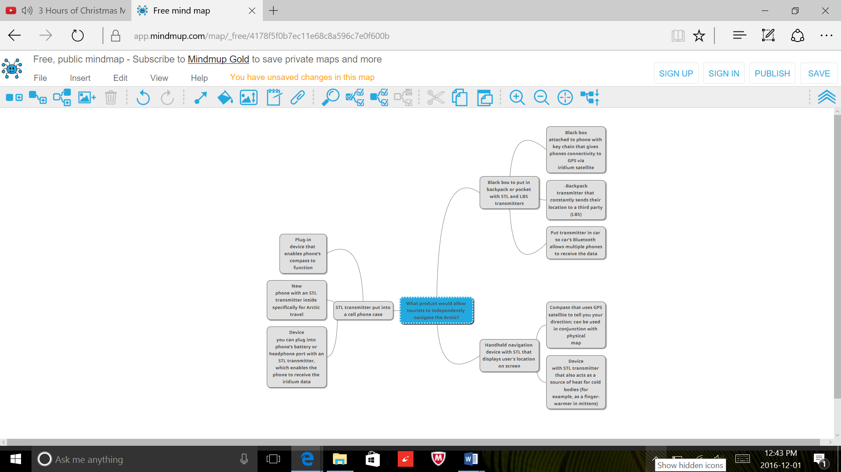

Figure A- 1: Mind map that shows how ideas were combined into concepts. The central node's children are the three final concepts. The children of each of the concepts are the ideas that were combined to formulate the concept. Any ideas not seen in the mind map were deemed inappropriate or ineffective ideas.

# Appendix B: Concept Evaluation

Table B- 1: The rubric used to score the ideas for the technological basis of the solution.

|  |  |  |  |  |  |
| --- | --- | --- | --- | --- | --- |
| Criteria | 1 | 2 | 3 | 4 | 5 |
| Cost | The cost for initial production, including development and manufacturing, is likely to be over $10 million. | The cost for initial production is likely to be less than $10 million | The cost for initial production is likely to be less than $5 million. | The cost for initial production, including development, is likely to be less than $1 million. | The cost for initial production, including development is likely to be less than $500 000. |
| Accuracy | Provides an error of greater than 7.8 m normally and over 300 m under adverse conditions. | Provides an error of less than or equal to 7.8m normally and less than 300 m under adverse conditions. | Provides an error of less than or equal to 6m normally and less than 300 m under adverse conditions. | Provides an error of less than 4 m normally and less than 100 m under adverse conditions. | Provides an error of less than 2m normally and less than 50 m under adverse conditions. |
| Reliability | System is likely to undergo failures and will provide no instantaneous alerts or will issue a notice less than 12 hours beforehand | System may fail instantaneously, but will provide an alert 10 s after an error or will issue a notice 12-23 hours beforehand. | System may fail instantaneously, but will provide an alert 5 s after an error or will issue a notice 24 hours beforehand. | System may fail, but will always issue a notice 48 hours beforehand | System is very unlikely to ever fail and will provide three days notice should it undergo an interruption. |
| Coverage | Coverage across less than 50% of the Canadian Arctic. | Coverage across 50-99% of the Canadian Arctic. | Coverage across the Canadian Arctic region | 90% coverage across the Arctic region | 100% coverage across the Arctic region |
| Environmental Impact | The solution requires many large, invasive alterations to be made to the Arctic environment. | The solution requires significant building, which may negatively impact the Arctic wildlife. | The solution involves introducing non-natural elements to the environment that would have an significant impact and/or the solution requires a small amount of construction (of no more than one building). | The solution involves introducing non-natural elements to the environment, but will have not have a significant impact on the wilderness. | The solution does not require building or disrupting the Arctic wilderness. |

Table B- 2: The rubric used to score product ideas.

|  |  |  |  |  |  |
| --- | --- | --- | --- | --- | --- |
| Criteria | 1 | 2 | 3 | 4 | 5 |
| Cost | The product would be developed with a target price of more than $700. | The product would be developed with a target price of $700 or less | The product would be developed with a target price of $400 or less | The product would be developed with a target price of $200 or less | The product would be developed with a target price of $100 or less. |
| Durability | The device cannot be designed to survive a five-foot fall or to be waterproof or to withstand cold temperatures below -10 degrees Celsius. | The device can be designed to withstand a five or greater-foot drop, temperatures between -49 and -10 degrees Celsius. | The device can be designed to withstand a seven-foot drop, temperatures down to -50 degrees Celsius, and can resist snow. | The device can be designed to withstand an seven-foot or greater drop, temperatures down to -60 degrees Celsius, and can be resistant to rain and snow. | The device can be designed to survive a ten-foot or greater drop, temperatures of -70 degrees Celsius, and rain and snow (i.e. it is waterproof). |
| Aesthetic | The product appears bland, bulky, and complicated, making it difficult for consumers to use. | The product has an unremarkable design, but it does not interfere with the consumer’s ability to use it. | The product has a clean design that allows for users to use it easily. | The product could be purchased in a variety of colors and is visually appealing. | The product is customizable to suit individual consumer’s needs. |
| Environmental Impact | It is infeasible to make the product out of environmentally conscious materials. For example, it requires mined materials, wood from endangered forests, or animal products. | The product can be made of materials whose extraction does not wreck havoc on the environment. For example, synthetically-produced materials that do not require further depletion of natural resources. | The product can be made of recyclable or re-used materials. However, if the device was lost, it would have a negative impact on the surrounding environment. | The product can be made of sustainable materials that would have little impact on the environment if the device was lost. | The product can be made of sustainable, biodegradable materials. |
| Universality | The product is unlikely to be purchased by three segments of tourists, but will appeal to the other one. | The product is unlikely to be purchased by two segments of tourists, but will appeal to the other two. | The product is unlikely to be purchased by one segment of tourists, but will appeal to the other three. | The product may be purchased by all four segments of tourists, but may appeal more to one segment than another. | The product will appeal to all segments types of tourists. |

# Appendix C

Table C-1 shows the analysis of materials considered for use in the phone case.

Table C- 1: Analysis of potential materials for use in the phone case

|  |  |  |
| --- | --- | --- |
| Material | Advantages | Disadvantages |
| Polyurethane | -Inexpensive  -Easy to manipulate  -Customizable and aesthetic  -Some protection from falls | -Looks poorly made  -Not a sustainable material  -Not durable and will crack if it hits a hard surface |
| Polycarbonate | -High strength and durability  -Wide working-temperature range  -Recyclable  -Lightweight  -Protects against drops up to 20 feet | -Shows dirt  -Changes color after long sunlight exposure  -Slippery material to grip  -Bulky |
| Leather | -Waterproof  -Stylish  -Soft material so does not crack | -Animal rights  -Expensive  -Poor protection |
| Silicone | -Durable and strong  -Easy to grip  -Inexpensive  -Temperature range to -100 degrees | -Not aesthetic  -Bulky  -Not biodegradable  -Difficult to clean |

# Appendix D

The following is the first draft of the code for the back-up protocol to track location using a mobile device’s sensors.

%Instantiate a link to the phone FIRST THEN RUN THIS

%connector on

%m = mobiledev; %variable to take input from phone

%SETUP---------------------------------------------------------------------

pause(3);%GPS signal lost for 5 seconds then the backup kicks in

m.AccelerationSensorEnabled = 1;%enable accelerometer

m.OrientationSensorEnabled = 1;%enable electronic compass

m.SampleRate = 'medium';

m.Logging = 1;

pause(15);

m.Logging = 0;

%SETUP---------------------------------------------------------------------

%DATA LOGGING--------------------------------------------------------------

[a, t] = accellog(m);%acceleration data

xAccel = a(:,1);

yAccel = a(:,2);

zAccel = a(:,3);

timeAccel = t;

mag = sqrt(sum(xAccel.^2 + yAccel.^2 + zAccel.^2, 2));

magNoG = mag - mean(mag);%negate the effects of gravity

%MIGHT NEED TO ADD TO END OF ARRAYS TO CONTINOUSLY ADD TO ARRAY

%FOR EXAMPLE: x(end+1) = a(:,1);

%DATA LOGGING--------------------------------------------------------------

%UTILIZE PEAK ANALYSIS TO FIND NUMBER OF STEPS-----------------------------

minPeakHeight = std(magNoG);

[pks, locs] = findpeaks(magNoG, 'MINPEAKHEIGHT', minPeakHeight);

numSteps = numel(pks);

%UTILIZE PEAK ANALYSIS TO FIND NUMBER OF STEPS-----------------------------

%FIND DISTANCE TRAVELLED---------------------------------------------------

%FIND TOTAL DISTANCE FIRST TO TEST BASIC ALGORITHM

stepLength = 0.67; %(m) average womans stride is 26.4inches or 0.67 meters

stepTime = 0.5;%(s) average time for a stride (obtained from Griffin)

totalDistance = stepLength*numSteps;%(m) total distance walked in meters

%display(totalDistance);

%NEXT STEP IS TO LOCATE DIRECTION OF STEPS

[o, t] = orientlog(m);%orientation azimuth(x) pitch(x) roll(z) and time(?)

xOrient = o(:,1);

timeOrient = t;

%attempt to formulate a way to determine if going in same direction

%if x and y orient are within x degrees of x y orient temp values do

%nothing just let the program keep running

%if the direction changes start new vector for plotting

%GRAB FIRST VALUE FROM ARRAYS TO INITIALIZE COMPARISON

xTemp = xOrient(1,1);

timeTemp = timeOrient(1,1);

%"origin"

x1 = 0;

y1 = 0;

%CHECK FOR DIVIATION FROM ORIENTATION

deviationAngle = 10;%(degrees) deviation angle

for i = 1:length(xOrient)%for loop goes through entire array

if (abs(xOrient(i,1)-xTemp) > deviationAngle)

%PUT TEMP VALUES IN TO VECTOR [MATRIX] AND THEN RESET TEMP VALUES

timeInDirection = timeOrient(i,1) - timeTemp;%(s)time spent in that direction rounded to nearest 0.5

stepsInDirection = round(timeInDirection/stepTime);

distanceInDirection = stepLength*stepsInDirection;

xPos = xOrient(i,1);

x2 = distanceInDirection*cos(xPos)+x1;

y2 = distanceInDirection*sin(xPos)+y1;

%HOUSEKEEPING

display(timeInDirection)

display(stepsInDirection)

display(distanceInDirection)

line([x1, x2], [y1,y2]);

x1 = x2;

y1 = y2;

xTemp = xOrient(i,1);%reset x and y orient values for later calculations

timeTemp = timeOrient(i,1);

end

end

x2 = distanceInDirection*cos(xPos)+x1;

y2 = distanceInDirection*sin(xPos)+y1;

%HOUSEKEEPING

display(timeInDirection)

display(stepsInDirection)

display(distanceInDirection)

line([x1, x2], [y1,y2]);

xlabel('xDirection (m)')

ylabel('yDirection (m)')

%FIND DISTANCE TRAVELLED---------------------------------------------------