Contents

- Introduction
  - Objective of the project
  - Brief description of the project
  - Technology used
    - Hardware Requirement
    - Software Requirement
    - Operating System Requirement

- Design Description

  - Flow Chart

- Project Description

  - Dataset Used

  - Model training and Evaluation

- Testing & Tools used

- Implementation

- Future scope

- Conclusion

- Bibliography

Introduction

Objective of the Project
The primary objective of this project is to leverage existing Closed-Circuit Television (CCTV) networks by incorporating advanced Artificial Intelligence (AI) and Machine Learning (ML) technologies for enhanced crowd management, crime prevention, and work monitoring. The project aims to achieve the following specific objectives:

1.Crowd Management:

- Develop AI models to monitor crowd density and detect anomalies in real-time.
- Implement algorithms for crowd flow analysis and congestion detection.
- Enable proactive measures to address overcrowding and ensure public safety in crowded areas.

2. Weapon Detection:
- Utilize ML models for automatic weapon detection using YOLOv8, for detection of the weapons.
- Seamlessly integrate weapon detection algorithms into the current CCTV systems, optimizing surveillance capabilities without disrupting existing operations.
- Categorizing the weapons mainly including Guns and Knives as separate category.

3.Crime Prevention:

- Utilize ML models for automatic weapon detection using YOLOv8, integrated with CCTV systems.
- Implement facial recognition to identify individuals of interest or those involved in criminal activities.
- Enhance overall security by providing instant alerts for suspicious behaviors or activities captured by CCTV cameras.

3.Technology Integration:

- Integrate YOLOv8 and OpenCV algorithms seamlessly into existing CCTV networks.
- Develop a scalable and efficient system architecture for real-time data processing and inference.
- Ensure compatibility with diverse CCTV hardware and software configurations for widespread adoption.

4.Ethical and Legal Compliance:

- Address privacy concerns through anonymization techniques in facial recognition and data handling.
- Ensure compliance with local regulations and guidelines governing video surveillance and data privacy.
- Promote transparency in the use of AI and ML technologies for public safety and security applications.

Brief description of the project
The project aims to enhance the functionality of existing Closed-Circuit Television (CCTV) networks by integrating cutting-edge Artificial Intelligence (AI) and Machine Learning (ML) techniques. The primary objectives are to improve crowd management, prevent crimes, and enhance work monitoring through intelligent video analysis and real-time decision-making.
Objectives:

- Crowd Management: Develop AI models to monitor crowd behavior, density, and flow patterns in public spaces. Implement algorithms to detect overcrowding, identify potential safety risks, and optimize crowd movement.
- Weapon Detection: This project integrates YOLOv8 for real-time weapon detection in CCTV footage, enabling immediate alerts upon weapon identification to strengthen security in public spaces and critical infrastructure. By seamlessly integrating these algorithms into existing CCTV systems and prioritizing privacy, the project aims to proactively mitigate threats and enhance public safety.
- Crime Prevention: Integrate AI-powered solutions for weapon detection and facial recognition into CCTV systems. Enable automated alerting for suspicious activities, enhance security measures, and facilitate rapid response to potential threats.
- Work Monitoring: Utilize ML models to monitor workplace activities and ensure compliance with safety protocols. Implement remote monitoring capabilities to prevent unauthorized access and improve operational efficiency.

Methodology:

The project will involve:

- Data collection from existing CCTV networks and creating a custom dataset including guns, knives and weapon category.
- Preprocessing of video data for training AI/ML models.
- Development and optimization of algorithms for weapon detection, and facial recognition using YOLOv8 and OpenCV.
- Integration of AI models into CCTV systems for real-time inference and training model on custom dataset.
- Testing and validation of the system under different scenarios and conditions.\

Expected Outcomes:

- Improved public safety and security in crowded areas and critical infrastructure sites.
- Enhanced efficiency in crime prevention through proactive surveillance and rapid response capabilities.
- Increased compliance with safety protocols and regulations in workplace environments.
- Scalable and adaptable AI-powered system that can be deployed across diverse CCTV networks.

The project will leverage state-of-the-art technologies such as YOLOv8 for weapon detection and OpenCV for face detection to achieve its objectives. Ethical considerations, including privacy protection and legal compliance, will be integral to the project's implementation.

Technology Used

Hardware Requirements: Standard server with sufficient processing power.

Software Requirements: Python libraries, Cleaned dataset, Yolov8 Model.

Operating System Requirements: Windows 11 pro, NVIDIA GeForce RTX 3080 Ti, 44GB, ntel(R) Core (TM) i9-10900K CPU @ 3.70GHz.

Design Description

Flow Chart
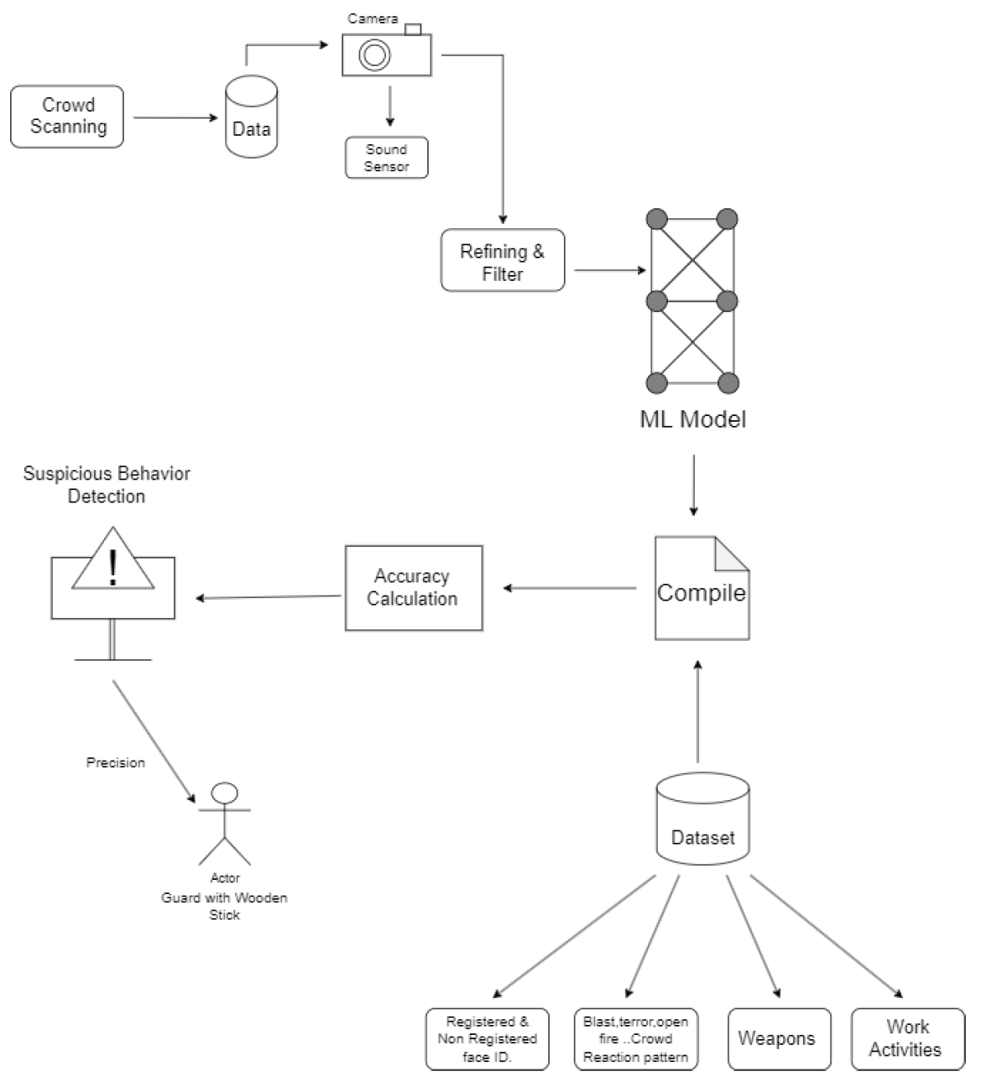
Figure 1

Figure 2: Flow of Architecture
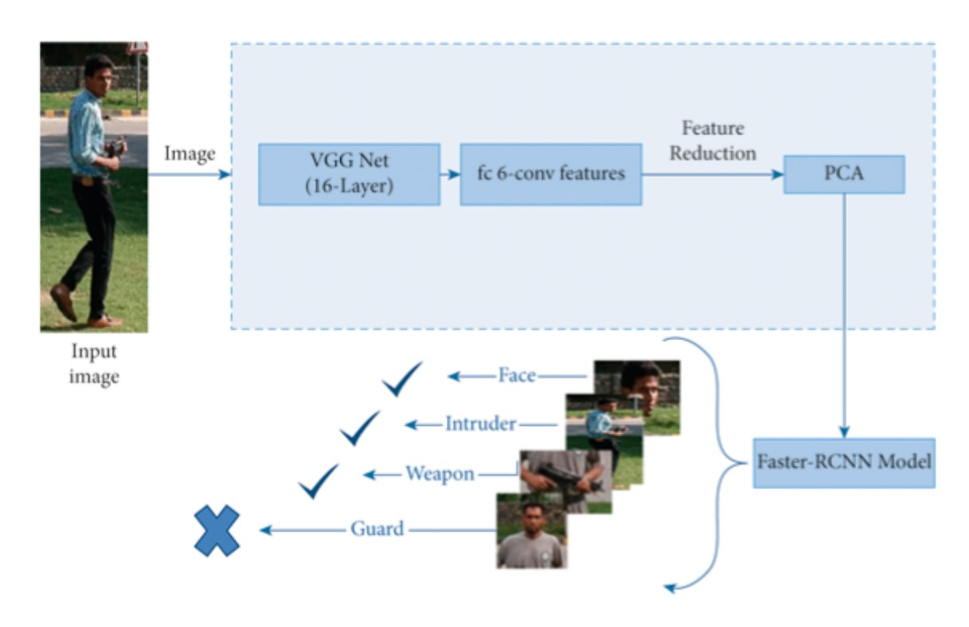 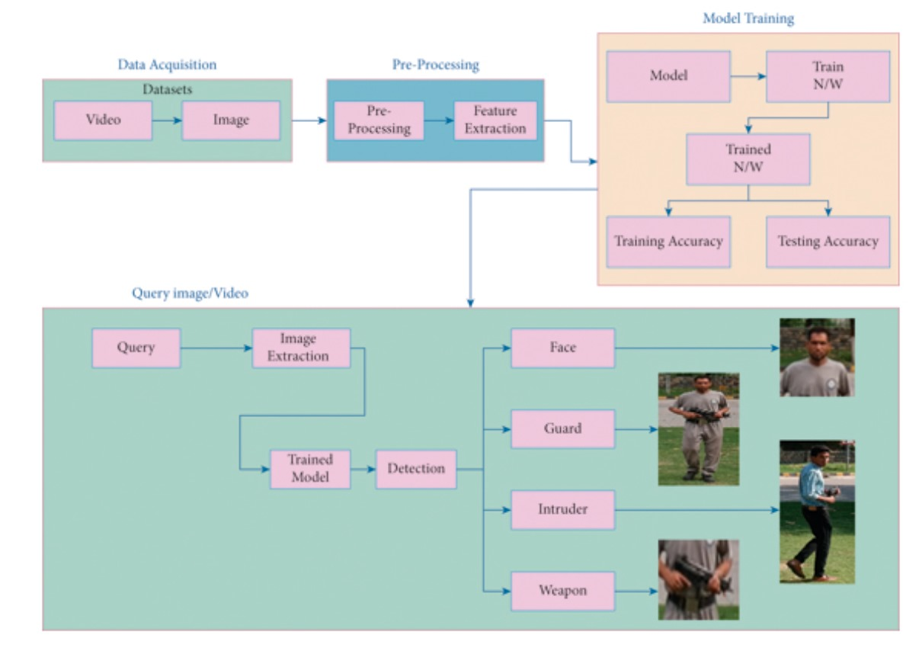Figure 3
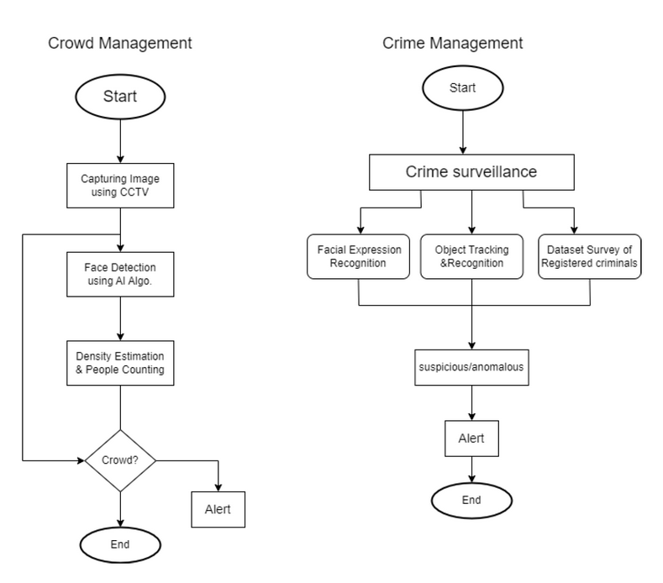
Figure 4
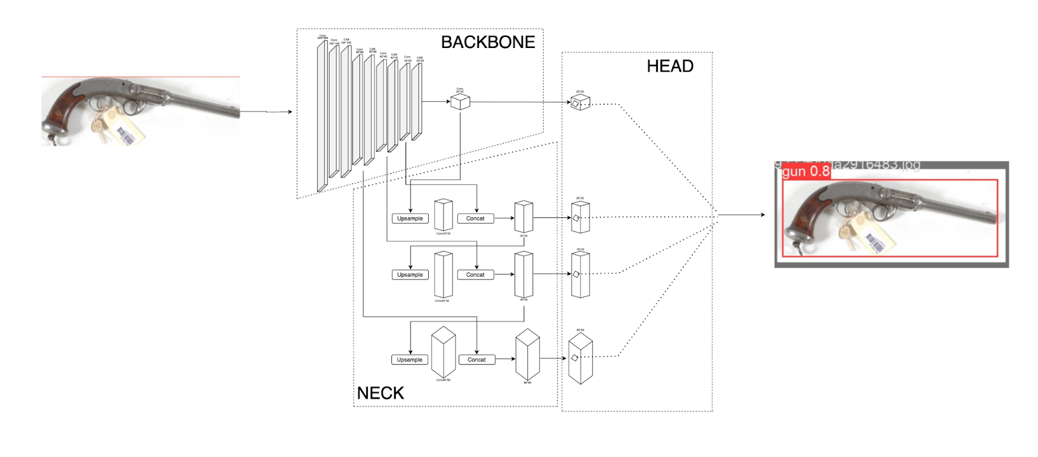
Figure 5: Proposed Architecture of Yolov8

Project Description
Object detection using advanced computer vision techniques has become fundamental in various applications, driving significant advancements in technology. This project focuses on addressing challenges related to small object detection within image data, with a specific emphasis on weapon detection using YOLOv8. The primary objective is to evaluate the effectiveness of YOLOv8 in detecting small objects, particularly weapons, within CCTV footage and images. This research aims to overcome limitations in current object detection models when dealing with small and irregularly shaped objects.

Dataset Used
A custom dataset comprising 700 images per class (Knives, Guns, Weapons) was meticulously collected from various internet resources, including Rob flow and open images. The dataset underwent rigorous preparation to ensure diversity and representativeness of each class. Image augmentation techniques were employed to diversify the dataset, including scaling, rotation, and viewpoint shifts. This augmentation process resulted in an enhanced dataset of approximately 2100 images across all classes. The dataset was divided using a cross-validation technique, with 80% of the images used for training and 20% for testing. This methodical approach enabled the assessment of model performance and generalization to new, untested images.

Model Training and Evaluation
Training commenced using YOLOv8 Nano for 150 epochs, followed by refinement using YOLOv8 Medium for an additional 300 epochs. This iterative training process aimed to optimize the model's ability to accurately detect and classify instances of small objects, including various types of weapons. A separate testing dataset consisting of 250 images per class was used to evaluate the trained models' performance in real-world scenarios. The testing phase allowed for rigorous validation of the models' efficacy in detecting and categorizing small objects of interest.
Through meticulous training and testing, the object detection models demonstrated proficiency in identifying Knives, Guns, and various types of Weapons. The project showcases the potential of AI-driven solutions for enhancing security and safety measures across diverse domains, including crime scene analysis and public safety initiatives.

Testing and Tools used
For testing YOLOv3 training, various approaches can be taken to ensure the model's accuracy, efficiency, and robustness. This includes testing the model on a diverse set of images and videos to evaluate its ability to detect objects of interest in different scenarios and environments. Additionally, performance metrics such as precision, recall, and F1-score can be calculated to assess the model's overall performance. Tools commonly used for testing YOLOv3 training include the COCO dataset for benchmarking, OpenCV for image manipulation and preprocessing, and custom scripts for evaluating the model's output against ground truth annotations. Other tools like TensorBoard can also be used for visualizing training progress and monitoring the model's performance over tim

Implementation
For implementing YOLOv8 for weapon detection, the process involves several key steps. First, you need to collect and annotate a dataset of images containing weapons. Next, you'll configure the YOLOv8 model architecture, which includes selecting the appropriate hyperparameters and adjusting the model's configuration file to suit your specific requirements. After configuring the model, you'll train it using the annotated dataset. This step involves feeding the images into the model, computing the loss function, and updating the model's weights using backpropagation.
Training can take a significant amount of time, depending on the size and complexity of your dataset. Once the model is trained, you'll need to test it using a separate validation dataset to evaluate its performance. This involves running the model on the validation images and calculating metrics such as precision, recall, and F1-score to assess its accuracy. For implementing YOLOv8 specifically for weapon detection, you can use tools like Darknet, an open-source neural network framework, which supports YOLOv8.
Darknet provides pre-trained weights for YOLOv8, which you can fine-tune on your weapon detection dataset. Additionally, you can use OpenCV for image manipulation and processing, as well as for displaying the detection results. Overall, implementing YOLOv8 for weapon detection requires a combination of data collection, model configuration, training, and testing, along with the use of tools like Darknet and OpenCV to facilitate the process.

Future Scope
In the future, the project aims to extend its capabilities beyond weapon detection to include the recognition and detection of violent behaviors such as fights, pushes, and physical altercations within CCTV footage. This expansion will involve leveraging the robustness and flexibility of YOLOv8 to identify and classify specific actions or behaviors indicative of violence in real-time.
To achieve this, additional training data will be curated to encompass a diverse range of violent behaviors captured in CCTV footage. This data will be used to fine-tune the YOLOv8 model, enabling it to accurately recognize and categorize various forms of violent interactions. Image augmentation techniques will be employed to enhance the dataset's diversity and improve the model's ability to generalize to different scenarios.
Once the model is trained and validated, the system will be integrated into existing CCTV networks to continuously monitor live video feeds. When instances of violence are detected, the system will trigger immediate alerts or notifications to designated authorities or security personnel, enabling swift intervention and response to mitigate potential risks and ensure public safety.
The integration of violence detection capabilities into the project aligns with its overarching goal of leveraging AI-driven solutions to enhance security measures and contribute to crime prevention efforts. By expanding the scope to include the detection of violent behaviors, the project aims to make significant advancements in leveraging computer vision technology for proactive incident monitoring and rapid response in various public and private settings.
Ongoing research and development efforts will focus on refining the violence detection algorithms, optimizing performance in real-world scenarios, and exploring applications across different domains such as law enforcement, transportation, and public safety initiatives.

Conclusion
The proposed approach achieves higher mean average precision and accuracy compared to individual historical models, with an average accuracy improvement of 3%. Additionally, the processing speed of the proposed technique surpasses that of earlier standalone models. The method relies on the angle formed by the weapon datapoints, the individual's elbow, and hip to establish the link between weapons and people, enabling the detection of weapons in a scene. However, limitations exist. The dataset comprises images from predetermined and controlled environments, potentially limiting the model's performance in real-world scenarios. Factors such as low resolution, haziness, location volatility, and blockage can significantly impact the model's precision.

Bibliography
- Pooja Pratihar, Detection Techniques for Human Safety from Concealed Weapons and Harmful EDS, International Review of Applied Engineering Research. ISSN 2248-9967 Volume 4, Number 1 (2014), pp. 71-76.
- T. Xu and Q. M. J. Wu, “Multisensor concealed weapon detection using the image fusion approach,” 6th International Conference on Imaging for Crime Prevention and Detection (ICDP-15), July 2015, pp. 1- 7.
- Han, K.; Wang, Y.; Tian, Q.; Guo, J.; Xu, C. Ghostnet: More features from cheap operations. In Proceedings of the 2020 IEEE/CVF Conference on Computer Vision and Pattern Recognition, Seattle, WA, USA, 13–19 June 2020; pp. 1580–1589.
- Xu, D.; Wu, Y. Improved YOLO-V3 with DenseNet for multi-scale remote sensing target detection. Sensors 2020, 20, 4276.
- Journal, I. J. C. S. M. C., & E, A. (2020). GUI BASED PREDICTION OF CRIME RATE USING MACHINE LEARNING APPROACH. IJCSMC, 9(3), 221–229.
- Sun, X.; Wang, P.; Wang, C.; Liu, Y.; Fu, K. PBNet: Part-based convolutional neural network for complex composite object detection in remote sensing imagery. ISPRS J. Photogramm. Remote Sens. 2021, 173, 50–65.
- Hanan Ashraf, M. Imran, A. M. Qahtani, A. Alsufyani, O. Almutiry et al., "Weapons detection for security and video surveillance using cnn and yolo- v5s," Computers, Materials & Continua, vol. 70, no.2, pp. 2761–2775, 2022.
- Warsi, Arif & Abdullah, Munaisyah & Husen, Mohd Nizam & Yahya, Muhammad. (2020). Automatic Handgun and Knife Detection Algorithms: A Review. 1-9. 10.1109/IMCOM48794.2020.9001725.
- Ma, J.; Hu, Z.; Shao, Q.;Wang, Y.; Zhou, Y.; Liu, J.; Liu, S. Detection of large herbivores in uav images: A new method for small target recognition in large-scale images. Diversity 2022, 14, 624.
- Lin, W.;Wu, Z.; Chen, J.; Huang, J.; Jin, L. Scale-Aware Modulation Meet Transformer. arXiv 2023, arXiv:2307.08579.
- Lai, H.; Chen, L.; Liu,W.; Yan, Z.; Ye, S. STC-YOLO: Small object detection network for traffic signs in complex environments.Sensors 2023, 23, 5307.
- Wan, D.; Lu, R.; Wang, S.; Shen, S.; Xu, T.; Lang, X. YOLO-HR: Improved YOLOv5 for Object Detection in High-Resolution Optical Remote Sensing Images. Remote Sens. 2023, 15, 614.

