Street Light Monitoring System

UML DIAGRAM

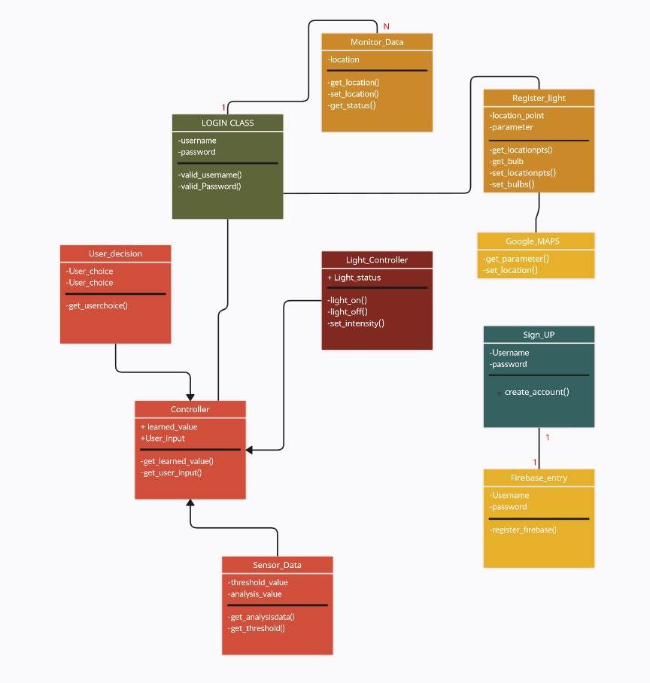

SEQUENCE DIAGRAM

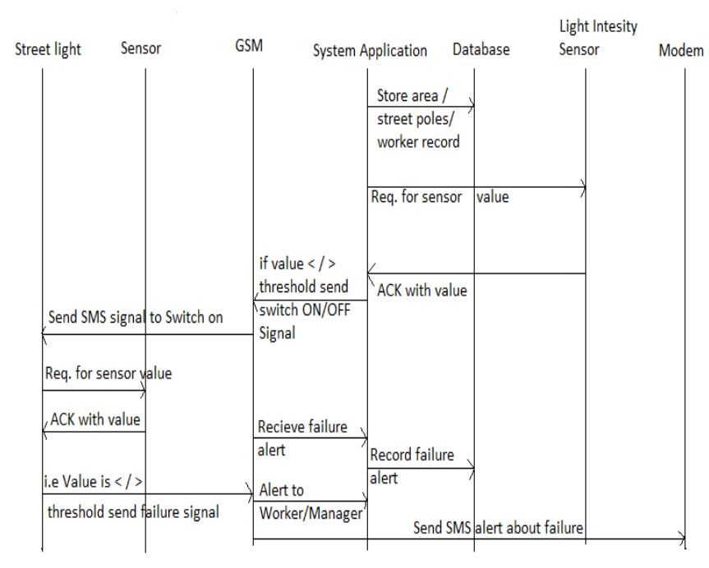

The application is designed in such a way that we place light sensors in all the street lights circuit and which are responsible to switch on and off automatically. Once the lights are switched on, current sensors placed at every light poles are responsible to report problem status to the centralized system with the help of GSM module attached with the circuit. With the status available in the centralized system, the workman now can easily locate the particular light to be taken care which minimizes the time to search it and repair. The system also collects useful information from each street light at the end of each day. The information is stored in the database such as power consumption, total number of burning hours, and total number of interruptions, tally the actual power consumption with the power supplied, details of fault detection i.e., actual location of street light.

USE CASE DIAGRAM

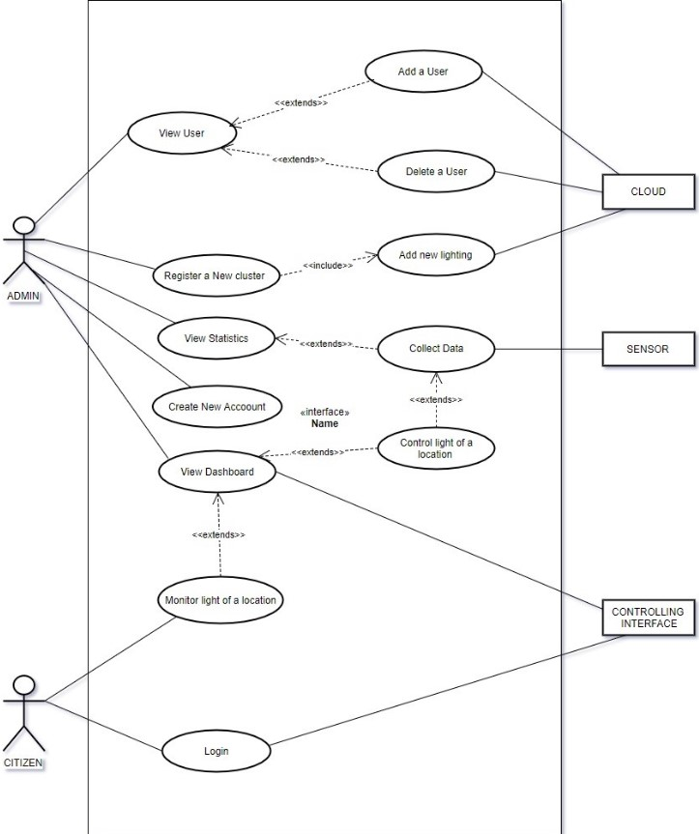

ACTIVITY DIAGRAM

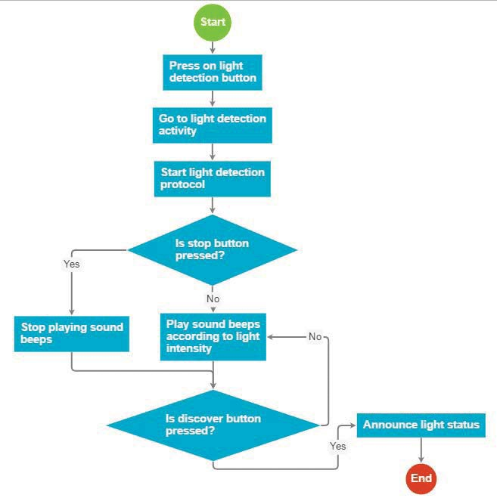

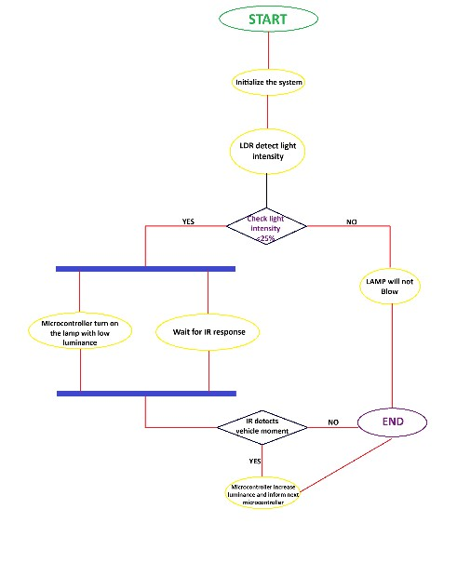

BLOCK DIAGRAM

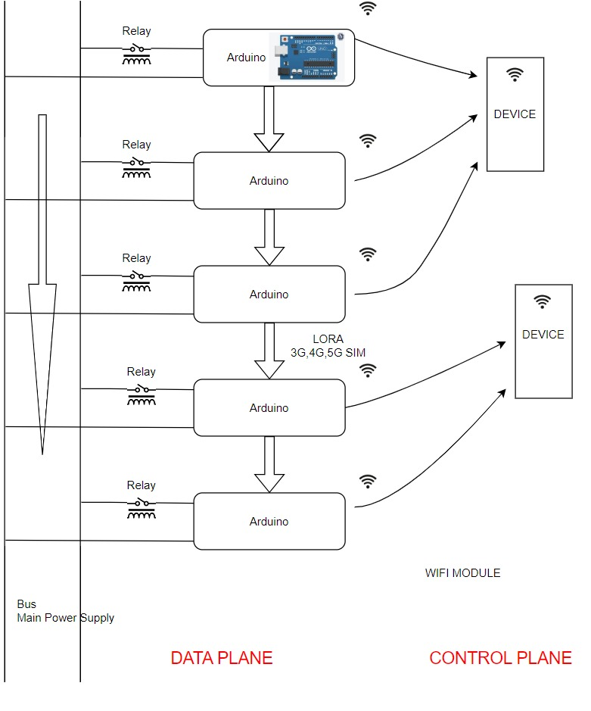

SENSOR DIAGRAM

