SMART STREET LIGHT MONITORING SYSTEM

ABSTRACT:

The proposed Smart Street Light Monitoring System aims to address challenges posed by outdated street lighting systems in both urban and rural areas. It utilizes a combination of light, motion, and weather sensors alongside GSM modules to automate street light controls remotely and manage fault reporting through servers. Real-time data collected periodically is analyzed using Wi-Fi and Loran modules for efficient maintenance, reducing downtime, and minimizing energy consumption.

The system enhances public safety, improves time precision, and promotes sustainability by transforming traditional lighting into a responsive, energy-efficient, and environmentally friendly solution. The "STREET LIGHT MONITORING AND CONTROL SYSTEM" project involves placing light sensors in all street light circuits for automatic switching on and off. Current sensors detect problems and report status to a centralized system via GSM modules. This allows workmen to easily locate faulty lights, reducing search and repair time.

The system also maintains a database to store useful information from each street light, such as power consumption, total burning hours, interruptions, and fault detection details. By optimizing power consumption, the system offers commercial benefits to businesses and contributes to the overall prosperity of the city. Key components include current sensors, GSM modules, Light Dependant Resistors (LDRs), and microcontrollers.

INTRODUCTION:

The proposed street light monitoring and control system addresses the inadequacies of poorly designed and maintained lighting systems, aiming to improve visibility, safety, and comfort for pedestrians and motorists while reducing energy consumption and maintenance costs. By placing light sensors in all street light circuits and utilizing GSM modules for centralized monitoring, the system enables automatic switching on and off of lights and real-time reporting of problems.

The system collects valuable data from each street light, such as power consumption, burning hours, interruptions, and fault detection details, storing them in a centralized database for analysis. Charts derived from this information provide insights into lighting performance and facilitate efficient maintenance. Additionally, the system incorporates optimal sleep scheduling protocols to prolong the lifespan of street lights.

Effective street lighting not only enhances road safety and deters crime but also improves the overall quality of life for residents and boosts commercial activity. By enabling timely repairs and reducing downtime, the proposed system aims to expedite fault resolution, contrasting with the current system where repairs often take days or even months. Overall, the system enhances public safety, fosters economic growth, and contributes to the prosperity of the city as a whole.

Constraints

|  |  |  |
| --- | --- | --- |
| 1. | No of poles | 5 |
| 2. | Light on each pole | 2 |
| 3. | Height of each street light pole | 20ft |
| 4. | Distance between 2 pole | Standard |
| 5. | Full cutoff fixture  Angle between pole and light | 180 degree  90 degree (max intensity) |
| 6. | Road Width and Length | 10ft and 300ft |
| 7. | LED light Intensity | 3000 to 5000 lumens |
| 8. | Wifi module covering area  LoRa covering area | 150 ft indoor..300 ft outdoor  10 miles - 15 km |

|  |  |  |
| --- | --- | --- |
| **S.NO.** | **Problems** | **Problems solved by the Invention** |
| 1. | The original street light system at max works on LDR sensor. Hence consumption of energy is not optimal. | By using PIR alongside LDR the brightness is automatically adjusted in response to detected movement. Hence reducing energy utilization drastically. |
| 2. | Maintenance of Street light is a task and is done very reluctantly. | Using LoRa device connects every street light pole to each other and Wi-Fi module fills the connectivity bridge between street light pole and the cloud(internet) finally connecting the server. |
| 3. | Cumulative data is not available for the street light of a particular area. | Data Display online on Live server like Internet of Things.  Linking map for live street update is also easily accomplished. |

**FLOW CHART**

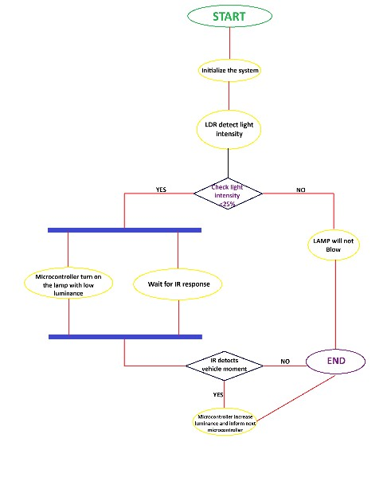

Block Diagram

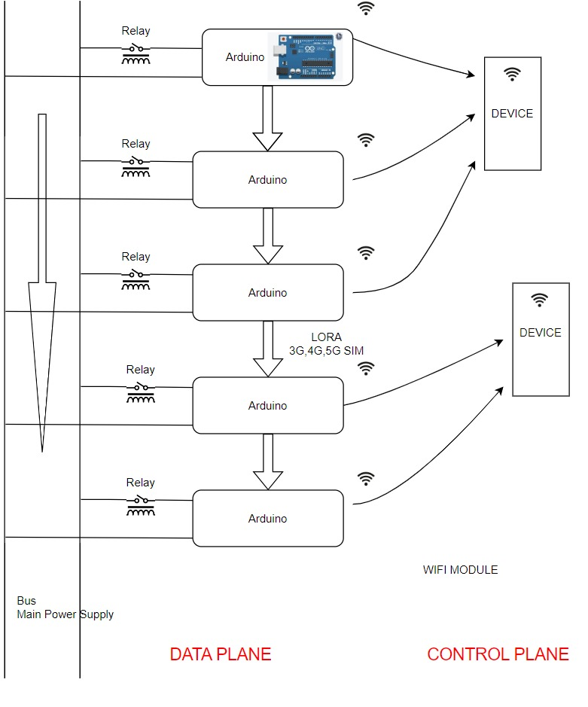

|  |  |
| --- | --- |
| FUNCTIONS | Electricity supply through the main line is distributed by BUS networking and is controlled by RELAY.  Communication between the LED’s is done so as to solve the short-range device connection to every LED problem.  So, LEDs are interconnected using LoRa or 3G,4G,5G connectivity using sim cards.  Wiring is also possible but is less preferred due to multiple damages experienced.  These LEDs are then controlled by mobile devices and control stations.  LED’s and devices communicate using the WIFI module.  Data movement bw diff arduinos is done using ROUTER bcz server is not always in vicinity. |
| REQUIREMENTS | RELAY, Arduino, Sensors ,Wifi module,LoRa,3G,4G,5G sim |

Sensor Diagram

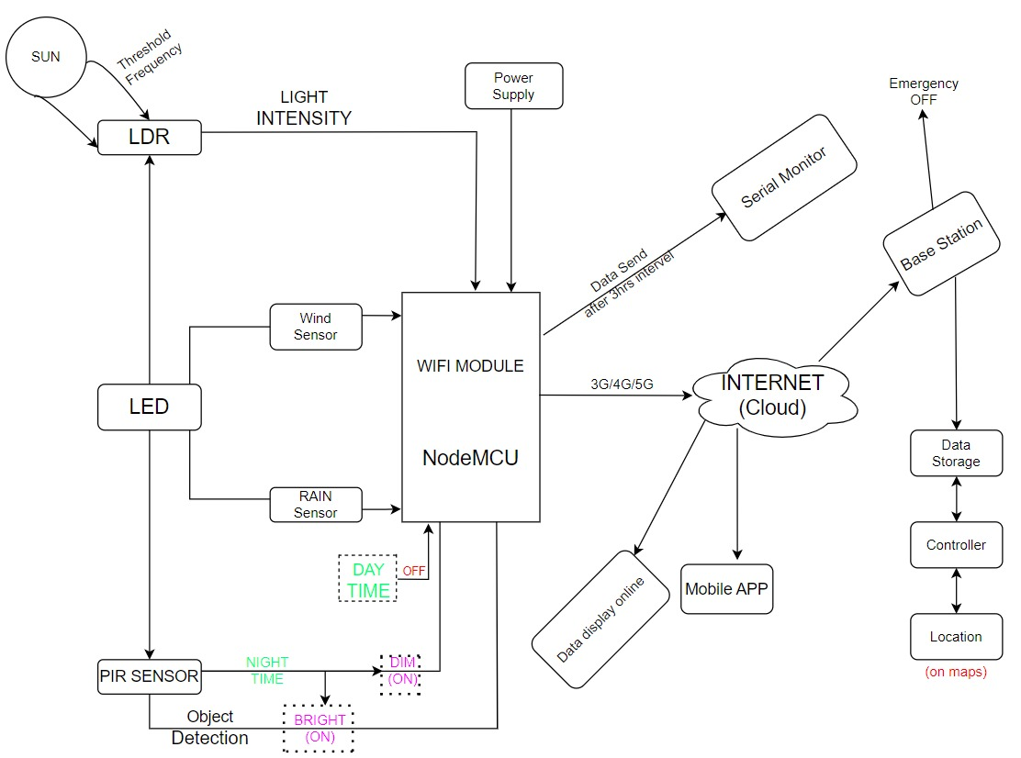

**FUNCTIONS**

* Turn the lights on by themselves at dusk and turn them off at dawn. according to the limitations Calibration of sun intensity: 250 lux
* The presence of sunlight is essential because without it, the light could go out due to several cars or street lights.
* 12 a.m. to 2 a.m. complete brightness dark from 2-4 a.m. Because there is less traffic and human movement during these times, lights are not necessary. Only when movement is detected should the previously faint lights be brightened.
* Sell these raw data to businesses or provide a simplified version of the data (safe, risky, exercise caution, etc.) to Google Maps so that people can travel more easily. For two- and four-wheelers and heavy motor vehicles, the simplified statistics will differ.

**REQUIREMENTS**

Sensors – LDR | PIR

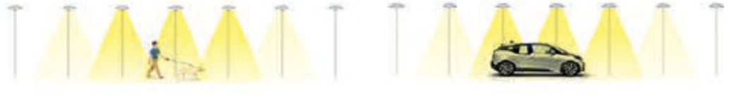

Literature Review

|  |  |  |
| --- | --- | --- |
| **S.No.** | **Author** | **Method/Technology** |
| **1.** | M. B. Kodad, A. Akherraz, A. El Habbani | This paper explores IoT-based solutions for street light control systems, providing insights into the integration of IoT technology for efficient monitoring. |
| **2.** | A. Alwisy, A. Nasr, A. Ghuniem | This paper discusses the design and implementation aspects of a smart street lighting system, covering various sensors and control mechanisms. |
| **3.** | A. S. Suryawanshi, M. V. Aware | The paper explores the integration of GPRS and web technology for intelligent street lighting, emphasizing remote monitoring and control. |

SEQUENCE DIAGRAM

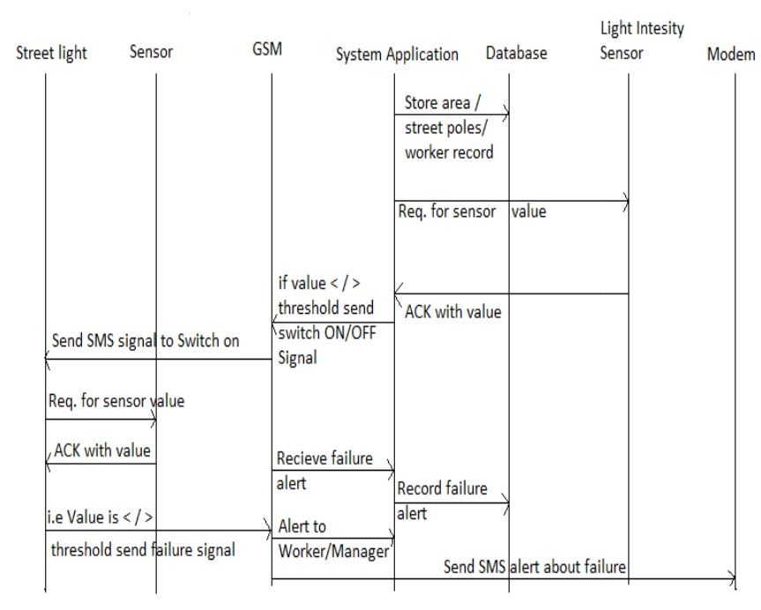

USE CASE DIAGRAM

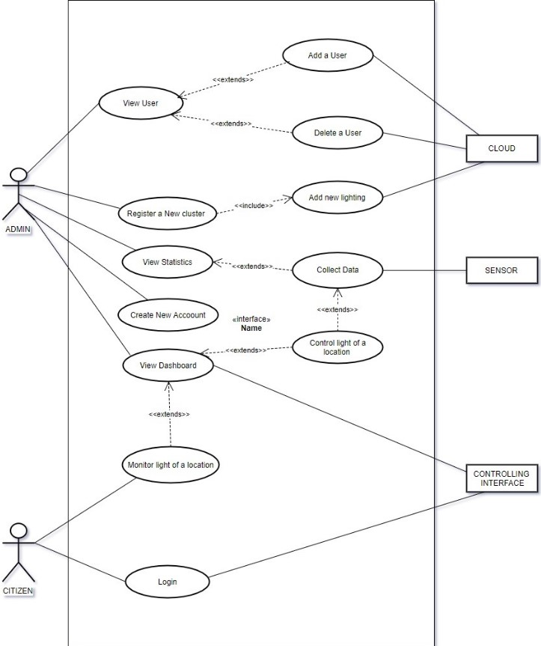

ADVANTAGES OF THE INVENTION

* . There is less power consumption since there is less light when there is no movement because the brightness is controlled by movement detection.
* The transition to online monitoring expedites and simplifies the process of defect discovery and repair by reducing the manpower requirements.
* Largely, the human error constraint is minimized now that the automatic on and off is dependent on a threshold frequency of 250 lux.

We would like to propose the following in order to offset the installation costs:

* The information about how the street light’s function, along with the wind and rain intensity at the previously observed area, will be kept in the system database and can be further sold to businesses such as Google Maps and Weather Applications, which use the location-specific meteorological data and light conditions to determine whether an area is safe for travel.

As long as we take back the old street lights with us, we will install the street lights for the government at no cost to them, offsetting our installation expenses.

UML DIAGRAM

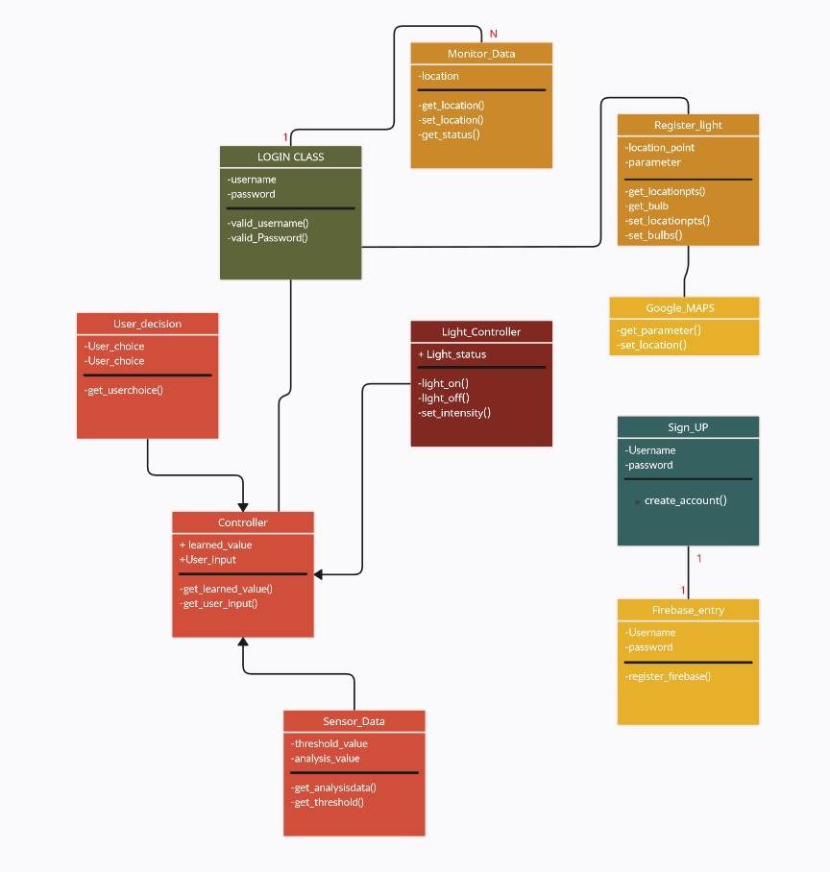

**Scope and Uniqueness of the Project**

* Street light false detection and alert notification.
* The useful information is collected from the street light at the end of each day this information is stored in a database and based on this information charts are derived.
* Wireless Communication
* The Details received on the server can be sold in the form of database.
* The usage of LoRa device between the different street light poles to establish connectivity between each pole so that if one of them malfunctions the others are still interlinked to share the information through the Wi-Fi module to the Servers End.

**Results Obtained**

* The street poles are now automatically turned on and off based on the solar threshold light, replacing the previous manual control method.
* The auto brightness feature, which employs a PIR sensor to detect movement and increase brightness when it does, was introduced to reduce energy use, the brightness is automatically adjusted in response to detected movement.
* With the use of Loran monitoring modules and centralized system status updates, workers can now quickly identify the specific light that needs attention, cutting down on the amount of time it takes to find and fix problems.
* The primary goal is to minimize daily power consumption, which results in a reduction in the number of personnel needed for maintenance and repairs.

**Communication Model**

Communication is done in 3 modes

1. Between LEDS (lora, ZigBee)
2. LED to network tower (done by 3G,4G)
3. Network tower to SERVER (IP based link)
4. **Wireless Connectivity:** The communication module enables wireless connectivity between street light controllers, sensors, and the central server, allowing seamless data exchange and control commands.
5. **Data Transmission:** It facilitates the transmission of sensor data, such as light levels and motion detection, from individual street light controllers to the central server in real-time, ensuring accurate monitoring and analysis.
6. **Remote Control:** enabling administrators to adjust lighting schedules, brightness levels, and other settings without manual intervention, enhancing operational flexibility.
7. **Fault Reporting:** In case of malfunctions or issues, the communication module sends instant alerts to the central server, enabling rapid response and minimizing downtime. This proactive approach aids in efficient maintenance.
8. **Two-way Communication:** allowing the central server to send commands back to street light controllers. This bidirectional communication ensures precise control and monitoring capabilities.

REFRENCES

1. Sakshee Srivastava, "Automatic Street Lights".

2. V.V.S. Madhuri, P. Mallikarjuna Sarma, N. Sandhya Rani, "Automatic Street Lighting using PLC".

3. Prof. K.Y. Rajput, Gargeyee Khatav, Monica Pujari, Priyanka Yadav, "Intelligent Street Lighting System Using GSM".

4. Omkar Natu, Prof. S.A. Chavan, "GSM based smart street light monitoring and control system".

5. R. Caponetto, G. Dongola, L. Fortuna, "Power Consumption Reduction in a Remote Controlled Street Lighting System", SPEEDAM 2008 International Symposium on Power Electronics, Electrical Drives, Automation and Motion.

6. A. Lay-Ekuakille, G. Vendramin, "LED-based Public Lighting System Reliability for a Reduced Impact on Environment and Energy Consumption".

7. R. Rubanath, T. Kavitha, "GSM Based RFID Approach To Automatic Street Lighting System", April 30th, 2012.

8. M. A. Wazed, N. Nafis, "Design and Fabrication Of Automatic Street Light Control System", Engineering e-Transaction Vol. 5, No. 1, June 2010.

9. Radhi Priyasree, Rafiya Kauser H., Vinitha E., Gangatharan N., "Automatic Street Light Intensity Control and Road Safety Module Using Embedded System", ICCCE 2012, April 12 & 13, 2012.

10. Meihua Xu, Yujie Zhang, Guoqin Wang, "Design of Intelligent Streetlight Monitoring System Based on STM32", 2012 IEEE Symposium on Electrical & Electronics Engineering (EEESYM).

11. Deepak Kapgate, "Wireless Streetlight Control System", International Journal of Computer Applications, Volume 41, No. 2, March 2012.

12. Jennic Ltd, "White Paper", Sheffield UK, April 2009.

13. Mircea Popa, Costin Cepişcă, "Energy Consumption Saving Solutions Based On Intelligent Street Lighting Control System", U.P.B. Sci.