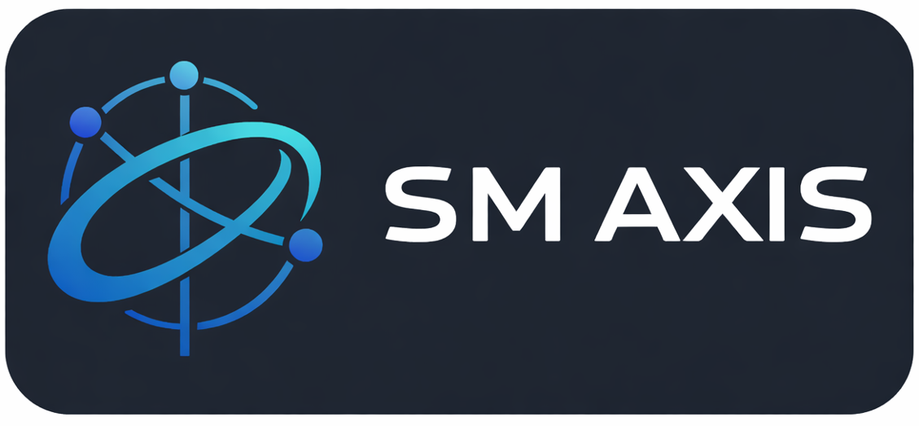

Dipholoholo Pty Ltd_Website Pricing
Prepared by: SM AXIS (PTY) LTD

Packages for a security website
Package | Description | Pages / Features | Price (ZAR)
Basic | Entry-level professional website for small security companies | Up to 4 pages (Home, About, Services, Contact)Responsive designSecurity-industry layoutServices overview (Guarding, Patrols, Access Control)Contact form with notificationsBasic animations | R3,500 – R5,000
Standard | Enhanced website for growing security firms requiring stronger online presence | Up to 6 pagesDedicated service pages (e.g. Armed Guards, CCTV, Patrols)Improved UI/UX and animations, SEO-friendly structurePerformance optimisationValidated contact forms | R5,000 – R8,500
Premium | Full corporate security website with advanced design and optimisation | 8–10 pagesCustom UI/UX aligned to brandAdvanced animations and interactionsSEO optimisation & Google indexing readinessPerformance & accessibility optimisationPriority revisions | R8,500 – R11,000

Optional Add-Ons (Quoted Separately)
- Additional pages: 600 – 1,000 per page
- SEO optimisation & Google indexing
- Copywriting and content assistance
- Maintenance and support plans
- Future feature enhancements

Pricing Notes
- Final pricing confirmed after scope and content approval.
- Hosting, domain, and third-party costs are included in the pricing.
- Any work outside agreed scope will be quoted separately.

