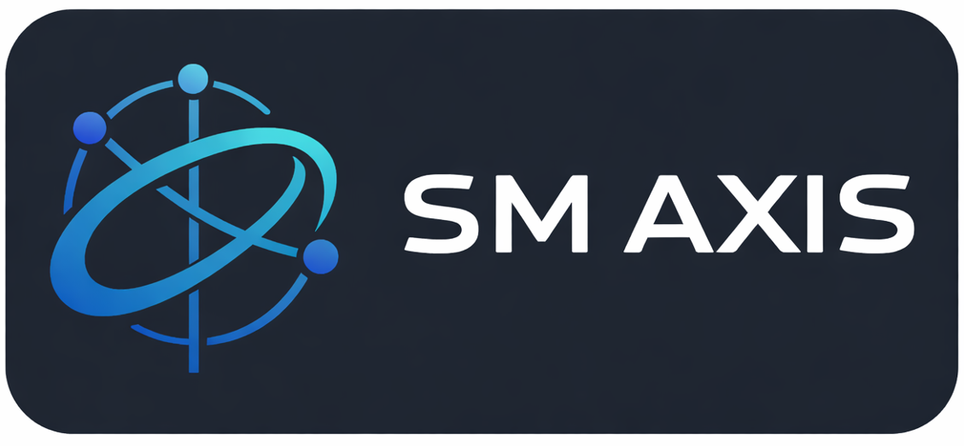

Boikhutsokhutso Pty Ltd – Website Prototype Overview
Prepared by: SM AXIS (PTY) LTD

Prototype Website (Already Developed)
A functional prototype website has been created to visually demonstrate the proposed design direction, layout structure, navigation flow, and overall user experience for Boikhutsokhutso Pty Ltd.
Preview Link:
https://boikhutsokhutso-web.vercel.app/

Key Points
- The prototype represents the intended look and feel of the final website.
- All content, imagery, and branding elements are placeholders unless confirmed otherwise.
- The prototype allows early feedback, reducing risk and ensuring alignment before final delivery.

Benefits
- Provides a clear visual reference for stakeholders.
- Enables efficient collaboration and feedback.
- Ensures the final website meets expectations before development begins.

Note: The prototype is for review purposes only and is not the final production website. Final delivery will include all approved content, branding, and functionality according to the chosen package.

